Environmental and Social Impact Assessment Report

Livable and Resilient Cities Project

Thimphu City, Bhutan
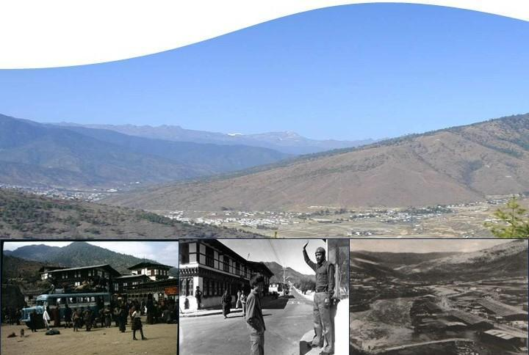

March, 2026



Prepared & submitted by: Phuensum Consultancy Services. Thimphu, Bhutan
Prepared for: Department of Human Settlement, MOIT, Royal Government of Bhutan

Disclaimer
This Environmental and Social Impact Assessment (ESIA) forms part of the environmental and social (E&S) due diligence for the Bhutan Livable and Resilient Cities Project (LRCP), a $48 million project consisting of $28 million in Green Climate Fund (GCF) financing. The ESIA was prepared by the Royal Government of Bhutan and follows Good International Industry Practices (GIIP) and the Green Climate Fund's (GCF) Environmental and Social Policy (ESP).
In accordance with the GCF's Information Disclosure Policy (IDP) and for the benefit of potentially project-affected people (PAP) and other interested stakeholders, this ESIA is being disclosed at the earliest opportunity. The disclosure of this ESIA should not be construed as final E&S clearance or endorsement of the project by the GCF. This ESIA may still contain gaps to fully address all pertinent E&S issues identified in the project. Any such gaps will be addressed with updates or through supplemental studies, assessments, and/or management plans to be completed within a reasonable timeframe and in accordance with the GCF Environmental and Social Policy and GIIP.

གསལ་བསྒྲགས།
མཐའ་འཁོར་དང་མི་སྡེའི་ཕན་གནོད་བརྟག་ཞིབ་ (Environmental and Social Impact Assessment – ESIA)འདི་ འབྲུག་གི་སྡོད་གནས་དང་གནོད་འཚེ་བཟོད་སྲན་ཅན་གྱི་གྲོང་ཁྱེར་ལས་འགུལ་ (Bhutan Livable and Resilient Cities Project – LRCP) གྱི་ མཐའ་འཁོར་དང་མི་སྡེ (E&S) འབྲེལ་བའི་ཞིབ་འཇུག་དང་བརྟག་ཞིབ་ཀྱི་ཆ་ཤས་ཅིག་ཨིན། ལས་འགུལ་འདི་གི་ རིན་ཐང་ཨ་རིའི་ཌོ་ལར་ ༤༨ ས་ཡ་ཨིནམ་དང་ དེ་ནང་ལུ་ Green Climate Fund (GCF) གི་ མ་དངུལ་ཌོ་ལར་༢༨ ས་ཡ་ཚུདཔ་ཨིན། མཐའ་འཁོར་དང་མི་སྡེའི་ཕན་གནོད་བརྟག་ཞིབ་འདི་ འབྲུག་་གཞུང་གིས་ རྒྱལ་སྤྱིའི་བཟོ་གྲྭ་དང་ལས་རིགས་ཀྱི་ལག་ལེན་ལེགས་ཤོམ་ (Good International Industry Practices – GIIP) དང་ Green Climate Fund (GCF) གི་ མཐའ་འཁོར་དང་མི་སྡེའི་སྲིད་བྱུས་ (Environmental and Social Policy – ESP) ལུ་གཞི་བཞག་སྟེ་བཟོ་ཡོདཔ་ཨིན།
GCF གི་བརྡ་དོན་གསལབསྒྲགས་སྲིད་བྱུས་ (Information Disclosure Policy – IDP) དང་འཁྲིལ་ ལས་འགུལ་འདི་གིས་གནོད་པ་འབྱུང་སྲིད་པའི་མི་སྡེ་ (Project-Affected People – PAP) དང་ གཞན་འབྲེལ་ཡོད་ལས་སྡེ་ཚུ་གི་ཁེ་ཕན་ལུ་གཞི་བཞག་སྟེ་ མཐའ་འཁོར་དང་མི་སྡེའི་ཕན་གནོད་བརྟག་་ཞིབ་འདི་ གང་མགྱོགས་གསལ་་བསྒྲགས་འབད་དེ་ཡོད། ཨིན་རུང་ བརྟག་་ཞིབ་འདི་གསལ་་བསྒྲགས་འབད་བ་ཙམ་གྱིས་ GCF ལས་འགུལ་གིས་ མཐའ་འཁོར་དང་མི་སྡེའི་ཉོག་མེད་་ (E&S Clearance) ཡང་ན་ ངོས་ལེན་གནང་ཡོདཔ་སྦེ་བསམ་ནི་མི་འོང་།
མཐའ་འཁོར་དང་མི་སྡེའི་ཕན་གནོད་བརྟག་ཞིབ་འདི་ནང་ ལས་འགུལ་དང་འབྲེལ་བའི་ གལ་ཅན་གྱི་མཐའ་འཁོར་དང་མི་སྡེའི་གནད་དོན་ཚུ་ བསལ་ནི་ནང་ ཁྱད་པར་དག་པ་ཅིག་འོང་སྲིད། དེ་བཟུམ་གྱི་ཁྱད་པར་་ཡོད་པ་ཅིན་ GCF གི་མཐའ་འཁོར་དང་མི་སྡེའི་སྲིད་བྱུས་ (Environmental and Social Policy) དང་ GIIP དང་འཁྲིལ་ཏེ་ བརྟག་ཞིབ་ཞིབ་དུས་མཐུན་བཟོ་ནི་ ཡང་ན་ ཁ་སྐོང་ཞིབ་འཇུག་འགོ་འདྲེན་འཐབ་ནི་ དེ་ལས་ འཛིན་སྐྱོང་འཆར་གཞི་ཚུ་བརྒྱུད་དེ་བསལ་ནི་ཨིན།
List of Abbreviations
Abbreviation |  | Full Form
ABS | : | Ability Bhutan Society
BAOWE | : | Bhutan Association of Women Entrepreneurs
BCTA | : | Bhutan Construction and Transport Authority
BDL | : | Below Detection Limit
BGTP | : | Bhutan Green Transport Project
BIS | : | Bureau of Indian Standards
BOD | : | Biochemical Oxygen Demand
BPC | : | Bhutan Power Corporation
BPL | : | Bus Priority Lane
BPS | : | Bus Priority Service
BUDP-II | : | Second Bhutan Urban Development Project
C-ESMP | : | Contractor's Environmental and Social Management Plan
CAP | : | Corrective Action Plan
CBS | : | City Bus Service
CBO | : | Community-Based Organization
CFP | : | Chance Finds Procedure
CHA | : | Critical Habitat Assessment
CHMP | : | Cultural Heritage Management Plan
CHS | : | Community Health and Safety
CI | : | Cumulative Impact
CITES | : | Convention on International Trade in Endangered Species of Wild Fauna and Flora
CO | : | Carbon Monoxide
CoC | : | Code of Conduct
COD | : | Chemical Oxygen Demand
CSO | : | Civil Society Organization
CSI | : | Cottage and Small Industries
CWSS | : | Central Water Supply Scheme
dBA | : | Decibels (A-weighted)
DCDD | : | Department of Culture and Dzongkha Development
DECC | : | Department of Environment and Climate Change
DGM | : | Department of Geology and Mines
DHS | : | Department of Human Settlements
DO | : | Dissolved Oxygen
DoFPS | : | Department of Forests and Park Services
E&S | : | Environmental and Social
EC | : | Environmental Clearance
EHS | : | Environmental, Health, and Safety
EIA | : | Environmental Impact Assessment
ESF | : | Environmental and Social Framework (World Bank)
ESIA | : | Environmental and Social Impact Assessment
ESMP | : | Environmental and Social Management Plan
ESRS | : | Environmental and Social Risk
ESS | : | Environmental and Social Standard (World Bank)
EV | : | Electric Vehicle
FGD | : | Focus Group Discussion
FNCA | : | Forest and Nature Conservation Act
FPIC | : | Free, Prior, and Informed Consent
GAP | : | Gender Action Plan
GBV | : | Gender-Based Violence
GCF | : | Green Climate Fund
GHG | : | Greenhouse Gas
GLOF | : | Glacial Lake Outburst Flood
GM | : | Grievance Mechanism
GRM | : | Grievance Redress Mechanism
IA | : | Implementing Agency
IBAT | : | Integrated Biodiversity Assessment Tool
IEE | : | Initial Environmental Examination
ITS | : | Intelligent Transport System
IUCN | : | International Union for Conservation of Nature
JDNP | : | Jigme Dorji National Park
JHA | : | Job Hazard Analysis
KBA | : | Key Biodiversity Area
KII | : | Key Informant Interview
km | : | Kilometer
LAP | : | Local Area Plan
LMP | : | Labor Management Procedures
LRCP | : | Livable and Resilient City Project
m³ | : | Cubic Meter
MLD | : | Million Liters per Day
MoF | : | Ministry of Finance
MoIT | : | Ministry of Infrastructure and Transport
MSIP | : | Management Strategies and Implementation Plans
NCHM | : | National Centre for Hydrology and Meteorology
NEC | : | National Environment Commission
NES | : | National Environmental Standards
NFI | : | National Forest Inventory
NGO | : | Non-Governmental Organization
NLC | : | National Land Commission
NMT | : | Non-Motorised Transport
NO2 | : | Nitrogen Dioxide
NRW | : | Non-Revenue Water
O&M | : | Operation and Maintenance
OHS | : | Occupational Health and Safety
PAP | : | Project Affected Person
PAVA | : | Property Assessment and Valuation Agency
PCR | : | Physical Cultural Resources
PIU | : | Project Implementation Unit
PMU | : | Project Management Unit
PM10 | : | Particulate Matter (10 micrometers or less)
PM2.5 | : | Particulate Matter (2.5 micrometers or less)
PMSC | : | Project Management and Supervision Consultant
PPE | : | Personal Protective Equipment
PPSD | : | Project Procurement Strategy for Development
PWD | : | Persons with Disabilities
RAP | : | Resettlement Action Plan
RBP | : | Royal Bhutan Police
RGoB | : | Royal Government of Bhutan
RFI | : | Request for Information
RoW | : | Right-of-Way
SCADA | : | Supervisory Control and Data Acquisition
SEA/SH | : | Sexual Exploitation and Abuse / Sexual Harassment
SEP | : | Stakeholder Engagement Plan
SOE | : | State-Owned Enterprise
SO2 | : | Sulphur Dioxide
SOP | : | Standard Operating Procedure
SRF | : | State Reserved Forest
STI | : | Sexually Transmitted Infection
TDS | : | Total Dissolved Solids
TMP | : | Traffic Management Plan
TOR | : | Terms of Reference
TSPM | : | Total Suspended Particulate Matter
TSS | : | Total Suspended Solids
TT | : | Thimphu Thromde
WB | : | World Bank
WBG | : | World Bank Group
WHO | : | World Health Organization
WTP | : | Water Treatment Plant

Executive Summary
The proposed Livable and Resilient City Project (LRCP) aims to enhance livability and climate resilience in Thimphu City by improving targeted infrastructure and service delivery. This Environmental and Social Impact Assessment (ESIA) focuses on the project's public transport and public space components. Specifically, Sub-component 1.2 will upgrade Norzin Lam and connecting paths along the bus priority corridor through accessible public-realm and sidewalk improvements, integrated utility ducts and power connections, a traffic circulation and management plan prioritizing pedestrians and bus operations while maintaining essential access, and enhanced drainage and sewer systems to reduce pluvial flood risk. Sub-component 1.3 will develop a climate-resilient 18.9-kilometre bus priority corridor (or Bus Priority Service, BPS) with dedicated lanes, upgraded road and bridge infrastructure, 75 shelters, 23 signalized pedestrian crossings, 50 electric buses, new and upgraded terminal and depot facilities, and integrated intelligent transport, ticketing, and operational management systems to improve public transport frequency, safety, accessibility, and efficiency. The project will be implemented by the Ministry of Infrastructure and Transport (MoIT) and Thimphu Thromde (TT), with potential financing from the Green Climate Fund (GCF) and the World Bank.
Environmental and Social Assessment
An environmental and social (E&S) assessment of the LRCP has been conducted in accordance with the World Bank's Environmental and Social Framework (ESF) and the relevant national laws of Bhutan. This assessment is based on a comprehensive review of feasibility study, field investigations, biodiversity surveys, baseline monitoring of air, noise, and water quality, and project-specific socioeconomic census surveys and stakeholder consultations conducted between 2023 and June 2025.
The environmental and social risk of the proposed activities is classified as Substantial according to the ESF. A comprehensive suite of E&S instruments has been prepared. These include this Environmental and Social Impact Assessment (ESIA) and Environmental and Social Management Plan, a Resettlement Action Plan (RAP) for the public transport and public space components, a Stakeholder Engagement Plan (SEP), a Gender Action Plan (GAP), a SEA/SH Prevention and Response Action Plan, and an Environmental and Social Commitment Plan (ESCP) for the entire project. A separate ESMP has been prepared for the water supply investments (Sub-component 1.1).
Additionally, the project has established a Labor Management Procedures (LMP) framework that sets the standards for labor and working conditions; a detailed, site-specific Labor Management Plan will be prepared by the contractor as a contractual requirement before works commence.
Environmental Baseline
Physical Environment. The BPS route extends through the relatively flat terrain of the Thimphu Valley (approx. 13.0 km) before gradually ascending into more sloped and hilly terrain in its northern section (approx. 5.7 km), with elevations ranging from 2,250 to 2,505 meters. Land use along the corridor is a mix of residential, commercial, institutional, and forested areas. Thimphu has a cool, temperate climate with warm summers and cold, dry winters, with average temperatures ranging from 6°C to 23°C. The hydrology is dominated by the Wang Chhu River and its tributaries. The city is highly vulnerable to flash floods, as evidenced by the catastrophic Dechencholing flood in August 2024, which underscores the increasing risk from intense rainfall and climate change. The geology consists of highly metamorphosed pre-Cambrian rocks, and some hilly sections along the route are identified as being prone to landslides.
Environmental Quality. Baseline monitoring shows that while air quality generally complies with Bhutan's National Environmental Standards (NES) 2020, it frequently exceeds the more stringent World Health Organization (WHO) Air Quality Guidelines of 2021. Nitrogen Dioxide (NO₂), primarily from vehicle emissions, is the most widespread pollutant of concern, with levels at most monitored locations significantly above the WHO guideline. Fine Particulate Matter (PM₂.₅) also exceeds WHO limits in high-traffic commercial areas like Doebum Lam. Noise levels across Thimphu frequently exceed both national and international (WBG EHS) guidelines, particularly at night in residential and sensitive areas, indicating a degraded acoustic environment largely driven by traffic.
Biological Environment. A 0.8 km section of the BPS route between Taba and Dechencholing passes through state-reserved forest land, primarily consisting of Blue Pine (Pinus wallichiana) mixed with oak species. While surveys confirmed no IUCN Red List flora in the immediate project footprint, species like Blue Pine and Walnut are nationally protected under the Forest and Nature Conservation Act. Common, adaptable fauna such as Wild Pig and Barking Deer are present in these forested areas. The Thimphu Wetlands, a designated Key Biodiversity Area (KBA) significant for the vulnerable Wood Snipe, is located to the west of the Wang Chhu River; the BPS route runs parallel on the opposite side of the river and does not physically encroach upon the KBA's boundaries.
Social Baseline
According to the Population and Housing Census of Bhutan (PHCB) 2017, the population of Thimphu Thromde was 114,551, with significant internal migration making it the nation's primary urban center. Reflecting this continued growth, more recent estimates from the National Statistics Bureau's (NSB) Population Projection for 2017-2027 indicate that the population has substantially increased, underscoring the city's dynamic expansion.
Project-specific surveys for the RAP in 2025 revealed critical social characteristics of the affected population. A vast majority of households will face economic displacement, mainly due to impact on businesses, along the BPS corridor and Norzin Lam operated by tenants, not property owners, making them highly vulnerable to loss of income and jobs. A key finding, particularly in the Norzin Lam area, is the high proportion of female-headed households (51%), which is significantly higher than the national average and points to a specific social dynamic requiring targeted engagement. Other vulnerable groups identified include persons with disabilities, the elderly, and those with livelihoods dependent on street-level activities. The project corridor is in close proximity to major cultural heritage sites, including the Dangrim Chorten, the highly sensitive National Memorial Chorten, Hejo Chorten, Dechencholing Palace, and Dolma Lhakhang/Pangrizampa.
Sensitive Receptors along the BPS Route
The BPS corridor and Norzin Lam improvement areas pass through key urban zones, placing a variety of important structures, amenities, and sensitive receptors in close proximity to project activities.
- Educational Institutions: The route passes near several schools, including highly sensitive designated Special Education Needs (SEN) schools like Sherubgatshel Primary School, Changzamtog Middle Secondary School, Etho Meto Primary School and Zilukha Middle Secondary School.
- Healthcare Facilities: The Jigme Dorji Wangchuck National Referral Hospital (JDWNRH) and Kidu Medical Center are key healthcare institutions situated directly along the BPS route, requiring careful management of access, noise, and dust.
- Cultural and Heritage Sites: The project corridor is near significant cultural and religious sites, including the National Memorial Chorten, Hejo Chorten, Dechencholing Palace, and Dolma Lhakhang/Pangrizampa, which are highly sensitive to disruptions from construction.
- Commercial and Public Amenities: The routes pass through Thimphu’s primary commercial hubs, public offices, the Centenary Farmers' Market, and various public playgrounds.
- Rivers and Streams: The BPS route crosses the Wang Chhu River and its tributaries at several locations, including the sites for construction or expansion of climate-resilient bridges at Pamtsho and Dechencholing.
- Forest Areas: The route includes a 0.8 km section that passes through state-reserved forest land between Taba and Dechencholing Bridge.
- Landslide-Prone Areas: Portions of the route (approximately 0.48 km north of the Supreme Court and Taba slide near Dechencholing bridge) are identified as being in or near areas susceptible to landslides and erosion.
Summary of Impact Significance
The ESIA assesses the significance of potential impacts, concluding that while the project will generate significant long-term benefits, it will also cause unavoidable, temporary adverse impacts, primarily during the construction phase.
Construction Phase Impacts (Temporary)
The most significant adverse social and economic impacts are rated as Substantial. These include the involuntary acquisition of private land and the formal allocation of government land required for project components. It is noted that while these land adjustments will affect assets like boundary walls and fences, no formal residential or commercial structures will be demolished; previously identified illegal encroachments within the project's right-of-way have been addressed through a separate notification process. The impacts also include direct, temporary disruptions to the livelihoods of over 600 businesses and their employees along the BPS corridor and Norzin Lam.
Impacts on community health and safety, such as increased traffic congestion, noise and dust pollution, and public safety hazards, are rated as Moderate to Substantial, particularly for sensitive receptors like schools (especially SEN schools), hospitals, and dense residential areas. Environmental impacts, including the removal of 309 trees (73 mature, 72 poles, 164 saplings) and risks to water quality during bridge construction, are also considered Moderate in the short term.
Operational Phase Impacts (Long-Term)
Conversely, the project is expected to generate Highly Positive long-term impacts. These include a significant reduction in GHG emissions and local air pollutants (NO₂, PM₂.₅), improved urban mobility and public transport reliability, enhanced public safety through improved street design, and increased climate resilience of critical transport infrastructure.
Potential adverse operational impacts, such as increased bus traffic, changes to local traffic patterns, potential for induced development leading to localized population shifts along the corridor, waste management at terminals, and localized increases in dust and noise from heightened activity, are considered Minor to Moderate and can be effectively managed through the proposed O&M plans.
Potential E&S Impacts and Mitigation Measures
The project's potential environmental and social impacts, along with their corresponding mitigation measures, are summarized in Table 1 and further elaborated in the Environmental and Social Management Plan (ESMP). These impacts and strategies are aligned with the World Bank's Environmental and Social Standards (ESS) and Bhutan's national regulations.

Table 1. Project's E&S Impacts and Mitigation Measures
# | The impact of various activities | Key Mitigation Measures
 | A. Pre-construction Phase
1 | Overall Project E&S Risk: The World Bank's Environmental and Social Risk Classification categorizes the Project risk as 'Substantial.' | Implementation of all project E&S instruments, including the ESCP, ESIA/ESMP, RAP, LMP, SEP, GAP, and the SEA/SH Prevention and Response Plan to manage all identified impacts.
2 | Climate Change Risks: Need for climate-resilient design to address increased risks of flash flooding (as seen in the 2024 Dechencholing flood), landslides, and urban heat stress. | Integration of Climate Adaptation into Project Design:  ● Design of bridges and drainage systems based on updated hydrological models to accommodate increased peak flood flows and debris.  ● Incorporation of robust bioengineering and structural solutions for slope stabilization in landslide-prone areas.  ● Use of heat-resistant paving materials and planting of native, climate-appropriate shade trees at bus stops and terminals.
3 | Land Acquisition and Resettlement: The project entails the acquisition of approximately 96.2 acres of government land and 0.16 acres of privately owned land to facilitate road widening. This process will affect 74 physical structures, including residential or commercial structures, temporary sheds or structures, and boundary walls and fences. Additionally, economic impacts are anticipated for 130 households residing along the BPS corridor and 540 households in the Norzin Lam area. These are tentative figures and may change during the finalization of the project design. | Implementation of Resettlement Action Plan (RAP): All compensation (based on updated valuation rates) and resettlement assistance must be completed before the start of any civil works in the affected area, as a prerequisite for land possession.
 | B. Construction Phase
4 | Labor and Worker Welfare Risks: Potential for discrimination, child/forced labour, non-compliant work conditions, and poor accommodation standards. | Strict implementation of the Labor Management Procedures (LMP), contractor's Labor Management Plan and Camp Management Plans, ensuring full compliance with Bhutanese Labor Laws, formal employment contracts, a zero-tolerance policy for child/forced labour, and a functional Worker's Grievance Redress Mechanism (GRM).
5 | Occupational Health and Safety (OHS) Risks: Hazards for workers from live traffic, working at heights on bridges, in-stream works, heavy machinery, confined spaces, and handling of hazardous materials. | The contractor must develop and implement a site-specific Occupational Health and Safety (OHS) Plan. The Plan must be fully compliant with both Bhutan's Regulation on OHSW, 2022, and the World Bank Group's Environmental, Health, and Safety (EHS) Guidelines, applying the more stringent provisions in all cases.  The OHS Plan will be based on a comprehensive Job Hazard Analysis and will prioritize risk mitigation according to the hierarchy of controls. This includes mandatory risk assessments, regular training, provision and enforcement of Personal Protective Equipment (PPE) as the final measure of protection, and documented emergency response procedures.
6 | Labor Influx and Community Interaction: Potential for social friction and increased risk of communicable diseases due to the influx of a large, predominantly male workforce. | Implementation of a contractor's Code of Conduct (CoC), mandatory cultural sensitivity training for all workers, and health awareness campaigns in coordination with local health authorities.
7 | Risk of Gender-Based Violence (GBV) and SEA/SH: Increased risk of SEA/SH (rated 'Moderate') due to the interaction between the workforce and local communities, especially women and girls. | Implementation of a comprehensive SEA/SH Prevention and Response Action Plan. This includes a zero-tolerance CoC, mandatory training for all personnel, public awareness campaigns, and a confidential, survivor-centric GRM with clear referral pathways to national support services (e.g., RENEW, JDWNRH).
8 | Improper Sourcing of Construction Materials: Use of approx. 32,000 m³ of aggregates and 17,000 m³ of stone. | Sourcing of all quarry materials exclusively from government-approved and licensed vendors like the Natural Resource Development Corporation Ltd. (NRDCL). The project will not develop any new quarry sites.
9 | Soil Erosion and Sedimentation: Land clearing for road widening and trenching can lead to soil erosion, causing sedimentation in the Wang Chhu River and its tributaries. | Implementation of a site-specific Erosion and Sediment Control Plan, including the use of silt fences and check dams, prompt stabilization of exposed areas with bioengineering, and proper management of surface water runoff.
10 | Landslide Risks: Construction activities near identified landslide-prone areas could exacerbate instability. | Implementation of engineered stabilization works as per the design, including Direct Seeding, Live Stacking, and Rock Anchorage, with all slope-related works supervised by a qualified geotechnical engineer.
11 | Pollution from In-stream Construction: Construction or expansion of two new bridges will involve in-stream works, risking sedimentation and pollution of aquatic habitats. | All in-stream works will be scheduled during the low-flow season (November to March). Robust sediment control measures (e.g., silt curtains, coffer dams) and spill containment protocols will be mandatory.
12 | Air and Noise Pollution: Construction activities will generate dust and noise, impacting sensitive receptors like schools (especially SEN schools), hospitals, and residential areas. | Implementation of an Air and Noise Management Plan, including dust suppression (water sprinkling), use of equipment with mufflers, and strict scheduling of noisy activities to avoid sensitive times (e.g., no work near schools during school hours).
13 | Generation of Construction Spoils: A surplus of approximately 21,000 m³ of spoil will require disposal. | Implementation of a Spoil Management Plan that prioritizes maximizing the reuse of excavated material. All surplus spoil will be transported to Thimphu Thromde's approved and designated disposal sites only.
14 | Generation of Construction Waste: Solid and hazardous waste (used oils, contaminated soils, etc.) generated from construction sites and worker camps. | Implementation of a Waste Management Plan, including on-site waste segregation, use of licensed contractors for hazardous waste disposal, and maximizing recycling and reuse of materials.
15 | Disruption to Public Utilities: Risk of accidental damage to water pipelines, power lines, and telecom cables during excavation. | Close coordination with all utility authorities to map existing lines before work begins. Use of safe excavation practices ("dial before you dig") and preparation of contingency plans for rapid repair of any damaged utilities.
16 | Traffic Congestion and Road Safety: Temporary Lane closures, detours, and movement of heavy vehicles will increase congestion and safety risks for road users. | Implementation of a comprehensive, site-specific Traffic Management Plan (TMP) for each work zone, including clear signage, detours, trained flag personnel, reduced speed limits, and advance public notification of disruptions.
17 | Community Safety Hazards: Risks to the public from open trenches, material stockpiles, and construction vehicle movements, particularly for children and vulnerable groups. | Implementation of a Community Health and Safety Plan: This includes hard-fencing all excavation sites, securing material storage areas, and conducting public awareness campaigns on construction site hazards.
18 | Restriction of Access: Construction will temporarily hinder access to hospitals, schools, businesses, and residences. | Provision of safe, clearly marked, and accessible temporary pedestrian paths, designed with universal access principles where leading to sensitive facilities. Emergency vehicle access to hospitals will be maintained at all times.
19 | Biodiversity Impacts (Flora and Fauna): Removal of 309 trees (73 mature, 72 poles, 164 saplings) and temporary disturbance to local fauna from construction noise and activity. | A compensatory afforestation program will be implemented by planting at least 1,000 native trees (a ratio exceeding 3:1). Pre-construction screenings will be conducted to repel fauna, and the worker Code of Conduct will enforce a strict ban on hunting.
20 | Indirect Impacts on Cultural Heritage: Vibration, dust, and access restrictions affecting nearby heritage sites like the National Memorial Chorten. | Implementation of a Cultural Heritage Management Plan, including vibration monitoring, pre-construction condition surveys of sensitive structures, and strict dust and noise control, in consultation with site authorities.
21 | Risk of Chance Finds: Excavation works carry a risk of uncovering previously unknown physical cultural resources. | Strict adherence to a Chance Finds Procedure: Immediately stop work, secure the site, and notify the Department of Culture and Dzongkha Development (DCDD) for expert assessment.
 | C. Operation and Maintenance (O&M) Phase
22 | Worker Health and Safety: OHS risks for staff conducting routine maintenance on roads, terminals, and the e-bus fleet. | Development and implementation of O&M-specific OHS Plans by TT and CBS, including protocols for safe work zones in live traffic, proper handling of e-bus systems, and regular safety training.
23 | Climate Change Adaptation: Ensuring long-term resilience of project infrastructure against ongoing climate risks. | Implementation of an Adaptive Management plan for climate resilience, including proactive pre-monsoon cleaning of drainage systems, regular inspection of slope stabilization works, and monitoring of heat-resilient pavements.
24 | Greenhouse Gas Emissions: Transitioning from diesel to a fleet of 50 electric buses. | High Positive Impact: The project will result in a significant net reduction in GHG emissions and local air pollutants (NOx, PM₂.₅), improving air quality and supporting Bhutan's carbon-negative commitment.
25 | Waste Generation: Management of solid waste from terminals and hazardous waste from e-bus maintenance (e.g., end-of-life batteries, used oils). | A mandatory battery take-back program will be included in the e-bus procurement contract. A comprehensive waste management system will be operationalized for terminals and depots, using licensed services for all hazardous waste.
26 | Community Health and Safety: Risks related to increased bus traffic, new pedestrian crossings, and personal security (especially for women) on the public transport network. | Ongoing implementation of comprehensive safety plans, regular safety audits, and public awareness campaigns. The project's Gender Action Plan (GAP) and SEA/SH Action Plan will continue to be implemented, ensuring features like adequate lighting, functional CCTV, and an accessible commuter GRM are maintained.
27 | Facility Maintenance: Ensuring the cleanliness, functionality, and accessibility of commuter facilities like toilets and drinking water at terminals. | Establishment and implementation of a regular maintenance and cleaning schedule for all terminal facilities, supported by a public feedback mechanism to ensure service quality.

Implementation Arrangements
The project will be implemented through coordinated arrangements involving MoIT, Thimphu Thromde (TT), and the PSC. A central Project Management Unit (PMU) housed in MoIT’s Department of Human Settlement (DHS) will lead overall project coordination, fiduciary management, E&S, monitoring, reporting, and implementation of public transport investments and related institutional reforms, while a Project Implementation Unit (PIU) in Thimphu Thromde will manage urban space improvements and water service investments. A Project Steering Committee, chaired by the MoIT Secretary, will provide strategic oversight, approve annual work plans, review progress, and guide major policy and implementation decisions.
To ensure robust E&S management, both the PMU and PIU will be supported by a Project Management and Supervision Consultant (PMSC), which will include dedicated Environmental and Social Specialists. The Contractor will be contractually required to hire its own qualified Environmental, Social, and Occupational Health and Safety (OHS) officers to manage on-the-ground implementation of the ESMP.
A formal, multi-tiered Grievance Redress Mechanism (GRM) will be established to ensure that all complaints are addressed systematically and promptly. The GRM will feature multiple uptake channels and specialized, confidential pathways for sensitive issues, including a separate Worker's GRM for labour-related concerns and a separate survivor-centric mechanism for any incidents related to Sexual Exploitation and Abuse/Sexual Harassment (SEA/SH).
Stakeholder Consultations and Disclosure
An extensive, multi-phase stakeholder engagement program was conducted during project preparation from September 2022 through June 2025. This involved a diverse methodology, including public meetings, targeted Focus Group Discussions (FGDs), and Key Informant Interviews, engaging hundreds of participants, including residents, business owners, local leaders, and vulnerable groups.
Feedback from consultations indicated overall support for an improved public transport system. However, significant concerns were raised, including: strong opposition to the full and immediate pedestrianization of Norzin Lam due to fears of economic disruption; the fairness and adequacy of compensation for land acquisition; traffic management during construction; and the need for inclusive design to ensure safety and accessibility for women, the elderly, and persons with disabilities.
The project design has been adapted in direct response to this feedback. Key changes include adopting a phased approach for the Norzin Lam improvements to monitor impacts before proceeding with further changes, implementing universal access in design feature, and committing to an update Resettlement Action Plan (RAP) using the latest valuation rates, to be reviewed by the World Bank team and the Project Management quality reviewers. A Gender Action Plan (GAP) has also been developed to address specific safety and accessibility concerns.

Conclusion
This Environmental and Social Impact Assessment (ESIA) was prepared for the urban transport and public space improvement components of the LRCP. Its purpose is to identify, assess, and propose mitigation measures for potential impacts, ensuring compliance with Bhutan's national regulations and the World Bank's Environmental and Social Framework (ESF). The assessment is based on detailed engineering designs, comprehensive baseline data collection—including air, noise, and water quality monitoring—and an extensive multi-phase stakeholder consultation program conducted from 2022 to 2025. Key baseline findings confirm existing urban pressures, such as ambient air (NO₂) and noise levels that exceed international health guidelines along the busy transport corridor. Social assessments identified a high proportion of tenant-run and women-led businesses, alongside other vulnerable groups, who are particularly susceptible to operational disruptions.
The ESIA concludes that the most significant adverse impacts will be temporary and will occur during the construction phase. These primarily include disruptions to traffic, local businesses, and community access; risks to worker and public safety; and temporary increases in noise and dust pollution. To manage these risks, a comprehensive Environmental and Social Management Plan (ESMP) has been developed, which will be a legally binding part of all construction contracts. The ESMP is supported by specific instruments including a Resettlement Action Plan (RAP) to address land acquisition and livelihood impacts, and robust plans for traffic management, occupational health and safety (OHS), and the prevention of sexual exploitation and abuse/sexual harassment (SEA/SH). While the project's overall E&S risk is classified as 'Substantial', its success hinges on the effective on-the-ground application of its management plans. The implementation approach for the LRCP is informed by lessons learned from previous urban development projects in Bhutan, including the World Bank-supported Second Bhutan Urban Development Project (BUDP-II). Past experience has highlighted the critical need for strengthening contractor capacity in E&S management, ensuring dedicated and robust supervision by the implementing agencies, and maintaining proactive communication with communities throughout the construction phase.
Accordingly, this project has been designed with an enhanced institutional framework that includes dedicated E&S specialists within the Project Management and Supervision Consultant (PMSC), contractual requirements for contractors to hire their own qualified E&S staff, and a comprehensive Stakeholder Engagement Plan (SEP) to guide continuous public liaison.
Therefore, the ESIA determines that with the rigorous implementation of these mitigation measures—which are built upon this experience—the residual adverse impacts can be effectively managed to acceptable levels, while delivering significant long-term positive impacts such as improved air quality, enhanced urban mobility, and safer, more inclusive public spaces.

བཅུད་དོན།
གྲོས་འཆར་བཀོད་ཡོད་མི་ སྡོད་གནས་དང་གནོད་འཚེ་བཟོད་སྲན་ཅན་གྱི་གྲོང་ཁྱེར་ལས་འགུལ་དེ་གིས དམིགས་གཏད་ཅན་གྱི་གཞི་རྟེན་དང་ ཞབས་ཏོག་ཚུ་ བཀྲམ་སྤེལ་འབད་ཐོག་ལས་ ཐིམ་ཕུག་ཁྲོམ་འདི་ གནམ་གཤིས་གདོང་ལེན་འབད་ཚུགསཔ་དང་ སྡོད་བཏུབ་ཡར་དྲག་གཏང་ནི་ལུ་ དམིགས་གཏད་སྐྱེདཔ་ཨིན། མཐའ་འཁོར་དང་མི་སྡེའི་ཕན་གནོད་བརྟག་ཞིབ་འདི་ (Environmental and Social Impact Assessment – ESIA) མི་མང་སྐྱེལ་འདྲེན་དང་ མི་མང་ས་གོ་ཀྱི་ཆ་ཤས་ཚུ་ལུ་དམིགས་སྟེ་བཟོ་ཡོདཔ་ཨིན། དམིགས་བསལ་དུ་ ཡན་ལག་ཆ་ཤས་ ༡.༢ གི་འོག་ལུ་ ནོར་འཛིན་ལམ་དང་ བཱསི་གི་གཙོ་རིམ་གྱི་བར་ལམ་བདའ་སྟེ་ཡོད་པའི་མཐུད་ལམ་ མི་མང་གི་ས་གོ་དང་ ཟུར་ལམ་ཚུ་ ཡར་དྲག་གཏང་ནི་ གཅིག་སྒྲིལ་འབད་ཡོད་པའི་མཐུན་རྐྱེན་དུང་ཅུང་དང་ གློག་ཤུགས་མཐུད་འབྲེལ་ཚུ་བྱིན་ནི། དགོས་མཁོ་ཆེ་བའི་ལྷོད་ལམ་ཚུ་རྒྱུན་སྐྱོང་འཐབ་སྟེ་ རྐང་ཐང་དང་བཱསི་ཚུ་ལུ་གཙོ་རིམ་བྱིན་ནིའི་དོན་ལུ་ རྒྱུན་འགྲུལ་འཛིན་སྐྱོང་ལེགས་བཅོས་འབད་ནི། ཆརཔ་ཤུགས་སྦེ་རྐྱབ་པའི་སྐབས་ ཆུ་རུད་འཐོན་ནི་གི་ཉེན་ཁ་མར་ཕབ་འབད་ནི་གི་དོན་ལུ་ བཙོག་གཡུར་དང་བཙོག་དུང་གི་ལམ་ལུགས་ཚུ་ ཡར་དྲག་གཏང་ནི་ཨིན། ཡན་ལག་ཆ་ཤས་ ༡.༣ གི་འོག་ལུ་ གནམ་གཤིས་འགྱུར་བ་ལུ་གདོང་ལེན་འབད་ཚུགས་པའི་ཀི་ལོ་མི་ཊར་ ༡༨.༩ འབད་མི་ བཱས་གི་གཙོ་རིམ་བར་ལམ་ (Bus Priority Corridor/BPS) ཅིག་བཟོ་ནི་ཨིན། འདི་ནང་ དམིགས་བསལ་བཱསི་ཀྱི་ལམ་ ཡར་དྲག་གཏང་ཡོད་པའི་ ལམ་དང་ཟམ་པ་ བཱས་བཞག་ས་༧༥་ རྐང་འགྲུལ་གྱི་དོན་ལུ་ བརྡ་རྟགས་ཡོད་པའི་ལམ་སྐེདཔ་བཏོག་ས་༢༣ གློག་མེད་བཱསི༥༠ གསརཔ་དང་ལེགས་བཅོས་འབད་ཡོད་པའི་འཐོན་འཛུལ་ས་ཁོངས་དང་མཛོད་ཁང་མཐུན་རྐྱེན། མི་མང་སྐྱེལ་འདྲེན་གྱི་གྱངས་ཁ་དང་ ཉེན་སྲུང་ འཇོན་ཐངས་ཚུ་ ཡར་དྲག་གཏང་ནིའི་དོན་ལུ་ བློ་རིག་ཅན་གྱི་སྐྱེལ་འདྲེན་དང་ ཤོག་འཛིན་སྤྲོད་ནི་ དེ་ལས་ ལག་ལེན་འཛིན་སྐྱོང་གི་རིམ་ལུགས་ཚུ་ གཅིག་སྒྲིལ་འབད་དེ་ཡོདཔ་བཟོ་ནི། ལས་འགུལ་འདི་ Green Climate Fund (GCF) དང་ འཛམ་གླིང་དངུལ་ཁང་གི་མ་དངུལ་རྒྱབ་སྐྱོར་ཐོག་ལས་ གཞི་རྟེན་མཁོ་ཆས་དང་སྐྱེལ་འདྲེན་ལྷན་ཁག་ དང་ ཐིམ་ཕུག་ཁྲོམ་སྡེ་གིས་ འགོ་བཙུགས་ནི་ཨིན།།

མཐའ་འཁོར་དང་མི་སྡེའི་བརྟག་ཞིབ།
LRCP གི་མཐའ་འཁོར་དང་མི་སྡེའི་ (E&S) བརྟག་ཞིབ་འདི་ འཛམ་གླིང་དངུལ་ཁང་གི་ མཐའ་འཁོར་དང་མི་སྡེའི་གཞི་བཀོད་ (ESF) དང་ འབྲུག་གི་འབྲེལ་ཡོད་ རྒྱལ་ཡོངས་ཁྲིམས་ལུགས་ཚུ་དང་འཁྲིལ་ཏེ་འབད་ཡོདཔ་ཨིན། དབྱེ་ཞིབ་འདི་ སྤྱི་ལོ་ ༢༠༢༣ དང་ སྤྱི་ལོ་ ༢༠༢༥ སྤྱི་ཟླ་ ༦ པའི་ནང་འཁོད་ འགོ་འདྲེན་འཐབ་ཡོད་པའི་ འོས་འབབ་ཀྱི་བརྟག་ཞིབ་དང་ ས་ཁོངས་ཞིབ་དཔྱད་ སྐྱེ་ལྡན་རིགས་སྣ་བརྟག་ཞིབ་ རླུང་དང་འུར་སྒྲ་ དེ་ལས་ ཆུའི་སྤུས་ཚད་ཀྱི་ལྟ་རྟོག་དང་ དམིགས་བསལ་གྱི་ལས་འགུལ་ མི་སྡེ་དཔལ་འབྱོར་གྱི་མི་རྩིས་དང་ འབྲེལ་ཡོད་ལས་སྡེའི་ཞལ་འཛོམས་ འགོ་འདྲེན་འཐབ་ཡོད་མི་ལུ་ གཞི་བཞག་སྟེ་ཨིན། གཞི་བཀོད་དང་འཁྲིལ་བ་ཅིན་ གྲོས་འཆར་བཀོད་ཡོད་པའི་ལས་སྣ་ཚུ་གི་ མཐའ་འཁོར་དང་མི་སྡེའི་ཉེན་ཁ་འདི་ རྒྱ་ཆེ་དྲགས་སྦེ་དབྱེ་ཁག་བཟོ་ནུག། མཐའ་འཁོར་དང་མི་སྡེའི་ཉེན་ཁ་ཚུ་ གདོང་ལེན་འབད་ཐབས་ལུ་ ཡིག་ཆ་ཚུ་ཆཚང་ཚུ་བཟོ་ཡོད། དེ་ནང་ མཐའ་འཁོར་དང་མི་སྡེའི་ཕན་གནོད་བརྟག་ཞིབ(ESIA) མཐའ་འཁོར་དང་མི་སྡེ་འཛིན་སྐྱོང་འཆར་གཞི་ (ESMP) མི་མང་སྐྱེལ་འདྲེན་དང་ མི་མང་ས་གོ་གི་ཆ་ཤས་ཀྱི་དོན་ལུ་ གནས་སྤོ་དང་ལེན་འཆར་གཞི་ (RAP) འབྲེལ་ཡོད་ལས་སྡེའི་་མཉམ་འབྲེལ་འཆར་གཞི་(SEP) ཕོ་མོའི་དང་ལེན་འཆར་གཞི་(GAP) འདོད་སྤྱོད་ཀྱི་ཉེས་བཀོལ་དང་ལོག་སྤྱོད/འདོད་སྤྱོད་ཀྱི་བརྙས་བཅོས་སྔོན་འགོག་དངགདོང་ལེན་བྱ་ལེན་འཆར་གཞི།(SEA/SH Prevention and Response Action Plan) དང་ ལས་འགུལ་ག་ར་འི་དོན་ལུ་མཐའ་འཁོར་དང་མི་སྡེའི་ཁས་ལེན་འཆར་གཞི་ (ESCP) ཚུ་ཚུདཔ་ཨིན། ཡན་ལག་ཆ་ཤས་ ༡.༡ གི་ནང་ ཆུ་བཀྲམ་སྤེལ་གྱི་ མ་རྩ་འཛུགས་ཚུ་གི་དོན་ལུ་ མཐའ་འཁོར་དང་མི་སྡེ་འཛིན་སྐྱོང་འཆར་གཞི་ESMP སོ་སོ་ཅིག་ཡང་བཟོ་ཡོད།
དེ་མ་ཚད་ ལས་འགུལ་ནང་ ལས་མི་འཛིན་སྐྱོང་བྱ་རིམ་ (Labor Management Procedures – LMP) གི་གཞི་ཁྲམ་ཅིག་ཡང་གཞི་བཙུགས་ཡོདཔ་དང་ འདི་གིས་ལས་མིའི་དཀའ་ངལ་དང་ལས་གཡོག་གནས་སྟངས་ཀྱི་ཚད་གཞི་ཚུ་བཟོཝ་ཨིན། ས་ཁོངས་དང་འབྲེལ་བའི་ ལས་མི་འཇིན་སྐྱོང་འཆར་གཞི་ཁ་གསལ་ཚུ་ ཁག་འབགཔ་གིས་སྦེ་ ལཱ་འགོ་མ་བཙུགས་པའི་ཧེ་མར་ འགན་འཛིན་གྱི་དགོས་མཁོ་དང་འཁྲིལ་བཟོ་དགོ།

མཐའ་འཁོར་གྱི་གཞི་རྟེན་གནས་སྟངས།

ཕྱིའི་མཐའ་འཁོར། བཱསི་གི་གཙོ་རིམ་ཞབས་ཏོག འདི་ ཐིམ་ཕུག་ལུང་གཤོང་ནང་ལས་ ཀི་ལོ་མི་ཊར་༡༣.༠ དེ་ཅིག་ འགྱོ་བའི་ཤུལ་ལས་ བྱང་ཕྱོགས་ས་ཁོངས་ནང་ རིམ་གྱིས་སྦེ་ གྱེན་ཐུར་དང་ གངས་རི་ཅན་གྱི་ ས་ཁོངས་ཚུ་ནང་ ཀི་ལོ་མི་ཊར་༥.༧ དེ་ཅིག་ འགྱོ་དོ་ཡོདཔ་ཨིན། ལམ་བདའ་སྟེ་ མཐོ་ཚད་མི་ཊར་༢,༢༥༠ ལས་༢,༥༠༥ ཚུན་ཡོདཔ་ཨིན། ལམ་བདའ་སྟེ་ ས་ཆ་ལག་ལེན་འཐབ་མི་འདི་ སྡོད་ཁྱིམ་དང་ཚོང་འབྲེལ་ གཙུག་སྡེ་ དེ་ལས་ ནགས་ཚལ་གྱི་ས་ཁོངས་ཚུ་ སླ་བསྲེ་རྐྱབ་སྟེ་ཡོདཔ་ཨིན།ཐིམ་ཕུག་གི་གནམ་གཤིས་འདི་ ་ བསིལ་དྲོད་ལྡན་སྦེ་ཡོདཔ་ད་ གནམ་བྱཱར་ཚ་དྲོད་རན་ཏོག་ཏོ་དང་ གནམ་དགུན་འདི་ བསིལ་ཏོང་ཏོ་སྦེ་ ཚ་དྲོད་ཚད་ཀྱི་ཚད་ ༦ ལས་ ༢༣ ཚུན་ཚོད་ཡོདཔ་ཨིན།ཆུ་གི་རིག་པ་འདི་ དབང་ཆུ་གཙང་ཆུ་དང་ དེ་གི་འཛོམས་ཆུ་ཚུ་གིས་ དབང་བསྒྱུར་འབད་དོ་ཡོདཔ་ཨིན། ཁྲོམ་སྡེ་འདི་ ཆུ་རུད་འཐོན་ནི་གི་ཉེན་ཁ་སྦོམ་ཡོདཔ་ཨིན་མི་འདི་ སྤྱི་ལོ་༢༠༢༤ སྤྱི་ཟླ་༨ པའི་ནང་ བདེ་ཆེན་ཆོས་གླིང་ལུ་ཆུ་རུད་འཐོན་མི་དེ་གིས་གསལ་སྟོན་འབད་དོ་ཡོདཔ་ལས་ དེ་གིས་ ཆརཔ་ཤུགས་སྦེ་རྐྱབ་མི་དང་ གནམ་གཤིས་་འགྱུར་བའི་ཉེན་ཁ་ཡར་སེང་འགྱོ་ཡོད་པའི་རྟགས་མཚན་ཨིན། ས་ཁམས་རིག་པ་འདི་ ཀེམ་བི་རི་ཡན་གྱི་ཧེ་མའི་རྡོ་ཚུ་ གནམ་མེད་ས་མེད་འགྱུར་བཅོས་འགྱོ་སྟེ་ཡོདཔ་དང་ ལམ་བདའ་སྟེ་ གངས་རི་གི་ས་གོ་ལ་ལུ་ཅིག་ ས་རུད་ཀྱི་ཉེན་ཁ་ཡོདཔ་སྦེ་ངོས་འཛིན་འབད་ཡོདཔ་ཨིན།

མཐའ་འཁོར་གྱི་སྤུས་ཚད།
གཞི་རྟེན་ལྟ་རྟོག་གིས་ རླུང་གི་སྤུས་ཚད་འདི་ སྤྱིར་བཏང་ལུ་ འབྲུག་གི་རྒྱལ་ཡོངས་མཐའ་འཁོར་ཚད་གཞི་༢༠༢༠ ཅན་མ་དང་འཁྲིལ་ཡོད་རུང་ འདི་གིས་འཕྲལ་འཕྲལ་ར་ འཛམ་གླིང་གསོ་བའི་ཚོགས་པ་གི་རླུང་གི་སྤུས་ཚད་ལམ་སྟོན་༢༠༢༡ ལས་ ལྷག་སྟེ་འགྱོ་དོ་ཡོདཔ་ཨིན། དེ་གི་ནང་ལས་ ནཱའི་ཊོ་ཇེན་ཌའི་ཨོཀ་སའིཌ་(ཨེན་ཨོ་༢)འདི་ སྣུམ་འཁོར་གྱི་ཐོན་རླུང་ལས་ཐོན་པའི་ བཙོག་རླུང་ཚུ་ལས་བརྟེན་ ཁྱབ་ཆེ་ཤོས་ཅིག་ཨིནམ་དང་ འཛམ་གླིང་གསོ་བའི་ཚོགས་་པ་གིས་ལམ་སྟོན་གྱི་ཚད་གཞི་ལས་ལྷག་སྟེ་ ལྟ་རྟོག་འབད་དོ་ཡོདཔ་ཨིན། Fine Particulate Matter (PM₂.₅) ཟེར་མི་འདི་ཡང་ སྣུམ་འཁོར་རྒྱུན་འགྲུལ་མཐོ་སུ་སྦེ་ཡོད་པའི་ ཚོང་འབྲེལ་གྱི་ས་གོ་ དོས་འབུམ་ལམ་བཟུམ་གྱི་ས་གནས་ནང་ འཛམ་གླིངགསོ་བའི་ཚོགས་པ་གི གི་ཚད་གཞི་ལས་མཐོ་སུ་སྦེ་ཡོད། ཐིམ་ཕུག་ལུ་ སྐད་ཀྱི་ཚད་གཞི་འདི་ རྒྱལ་ཡོངས་དང་རྒྱལ་སྤྱི་གཉིས་ཆ་རའི་ལམ་སྟོན་ཚུ་ལས་ འཕྲལ་འཕྲལ་ར་བརྒལ་དོ་ཡོདཔ་དང་ ལྷག་པར་དུ་ ཕྱི་རུ་སྡོད་ཁང་དང་ གཞན་མི་ ཉེན་ཅན་ས་གོ་ཚུ་ནང་ལས་ཕར་ཡང་ འུར་སྒྲ་ཤུགས་སྦེ་རྐྱབ་དོ་ཡོདཔ་ཨིན་མས། འདི་གིས་ སྐད་ཀྱི་གནས་སྟངས་སྐྱོ་དྲགས་ བརྡ་སྟོན་འབདཝ་ཨིནམ་དང་ གཙོ་བོ་ར་ རྒྱུན་འགྲུལ་ལུ་བརྟེན་བྱུང་བྱུངམ་ཨིན།
སྐྱེ་ལྡན་གནས་སྟངས།
རྟ་འབབ་ལས་ བདེ་ཆེན་ཆོས་གླིང་གི་བར་ན་ ཀི་ལོ་མི་ཊར་༠.༨ འབད་མི་ བཱསི་གི་གཙོ་རིམ་ཞབས་ཏོག་བར་ལམ་འདི་ མངའ་སྡེའི་གསོག་འཇོག་འབད་ཡོད་པའི་་ནགས་ཚལ་ལས་བརྒྱུད་དེ་འགྱོ་དོ་ཡོདཔ་ད་ འདི་ནང་ གཙོ་བོ་ར་གཏོང་ཕུ་ཤིངདང་ སི་སི་ཤིང་གི་རིགས་ཚུ་སླ་བསྲེ་སྟེ་ཡོདཔ་ཨིན། ཞིབ་འཇུག་དང་འཁྲིལཝ་ད་ ལས་འགུལ་གྱི་ས་ཁོངས་ནང་ ཉེན་ཅན་གྱི་རྩི་ཤིང་རིགས་སྣ་ཚུ་མེད་རུང་ གཏོང་ཕུ་ཤིང་དང་ སྟར་གོ་ཤིང་བཟུམ་གྱི་རིགས་ཚུ་ ནགས་ཚལ་དང་རང་བཞིན་ཉམས་སྲུང་བཅའ་ཁྲིམསཀྱི་འོག་ལུ་ ན འོག་ལུ་ ་སྲུང་སྐྱོབ་འབད་དགོ་པའི་རིགས་ཨིན།ནགས་ཚལ་གྱི་ས་ཁོངས་ཚུ་ནང་ སྤྱིར་བཏང་གི་སེམས་ཅན་ རི་ཕག་དང་ ཀ་ཤ་ཚུ་ཡང་ཡོདཔ་ཨིན། ཐིམ་ཕུག་ཆུ་ཞིང་དེ་ ཉེན་ཅན་ནགས་ཚལ་གྱི་རིགས་ངོས་འཛིན་འབད་ནི་དོན་ལུ་ སྐྱེ་ལྡན་རིགས་སྣ་གི་ས་ཁོངས་གཙོ་བོ་ཅིག་ཨིན་ བཱསི་གི་གཙོ་རིམ་ཞབས་ཏོག་བར་ལམ་འདི་ ཝང་ཆུ་གི་ནུབ་ཕྱོགས་ཁ་ཐུག་ཆགས་ཏེ་ཡོདཔ་ལས་ སྐྱེ་ལྡན་རིགས་སྣའི་ས་ཁོངས་གཙོ་བོ་ཚུ་ལུ་གནོད་པ་མེད།

མི་སྡེའི་གནས་སྟངས།
འབྲུག་གི་མི་རློབས་དང་ཁྱིམ་གྱི་གྲངས་རྩིས་ (PHCB) ༢༠༡༧ ཅན་མ་དང་འཁྲིལཝ་ད་ ཐིམ་ཕུག་ཁྲོམ་སྡེའི་མི་རླེབས་་འདི་ ༡༡༤,༥༥༡ ཨིནམ་དང་ ནང་འཁོད་གཞིས་སྤོ་མི་དང་འབྲེལ་ རྒྱལ་ཁབ་ཀྱི་ཁྲོམ་ལྟེ་བ་གཙོ་བོ་ཅིག་སྦེ་འཐོན་ཏེ་འདུག། མི་རློབས་ཡར་འཕར་འཕྲོ་མཐུན་འགྱོ་མི་དང་འབྲེལ་ རྒྱལ་ཡོངས་རྩིས་དཔྱད་བཀོད་འཛིན་ (NSB) གིས སྤྱི་ལོ་༢༠༡༧-༢༠༢༧ གྱི་དོན་ལུ་ མི་རློབས་ཕོ་ཚོད་བཏོན་མི་དང་འཁྲིལཝ་ད་ ཁྲོམ་སྡེ་འདི་ འཕྲོ་མཐུད་དེ་ར་ གོང་འཕེལ་དང་ མཁས་རིག་གོང་འཕེལ་གྱི་གནས་སྟངས་ཚུ་ གསལ་སྟོན་འབད་མི་ལུ་བརྟེན་ མི་རློབས་འདི་ རྒྱ་ཆེ་དྲགས་སྦེ་ར་ ཡར་སེང་འགྱོ་སྟེ་ཡོདཔ་སྦེ་ཨིན་མས།
སྤྱི་ལོ་༢༠༢༥ ལུ་ གཞིས་ཆགས་དང་ལེན་འཆར་གཞི་RAP གི་དོན་ལུ་ དམིགས་བསལ་ལས་འགུལ་བརྟག་ཞིབ་འབད་བའི་སྐབས་ གནོད་པ་འབྱུང་ཡོད་པའི་མི་རློབས་ཀྱི་ མི་སྡེའི་ཁྱད་ཆོས་གལ་ཅན་ཚུ་ གསལ་སྟོན་འབད་ནུག། ཁྱིམ་གུང་པ་མང་ཤོས་ཅིག་གིས་ དཔལ་འབྱོར་གྱི་ གནས་སྟངས་སྐྱོ་དྲགས་སྦེ་ འགྱོ་ནི་ཨིནམ་ད་ དེ་ཡང་ གཙོ་བོ་ར་ བི་པི་ཨེསི་གི་བར་ལམ་དང་ ནོར་འཛིན་ལམ་བདའ་སྟེ་ ཚོང་འབྲེལ་ལུ་ ཐོ་ཕོག་མི་ལུ་བརྟེན་ འོང་འབབ་དང་ ལཱ་གཡོག་ཚུ་ མེདཔ་ཐལ་ནི་གི་ ཉེན་ཁ་སྦོམ་ཡོདཔ་ལས་་ཨིན། དམིགས་བསལ་གྱིས་ ནོར་འཛིན་ལམ་ས་ཁོངས་ནང་ ཁྱིམ་གུང་བརྒྱ་ཆ་༥༡ དེ་ཅིག་ ཨམ་སྲུ་གིས་ འགོ་ཁྲིད་འབད་ཡོདཔ་སྦེ་ ཤེས་རྟོགས་བྱུང་ནུག། འདི་ཡང་ རྒྱལ་ཡོངས་ཀྱི་སྤྱིར་སྙོམས་ལས་ མཐོ་དྲགས་སྦེ་ཡོདཔ་ལས་ དམིགས་གཏད་བསྐྱེད་དེ་ འབྲེལ་གཏོགས་འབད་དགོ་པའི་ མི་སྡེ་གི་གནས་སྟངས་ཚུ་ གསལ་སྟོན་འབདཝ་ཨིན་མས། གཞན་ཡང་ ཉེན་ཁ་ཡོད་པའི་སྡེ་ཚན་གཞན་ཚུ་ཡང་ དབང་པོ་སྐྱོན་ཅན་དང་ རྒན་རྒས་ དེ་ལས་ ཁྲོམ་གྱི་ལས་སྣ་ཚུ་ལུ་བརྟེན་ཏེ་ འཚོ་བ་སྐྱོང་མི་ཚུ་ཨིན་མས། ལས་འགུལ་གྱི་བར་ལམ་འདི་ དངས་རིངམོ་མཆོད་རྟེན་དང་ རྒྱལ་ཡོངས་རྗེས་དྲན་རྟེན་མཆོད་རྟེན་ ཧེ་ཇོ་མཆོད་རྟེན་ བདེ་ཆེན་ཆོས་གླིང་ཕོ་བྲང་ དེ་ལས་ སྒྲོལ་མ་ལྷ་ཁང་/པང་རི་ཟམ་པ་ཚུ་བརྩིས་ཏེ་ ལམ་སྲོལ་གྱི་ ས་ཁོངས་གཙོ་བོ་ཚུ་གི་ ཉེ་འདབས་ལུ་ཡོདཔ་ཨིན།

BPS བར་ལམ་བདའ་སྟེ་ཚོར་ཤུགས་ཅན་གྱི་མི་སྡེ་དང་མཐུན་རྐྱེན།
BPS བར་ལམ་དང་ ནོར་འཛིན་ལམ་ལེགས་བཅོས་ཀྱི་ས་གོ་ཚུ་ ཁྲོམ་གྱི་ས་གོ་གཙོ་བོ་ཚུ་ལས་བརྒྱུད་དེ་ འགྱོ་དོ་ཡོདཔ་དང་ ལས་འགུལ་གྱི་ལས་སྣ་ཚུ་གི་ ཉེ་འདབས་ལུ་ གལ་ཆེ་བའི་བཟོ་བཀོད་དང་མཐུན་རྐྱེན་ དེ་ལས་ ཚོར་ཤུགས་ཀྱི་ལེན་འཕྲུལ་མ་འདྲཝ་ཚུ་བཙུགས་ཏེ་ཡོདཔ་ཨིན།
- ཤེས་ཡོན་གཙུག་སྡེ། ལམ་འདི་ ཤེར་རབ་དགའ་ཚལ་སློབ་གྲྭ་ཆུང་བ། ལྕང་ཟམ་ཏོག་འབྲིང་རིམ་སློབ་གྲྭ་བར་མ། ཨེ་ཏོ་མེ་ཏོག་སློབ་གྲྭ་ཆུང་བ། དེ་ལས་ ཟི་ལུ་ཁ་འབྲིང་རིམ་སློབ་གྲྭ་བར་མ་ཚུ་བརྩིས་སྟེ་ དམིགས་བསལ་ཤེས་ཡོན་དགོ་མི་ སློབ་གྲྭ་ལེ་ཤ་ཚུདཔ་ཨིན།
- གསོ་བའི་མཐུན་རྐྱེན། འཇིགས་མེད་རྡོ་རྗེ་དབང་ཕྱུག་རྒྱལ་ཡོངས་གཙོ་བསྟེན་སྨན་ཁང་ དང་ སྐྱིད་སྡུག་གསོ་བའི་ལྟེ་བ་ཚུ་ BPS བར་ལམ་བདའ་སྟེ་ ཐད་སྐར་ཆགས་ཡོདཔ་ལས་ འཛུལ་སྤྱོད་ དང་ སྐད་ དེ་ལས་ ཐལཝ་ཚུ་ལེགས་ཤོམ་སྦེ་འཛིན་སྐྱོང་འཐབ་དགོ།
- ལམ་སྲོལ་དང་སྔར་སྲོལ་ས་ཁོངས། ལས་འགུལ་གྱི་བར་ལམ་འདི་ རྒྱལ་ཡོངས་རྗེས་དྲན་རྟེན་མཆོད་རྟེན་ ཧེ་ཇོ་མཆོད་རྟེན་ བདེ་ཆེན་ཆོས་གླིང་ཕོ་བྲང་ དེ་ལས་ སྒྲོལ་མ་ལྷ་ཁང་/པང་རི་ཟམ་པ་ཚུ་བརྩིས་ཏེ་ ལམ་སྲོལ་དང་སྔར་སྲོལ་གྱི་ ས་ཁོངས་གཙོ་བོ་ཚུ་གི་ ཉེ་འདབས་ལུ་ཡོདཔ་ཨིན།
- ཚོང་ལས་དང་མི་མང་གི་མཐུན་རྐྱེན། ལམ་འདི་ ཐིམ་ཕུག་གི་ཚོང་འབྲེལ་ལྟེ་བ་གཙོ་བོ་དང་ མི་མང་ཡིག་ཚང་ དེ་ལས་ རྒྱ་འཁོར་་སོ་ནམ་གྱི་ཚོང་ཁྲོམ་དང་ མི་མང་རྩེད་ཐང་ཚུ་ལས་བརྒྱུད་དེ་འགྱོཝ་ཨིན།
- གཙང་ཆུ་དང་རོང་ཆུ། BPS བར་ལམ་འདི་ སྤམ་ཚོ་དང་བདེ་ཆེན་ཆོས་གླིང་ལུ་ གནམ་གཤིས་ལུ་གདོང་ལེན་འབད་ཚུགས་པའི་ཟམ་རྐྱབ་ནི་དང་རྒྱ་སྐྱེད་གཏང་ནི་གི་ས་གོ་ཚུ་བརྩིས་ཏེ་ ཝང་ཆུ་དང་དེའི་ཡན་ལག་ཚུ་བརྒལ་ཏེ་ འགྱོཝ་ཨིན།
- ནགས་ཚལ་ས་ཁོངས། ལམ་དེ་ནང་ རྟ་བབས་་དང་ བདེ་ཆེན་ཆོ་གླིང་ཟམ་གྱི་བར་ན་ རྒྱལ་ཁབ་ཀྱི་གསོག་འཇོག་འབད་ནེ་ཡོད་པའི་ ནགས་ཚལ་ས་ཆ་ ཀི་ལོ་མི་ཊར་༠.༨ འབད་མི་ ས་ཁོངས་ཅིག་ ཚུདཔ་ཨིན།
- ས་རུད་འབྱུང་ཉེན་ཅན་གྱི་ས་ཁོངས། ལམ་གྱི་ཆ་ཤས (བྱང་ཕྱོགས་ལུ་ མངོན་མཐོ་ཁྲིམས་ཀྱི་འདུན་ས་ལས་ ཀི་ལོ་མི་ཊར་༤༨ དེ་ཅིག་གི་ས་ཁར་ དང་ བདེ་ཆེན་ཆོས་གླིང་ཟམ་པའི་རྩ་བར་ཡོད་པའི་ རྟ་བབས་ས་ཁོངས་ནང་) ས་རུད་དང་རུད་ཆད་ནིའི་ཉེན་ཁ་ཡོདཔ་སྦེ་ ངོས་འཛིན་འབད་དེ་ཡོད།
གལ་གནད་ཅན་གྱི་གྲུབ་འབྲས་ཀྱི་བཅུད་དོན།
ESIA གིས་ལས་འགུལ་གྱི་འོས་འབབ་ཅན་གྱི་ཕན་གནོད་ཀྱི་སྐོར་ལས་ དབྱེ་ཞིབ་འབད་དོ་ཡོདཔ་ད་ ལས་འགུལ་འདི་གིས་ ཡུན་རིང་གི་ཁེ་ཕན་ཚུ་ འབྱུང་ནི་ཨིན་རུང་ བཟོ་སྐྲུན་འབད་བའི་སྐབས་ལུ་ཡང་ བཀག་མ་ཚུགསཔ་པའི་ གནས་སྐབསཀྱི་་གནོད་པ་འབྱུང་འོང་།
བཟོ་སྐྲུན་གནས་རིམ་གྱི་ཕན་གནོད།(གནས་སྐབས)
མི་སྡེ་དང་དཔལ་འབྱོར་གྱི་གནོད་པ་གལ་ཅན་ཚུ་རྒྱ་ཆེ་དྲགས་སྦེ་བརྩི་འཇོག་འབདཝ་ཨིན། དེ་ཚུ་ནང་ ལས་འགུལ་གྱི་ཆ་ཤས་ལུ་་དགོས་མཁོ་ཡོད་པའི ་སྒེར་གྱི་ས་ཆ་བཙན་དབང་གྱི་ས་ཆ་མཁོ་སྒྲུབ་ (involuntary acquisition) དང་ གཞུང་གི་ས་ཆ་ཚུ་ གཞུང་འབྲེལ་དུ་ བགོ་བཀྲམ་འབད་ནི་ཚུ་ཨིན་པས།
ས་ཆ་བདེ་སྒྲིགའབད་བའི་སྐབས་ ས་མཚམས་ཀྱི་་གྱང་དང་རཝ་གི་རྒྱུ་དངོས་ཚུ་ལུ་ གནོད་སྐྱོན་འབྱུང་ནི་ཨིན་རུང་ སྒྲིག་མཐུན་གྱི་སྡོད་ཁང་དང་ཚོང་འབྲེལ་གྱི་བཟོ་བཀོད་ཚུ་ བརྡལ་གཏང་ནི་མེདཔ་ཨིན། ཧེ་མ་ལས་ ལས་འགུལ་གྱི་ལམཐོབ་དབང་ས་ཁོངས་ནང་་ ཁྲིམས་འགལ་གྱི་ཐོག་ལས་ ཧམ་འཛུལ་འབད་མི་ཚུ་ཡང་ གསལ་བསྒྲགས་ཀྱི་བྱ་རིམ་སོ་སོ་གི་ཐོག་ལས་ བཀོད་དེ་ཡོད། དེ་ཁར་ BPS བར་ལམ་དང་ ་དང་ནོར་འཛིན་ལམ་བདའ་སྟེ་ཚོང་ལས་ ༦༠༠ ལྷགཔ་ཅིག་དང་ དེའི་ལས་མི་ཚུའི་ འཚོ་ཐབས་ལུ་ ཐད་ཀར་དང་གནས་སྐབས་ཀྱི་བར་ཆད་འབྱུང་ནི་ཨིན།
མི་སྡེའི་འཕྲོད་བསྟེན་དང་ཉེན་སྲུང་ལུ་ ཕན་གནོད་ དཔེར་ན་ སྣུམ་འཁོར་མ་ཤོང་པའི་དཀའ་ངལ་དང་ འུར་སྐད་དང་ཐལཝ་་ དེ་ལས་ དམིགས་བསལ་དུ་ སློབ་གྲྭ་(དམིགས་བསལ་གྱི་ཤེས་ཡོན་དང་ལྡན་པའི་སློབ་གྲྭ།) སྨན་ཁང་དང་ཁྱིམ་ལེ་ཤ་ཡོད་པའི་ས་ཁོངས་ཚུ་གི་དོན་ལུ་ དམིགས་བསལ་གྱི་ཉེན་སྲུང་རྒྱ་ཆེཝ་སྦེ་ བརྩི་འཇོག་འབདཝ་ཨིན།ཟམ་རྐྱབ་པའི་སྐབས་ ཤིང་༣༠༩ (རྒས་ཤོས་༧༣ (ཀཝ་ ༧༢, ལྕངམ་ ༡༦༤) བཏོན་གཏང་མི་དང་ འཐུང་ཆུའི་སྤུས་ཚད་ལུ་ཉེན་ཁ་ཡོད་མི་ཚུ་ཡདུས་ཐུང་གི་་སྐབས་ ཚད་ལྡན་ཅིག་སྦེ་བརྩི་འཇོག་འབདཝ་ཨིན།

ལག་ལེན་གནས་རིམ་གྱི་ཕན་གནོད།(ཡུན་རིང།)
དེ་དང་འབྲེལ་ ལས་འགུལ་འདི་གིས་ ཡུན་རིང་གི་ཁེ་ཕན་སྦོམ་སྦེ་ར་འབྱུང་ཚུགས་པའི་རེ་བ་སྐྱེདཔ་ཨིན། འདི་ཚུ་ཡང་ GHG འཐོན་རླུང་དང་ ས་གནས་ཀྱི་རླུང་བཙོག་པ་ (NO2, PM2.5) མར་ཕབ་འབད་ནི་དང་ ཁྲོམ་ཚོགས་ནང་ འགྲུལ་སྐྱོད་དང་ མི་མང་སྐྱེལ་འདྲེན་གྱི་བློ་གཏད་ཡར་དྲག་གཏང་ནི་ ་ ཁྲོམ་ལམ་བཟོ་བཀོད་ཡར་དྲག་བཏང་ཐོག་ལས་ མི་མང་གི་ཉེན་སྲུང་ཡར་དྲག་གཏང་ནི་ དེ་ལས་ གལ་ཅན་གྱི་སྐྱེལ་འདྲེན་མཐུན་རྐྱེན་ཚུ་ གནམ་གཤིས་ལུ་ གདོང་ལེན་འབད་ཚུགསཔ་སྦེ་ ཡར་དྲག་གཏང་ནི་ཚུ་ཨིན།
བཱསི་རྒྱུན་འགྲུལ་ཡར་སེང་འགྱོ་ནི་དང་། ས་གནས་ཀྱི་རྒྱུན་འགྲུལ་གྱི་བཟོ་རྣམ་ལུ་བསྒྱུར་བ། བར་་ལམ་བདའ་སྟེ་ ས་གནས་ཀྱི་མི་རློབས་གནས་སྤོ་འགྱོ་ནི་དང་། ས་གནས་ཀྱི་ཕྱགས་སྙིགས་འཛིན་སྐྱོང་འཐབ་ནི། ལས་སྣ་སྦོམ་ལས་བརྟེན་ ཐལཝ་དང་འུར་སྐད་ཡར་སེང་འགྱོ་ནི་ལ་སོགས་པའི་ལག་ལེན་གྱི་བྱེམ་ཚུ་ལ དམའ་ཤོས་ཅིག་སྦེ་བརྩི་འཇོག་འབད་ནི་དང་ གྲོས་འཆར་བཀོད་ཡོད་པའི་ ལག་ལེན་དང་རྒྱུན་སྐྱོང་འཆར་གཞི་གི་ཐོག་ལུ་ ལེགས་ཤོམ་སྦེ་འཛིན་སྐྱོང་འཐབ་ཚུགས།

འོས་འབབ་ཅན་གྱི་མཐའ་འཁོར་དང་མི་སྡེའི་ཕན་གནོད་དང་ མར་ཕབ་ཐབས་ལམ།
ལས་འགུལ་འདི་ལས ་འབྱུང་སྲིད་པའི་མཐའ་འཁོར་དང་མི་སྡེའི་ཕན་གནོད་ཚུ་དང་ དེའི་མར་ཕབ་ཐབས་ལམ་ཚུ་ ཐིག་ཁྲམ་ ༡ ནང་བཅུད་བསྡུས་ཏེ་བཀོད་ཡོདཔ་དང་ ཁ་གསལ་དེ་ མཐའ་འཁོར་དང་མི་སྡེའི་འཛིན་སྐྱོང་འཆར་གཞི་ (ESMP) ནང་བཀོད་ཡོད། འ་ནཱི་ཕན་གནོད་དང་ཐབས་བྱུས་ཚུ་ འཛམ་གླིང་དངུལ་ཁང་གི་རང་བཞིན་གནས་སྟངས་དང་མི་སྡེའི་གནས་ཚད་དང་ འབྲུག་གི་ཁྲིམས་ལུགས་ཚུ་དང་གཅིག་ཁར་ མཐུནམ་སྦེ་ཡོདཔ་ཨིན།
ཐིག་ཁྲམ་ ༡ པ། ལས་འགུལ་གྱི་མཐའ་འཁོར་དང་མི་སྡེའི་ཕན་གནོད་དང་ མར་ཕབ་ཐབས་ལམ།
ལས་དོན་སྣ་ཚོགས་ཀྱི་ཕན་གནོད། མར་ཕབ་ཐབས་ལམ་གཙོ་བོ་ཚུ།
ཀ. ལས་འགུལ་་འགོ་མ་བཙུགས་པའི་གོ་རིམ།

༡ | སྤྱིར་གཏང་ལས་འགུལ་གྱི་ མཐའ་འཁོར་དང་མི་སྡེའི་ ཉེན་ཁ། འཛམ་གླིང་དངུལ་ཁང་གིས་མཐའ་འཁོར་དང་མི་སྡེའི་ཉེན་ཁ་གི་ དབྱེ་ཁག་འདི་མཐོ་སུ་སྦེ་བཀོད་ཡོདཔ་ཨིན། | འགྱུར་བ་ག་ར་ངོས་འཛིན་འབད་ནིའི་དོན་ལུ་ ESCP, ESIA/ESMP, RAP, LMP, SEP, GAP, and the SEA/SH བརྩིས་པའི་ འགུལ་ཆ་མཉམ་གྱི་ ལག་ལེན་འཆར་གཞི་ཚུ་ལག་ལེན་འཐབ་ནི།།

༢ | གནམ་གཤིས་འགྱུར་བའི་ཉེན་ཁ། ཆུ་རུད་ཀྱི་ཉེན་ཁ་ ཡར་སེང་འགྱོ་ནི་དང་ ས་རུད་ཚུ་དང་ ཁྲོམ་གྱི་ཚ་དྲོད་གི་ཚ་གྱང་ཚུ་བསལ་ནིའི་དོན་ལུ་ གནམ་གཤིས་དང་འབྲེལ་བའི་བཟོ་བཀོད་བཟོ་དགོཔ་འདུག།(སྤྱི་ལོ་༢༠༢༤ ལུ་ བདེ་ཆེན་ཆོས་གླིང་ལུ་ ཆུ་རུད་འཐོན་མི) | ལས་འགུལ་གྱི་བཟོ་བཀོད་ནང་ གནམ་གཤིས་དང་ལེན་དང་མཉམ་སྡེབ།  • ཟམ་རྐྱབ་ནི་དང་ བཙོག་གཡུར་རྐྱབ་ནི་གི་བཟོ་བཀོད་འདི་ ཆུ་རུད་འཐོན་མི་དང་ ཆག་རུད་འཐོན་མི་ཚུ་ ཤོང་ཚུགས་ནིའི་དོན་ལུ་ ཆུ་རུད་རིག་པའི་བཟོ་བཀོད་ལུ་གཞི་བཞག་སྟེ་ བཟོ་ནི།  • ས་རུད་འབྱུང་ཉེན་ཡོད་པའི་ས་ཁོངས་ཚུ་ནང་ གྱེན་རྩ་བརྟན་ཏོག་ཏོ་བཟོ་ནིའི་དོན་ལུ་ སྟོབས་ཤུགས་ཅན་གྱི་སྐྱེ་ལྡན་འཕྲུལ་ལས་དང་ བཟོ་བཀོད་ཀྱི་ཐབས་ཤེས་མཉམ་སྡེབ་འབད་ནི།  • ཚ་དྲོད་བཀག་ཚུགས་པའི་ རྡོ་ཆལ་གྱི་ཅ་ཆས་ཚུ་ལག་ལེན་འཐབ་ནི་དང་ ས་གནས་དང་བསྟུན་པའི་བསིལ་དྲོད་གནས་སྟངས་ལྡན་པའི་གྱིབ་མ་གི་ཤིང་ཚུ་ བཱསི་བཀག་ས་དང་འཐོན་འཛུལ་ས་ཁོངས་ཚུ་ནང་བཙུགས་ནི།

༣ | ས་ཆ་བཙན་ལེན་དང་སྤོ་བཤུད། ལས་འགུལ་འདི་ལུ་ལམ་རྒྱ་སྐྱེད་ནིའི་དོན་ལུ་  གཞུང་ས་ཧེག་ཊར་ ༩༦.༢ དང་ སྒེར་གྱི་ས་ཆ་ཨེ་ཀར་ ༠.༡༦ བཙན་ལེན་འབད་དགོཔ་ཨིན།  འདི་གིས་ ཁང་ཁྱིམ་དང་ཚོང་ཁང་ གནས་སྐབས་ཀྱི་ཁང་མིག་/བཟོ་བཀོད་  དེ་ལས་ར་བ་དང་རྩིགཔ་ཚུ་བརྩིས་ཏེ་ གཞི་བཀོད་ ༧༤ ལུ་གནོད་རྐྱེན་འབྱུང་ནི་ཨིན།  གཞན་ཡང་ BPS བར་ལམ་དང་ Norzin Lam ས་ཁོངས་ནང་ ཁྱིམ་ ༡༣༠ དང་ ༥༤༠  ལུ་དཔལ་འབྱོར་གྱི་གནོད་་རྐྱེན་འབྱུང་ནི་ཨིན།  ཨིན་རུང་ ཨང་གྲངས་འདི་ཚུ་ལས་འགུལ་གྱི་བཟོ་བཀོད་མཇུག་བསྡུ་བའི་སྐབས་ལུ་འགྱུར་སྲིད།

B. བཟོ་སྐྲུན་གྱི་གོ་རིམ།
# | ལས་དོན་སྣ་ཚོགས་ཀྱི་ཤུགས་རྐྱེན | མར་ཕབ་ཐབས་གཙོ་བོ
༤ | ་ལས་མིའི་བདེ་ཐབས་ཀྱི་ཉེན་ཁ། ཉེན་ཁ་འདི་ ཉེ་རིང་ཕྱེ་ནི་ ཨ་ལུ་ཡང་ན་བཙན་སྐུལ་གྱི་ལས་མི་ ལཱ་འབད་བའི་གནས་སྟངས་སྐྱོ་དྲགས་དང་ ལཱ་འབད་མི་གི་སྡོད་གནས་ཚུ་ཚུདཔ་ཨིན། | ལས་མི་འཛིན་སྐྱོང་བྱ་རིམ་ (LMP) དང་ ཁག་འབགཔ་གི་ལས་གཡོགཔ་འཛིན་སྐྱོང་འཆར་གཞི་ དེ་ལས་ སྒར་འཛིན་སྐྱོང་འཆར་གཞི་ཚུ་ དམ་དམ་སྦེ་ལག་ལེན་འཐབ་དགོ། འབྲུག་པའི་ལཱ་གཡོག་གི་ཁྲིམས་ལུགས་ལུ་གནས་ཐབས་ངེས་བརྟན་བཟོ་ནི་དང་ སྒྲིག་མཐུན་གྱི་ལཱ་གཡོག་གན་རྒྱ་ཚུ་བྱིན་ནི། ཨ་ལུ་དང་བཙན་སྐུལ་གྱི་ལཱ་གཡོག་ཚུ་ བཀག་ཆ་འབད་ནི། དེ་ལས་ ལཱ་འབད་མི་ཚུ་གི་ཉོག་སེལ་གྱི་ཐབས་ལམ་ཚུ་ ལཱ་འབད་བཏུབ་སྦེ་བཞག་ནི།
༥ | ལཱ་གཡོག་གི་འཕྲོད་བསྟེན་དང་ཉེན་སྲུང་ (OHS) ཀྱི་ཉེན་ཁ། གལས་མི་ཚུ་ལུ་ སྣུམ་འཁོར་རྒྱུན་འགྲུལ་ ཟམ་མཐོ་སར་ལཱ་འབད་མི་ གཙང་ཆུ་ནང་ལས་ཕར་ལཱ་འབད་མི་ འཕྲུལ་ཆས་ལྗིད་ཅན་ ས་གོ་ཚུ་ནང་བསྡམས་དྲགས་ནང་ལཱ་འབད་ནི་ གནོད་ཉེན་ཅན་གྱི་ཅ་ཆས་ཚུ་ལག་ལེན་འཐབ་སྟེ་ རྐྱེན་ངན་འབྱུང་ནི། | ཁག་འབགཔ་གིས་ ས་ཁོངས་ངེས་གསལ་ཅན་གྱི་ འཕྲོད་བསྟེན་དང་ལཱ་གཡོག་ཉེན་སྲུང་འཆར་གཞི་འདི་ གོང་འཕེལ་དང་ གཞི་བཙུགས་འབད་དགོ། འཆར་གཞི་འདི་ འབྲུག་གི་སྒྲིག་གཞི་ ཨོ་ཨེཆ་ཨེསི་ཌབ་ལུ་༢༠༢༢ དང་ འཛམ་གླིང་དངུལ་ཁང་གི་ མཐའ་འཁོར་འཕྲོད་བསྟེན་དང་ཉེན་སྲུང་གི་སྡེ་ཚན་གྱི་ལམ་སྟོན་གཉིས་ཆ་ར་དང་གཅིག་ཁར་ གནས་སྟངས་ག་བཟུམ་ནང་འབད་རུང་ སྒྲིག་གཞི་དམ་དྲགས་སྦེ་བཙུགས་ཏེ་ ཡོངས་རྫོགས་སྦེ་གནས་དགོ།  ལཱ་གཡོག་གི་འཕྲོད་བསྟེན་དང་ཉེན་སྲུང་འཆར་གཞི་འདི་ནང་་ ལཱ་གཡོག་གི་ཉེན་ཁའི་དབྱེ་དཔྱད་མཐིལ་ཕྱིན་ལུ་གཞི་བཞག་སྟེ་ཨིནམ་དང་ བཀག་འཛིན་གྱི་གོ་རིམ་དང་འཁྲིལ་ཏེ་ ཉེན་ཁ་མར་ཕབ་འདི་གཙོ་རིམ་གཟུང་ནི་ཨིན། འདི་ནང་ལུ་ ཉེན་ཁ་བརྟག་ཞིབ་འབད་དགོཔ་དང་ སྦྱོང་བརྡར་ཚུ་བྱིན་དགོཔ་མ་ཚད་ ཉུང་མཐའི་ཉེན་སྲུང་གི་ཐབས་ལམ་སྦེ་ སྒེར་དོན་ཉེན་སྲུང་མཁོ་ཆས་ཚུ་སྤྲོད་ནི་དང་ ཁྲིམས་ལུགས་ལག་ལེན་འཐབ་ནི། དེ་ལས་ གློ་བུར་ཉེན་འཚུབ་གདོང་ལེན་གྱི་བྱ་རིམ་ཚུ་ ཡིག་ཐོག་བཀོད་དགོཔ་ཚུ་ཚུདཔ་ཨིན།
༦ | ལས་མི་ནང་འདྲེན་ཡར་སེང་དང་མི་སྡེའི་འབྲེལ་མཐུད། ལས་གཡོགཔ་ལེ་ཤ་འོང་མི་དང་ དམིགས་བསལ་དུ་ཕོ་སྐྱེས་ཚུ་གིས་ མི་སྡེའི་ཚ་གྱང་ལང་བཅུག་ནི་དང་ འབུ་ཉེན་ཅན་གྱི་ནད་གཞི་ཚུ་འཐོབ་ནི་གི་ཉེན་ཁ་ཡང་ ཡར་སེང་གཏང་ནི་ཨིན། | ཁག་འབགཔ་གི་ཀུན་སྤྱོད་རྣམ་གཞག་ ༼CoC༽ ལག་ལེན་འཐབ་ནི། ལས་གཡོགཔ་ག་ར་གི་དོན་ལུ་ ངེས་པར་དུ་ལམ་སྲོལ་གྱི་ཉེན་སྲུང་གི་སྦྱོང་བརྡར་དང་ ས་གནས་ཀྱི་གསོ་བའི་དབང་འཛིན་ཚུ་དང་མཉམ་འབྲེལ་འབད་དེ་ གསོ་བའི་གོ་བརྡའི་ལས་རིམ་ཚུ་གཞི་བཙུགས་འབད་ནི།
༧ | ཕོ་མོའི་དབྱེ་བ་ལུ་བརྟེན་པའི་རྩུབ་སྤྱོད་ཀྱི་ཉེན་ཁ། ལས་མི་དང་ས་གནས་ཀྱི་མི་སྡེའི་བར་ན་འབྲེལ་ལས་བརྟེན་ མིགས་བསལ་གྱིས་ཨམ་སྲུ་དང་བུམོ་ཚུ་གི་བར་ནSEA/SH ་གི་ཉེན་ཁ་ཡར་སེང་འགྱོཝ་ཨིན།་ | SEA/SH བཀག་ཐབས་དང་ ངོས་ལེན་འཆར་གཞི་ ཆ་ཚང་གཞི་བཙུགས་འབད་ནི། དེ་ནང་ བཟོད་བསྲན་མེད་མི་ ཀུན་སྤྱོད་རྣམ་གཞག་ དང་ ལས་གཡོགཔ་ག་ར་ལུ་ ངེས་པར་དུ་སྦྱོང་བརྡར་བྱིན་ནི། མི་མང་གོ་བརྡའི་སྐུལ་བསྒྲགས་དང་ གསང་བ་ཚུ་དང་སྦྲགས་ཏེ་ རྒྱལ་ཡོངས་རྒྱབ་སྐྱོར་ཞབས་ཏོག་ ༼དཔེར་ན་ RENEW and JDWNRH༽ ཚུ་ཚུདཔ་ཨིན།

B. བཟོ་བསྐྲུན་གྱི་གོ་རིམ།
# | ལས་དོན་སྣ་ཚོགས་ཀྱི་ཤུགས་རྐྱེན | མར་ཕབ་ཐབས་གཙོ་བོ
༨ | བཟོ་སྐྲུན་རྒྱུ་ཆ་ཚུ་ཚུལ་མིན་སྒྲུབ་སྤྱོད། རྡོ་དང་རྡོ་ཕྲན་སོགས་ཀྱི་རྒྱུ་ཆ་ ཧེག་ཊར་གྱུར་ཚད་མ་ ༣༢,༠༠༠ m³ དང་ རྡོ་ ༡༧,༠༠༠ m³ ཙམ་ལག་ལེན་འཐབ་དགོཔ། | བཟོ་བསྐྲུན་རྒྱུ་ཆ་ཆ་མཉམ་ གཞུང་གིས་ཆོག་ཐམ་གནང་མི་དང་ ཆོག་ཐམ་ཅན་གྱི་བཙོང་མི་ཚུ་ལས་རྐྱངམ་གཅིག་ལེན་དགོ། དཔེར་ན་ རང་བཞིན་འཐོན་བསྐྱེད་གོང་འཕེལ་ལས་འཛིན་ (NRDCL) ལས་ལེན་དགོ། ལས་འགུལ་འདི་གིས་ རྡོ་བཏོན་སའི ས་གོ་་གསརཔ་ཚུ་མི་བཟོ།
༩ | ས་རུད་དང་བྱེ་མ་ཆུ་ནང་འདྲེས་ནི། ལམ་རྒྱ་སྐྱེད་ཀྱི་དོན་ལུ་ས་བརྐོ་ནི་དང་ ས་སློང་ནི་ལས་བརྟེན་ཏེ་ས་རུད་འབྱུང་སྟེ་ Wang Chhu དང་དེའི་ཆུ་ཡུར་ཚུ་ནང་བྱེ་མ་དང་ས་འདྲེས་སྲིད། | ས་ཁོངས་ནང་ ས་རུད་དང་ བྱེམ་ཆུ་ནང་འདྲེས་ནི་ལས་བཀག་འཛིན་འཆར་གཞི་ལག་ལེན་འཐབ་ནི། རག་རོག་རཝ་རྐྱབ་ནི་དང་ ཆུ་བྱག་བཀག་ནི་ཚུ་བརྩིས་ཏེ་ སྐྱེ་ལྡན་འཕྲུལ་ལས་དང་འབྲེལ་བའི་ ས་ཁོངས་ཉེན་ཅན་ཚུ་ འདི་འཕྲོ་ལས་སྒྲིང་སྒྲི་བཟོ་ནི་དང་ ཁ་ཐོག་གི་ཆུའི་རུད་ཚུ་ ཚུལ་མཐུན་གྱི་ཐོག་ལས་ འཛིན་སྐྱོང་འབད་ནི
༡༠ | ས་རྡིབ་ཀྱི་ཉེན་ཁ། ས་རྡིབ་ཉེན་ཅན་གྱི་ས་ཁོངས་ཚུ་ཉེ་འདབས་ལུ་བཟོ་སྐྲུན་གྱི་ལས་སྣ་་འབད་བ་ཅིན་ ས་གཞི་བརྟན་ཏོག་ལུ་གནོད་སྐྱོན་ཡར་སེང་འགྱོ་སྲིད། | བཟོ་བཀོད་ལྟར་དུ་ ས་གཞི་རྩ་བརྟན་བཟོ་ཐབས་ཀྱི་ལས་སྣ་ཚུ་ལག་ལེན་འཐབ་དགོ། དེ་ནང་ Direct Seeding, Live Stacking དང་ Rock Anchorage ཚུ་ཚུདཔ་དང་ ས་རྡིབ་དང་འབྲེལ་བའི་ལས་སྣ་ཆ་མཉམ་ འོས་འབབ་ཅན་གྱི་ ས་ཁམས་འཕྲུལ་རིག་འགོ་དཔོན་གྱིས་ལྟ་རྟོག་འབད་དགོ།
༡༡ | ཆུའི་ནང་ལས་སྣ་འབད་བའི་སྐབས་ཀྱི་བཙོག་གྲིབ། ཟམ་གསརཔ་གཉིས་རྐྱབ་ནི་ཡང་ན་རྒྱ་སྐྱེད་གཏང་ནི་གིས་ རོང་ཆུ་ནང་ལཱ་འབད་ནི་དང་ ཆུར་གནས་ཀྱི་བཙོག་གྲིབ་ཀྱི་ཉེན་ཁ་ཚུ་ནང་ཚུདཔ་ཨིན། | རྒྱུན་ལམ་ནང་གི་ལཱ་ཚུ་ག་ར་ རྒྱུན་འབབ་དམའ་བའི་ནམ་དུས་ ༼ཟླ་བཅུ་གཅིག་པ་ལས་གསུམ་པ་ཚུན།༽ ལུ་ ལས་འཆར་བཟོ་ནི་ཨིན། ཤུགས་ཅན་གྱི་རག་རོ་བཀག་འཛིན་ཐབས་ལམ་ དཔེར་ན་ རག་རོག་ཡོལ་ལི་དང་ ཆུ་བྱག་སྒྲོམ། དེ་ལས་ རག་རོག་བཀག་ཆའི་ལམ་ལུགས་ཚུ་ ངེས་པར་དུ་དགོཔ་ཨིན།
༡༢ | རླུང་དང་སྐད་ཀྱི་བཙོག་གྲི། བཟོ་སྐྲུན་གྱི་ལས་སྣ་ཚུ་ལས་བརྟེན་ ཐལཝ་དང་འུར་སྐད་འཐོན་ནི་ཨིནམ་ལས་ སློབ་གྲྭ་ཚུ་(དམིགས་བསལ་གྱི་ SEN schools) དང་ སྨན་ཁང་ཚུ་དང་སྡོད་ཁང་ཚུ་ནང་ ཕན་གནོད་འབྱུང་ནི་ཨིན། | རླུང་དང་སྐད་ཀྱི་འཛིན་སྐྱོང་འཆར་གཞི ལག་ལེན་འཐབ་དགོ། དེ་གིས་ས་བརྐོ་ཡོད་པའི་རྒྱུ་ཆ་ཚུ་ ལོག་ལག་ལེན་འཐབ་ནི་ལུ་ གཙོ་རིམ་མང་ཤོས་བཟོཝ་ཨིན། ཕྱགས་སྙིགས་ལྷག་ལུས་ཚུ་ག་ར་ ཐིམ་ཕུག་ཁྲོམ་སྡེ་གིས་ ངོས་ལེན་འབད་དེ་ ངོས་འཛིན་འབད་ཡོད་པའི་ཕྱགས་སྙིགས་བཀོ་སའི་ས་གོ་ཚུ་ནང་རྐྱངམ་གཅིག་ སྐྱེལ་འདྲེན་འབད་ནི་ཨིན།ཨིན།
༡༣ | བཟོ་སྐྲུན་གྱི་རྒྱུ་ཆས་དང་ཕྱགས་སྙིགས། ས་རྒྱུ་ལྷག་མ་ ༢༡,༠༠༠ m³ ཙམ་ཡོད་ནི་ལས་ འདི་ཚུ་བཀོག་དགོཔ་འབྱུང་ནི་ཨིན། | Spoil Management Plan བཟོ་དགོཔ་དང་ ས་རྒྱུ་བཏོན་མི་ཚུ་ལས་མང་ཤོས་ལོག་སྤྱོད་འཐབ་ཐབས་གཙོ་བོར་བཞག་དགོ། ལྷག་ལུས་པའི་ས་རྒྱུ་ཚུ་ ཐིམ་ཕུག་ཁྲོམ་སྡེ་གིས་ཆོག་ཐམ་གནང་བའི་ས་རྒྱུ་བཀོག་སའི་ས་ཁོངས་ཚུ་ལུ་རྐྱངམ་གཅིག་བསྐྱལ་དགོ།
༡༤ | བཟོ་སྐྲུན་གྱི་ཕྱགས་རྙིགས་། བཕྱགས་སྙིགས་ས་ཀྲག་ཀྲ་དང་ གནོད་ཉེན་ཅན་གྱི་ཕྱགས་སྙིགས་ ༼ལག་ལེན་འཐབ་ཡོད་པའི་མར་ཁུ་དང་ བཙོག་པ་ཞུགས་པའི་ས་ལ་སོགས་པ་༽ བཟོ་སྐྲུན་གྱི་ས་ཁོངས་དང་ ལས་མི་གི་སྡོད་སྒར་ཚུ་ལས་ཐོན་འབྱུངམ་ཨིན། | ས་ཁོངས་ཀྱི་ཕྱགས་རྙིགས་དབྱེ་བ་ཕྱེ་ནི་ ཉེན་ཁ་ཅན་གྱི་ཕྱགས་རྙིགས་བཀོ་སའི་དོན་ལུ་ ཆོག་ཐམ་ཡོད་པའི་ཁག་འབགཔ་ལག་ལེན་འཐབ་ནི་དང་ རྒྱུ་ཆ་ཚུ་ སླར་བཟོ་དང་ སླར་སྤྱོད་འབད་ནི་ཚུ་བརྩིས་ཏེ་ ཕྱགས་རྙིགས་འཛིན་སྐྱོང་འཆར་གཞི་ལག་ལེན་འཐབ་ནི།
༡༥ | མི་དམངས་ཀྱི་མཐུན་རྐྱེན་ལུ་བར་ཆད་: ས་བརྐོ་བའི་སྐབས་ལུ་ གློག་ཐག་དང་ཆུ་དུང་ དེ་ལས་ བརྒྱུད་འཕྲིན་གྱི་རྒྱུན་ལམ་ཚུ་ལུ་ གློ་བུར་གྱི་གནོད་སྐྱོན་འབྱུང་ནི་གི་ཉེན་ཁ་ཡོད། | ལཱ་འགོ་མ་བཙུགས་པའི་ཧེ་མ་ ད་ལྟོ་ཡོད་པའི་རྒྱུན་ལམ་སབ་ཁྲ་བཟོ་ནིའི་དོན་ལུ་ མཐུན་རྐྱེན་དབང་འཛིན་ཚུ་དང་གཅིག་ཁར་ འབྲེལ་མཐུདའབད་དགོ། ས་རྐོ་ནིའི་སྦྱང་བ་ཉེན་སྲུང་ཅན་ ལག་ལེན་འཐབ་ནི་དང་ ཕན་ཆས་མེདཔ་ཐལ་མི་ཚུ་མགྱོགས་པར་བཅོ་ཁ་རྐྱབ་ནིའི་དོན་ལུ་ འབྱུང་སྲིད་པའི་འཆར་གཞི་ཚུ་གྲ་སྒྲིག་འབད
༡༦ | སྣུམ་འཁོར་མ་ཤོང་པའི་དཀའ་ངལ་དང་ འཁོར་ལམ་ཉེན་སྲུང་། གནས་སྐབས་ཀྱི་ལམ་་སྒོ་བསྡམ་ནི་ དེ་ལས་ སྣུམ་འཁོར་ལྗིད་ཅན་ཚུ་ རྒྱུན་འགྲུལ་འཐབ་ནི་འདི་གིས་ སྣུམ་འཁོར་ལམ་གཏང་མི་ཚུ་ལུ་ མ་ཤོང་པའི་དཀའ་ངལ་དང་ ཉེན་སྲུང་གི་ཉེན་ཁ་ཚུ་ འབྱུང་འོང་། | ལཱ་གི་ས་ཁོངས་རེ་རེ་ནང་ལུ་ བརྡ་སྟོན་ཧིང་སང་ས་དང་། སྐོར་ལམ། བརྡ་སྦྱང་། ལས་གཡོགཔ་སྦྱང་བ་འབད་མི། མགྱོགས་ཚད་མར་ཕབ་འབད་མི། དེ་ལས་ བར་ཆད་ཀྱི་སྐོར་ལས་ མི་དམངས་ལུ་སྔོན་གྱི་ཉེན་བརྡ་ཚུ་བརྩིས་པའི་ རྒྱུན་འགྲུལ་འཛིན་སྐྱོང་འཆར་གཞི་ཆ་ཚང་ཅིག་ལག་ལེན་འཐབ་ནི།
༡༧ | མི་སྡེའི་ཉེན་སྲུང་གི་ཉེན་ཁ། སྤྱི་མང་ལུ་ས་སློང་ས་ཁ་ཕྱེ་བཞག་ནི་ རྒྱུ་ཆ་བསགས་ས་དང་ བཟོ་བསྐྲུན་གྱི་སྣུམ་འཁོར་འགྲུལ་བསྐྱོད་ལས་ཉེན་ཁ་འབྱུང་སྲིདཔ་དང་ ལྷག་པར་དུ་ཨ་ལུ་དང་ཉམ་ཆུང་གི་སྡེ་ཚན་ཚུ་ལུ་ཉེན་ཁ་ཆེ་བ་ཡོད། | མི་སྡེ་གསོ་བ་དང་ཉེན་སྲུང་འཆར་གཞི་ ལག་ལེན་འཐབ་དགོ། འདི་ཡང་ ས་རྐོ་སའི་ས་གོ་ཚུ་ནང་ལས་ཕར་ རཝ་སྒྲིང་སྒྲི་སྦེ་རྐྱབ་ནི། ས་གོ་ཚུ་ནང་ ཅ་ཆས་ཚུ་ཉེན་སྲུང་དང་ལྡནམ་སྦེ་བཞག་ནི། དེ་ལས་ བཟོ་སྐྲུན་གྱི་ས་གོ་ཚུ་ནང་ལས་ཕར་ ཉེན་ཁ་ཡོད་པའི་སྐོར་ལས་ མི་དམངས་ལུ་གོ་བ་བརྡ་སྤྲོད་ཀྱི་ལས་རིམ་ཚུ་ འགོ་འདྲེན་འཐབ་ནི་ཚུ་ཚུདཔ་ཨིན།
༡༨ | འཛུལ་སྤྱོད་ལུ་བཀག་ཆ། བཟོ་བསྐྲུན་གྱི་སྐབས་ལུ་སྨན་ཁང་ སློབ་གྲྭ་ ཚོང་ཁང་ དེ་ལས་སྡོད་ཁྱིམ་ཚུ་ལུ་གནས་སྐབས་ཀྱི་འཛུལ་སྤྱོད་དཀའ་ངལ་འབྱུང་སྲིད། | ཉེན་སྲུང་དང་ལྡནམ་སྦེ་ རྟགས་བཀོད་ཧིང་སང་ས་དང་ གོ་སྐབས་ཡོད་པའི་ གནས་སྐབས་ཀྱི་རྐང་ཐང་འགྱོ་མི་གི་ལམ་ཚུ་ རྒྱལ་སྤྱིའི་གོ་སྐབས་གཞི་རྩ་དང་བསྟུན་བཟོ་བཀོད་འབད་ཞིནམ་ལས་ དེ་གིས་ ཚོར་ཤུགས་ཀྱི་མཐུན་རྐྱེན་ཚུ་བྱིནམ་ཨིན། སྨན་ཁང་ཚུ་ནང་ གློ་བུར་གྱི་སྣུམ་འཁོར་ལྷོད་ལམ་འདི་ ཨ་རྟག་ར་ རྒྱུན་སྐྱོང་འབད་འོང་།
༡༩ | སྐྱེ་ལྡན་རིགས་སྣ་ཕན་གནོད། (རྩི་ཤིང་དང་སྲོག་ཆགས) རྩི་ཤིང་ ༣༠༩ (རྩི་ཤིང་རྒས་པ་ ༧༣ དང་ སྡོང་ཕྲན་ ༧༢ དེ་ལས་ལྕངམ་ ༡༦༤) བཏོན་དགོཔ་དང་ བཟོ་སྐྲུན་གྱི་སྐབས་ སྲོག་ཆགས་ལུ་གནས་སྐབས་ཀྱི་རྐྱེན་ངན་་འབྱུང་སྲིད། | རྒུད་འཐུས་ཀྱི་ནགས་ཚལ་བཙུགས་ནི་གི་ལས་རིམ་འདི་ ཉུང་མཐའ་ཤིང་ངོ་མ་ ༡༠༠༠ བཙུགས་ཞིནམ་ལས་ གཞི་བཙུགས་འབད་ནི་ཨིན། བཟོ་སྐྲུན་གྱི་ཧེ་མའི་ཚུསྲོག་ཆགས་ཀྱི་རིགས་ཚུ་བདའ་གཏང་ནིའི་དོན་ལུ་དང་བརྟག་ཞིབ་འབད་ནི་དང་ ལཱ་འབད་མི་ཚུ་གི་སྒྲིག་གཞི་གི་ཐོག་ལས་ ཤ་བདའ་ནི་འདི་ བཀག་ཆ་དམ་དམ་སྦེ་འབད་ནི་ཨིན།

 | ལས་དོན་སྣ་ཚོགས་ཀྱི་ཤུགས་རྐྱེན | མར་ཕབ་ཐབས་གཙོ་བོ
༢༠ | ལམ་སྲོལ་གྱི་ས་ཁོངས་ལུ་ ཐད་ཀར་མིན་པའི་ཕན་གནོད། རྒྱལ་ཡོངས་རྗེས་དྲན་ མཆོད་བརྟེན་་བཟུམ་མའི་ ཉེ་འདབས་ཀྱི་ས་ཁོངས་ཚུ་ནང་ འདར་གསིག་དང་ ཐལཝ་ དེ་ལས་ ལྷོད་ལམ་བཀག་དམ་ཚུ་གིས་ གནོད་པ་འོང་། | ས་ཁོངས་ཀྱི་དབང་འཛིན་ཚུ་དང་གཅིག་ཁར་ གྲོས་བསྟུན་འབད་དེ་ འདར་གསིག་གི་ལྟ་རྟོག་དང་ བཟོ་སྐྲུན་གྱི་སྐབས་ལུ་ ཚོར་ཤུགས་ཅན་གྱི་བཟོ་བཀོད་ཀྱི་གནས་སྟངས་ཚུ་ བརྟག་ཞིབ་འབད་ནི་ དེ་ལས་ ཐལཝ་དང་འུར་སྐད་དམ་འཛིན་ཚུ་བརྩིས་པའི་ སྲོལ་ཁྱུན་གྱི་འཛིན་སྐྱོང་འཆར་གཞི་ གཞི་བཙུགས་འབད་ནི།
༢༡ | རྐྱེན་ངན་གྱི་གསར་རྙེད་ (Chance Finds) ཀྱི་ཉེན་ཁ། ས་བརྐོ་ནིའི་ལཱ་ཚུ་གི་སྐབས་ ཧེ་མ་མ་ཤེས་པའི་ ཕྱིའི་ལམ་སྲོལ་གྱི་ཐོན་སྐྱེད་ཚུ་ ཐོབ་ནི་གི་ཉེན་ཁ་ཡོད། | Chance Finds Procedure ལུ་དམ་དམ་སྦེ་གནས་དགོ། དངོས་གཞིའི་རྒྱུ་ནོར་ གསརཔ་རེ་འཐོན་པ་ཅིན་ ལས་སྣ་འདི་ འདི་འཕྲོ་ལས་མཚམས་འཇོག་འབད་ནེ་ ས་གནས་ཉེན་སྲུང་འབད་ནི་དང་ སྲོལ་འཛིན་དང་རྫོང་ཁ་གོང་འཕེལ་ལྷན་ཚོགས་ལུ་ སྙན་ཞུ་འབད་དེ་ མཁས་པ་ཚུ་གིས་དཔྱད་ཞིབ་འབད་བཅུག་དགོ།

C.ལག་ལེན་དང་རྒྱུན་སྐྱོང་གནས་རིམ (O&M)།
# | ལས་དོན་སྣ་ཚོགས་ཀྱི་ཤུགས་རྐྱེན | མར་ཕབ་ཐབས་གཙོ་བོ
༢༢ | ལས་མིའི་གསོ་བ་དང་ཉེན་སྲུང་། འཁོར་ལམ་ འཐོན་འཛུལ་ས་ཁོངས་ གློག་ཐོག་བཱསི་ཚུ་ ཉིན་བསྟར་གྱི་རྒྱུན་སྐྱོང་འགོ་འདྲེན་འཐབ་མི་ ལས་གཡོགཔ་ཚུ་ལུ་ ཨོ་ཨེཆ་ཨེསི་གི་ཉེན་ཁ་ཡོད། | O&M དང་འབྲེལ་བའི་ OHS འཆར་གཞི་ཚུ་བཟོ་སྒྲིག་དང་ལག་ལེན་འཐབ་དགོ། དེ་ནང་ དངོས་མཐོང་རྒྱུན་འགྲུལ་ནང་ ཉེན་སྲུང་དང་ལྡན་པའི་ས་ཁོངས་ཀྱི་སྒྲིག་གཞི། གློག་ཐོག་བཱསི་གི་ལམ་ལུགས་ཚུ་ ཚུལ་མཐུན་སྦེ་བདག་འཛིན་འཐབ་ནི། དེ་ལས་ དུས་རྒྱུན་ཉེན་སྲུང་གི་སྦྱོང་བརྡར་བྱིན་དགོ།
༢༣ | གནམ་གཤིས་འགྱུར་འགྲོད་ལུ་འབྲེལ་མཐུན། ད་ལྟོ་འབྱུང་བཞིན་ཡོད་པའི་ གནམ་གཤིས་་གནས་སྟངས་ཀྱི་ཉེན་ཁའི་ཁ་ཐད་དུ་ ལས་འགུལ་རྟེན་གཞི་གི་ ཡུན་རིང་གི་ བཟོད་བསྲན་ངེས་བརྟན་བཟོ་ནི། | བསིལ་དྲོད་དང་ལྡནམ་སྦེ་བཞག་ཐབས་ལུ་ གནམ་གཤིས་་ལེགས་འགྱུར་དང་འབྲེལ་བའི་འཛིན་སྐྱོང་འཆར་གཞི་ལག་ལེན་འཐབ་ནི། དེ་ནང་ ཆུའི་གཡུར་བ་ཚུ་ གནམ་བྱཱར་མ་རནམ་ལས་ ཕྱག་དར་རྐྱབ་ནི་དང་ གྱེན་གཟར་དྲགས་སྦེ་ བལྟ་རྟོག་འབད་ནི་ཚུ་ཚུདཔ་ཨིན།
༢༤ | ནག་རླུང་ས་སྣུམ་འཐོན་རླུང་། ཌི་ཟལ་ལས་ གློག་མེ་བཱསི་༥༠ ལུ་་སོར་སྒྱུར། | ཕན་པ་ཆེ་ཤོས། ལས་འགུལ་འདི་གིས་ ནག་རླུང་བཏོན་ཏེ་ ས་གནས་ཀྱི་རླུང་བཙོག་པ་ NOx དང་ PM2.5 ཚུ་ མར་ཕབ་འབད་ཚུགས། འདི་གིས་ རླུང་གི་སྤུས་ཚད་ཡར་དྲག་བཏང་ནི་དང་ འབྲུག་གིས་ ནག་རླུང་མེདཔ་སྦེ་སྡོད་ནི་གི་ ཁས་བླངས་འབད་མི་ལུ་ རྒྱབ་སྐྱོར་འབད་ནི་ཨིན་མས།

 | ལས་དོན་སྣ་ཚོགས་ཀྱི་ཤུགས་རྐྱེན | མར་ཕབ་ཐབས་གཙོ་བོ

༢༥ | ཕྱགས་སྙིགས་བཟོ་སྐྱོང་། འཐོན་འཛུལ་ས་ཁོངས་ནང་ལས་འཐོན་མི་ཕྱགས་སྙིགས་དང་ གློག་མེ་བཱསི་ཉམས་བཅོས་ལས་འཐོན་མི་ཕྱགས་སྙིགས་འཛིན་སྐྱོང་། | ཉེན་ཁ་ཅན་གྱི་ཕྱགས་སྙིགས་ག་རའི་དོན་ལུ་ ཆོག་ཐམ་ཡོད་པའི་ཞབས་ཏོག་ཚུ་ལག་ལེན་འཐབ་སྟེ་ ཕྱགས་སྙིགས་ཀྱི་འཛིན་སྐྱོང་ཆ་ཚང་རིམ་ལུགས་ཅིག་ འགོ་བཙུགས་ནི་ཨིན་མས།

༢༦ | མི་སྡེའི་གསོ་བ་དང་ཉེན་སྲུང་། མི་མང་སྐྱེལ་འདྲེན་གྱི་རྒྱུན་འགྲུལ་ཡར་སེང་འགྱོ་མི་དང་ རྐང་འགྲུལ་པའི་སྐེདཔ་བཏོག་ནི་གསརཔ་ དེ་ལས་ དམིགས་བསལ་དུ་ ཨམ་སྲུ་ཚུ་གི་དོན་ལུ་ མི་མང་སྐྱེལ་འདྲེན་གྱི་རྒྱུན་ལམ་གྱི་ སྒེར་དོན་ཉེན་སྲུང་དང་འབྲེལ་བའི་ ཉེན་ཁ། | ཉེན་སྲུང་གི་འཆར་གཞི་ཡོངས་རྫོགས་ལག་ལེན་དང་ ཉེན་སྲུང་ཀྱི་ཞིབ་དཔྱད་ དེ་ལས་མི་མང་ལུ་དྲན་ཤེས་སྤེལ་བའི་ལས་རིམ་ཚུ་རྒྱུན་མཐུད་འབད་དགོ། ལས་འགུལ་གྱི་ Gender Action Plan (GAP) དང་ SEA/SH Action Plan ཡང་རྒྱུན་མཐུད་དེ་ལག་ལེན་འཐབ་དགོཔ་དང་ འོད་ཤེལ་ལེགས་ཤོམ་ ལག་ལེན་བྱེད་བདེ་བའི་CCTV དང་ འཛུལ་སྤྱོད་བདེ་བའི་མི་མང་འགྲུལ་འཁོར་ཉོགས་བཤད་སེལ་ཐབས་ལམ་ (GRM) ཚུ་ཡོདཔ་ངེས་བརྟན་བཟོ་དགོ།

༢༧ | མཐུན་རྐྱེན་རྒྱུན་སྐྱོང། དུས་རྒྱུན་རྒྱུན་འགྲུལ་འཐབ་མི་ཚུ་གི་དོན་ལུ་ ་མཐུན་རྐྱེན་ དཔེར་ན་ ཆབ་གསང་དང་ འཐུང་ཆུ་ཚུ་ གཙང་སྦྲ་དང་ལྡནམ་སྦེ་བཞག་ནི། | ཞབས་ཏོག་གི་སྤུས་ཚད་ལེགས་ཤོམ་སྦེ་བཞག་ཐབས་ལུ་ མི་དམངས་ཀྱི་བསམ་ལན་རིམ་ལུགས་དང་གཅིག་ མཐུན་རྐྱེན་ཚུ་གི་དོན་ལུ་ དུས་རྒྱུན་གྱི་འཕྱག་འདར་དང་རྒྱུན་སྐྱོང་གི་ལས་འཆར་ཚུ་བཟོ།

ལག་ལེན་བདེ་སྒྲིག
ལས་འགུལ་འདི་ གཞི་རྟེན་མཁོ་ཆས་དང་སྐྱེལ་འདྲེན་ལྷན་ཁག་(MoIT) དང་ ཐིམ་ཕུག་ཁྲོམ་སྡེ་ (TT) དེ་ལས་ ལས་འགུལ་ལས་བྱེད་ཚོགས་ཆུང་ (PSC) གི་མཉམ་འབྲེལ་ཐོག་ལུ་ལག་ལེན་འཐབ་ནི་ཨིན། གཞི་རྟེན་མཁོ་ཆས་དང་སྐྱེལ་འདྲེན་ལྷན་ཁག་ གཞིས་ཆགས་ལས་ཁུངས་ཀྱི་འོག་ལུ་ཡོད་པའི་ ལས་འགུལ་འཛིན་སྐྱོང་སྡེ་ཕྲན་གྱིས་ ལས་འགུལ་གྱི་འགོ་འདྲེན་དང་ དངུལ་སྤྲོད་འཛིན་སྐྱོང་ མཐའ་འཁོར་དང་མི་སྡེ་ ལྟ་རྟོག་འབད་ནི་དང་སྙན་ཞུ་འབད་ནི་ དེ་ལས་ མི་མང་སྐྱེལ་འདྲེན་མ་རྩ་གཞི་བཙུགས་དང་ འབྲེལ་ཡོད་་གཙུག་སྡེའི་ལེགས་སྒྱུར་ཚུ་ འགོ་འདྲེན་འཐབ་ནི་ཨིནམ་དང་ ཐིམ་ཕུག་ཁྲོམ་སྡེ་གི་འོག་ལུ་ཡོད་པའི་ ལས་འགུལ་ལག་ལེན་སྡེ་ཕྲན་གྱིས་ ཁྲོམ་སྡེའི་མཐུན་རྐྱེན་ཡར་དྲག་དང་ ཆུའི་ཞབས་ཏོག་དང་འབྲེལ་བའི་མ་རྩ་བཙུགས་ཐབས་ཚུ་འཛིན་སྐྱོང་འབད་ནི་ཨིན། གཞི་རྟེན་མཁོ་ཆས་དང་སྐྱེལ་འདྲེན་ལྷན་ཁག་གི་ དྲགོས་དྲུང་ཆེན་གྱིས་ ཁྲི་འཛིན་འབད་ཡོད་པའི་ ལས་འགུལ་ལས་བྱེད་ཚོགས་ཆུང་གིས་ ཐབས་བྱུས་ཀྱི་ལྟ་རྟོགས་དང་ ལོ་བསྟར་གྱི་ལཱ་གི་འཆར་གཞི་ཚུ་ ཆ་འཇོག་འབད་ནི་ ཡར་འཕེལ་ཚུ་ བསྐྱར་ཞིབ་འབད་ནི་ དེ་ལས་ སྲིད་བྱུས་གཙོ་བོ་དང་ གཞི་བཙུགས་ཀྱི་གྲོས་ཆོད་ཚུ་ལུ་ ལམ་སྟོན་འབད་ནི་ཨིན།
མཐའ་འཁོར་དང་མི་སྡེ་འཛིན་སྐྱོང་ངེས་བརྟན་བཟོ་ནིའི་དོན་ལུ་ ལས་འགུལ་འཛིན་སྐྱོང་སྡེ་ཕྲན་དང་ ལས་འགུལ་ལག་ལེན་སྡེ་ཕྲན་གཉིས་ཆ་ར་ལུ་ བརྩོན་ཤུགས་ཅན་གྱི་མཐའ་འཁོར་ མི་སྡེའི་མཁས་མཆོག་ཚུ་ཡོད་པའི་ ལས་འགུལ་འཛིན་སྐྱོང་དང་ལྟ་རྟོག་གྲོས་སྟོན་པ་གིས་ རྒྱབ་སྐྱོར་འབད་འོང་། ཁག་འབགཔ་གིས་ ས་ཁོངས་ནང མཐའ་འཁོར་དང་མི་སྡེ་འཛིན་སྐྱོང་འཆར་གཞི་ ལག་ལེན་འཐབ་ནིའི་དོན་ལུ་ ཁོང་ར་གི་མཐར་འཁྱོལ་ཅན་གྱི་ མཐའ་འཁོར་དང་མི་སྡེ་ ལཱ་གཡོག་དང་ཉེན་སྲུང་འགོ་དཔོན་ཚུ་ གླ་ཁར་ལེན་དགོ།
ཉོག་བཤད་ག་ར་ རིམ་སྒྲིག་དང་དུས་འཕྲོ་ལས་བསལ་ཐབས་ལུ་ ལུགས་མཐུན་ཐོག་ གནས་རིམ་སྣ་ཚོགས་ཀྱི་ ཉོག་སེལ་ཐབས་ལམ་ གཞི་བཙུགས་འབད་འོང་། ཉོག་སེལ་ཐབས་ལམ་ནང་ ཉོགས་བཤད་ཕུལ་ཐབས་ལམ་སྣ་ཚོགས་དང་ ཉེན་ཁ་ཆེ་བའི་གནད་དོན་ཚུ་གསང་བའི་ཐོག་ལས་སེལ་ཐབས་ལམ་ཚུ་ཡང་ཚུདཔ་ཨིན། དེ་ནང་ ལས་མི་་དཀའ་ངལ་་དང་འབྲེལ་བའི་ཉོགས་བཤད་ལུ་ ལས་མིའི་ཉོག་བཤད་ཐབས་ལམ་སོ་སོ་དང་ འདོད་སྤྱོད་ལོག་སྤྱོད་དང་ ཡང་ན་ འདོད་སྤྱོད་བརྙས་བཅོས་དང་འབྲེལ་བའི་བྱུང་རྐྱེན་ཚུ་དང་འབྲེལ་བའི་སེལ་ཐབས་ལམ་སོ་སོ་ཡང་ཡོདཔ་ཨིན།

འབྲེལ་ཡོད་ལས་སྡེ་ཚུ་དང་གྲོས་བསྟུན་དང་གསལ་བསྒྲགས།
ལས་འགུལ་གྱི་གྲ་སྒྲིག་གི་གོ་རིམ་སྐབས་ སྤྱི་ལོ་༢༠༢༢ སྤྱི་ཟླ་༩ པ་ལས་ སྤྱི་ལོ་༢༠༢༥ སྤྱི་ ༦ པ་ཚུན་ འབྲེལ་ཡོད་ལས་སྡེ་ཚུ་དང་གཅིག་ཁར་ ་བསྟུན་གྲོས་ཀྱི་ལས་རིམ་ རྒྱ་ཆེཝ་འགོ་འདྲེན་འཐབ་ཅི། འདི་ནང་ མི་མང་ཞལ་འཛོམས་དང་ དམིགས་གཏད་སྡེ་ཚན་གྱི་གྲོས་བསྡུར་ཚུ་་ བརྡ་དོན་གཙོ་བོ་གི་དྲི་བ་དྲིས་ལན་ཚུ་དང་ དེ་ནང་སྡོད་མི་དང་ ཚོང་པ་ དེ་ལས་ ས་གནས་ཀྱི་འགོ་ཁྲིདཔ་ དེ་ལས་ ཉེན་ཅན་སྡེ་ཚན་ཚུ་བརྩིས་པའི་ གྲལ་གཏོགས་པ་བརྒྱ་ལས་བཅད་དེ་ གྲལ་གཏོགས་འབད་མི་གི་ ཐབས་ཤེས་སྣ་ཚོགས་ཚུ་ཚུདཔ་ཨིན།
གྲོས་བསྟུན་གྱི་སྐབས་ བསམ་འཆར་ཚུ་ མི་མང་སྐྱེལ་འདྲེན་ལམ་ལུགས་ ཡར་དྲག་གཏང་ནི་ལུ་ སྤྱིར་བཏང་རྒྱབ་སྐྱོར་ཡོད་པའི་ བརྡ་མཚོན་སྟོནམ་ཨིན། ཨིན་རུང་ གལ་ཆེ་བའི་ཚ་གྱང་ལེ་ཤ་བཤད་ཡོདཔ་དང་ དེ་ཚུ་ཡང་ དཔལ་འབྱོར་ལུ་གནོད་སྐྱོན་འབྱུང་ནི་ཨིན་པའི་ཚ་གྱང་གིས་ ནོར་འཛིན་ལམ་འདི ་རྐང་སྟོང་སྦེ་འགྲོ་འགྲུལ་འཐབ་ས་བཟོ་ནི་ལུ་ རྒྱབ་འགལ་སྦོམ་སྦེ་ར་འབད་དོ་ཡོདཔ་དང་ ས་ཆ་ཉོ་སྒྲུབ་དང་འབྲེལ་བའི་ རྒུད་འཐུས་ཚུ་ འདྲ་མཉམ་དང་ལངམ་སྦེ་སྤྲོད་དགོཔ་ བཟོ་སྐྲུན་གྱི་སྐབས་ སྣུམ་འཁོར་རྒྱུན་འགྲུལ་འཛིན་སྐྱོང་འཐབ་དགོཔ་ དེ་ལས་ ཨམ་སྲུ་དང་རྒན་ཤོས་ དེ་ལས་ དབང་པོ་སྐྱོན་ཅན་ཚུ་གི་དོན་ལུ་ ཉེན་སྲུང་དང་གོ་སྐབས་ཚུ་ ཚུད་དེ་བཟོ་དགོཔ་ལས་བརྟེན་ཨིན།
ལས་འགུལ་གྱི་བཟོ་བཀོད་འདི་བསམ་ལན་འདི་ལུ་ཐད་ཀར་དུ་ལན་གསལ་སྦེ་འབྲེལ་མཐུན་བཟོ་ཡོད། བསྒྱུར་བཅོས་གཙོ་བོ་ཚུ་ འཛམ་གླིང་དངུལ་ཁང་དང་ ལས་འགུལ་འཛིན་སྐྱོང་གི་སྤུས་ཚད་ཞིབ་དཔྱདཔ་ཚུ་གིས་ བསྐྱར་ཞིབ་འབད་ནི་གི་དོན་ལུ་ ནོར་འཛིན་ལམ་གྱི་ལེགས་བཅོས་ཀྱི་ཐབས་ལམ་རིམ་པ་སྦེ་ཆ་འཇོག་འབད་ནི་ བཟོ་བཀོད་ཀྱི་ཁྱད་ཆོས་ཚུ་ ག་ར་གིས་ལག་ལེན་འཐབ་ཚུགསཔ་བཟོ་ནི་ འཕྲལ་གྱི་གནས་གོང་ཚད་གཞི་་ཚུ་ལག་ལེན་འཐབ་སྟེ་ གཞིས་ཆགས་དང་ལེན་འཆར་གཞི་ (ཨར་ཨེ་པི) དུས་མཐུན་བཟོ་ནི་ཚུ་ཨིན། དེ་དང་འབྲེལ་ ཕོ་མོའི་དང་ལེན་་འཆར་གཞི་ (Gender Action Plan – GAP) འདི་ དམིགས་བསལ་གྱི་ཉེན་སྲུང་དང་ གོ་སྐབས་དང་འབྲེལ་བའི་་ཚ་གྱང་ཚུ་བསལ་ནིའི་དོན་ལུ་བཟོ་སྟེ་ཡོད།
མཇུག་བསྡུ།
འ་ནཱི་ མཐའ་འཁོར་དང་མི་སྡེའི་ཕན་གནོད་བརྟག་ཞིབ་འདི་ ཨེལ་ཨར་སི་པི་གི་ཆ་ཤས་ཅིག་ཨིན་མི་ ཁྲོམ་གྱི་སྐྱེལ་འདྲེན་དང་ མི་མང་ས་གོ་ཡར་དྲག་གི་ ཚུ་གི་དོན་ལུ་ གྲ་སྒྲིག་འབད་ཡོདཔ་ཨིན། དེ་གི་དམིགས་ཡུལ་འདི་ འབྲུག་གི་རྒྱལ་ཡོངས་སྒྲིག་གཞི་དང་ འཛམ་གླིང་དངུལ་ཁང་གི་ མཐའ་འཁོར་དང་མི་སྡེ་གཞི་བཀོད་ཚུ་ལུ་ གནས་དགོཔ་ངེས་གཏན་བཟོ་ནི་དང་ འོས་འབབ་ཅན་གྱི་གནོད་པ་ཚུ་ ངོས་འཛིན་འབད་ནི་དང་ བརྟག་ཞིབ་འབད་ནི་ དེ་ལས་ མར་ཕབ་ཀྱི་ཐབས་ལམ་ཚུ་ གྲོས་འཆར་བཀོད་ནི་འདི་ཨིན།
དབྱེ་ཞིབ་འདི་ཡང་ བཟོ་རིག་གི་བཟོ་བཀོད་ཁ་གསལ་དང་ རླུང་དང་སྐད་ ཆུའི་སྤུས་ཚད་ལྟ་རྟོག་གི་ གནས་སྡུད་ཆ་ཚང་ དེ་ལས་ སྤྱི་ལོ་ ༢༠༢༢ ལས་ ༢༠༢༥ ཚུན་ འགོ་འདྲེན་འཐབ་ཡོད་པའི་ འབྲེལ་ཡོད་ལས་སྡེའི་ཞལ་འཛོམས་ཀྱི་ལས་རིམ་ཚུ་ལུ་གཞི་བཞག་སྟེ་ཨིན། ཞིབ་རྟོག་དང་འཁྲིལཝ་ད་ ད་ལྟོ་ཡོད་པའི་ཁྲོམ་གྱི་གནོན་ཤུགས་ དཔེར་ན་ མཐའ་འཁོར་རླུང་(ཨེན་ཨོ༢) དང་ སྐད་ཀྱི་ཚད་གཞི་ཚུ་ འུར་བྱེལ་ཅན་གྱི་སྐྱེལ་འདྲེན་བར་ལམ་བདའ་སྟེ་ རྒྱལ་སྤྱིའི་གསོ་བའི་ལམ་སྟོན་ལས་ལྷག་སྟེ་ཡོདཔ་སྦེ་ གསལ་སྟོན་འབདཝ་ཨིན། མི་སྡེའི་དབྱེ་ཞིབ་ནང་ ཁང་གླར་སྡོད་མི་དང་ ཨམ་སྲུ་གིས་ འགོ་འཁྲིད་འབད་མི་ ཚོང་འབྲེལ་གྱི་ ཚད་གཞི་མཐོ་དྲགས་སྦེ་ ངོས་འཛིན་འབད་ཡོདཔ་ད་ གཞན་ཉེན་ཅན་གྱི་སྡེ་ཚན་ཚུ་ཡང་ དམིགས་བསལ་གྱིས་ ལག་ལེན་འཐབ་ནི་ལུ་ བར་ཆད་བྱུང་ནི་གི་ ཉེན་ཁ་ཡོདཔ་སྦེ་ ངོས་འཛིན་འབད་ནུག།
ESIA གི་སྙན་ཞུ་ནང་འཁྲིལཝ་ད་ གནོད་སྐྱོན་ཆེ་ཤོས་ཚུ་གནས་སྐབས་ཅན་ཨིནམ་དང་ དེ་ཡང་ བཟོ་སྐྲུན་གྱི་གོ་རིམ་སྐབས་་འབྱུང་ཟེར་ཨིན་མས། འདི་ནང་ སྣུམ་འཁོར་རྒྱུན་འགྲུལ་དང་ ས་གནས་ཀྱི་ཚོང་ལཱ་ དེ་ལས་ མི་སྡེའི་ལྷོད་ལམ་ལུ་བར་ཆད་རྐྱབ་ནི་ ལཱ་འབད་མི་དང་ མི་སྡེའི་ཉེན་སྲུང་ལུ་ ཉེན་ཁ་དང་ གནས་སྐབས་ཀྱི་འུར་སྐད་དང་ཐལཝ་གི་དཀའ་ངལ་ཚུ་ཚུདཔ་ཨིན།ཉེན་ཁ་འདི་ཚུ་འཛིན་སྐྱོང་་འབད་ཐབས་ལུ་ མཐའ་འཁོར་དང་མི་སྡེ་འཛིན་སྐྱོང་འཆར་གཞི་ Environmental and Social Management Plan (ESMP) ཡོངས་སུ་རྫོགས་པ་ཅིག་བཟོ་སྟེ་ཡོདཔ་ལས་ བཟོ་བསྐྲུན་གྱི་གན་རྒྱ་ག་རའི་ནང་ ཁྲིམས་མཐུན་གྱི་ ཆ་ཤས་ཅིག་སྦེ་འོང་ནི་ཨིན། མཐའ་འཁོར་དང་མི་སྡེ་འཛིན་སྐྱོང་འཆར་གཞི་འདི་ESMP ས་ཆ་ཉོ་སྒྲུབ་དང་ འཚོ་བའི་གནས་སྟངས་ལུ་ གནོད་སྐྱོན་བྱུང་མི་ཚུ་ བསལ་ཐབས་ལུ་ གཞིས་ཆགས་ལག་ལེན་འཆར་གཞི་ (RAP) དང་ འགྲུལ་སྐྱོད་འཛིན་སྐྱོང་ ལཱ་གཡོག་གི་གསོ་བ་དང་ཉེན་སྲུང་ (OHS) དེ་ལས་ ལོག་སྤྱོད་/འདོད་སྤྱོད་ཀྱི་ གནོད་འཚེ་ཚུ་ བཀག་ཐབས་ལུ་ འཆར་གཞི་སྒྲིང་སྒྲིང་ཡོད་མི་ཚུ་བརྩིས་ཏེ་ དམིགས་བསལ་གྱི་ལག་ཆས་ཚུ་གིས་ རྒྱབ་སྐྱོར་འབདཝ་ཨིན།སྤྱིར་གཏང་ལས་འགུལ་གྱི་ མཐའ་འཁོར་དང་མི་སྡེའི་ཉེན་ཁ་སྤྱིར་བཏང་ མཐོ་སུ་སྦེ་ དབྱེ་བ་ཕྱེ་ཡོད་རུང་འདི་གི་མཐར་འཁྱོལ་འདི་ འཛིན་སྐྱོང་འཆར་གཞི་ལག་ལེན་ལུ་རག་ལས། LRCP གཞི་བཙུགས་ཀྱི་ཐབས་ལམ་འདི་ འཛམ་གླིང་དངུལ་ཁང་གིས་ རྒྱབ་སྐྱོར་འབད་དེ་ཡོད་པའི་འབྲུག་གི་ཁྲོམ་སྡེ་གོང་འཕེལ་ལས་འགུལ་གཉིས་པ་ ༼བི་ཡུ་ཌི་པི-༢༽ བརྩིས་པའི་ ཧེ་མ་གི་འབྲུག་གི་ཁྲོམ་སྡེ་གོང་འཕེལ་ལས་འགུལ་ཚུ་ལས་ ཉམས་མྱོང་ཐོབ་ཡོད་ཨིན། ཧེ་མའི་ཉམས་མྱོང་ལས་ མཐའ་འཁོར་དང་མི་སྡེ་འཛིན་སྐྱོང་གི་དོན་ལུ་ ཁག་འབགཔ་གི་ལྕོགས་གྲུབ་ཡར་དྲག་གཏང་དགོཔ་དང་ ལག་ལེན་འཐབ་མི་ལས་སྡེ་ཚུ་གིས་ བརྩོན་ཤུགས་དང་ ལྟ་རྟོག་སྒྲིང་སྒྲིང་འབད་དགོཔ་ དེ་ལས་ བཟོ་སྐྲུན་གྱི་གནས་རིམ་ནང་ མི་སྡེ་ཚུ་དང་གཅིག་ཁར་ འབྲེལ་བ་འཐབ་དགོཔ་ཁག་ཆེཝ་སྦེ་ གསལ་སྟོན་འབད་ནུག།དེ་དང་འབྲེལ་ ལས་འགུལ་འདི་ཡང་ ལས་འགུལ་འཛིན་སྐྱོང་དང་ལྟ་རྟོག་གྲོས་སྟོན་པ་༼པི་ཨེམ་ཨེསི་སི་༽གི་ནང་འཁོད་ལུ་ མཐའ་འཁོར་དང་མི་སྡེ་ མཁས་མཆོག་ཚུ་གྲལ་བཙུགས་འབད་ཡོདཔ་དང་ ཁག་འབགཔ་ཚུ་གིས་ རང་སོའི་ཤེས་ཚད་ཅན་གྱི་ལས་བྱེདཔ་ཚུ་ གླ་ཁར་ལེན་དགོ་པའི་ གན་རྒྱ་གི་དགོས་མཁོ་ དེ་ལས་ མི་མང་ལུ་ ལམ་སྟོན་འབད་ནིའི་དོན་ལུ་ བཅའ་མར་གཏོགས་མི་ཚུ་ འབྲེལ་གཏོགས་འབད་ནི་གི་འཆར་གཞི་ཡོངས་སུ་རྫོགས་པ་ཚུ་ བཙུགས་ཏེ་ བཟོ་བཀོད་འབད་ཡོདཔ་ཨིན།་ ལ། དེ་འབདཝ་ལས་ ཨི་ཨེས་ཨའི་ཨེ་གིས་ ཉམས་མྱོང་འདི་ལུ་གཞི་བཞག་སྟེ་ མར་ཕབ་ཀྱི་ཐབས་ལམ་ཚུ་ ལག་ལེན་ལེགས་ཤོམ་སྦེ་འཐབ་སྟེ་ ཉམས་མྱོང་འདི་ལུ་བརྟེན་ཏེ་ ལྷག་ལུས་ཀྱི་གནོད་པ་འདི་ ངོས་ལེན་ཅན་གྱི་གནས་ཚད་ནང་ བཀག་འཛིན་ལེགས་ཤོམ་སྦེ་འཐབ་ཚུགསཔ་མ་ཚད་ རླུང་གི་སྤུས་ཚད་ཡར་དྲག་གཏང་ནི་དང་ ཁྲོམ་གྱི་འགྲུལ་སྐྱོད་ཡར་དྲག་གཏང་ནི། དེ་ལས་ ཉེན་སྲུང་དང་ལྡན་པའི་མི་སྡེའི་ས་གོ་ཚུ་བརྩིས་པའི་ ཡུན་རིང་གི་ངེས་གཏན་གྱི་ཕན་པ་་འབག་ཚུགསཔ་སྦེ་ གཏན་འབེབས་འབདཝ་ཨིན།

Table of Contents
Executive Summary iii
1 Introduction 1
1.1 Background 1
1.2 The Livable and Resilient Cities Project (LRCP) 2
1.2.1 Resilient Urban Public Spaces and Low-Emission Mobility 2
1.2.2 Low-Emission Public Transport 2
1.3 Purpose and Scope of this ESIA Report 4
2 Project Description 5
2.1 PROJECT COMPONENTS AND ACTIVITIES 5
2.1.1 Low-Emission Public Transport 5
2.2 Urban Placemaking on Norzin Lam (Complete Street Concept) 6
2.3 Alleyway Development 6
2.4 Community Health and Safety by Design 8
2.4.1 Pedestrian and Road User Safety (Urban Transport Component) 8
2.4.2 Fire Safety and Emergency Preparedness 9
2.5 Climate Change Adaptation and Resilience 10
2.6 Resource Utilization and Management 10
2.6.1 Material Sourcing and Quantities 10
2.6.2 Sustainable Construction Practices 10
2.7 Contractor's Workforce, Facilities, and Equipment 11
2.7.1 Workforce 11
2.7.2 Contractor's Site Facilities 11
2.7.3 Indicative List of Major Equipment 12
2.8 Project Implementation Timeline 13
2.9 Operations and Maintenance (O&M) Framework 13
3 Alternative Analysis 15
3.1 Introduction 15
3.2 "Without Project" Scenario 15
3.3 Alternatives for Bus Priority Service 16
3.3.1 Option 1: BPS Route 1 (Selected Option) 16
3.3.2 Option 2: BPS Route 2 16
3.3.3 Option 3: BPS Route 3 16
3.3.4 Recommendations 16
3.3.5 Busway Design Alternatives 17
3.4 ALTERNATIVES FOR URBAN PLACEMAKING ON NORZIN LAM 18
4 Legal, Regulatory, and Administrative Framework 21
4.1 Introduction 21
4.2 Applicable National E&S Regulations 21
4.3 Relevant International Conventions 24
4.4 World Bank Environmental and Social Framework (ESF) and Guidelines 24
4.4.1 World Bank ESF 24
4.4.2 WBG General and Sector-Specific EHS Guidelines 25
4.4.3 Comparison of WB ESSs and National Regulations 25
5 Environmental and Social Baseline 28
5.1 Methodology for Baseline Data Collection 28
5.1.1 Project Area of Influence: 28
5.1.2 Direct Impact Areas 28
5.2 Methodology 29
5.3 Physical Environment 31
5.3.1 Terrain 31
5.3.2 Land Use 31
5.3.3 Climate 32
5.3.4 Hydrology 32
5.3.5 Geology 34
5.3.6 Natural Hazards 35
5.4 Environmental Quality 39
5.4.1 Air Quality 39
5.4.2 Analysis of Baseline Noise Quality Data 43
5.4.3 Analysis of Water Quality Monitoring Data Along the BPS Route 46
5.5 Biological Environment 50
5.5.1 Forests 50
5.5.2 Conservation Status of Species: 50
5.5.3 Considerations from NFI 2023: 50
5.5.4 Implications for LRCP: 51
5.5.5 Fauna 51
5.5.6 Avifauna 52
5.5.7 Fish 52
5.5.8 Legally Protected Areas and Internationally Recognised Areas of High Biodiversity Value 54
5.6 Social and Community Profile 56
5.6.1 Demography and Household Characteristics 56
5.6.2 Land and Property Ownership 57
5.6.3 Schools, Education, and Literacy Level 58
5.6.4 Health Facilities and Situation 59
5.6.7 Livelihoods, Income, and Employment 60
5.6.8 Employment Profile 61
5.6.9 Disadvantaged and Vulnerable Groups 62
5.7 Cultural Heritage 66
5.8 Indigenous Peoples and Diversity (ESS7) 69
5.8.1 Definition of Indigenous Peoples/Sub-Saharan African Historically Underserved Traditional Local Communities under ESS7: 69
5.8.2 Assessment of Indigenous Peoples Status in Bhutan and for the LRCP Area: 69
5.8.3 Conclusion on Applicability of ESS7 for LRCP: 70
6 Potential Environmental and Social Impacts and Risks and their Mitigations 72
6.1 Impact Assessment Methodology 72
6.2 Impact Magnitude: 72
6.2.1 Sensitivity of Receptor 73
6.2.2 Assigning Significance 73
6.3 Sensitive Receptors 74
6.3.1 Sensitive Receptors Relevant to the Urban Transport Component (BPS Route and Norzin Lam NMT): 74
6.3.2 General Considerations: 77
6.4 Summary of Assessed Impacts 78
6.5 Pre-construction Phase: Risks, Impacts, and Mitigation Framework 83
6.5.1 Climate Change Adaptation and Resilience 83
6.5.2 Mitigating Urban Heat Island Effect (Heat Stress Mitigation) 84
6.5.3 Climate Mitigation Co-benefits 84
6.5.4 ESS5: Land Acquisition, Restrictions on Land Use and Involuntary Resettlement – Related Impacts and Mitigation Measures 84
6.6 Construction Phase: Risks, Impacts, and Mitigation Framework 85
6.6.1 ESS2: Labor and Working Conditions – Related Impacts and Risks 85
6.6.2 Risk of Gender-Based Violence (GBV), Sexual Exploitation and Abuse (SEA), and Sexual Harassment (SH) 91
6.6.3 ESS3: (Resource Efficiency and Pollution Prevention) – Related Impacts and Mitigation Measures 92
6.6.4 ESS4: Community Health and Safety – Related Impacts and Mitigation Measures 97
6.6.5 ESS6 (Biodiversity Conservation and Sustainable Management of Living Natural Resources) – Related Impacts and Mitigation Measures 103
6.6.6 ESS8: Cultural Heritage – Related Impacts and Mitigation Measures 107
6.7 Risk Management of Chance Finds 108
6.7.1 Chance Finds Procedure: 108
6.8 Operational Phase: Risks, Impacts, and Mitigation Framework 109
6.8.1 Workers' Health and Safety during Infrastructure Maintenance Works (O&M Phase) 109
6.8.2 Workers' Health and Safety during Bus Services Operation (O&M Phase) 110
6.8.3 Resource Efficiency during O&M 110
6.8.4 Greenhouse Gas Emissions 110
6.8.5 Generation of Waste During Operation 111
6.8.6 Wastewater Discharges during Operation 112
6.8.7 Community Health and Safety during O&M 112
6.8.8 Maintenance of Washrooms and Drinking Water (Primarily Transport Terminals) 113
6.8.9 Climate Change Adaptation Measures during the Operational Phase of the LRCP 114
6.9 Positive Impacts and Project Benefits 115
6.9.1 Benefits from the Urban Transport Component 115
6.10 Assessment of Cumulative Impacts 115
6.10.1 Definition and Relevance of Cumulative Impacts 115
7 Environmental and Social Management Plan (ESMP) 118
7.1 Scope of this ESMP: 118
7.2 Objectives of the ESMP 118
7.3 Key Components of the Management Plan 118
7.4 Integration of ESMP into Bidding and Contract Documents 119
7.5 Pre-Construction Stage: Finalization of E&S Management Plans 122
7.6 Construction Stage Mitigation Plan 124
7.7 Construction Stage Environmental and Social Monitoring Plan 135
7.7.1 Roles and Responsibilities 135
7.7.2 Monitoring Framework 135
7.8 ESMP Reporting and Performance Review 137
7.8.1 Reporting Schedule and Responsibilities 137
7.8.2 Reporting Content 138
7.9 Operation and Maintenance (O&M) Stage - Environmental and Social Management Plan 139
7.10 O&M Stage Monitoring Plan 140
7.11 Capacity Building and Training Plan 141
7.11.1 Training Program 141
7.12 ESMP Implementation Budget 142
7.12.1 Budget Principles 142
7.12.2 Estimated Budget 142
8 Institutional Structure, Implementation Arrangements and Capacity Review 144
8.1 Project Implementation Framework 144
8.2 Roles and Responsibilities for ESMP Implementation 144
8.2.1 Project Management Unit (PMU) - Housed at DHS/MoIT 144
8.2.2 Project Implementation Unit (PIU) - Housed at Thimphu Thromde 145
8.3 Environmental and Social Commitment Plan (ESCP) 146
8.4 Institutional Capacity Assessment 146
8.4.1 Department of Human Settlement (DHS) – PMU 147
8.4.2 Thimphu Thromde (TT) – PIU 147
8.4.3 City Bus Service (CBS) 147
8.4.4 Summary of Key Capacity Gaps 147
8.4.5 Recommended Actions to Strengthen Capacity 148
8.5 Grievance Redress Mechanism (GRM) 148
8.5.1 Commitment and Objective 148
8.5.2 Principles and Structure of the LRCP Grievance Mechanism 149
9 Stakeholder Engagement and Public Consultation 151
9.1 Stakeholder Identification and Analysis 151
9.1.1 Affected Parties 151
9.1.2 Other Interested Parties 151
9.1.3 Summary of Stakeholder Engagement Activities 152
9.2 Consolidated Stakeholder Feedback, Responses, and Follow-up Actions for LRCP (From August 2023 & May-June 2025 Consultations) 154
10 Reference 163
Appendix-1: Terms of Reference (TOR) 164
Appendix-2: Inventory of Affected Trees 168
Appendix-3: Participants in Public Consultation Sessions 171
Appendix-4: Environmental and Social Screening Form (Project Concept Stage) 175
Appendix-5: Guidance Note on the Preparation of the Contractor’s Environmental and Social Management Plan (C-ESMP) 178

List of Tables
Table 1: Resource requirement for the Low Emission Public Transport 11
Table 2: List of Equipment 12
Table 3: Indicative Project Implementation Timeline 13
Table 4: Applicable National E&S Regulations to the LRCP 21
Table 5:: Comparison of ESSs with national requirements for the Livable and Resilient City Project (LRCP) 26
Table 6: Air Quality Monitoring Data along the BPS Route 40
Table 7: Noise levels at Various Locations 43
Table 8: Water Quality Monitoring Data along the BPS Route 46
Table 9: Schools along the BPS route 59
Table 10: Classification of Impact Magnitude 72
Table 11: Criteria for Determining Sensitivity 73
Table 12: Criteria for Determining Significance of Impacts 74
Table 13: List of Sensitive Receptors 77
Table 14: Potential Impacts and Their Significance for Urban Transport Component 79
Table 15: Estimated Baseline Air Emissions from BPS Operations 111
Table 16: E&S Conditions in the Bidding Documents 120
Table 17 E&S Conditions and Deliverables for the Pre-Construction Stage 122
Table 18: E&S Impacts and Risks in Construction Mitigation Measures 124
Table 19: Construction Stage Monitoring Plan 136
Table 20: ESMP Monitoring and Compliance Reports for LRCP 138
Table 21: E&S Impacts and Risks in O&M and Mitigation Measures for urban transport component 139
Table 22: O&M Stage Monitoring Plan for Urban Transport Component 140
Table 23: LRCP Environmental and Social Training Program 141
Table 24: Indicative ESMP Implementation Budget 143
Table 25: Summary of public consultation feedback from August 2023 and May–June 2025. 155

List of Figures
Figure 1: LRCP Project Components Locations in Thimphu: Proposed Bus Priority Lane 3
Figure 2: Road Widening Types along the BPS Route 6
Figure 3: Cross-Section Diagrams: Current & Proposed 4-Lane Roads, 2-Lane Road, and Bridge Layouts 7
Figure 4: Visual Documentation of Alley Locations: Google Images References and Photographic Records 7
Figure 5:New Terminal Site Plans for Ngabiphu and Dangrina 8
Figure 6: Locations of Terminals and City Bus Depot 8
Figure 7: Norzin Lam (left) and Proposed Design of Pedestrianization (right) 9
Figure 8: Design direction for two-lane/four-lane dual carriageway section (Option 1) 19
Figure 9: Design Direction for Four-Lane dual Carriageway(Option 2, Center) 19
Figure 10: Bus Route Options for BGTP 20
Figure 11: Average maximum and minimum temperatures of Thimphu 32
Figure 12: Average monthly and annual rainfall data (in mm) in Thimphu 32
Figure 13: Locations of River Crossings along the BPS Route 34
Figure 14: GLOF Hazard Context for the Livable and Resilient City Project (LRCP) 37
Figure 15: Damages from Dechencholing flash flood of August, 2024 (Source: BBS & Social Media) and Cyclone Aila, 2009 (Source: Karma Chogyel, PCS) 39
Figure 16: Locations of Air, Noise and Water Quality Monitoring sites 43
Figure 17: Forest Types in Bhutan (Source: NFI, 2023): Thimphu Valley is predominantly covered by Blue Pine Forest. 51
Figure 18: Wildlife observed in and around Thimphu valley 53
Figure 19: Frequently Observed Bird Species in Thimphu Valley (June 2025) 54
Figure 20: Strategic Urban Transport Development in the Context of Key Biodiversity Areas (KBA) 55
Figure 21: Religious and Cultural Sites along the BPS route from Ngabirong (South) to Dangrina (North) 68
Figure 22: Sensitive Locations along the BPS Alignment 76
Figure 23: Traffic Management at the Construction Sites 101
Figure 24: LRCP Project Organizational Chart 144
Figure 25: Overview of the Grievance Redress Mechanism 150
Figure 26: Photographic Record of Thromde Thuemi Meetings and Public Consultations in Northern, Central, and Southern Thimphu of 2023 and 2025. 154

Introduction

Background
The Royal Government of Bhutan (RGoB) is currently preparing the Livable and Resilient Cities Project (LRCP), (hereafter referred to as "the Project"), with potential funding from the World Bank and Green Climate Fund (GCF). The overarching aim of the Project is to enhance livability and climate resilience in Thimphu Thromde, the capital city of Bhutan, through improved infrastructure and service delivery. The Project is designed to address challenges stemming from rapid urbanization, including the growth in private vehicle ownership, increasing traffic congestion, inadequacies in infrastructure for non-motorized transport and the urban public transport system, and the need for continued improvements in essential urban services like water supply.
The LRCP builds upon existing frameworks such as the Bhutan Green Transport Plan (BGTP), the Thimphu Structure Plan, The Low Emission Transport Master Plan for lessons learned from previous World Bank-supported initiatives like the Second Bhutan Urban Development Project (BUDP-II). Notably, BUDP-II (which closed in 2019 after an Additional Financing phase) played a significant role in Thimphu's urban development, including key investments in the city's water supply system. This included the financing and development of the Central Water Supply Scheme (CWSS), which featured a water intake at Dodeyna (within Jigme Dorji National Park), a 14km transmission pipeline, and a 10 MLD Water Treatment Plant at Taba. The LRCP's water sector activities will, in part, focus on upgrading and rehabilitating this existing infrastructure, underscoring the continuity of efforts to enhance Thimphu's water security with World Bank support. The LRCP is expected to be in operation between 2025-2030.
The Ministry of Infrastructure and Transport (MoIT) will be the main implementing Ministry, hosting the Project Management Unit (PMU). During project preparation and implementation, the Department of Human Settlements (DHS) under MoIT will serve as the focal agency to coordinate and manage the project. This will be done in close coordination with the Thimphu Thromde (TT), and other relevant agencies, including the City Bus Service (CBS) for transport components. Thimphu Thromde will host the Project Implementation Unit (PIU) responsible for the direct implementation of urban placemaking and water investment components.
The LRCP is being prepared under the World Bank’s Environmental and Social Framework (ESF) and is also slated for co-financing through the Green Climate Fund. Given the nature of the proposed activities, which primarily involve upgrading and improvements of small to medium-sized infrastructure in a crowded urban area rich in cultural heritage (including the sensitive Dodeyna area for the water intake), and considering the capacity constraints of implementing agencies, the environmental and social risk for the Project is rated as Substantial as per ESF risk classification criteria. The SEA/SH risk is rated Moderate.
To align with Environmental and Social Framework (ESF) requirements, the DHS and TT have prepared a comprehensive suite of environmental and social instruments. These include an ESIA/ESMP and RAP tailored to urban transport activities, an ESMP for water supply infrastructure, and project-wide documents such as the Stakeholder Engagement Plan (SEP), Environmental and Social Commitment Plan (ESCP), Gender Action Plan (GAP), SEA/SH Prevention and Response Action Plan, and a Code of Conduct. Additionally, each instrument will incorporate provisions for assessing and enhancing environmental and social capacity throughout project implementation.

The Livable and Resilient Cities Project (LRCP)
The Project will comprise two main components:
- Resilient and low-carbon service delivery
- Urban management, planning, and capacity building for improved climate resilience
Component 1 finances the core physical investments that will improve the resilience and sustainability of urban services in Thimphu. The city is facing the combined pressures of rapid urbanization, rising vehicle ownership, and increasing climate stress. More intense rainfall is increasing the risk of erosion, landslides, pluvial flooding, and river scour, while longer and more variable dry seasons are worsening seasonal water shortages. These pressures threaten the reliability of two systems that are critical to urban productivity and livability: the water supply network and the transport network. They also impose growing costs through service disruption, emergency repairs, congestion, and deteriorating public space.
The purpose of this component is therefore to improve climate-resilient service delivery while also shifting the city toward lower-carbon mobility. The component combines investments in resilient water infrastructure, pedestrian-oriented public realm improvements, and the first phase of a low-emission public transport system built around bus priority infrastructure and electric buses (See Figure 1). The expected results are more reliable water services during droughts and extreme rainfall events, safer and more attractive walking conditions, and a faster, cleaner, and more reliable public transport system. These investments contribute to direct climate outcomes in two ways. First, they strengthen adaptation by reducing service interruptions caused by climate-related hazards and by improving the capacity of the city to manage hydrological variability. Second, they support mitigation by enabling a modal shift away from private vehicles and toward non-motorized and electric public transport. Over the longer term, Component 1 contributes to a paradigm shift by demonstrating how climate-resilient water infrastructure, street design, and low-emission mobility can be planned and delivered as one integrated urban system rather than as isolated sectoral investments.
Component 2 strengthens the institutions, systems, and management arrangements needed to sustain and scale the investments financed under Component 1. Without stronger service delivery institutions, better planning systems, and clearer operational responsibilities, the benefits of the physical investments would be difficult to maintain over time. The component therefore focuses on water and transport sector institutions, project management systems, and the technical assistance required to translate the infrastructure investments into durable improvements in service quality and climate resilience.
The purpose of this component is to create the enabling environment for long-term climate-resilient urban service delivery. It will do so by strengthening utility-style water management within Thimphu Thromde, supporting the transition of CBS into a more autonomous and professionally managed transport operator, preparing follow-on investments aligned with national and city strategies, and ensuring effective project management and monitoring. The expected results are stronger institutions, more data-driven service management, improved financial and operational sustainability, and a pipeline of additional climate-resilient urban investments. These outcomes contribute directly to adaptation by improving the capacity of agencies to plan for and respond to floods, droughts, and other climate shocks, and they reinforce mitigation by institutionalizing the systems needed for low-emission public transport. Over the longer term, Component 2 supports a paradigm shift by embedding climate resilience and low-carbon service standards into the way Bhutan plans, finances, and manages urban services.

Figure 1: LRCP Project Components Locations in Thimphu: Proposed Bus Priority Lane
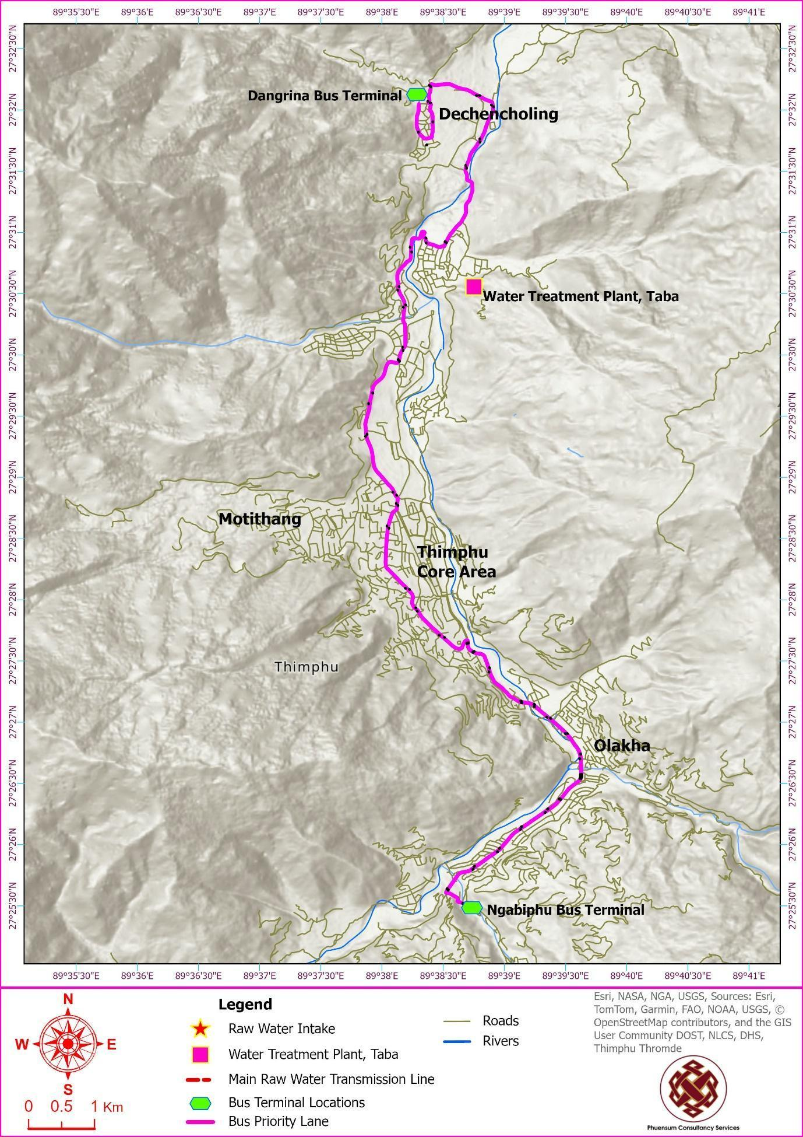

Purpose and Scope of this ESIA Report
This Environmental and Social Impact Assessment (ESIA) report primarily focuses on the public transport and urban space improvement activities (subcomponents 1.2 and 1.3) of the LRCP.
For the Water Supply Works (subcomponent 1.1), a separate Environmental and Social Management Plan (ESMP) has been prepared to address its environmental and social risks.
The objectives of this ESIA are to:
- Establish the environmental and social baseline conditions in the project's area of influence.
- Identify and assess potential adverse and positive environmental and social impacts and risks of the project.
- Propose feasible and cost-effective mitigation measures.
- Develop an Environmental and Social Management Plan (ESMP) specifically for the Urban Transport component.
- Ensure compliance with Bhutan's national laws and the World Bank's Environmental and Social Framework (ESF).

Project Description
This chapter provides a detailed description of the LRCP, focusing on the urban space improvements and public transport activities included under Component 1: Resilient and Low-Carbon Service Delivery.

Low-Emission Public Transport
Sub-component 1.3 supports the physical transition toward a cleaner and more reliable public transport system in Thimphu. Rising car use has contributed to congestion, longer travel times, and increasing emissions, while the existing bus system lacks the speed, reliability, and passenger amenities needed to attract a larger share of trips. This sub-component therefore finances the core transport assets required for a step change in service quality, including bus priority infrastructure, electric buses, charging and depot facilities, and digital systems for operations and passenger information. These investments are central to the mitigation ambition of the project and, by improving corridor drainage, bridge resilience, and pedestrian access, also contribute to adaptation outcomes. The MoIT PMU will lead procurement and implementation of the infrastructure, while CBS will assume operational responsibility once assets are commissioned. Key activities include:

Bus Priority Service (BPS) Corridor and Infrastructure
The project will develop an 18.7 km BPS corridor to facilitate the rapid and reliable movement of public buses. See Figure 1-4. This involves:
- Road Widening: Expanding approximately 3.9 km of existing 2-lane roads to a 4-lane configuration to create dedicated bus priority lanes.
- Corridor Optimization: Optimizing 13 km of existing 4-lane roads with minor widening and re-configuration to integrate the BPS and improve pedestrian pathways.
- Bridge Enhancements: Widening of two bridges and a culverts at Pamtsho and Dechencholing to accommodate the dedicated lanes. Bridge protection works, including measures to prevent pier and abutment scour, will be included. These works will improve traffic flow and withstand projected flood risks.

Passenger Facilities and Terminals
To improve the commuter experience and support operations, the project will:
- Bus Stop Enhancement: Construct 75 bus shelters and 75 bus bays along the BPS route. These facilities will feature universal access design, weather protection, seating, real-time information displays, and solar-powered lighting.
- New Bus Terminals: Establish two new, modern terminal stations at Ngabiphu (southern terminal) and Dangrina (northern terminal). These terminals will be equipped with:
  - Administrative and maintenance buildings.
  - E-bus charging stations and parking slots.
  - Accessible passenger facilities, including waiting areas, restrooms, and ticketing services.

Fleet Modernization and Management
- Procurement of Electric Buses: The project will finance the procurement of a fleet of 50 new battery-electric buses (e-buses). These e-buses will operate on the BPS corridor, producing zero localized tailpipe emissions (like PM₂.₅ and NOx) and reducing noise pollution.
- Charging Infrastructure: In addition to terminal-based chargers, the project will develop a robust and reliable charging ecosystem to ensure high operational availability for the e-bus fleet.
- Sustainable Battery Management: The procurement process will include a contractual requirement for the supplier to establish a battery take-back program. This ensures that end-of-life batteries are managed, recycled, or disposed of in an environmentally responsible manner.

Urban Space Improvements
Sub-component 1.2 focuses on the public realm improvements needed to make walking and public transport access safer, more convenient, and more resilient to climate impacts. Norzin Lam is the city's main commercial spine, yet it currently experiences congestion, limited pedestrian space, poor accessibility, and localized drainage problems. Likewise, sidewalks and connecting paths along the proposed bus priority corridor do not yet provide a high-quality walking environment or strong first- and last-mile links to public transport. This sub-component therefore improves the street environment in ways that directly support the public transport investments under Sub-component 1.3 while also reducing flood risk and improving the quality of public space. Implementation responsibility rests with Thimphu Thromde through the PIU.
The final design for Norzin Lam will be developed through a participatory process, engaging key stakeholders such as local businesses, residents, and vulnerable groups to ensure the improvements meet community needs and enhance economic vitality.
Core Interventions:
  - Sidewalk Improvements: Widening, upgrading, and ensuring the continuity of sidewalks to provide ample, safe, and accessible space for pedestrians.
  - Pedestrian Crossings: Installing clearly marked and safe pedestrian crossings at key intersections.
  - Traffic and Parking Management: Redesigning the street layout to calm traffic, which may include lane reductions and reorganizing on-street parking to reclaim space for public use.
The project will undertake the comprehensive redesign and reconstruction of five key alleyways that connect to Norzin Lam (Figure 4). This work will involve removing obstructions, re-grading surfaces for universal design, and upgrading underlying utilities to create safe and attractive pedestrian links.
These interventions are designed to create a cohesive and high-quality urban environment that reduces traffic congestion, enhances the pedestrian experience, and boosts the economic and social vitality of Thimphu's main boulevard.
Figure 2: Road Widening Types along the BPS Route
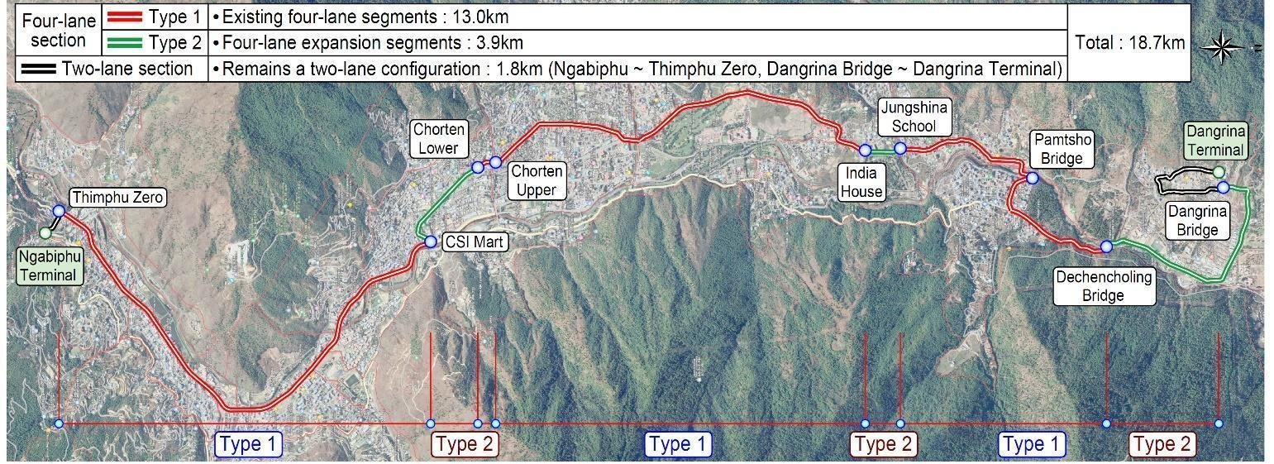

Figure 3: Cross-Section Diagrams: Current & Proposed 4-Lane Roads, 2-Lane Road, and Bridge Layouts
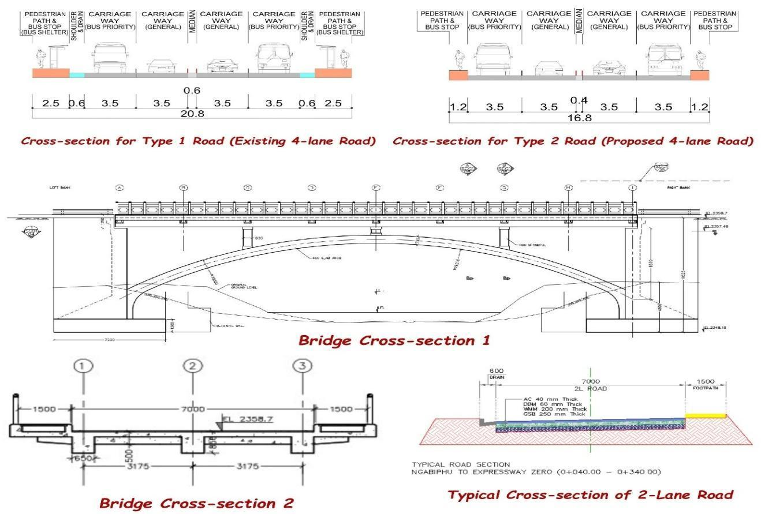
Figure 4: Visual Documentation of Alley Locations: Google Images References and Photographic Records
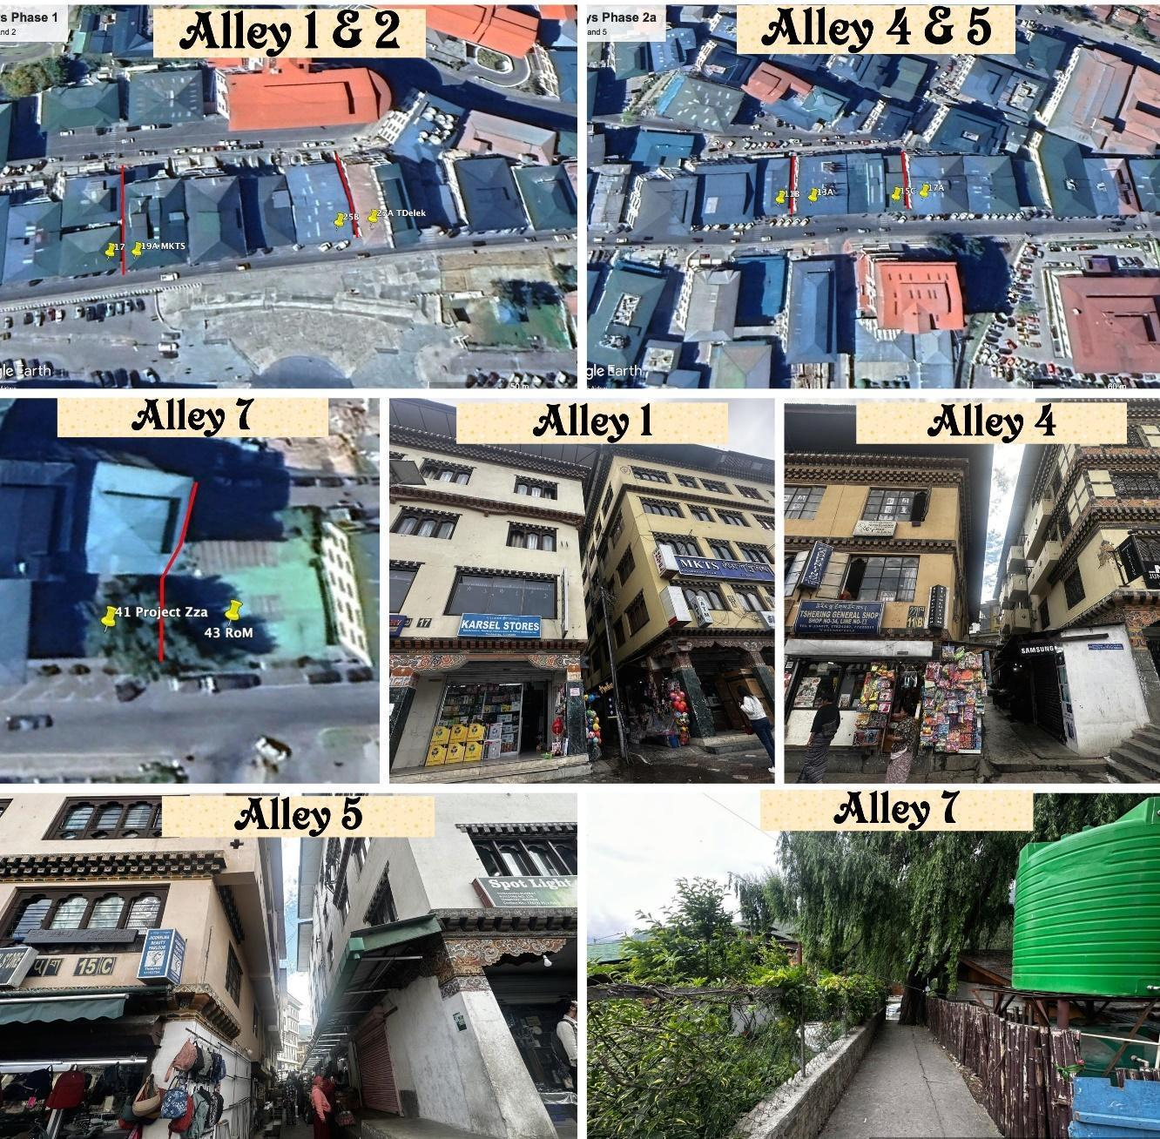

Figure 5:New Terminal Site Plans for Ngabiphu and Dangrina  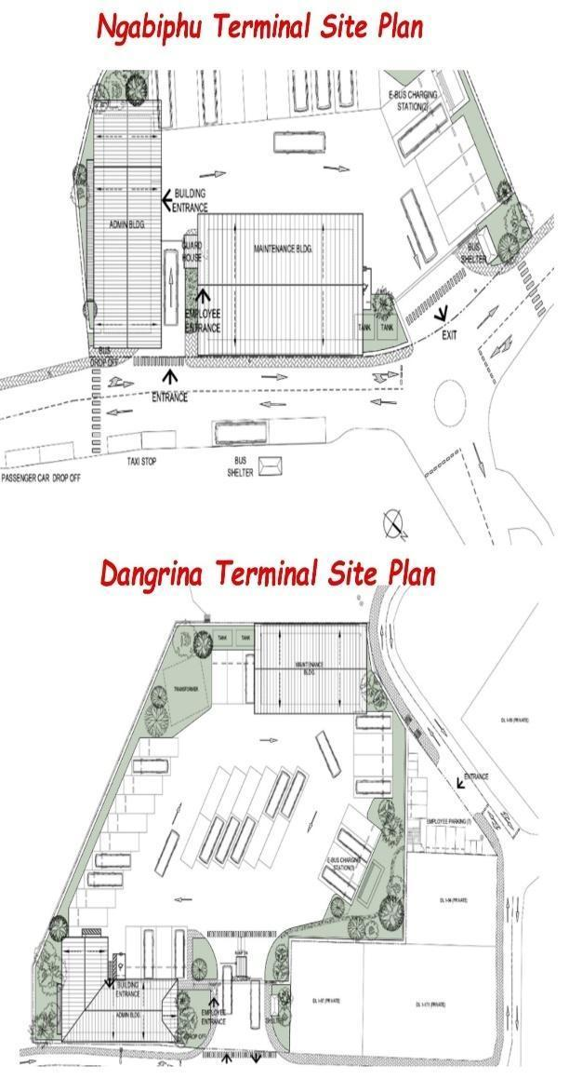 | Figure 6: Locations of Terminals and City Bus Depot  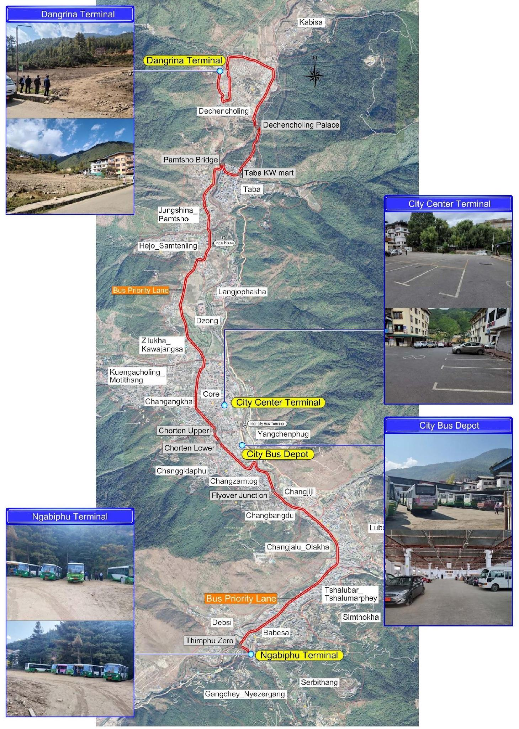

Community Health and Safety by Design
Ensuring the health, safety, and security of the public and project workers is a paramount consideration integrated into every stage of the LRCP. The project design incorporates multiple features to mitigate risks and enhance safety for all, particularly for vulnerable groups.

Pedestrian and Road User Safety (Urban Transport Component)
The design of the BPS corridor and the urban placemaking improvements on Norzin Lam prioritizes the safety and accessibility of pedestrians and all road users. Key design features include:
- Safe and Accessible Infrastructure:
- Pedestrian Pathways: Sidewalks along all project corridors will be constructed or upgraded to be wide, continuous, and free from obstructions. The complete street approach for Norzin Lam will significantly enhance the pedestrian environment in the city's busiest area.
  - Signalized Crossings: The project will install 23 signalized pedestrian crossings to ensure the safety and convenience of pedestrians and bus passengers.
  - Universal Access Design: All new terminals, bus stops, and pedestrian pathways will be designed to comply with universal accessibility standards, incorporating features such as ramps and tactile paving for the visually impaired.
- Accessible Public Transport:
  - Buses: The new fleet of 50 electric buses will feature low-floor designs to allow for easy boarding and alighting, along with designated spaces for wheelchairs.
  - Information: Information and signage at terminals and on buses will be provided in multiple formats where feasible, potentially including audio announcements, to cater to a wide range of users.
- Traffic Management and Safety by Design:
  - Traffic Calming and Segregation: The project incorporates traffic calming measures like raised intersections. The creation of a dedicated bus lane helps to segregate traffic, leading to more predictable traffic flows and reducing potential conflicts between buses and other vehicles.
  - Enhanced Visibility: The design includes provisions for adequate street lighting at bus stops, terminals, and along pedestrian pathways to improve visibility and safety, especially during nighttime hours.
- Public Awareness: The project will support public awareness campaigns to educate the community on how to safely use the new infrastructure, including navigating pedestrian crossings and interacting with the BPS.

Fire Safety and Emergency Preparedness
The LRCP incorporates robust fire safety and emergency preparedness features into the design of all new and upgraded infrastructure to ensure the safety of the public, project staff, and assets.
- Infrastructure Design: The new bus terminals at Ngabiphu and Dangrina will be designed and constructed in full compliance with Bhutan's national fire safety codes. This includes the strategic installation of fire safety equipment such as:
  - Fire extinguishers and fire hose reels.
  - Automated fire detection systems (e.g., heat, smoke detectors).
  - Alarm and public address (PA) systems for emergency announcements.
  - Emergency lighting and clearly marked evacuation routes and exits.
- Capacity Building: The project will include training for all terminal and bus operator staff on fire safety, emergency response, and the use of safety equipment
Figure 7: Norzin Lam (left) and Proposed Design of Pedestrianization (right)
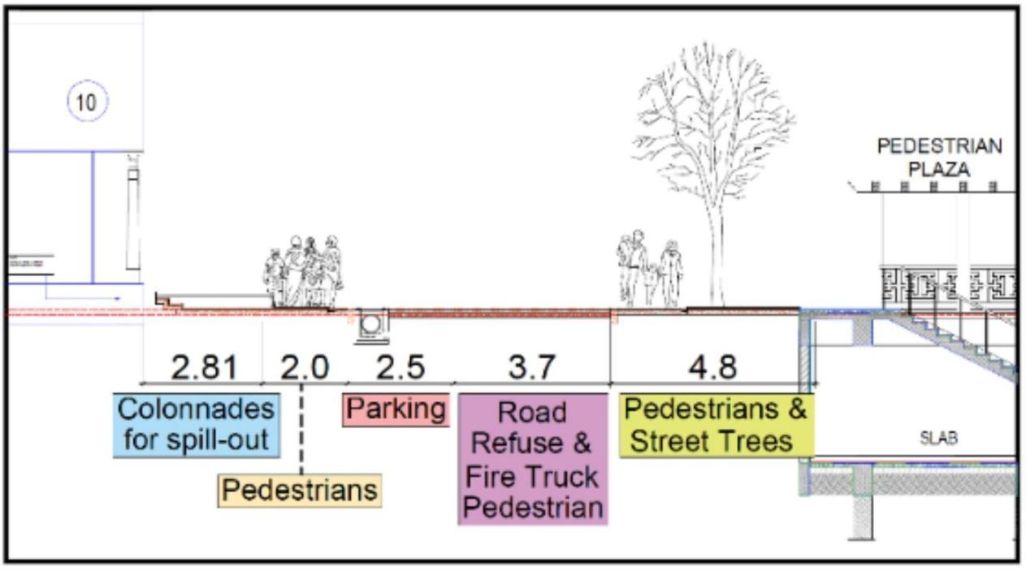

Climate Change Adaptation and Resilience
A central objective of the LRCP is to build Thimphu's resilience to climate change. The project design incorporates a range of strategies to adapt to potential climate-related challenges, such as the increased frequency and intensity of rainfall, extreme weather events, and rising temperatures. Key climate adaptation measures integrated into the project include:
- Resilient Infrastructure Design: All new transport infrastructure will be designed to withstand climate impacts. This includes:
  - Bridges and Drainage: The design of bridges and culverts will account for projected increases in peak flood flows, informed by recent events like the 2024 Dechencholing flood, to ensure adequate hydraulic capacity and reduce the risk of washouts.
  - Roads and Slopes: Road designs in hilly and landslide-prone areas will incorporate enhanced slope stability and erosion control measures, such as bioengineering solutions, to mitigate risks exacerbated by intense rainfall.
- Climate Mitigation Co-benefits: The project's emphasis on transitioning to 50 electric buses and promoting active mobility through enhanced pedestrian infrastructure not only builds urban resilience but also directly contributes to climate change mitigation by reducing greenhouse gas emissions from the transport sector.

Resource Utilization and Management
The construction activities for the LRCP's urban transport and public space improvement components will require a significant volume of construction materials. The project is committed to applying principles of resource efficiency and sustainable procurement throughout its implementation.

Material Sourcing and Quantities
The materials required will be sourced both locally and internationally, based on availability, quality standards, and cost-effectiveness. All locally sourced quarry materials, such as sand, aggregate, and stone, will be procured exclusively from vendors licensed by the Natural Resource Development Corporation Ltd. (NRDCL) or other government-approved sources. This ensures that materials are extracted from environmentally compliant locations. Table 1 provides the required resources for Implementing the Low-Emission Public Transport Component.

Sustainable Construction Practices
The project design and construction contracts will mandate adherence to best practices in sustainable construction to ensure the efficient use of resources and the minimization of waste. This includes:
- Maximizing the reuse of excavated materials for backfilling and other project needs to reduce the requirement for new quarry materials and minimize spoil disposal.
- Promoting the use of energy-efficient technologies and water conservation measures at all construction sites and worker camps.
- Implementing a comprehensive Waste Management Plan to segregate and properly dispose of or recycle all construction debris.
Table 1: Resource requirement for the Low Emission Public Transport
No. | Material | Source | Quantity required
1 | Cement | Local | 757 Metric ton (MT)
2 | Bitumen | Imported | 2387 MT
3 | Rebars | Local | 158 MT
4 | PPGI (iron) roofing sheets | Imported | 2310 sq.m.
5 | UPVC door/window frames for bus stop | Imported | 1022 m
6 | Bricks | Imported | 804 cu.m.
7 | PUFF Panels for insulation in bus stop | Imported | 1080 sq.m.
8 | Aluminium composite panels | Imported | 138 sq.m.
9 | Solar Panels | Imported | 1659 sq.m.
10 | Tiles | Imported | 2250 sq.m.
11 | Timber | Local | 796 cu.m.
12 | Sand | Local | 1787 cu.m.
13 | Aggregate | Local | 32058 cu.m.
14 | Stone | Local | 16850 cu.m

Contractor's Workforce, Facilities, and Equipment
This section outlines the anticipated requirements for the contractor's workforce, site facilities, and major equipment needed to implement the civil works for the LRCP.

Workforce
The construction works for both the Urban Transport and Water Sector components will require a significant labour force. It is estimated that an average of 200 workers per day will be needed over the two-year construction period, with this number potentially increasing during peak activities. It is anticipated that a substantial portion of this workforce (approximately 80%) may be comprised of foreign workers, sourced in compliance with national labour regulations.
To manage the potential social risks associated with a large, non-local workforce, contractors will be required to prioritize the hiring of local labour where feasible to minimize the need for temporary worker accommodation. For all non-local workers, the contractor must manage their interactions with local communities through the strict enforcement of a Code of Conduct. Measures will also be implemented to mitigate the risk of inflating the local rental market, which could inadvertently displace local residents. These measures will be detailed in the Contractor's Environmental and Social Management Plan (C-ESMP).

Contractor's Site Facilities
To support the construction activities, the Contractor(s) will be required to establish temporary site facilities. The siting, management, and eventual decommissioning of these facilities will be a key part of the Contractor's Environmental and Social Management Plan (C-ESMP). Crucially, the selection of any site for camps, yards, or other facilities will be subject to the same environmental and social due diligence as other project components, including baseline assessments and the application of relevant mitigation measures.
- Construction Yards and Material Storage: Laydown areas for storing materials, fabricating components, and situating major equipment (like a hot mix plant or concrete batching plant) will be required. These will be established at locations approved by Thimphu Thromde, such as within the footprint of the proposed new bus terminal sites.
- Worker Accommodation: The Contractor will be responsible for providing all project workers with accommodation that is safe, clean, and fully compliant with the standards established in this project's Environmental and Social Management Plan (ESMP). These standards are derived from Bhutan's Regulation on Occupational Health, Safety and Welfare (OHSW), 2022, and the IFC/EBRD Guidance Note on Workers' Accommodation. This may involve:
  - Establishing a dedicated, well-managed construction camp at a PIU-approved location, designed and operated in full adherence to the standards referenced above.
  - Arranging for workers to be housed in rented private accommodation. Any such rental housing must be assessed and certified by the Contractor to meet the same minimum standards for health, safety, space, and sanitation as a dedicated camp.
  - The C-ESMP must include a detailed Worker Accommodation Plan for approval by the PIU/PMSC before any workers are mobilized to the site.
- Accessory Facilities: The project will utilize existing city infrastructure where possible. No new dedicated access roads are planned, and spoil/waste will be managed through city-approved disposal sites. The project will not develop any new quarry sites.

Indicative List of Major Equipment
The implementation of the LRCP will require the use of various types of heavy machinery and equipment. The Contractor will be responsible for ensuring all equipment is well-maintained to minimize emissions and noise. An indicative list of major equipment shown in the Table 2:
Table 2: List of Equipment
Category | Equipment | Quantity | Function
Paving and Road Construction | Hot Mix Plant | 1 | Produces asphalt mixtures for road surfacing
 | Paver Machine | 1 | Lays asphalt on roadbeds
 | Bitumen Sprayer | 1 | Applies bitumen on the road surface for binding
 | Steel Wheeled Roller & Vibratory Rollers | 2 | Compacts asphalt to create a smooth road surface
Material Transportation and Handling | Tipper Trucks | 5 | Transports soil, aggregate, and asphalt
 | Wheel Loaders | 2 | Loads and moves materials around the site
Concrete Preparation and Placement | Concrete Mixers/Batching Plant | 6/1 | Mixes concrete for various structures
 | Concrete Pumps | 2 | Transfers liquid concrete to specific locations
 | Concrete Vibrators | 6 | Ensures proper compaction and removal of air bubbles in concrete
Excavation and Earth Moving | Excavators | 2 | Excavates earth for foundations, trenches, and other purposes
Compaction and Surface Preparation | Plate Type Compactors | 2 | Compacts soil and asphalt in smaller areas
 | Bitumen Heating Kettle | 2 | Melts and heats bitumen for application
Support and Auxiliary Equipment | Air Compressors | 2 | Powers pneumatic tools and equipment
 | Water Tankers | 2 | Provides water for construction processes and dust control
 | Water Pumps | 4 | Moves water to required locations

Project Implementation Timeline
The overall implementation timeline for the LRCP is planned from early 2026 to early 2028. The project will be executed in a phased manner to ensure a logical sequence of activities and to manage disruptions effectively. The construction period for the major civil works is expected to span approximately 1.5 to 2 years within this broader schedule.
The project timeline is structured across five main phases as detailed below in table 3:
Table 3: Indicative Project Implementation Timeline
Phase | Description & Key Activities | Indicative Timeline
1. Funding Acquisition | This phase involves finalizing all financial arrangements for the project, including securing the necessary funding and completing the budget allocation and financial planning.  E&S Actions:  ● Finalization and public disclosure of all key E&S instruments (ESIA, ESMP, RAP, SEP).  ● Establishment of the project-level Grievance Redress Mechanism (GRM). | Q1 2026
2. Procurement & Contracting | This critical phase includes the tendering and contracting process for all major project components, including the procurement of the e-bus fleet, civil works construction services, and associated equipment.  E&S Actions:  ● Integration of the ESMP, Code of Conduct, and other E&S requirements into all bidding and contract documents. | Q2 2026
3. Construction of Infrastructure | This phase covers the main civil works for the project. The construction will be carefully managed to minimize disruption to traffic and daily activities. Key activities include:  ● Building new bus depots and terminals.  ● Constructing charging stations and related infrastructure.  ● Development and installation of the Intelligent Transport System (ITS).  E&S Actions:  ● Prerequisite: Full implementation of the Resettlement Action Plan (RAP), including payment of all compensation, before accessing any site.  ● Prerequisite: Contractor submission and PIU/PMSC approval of the site-specific Contractor's ESMP (C-ESMP).  ● Ongoing implementation and supervision of all ESMP/C-ESMP mitigation measures (e.g., OHS, traffic management, dust control).  ● Regular E&S monitoring and reporting. | Q3 2026 – Q4 2027
4. Deployment & Operational Setup | As construction nears completion, this phase focuses on preparing for the launch of the new services. This includes:  ● Delivery and testing of the new electric bus fleet.  ● Setup and commissioning of all operational systems.  ● Staff training and conducting trial runs of the new BPS.  E&S Actions:  ● Contractor completes all site restoration and demobilization activities as per the approved C-ESMP.  ● Training of O&M staff (e.g., CBS, TT) on operational phase E&S responsibilities. | Q2 2027 – Q4 2027
5. Operational Launch & Monitoring | This phase marks the official launch of the new bus services to the public. It will be followed by a period of ongoing monitoring and evaluation to optimize system performance and make any necessary adjustments.  E&S Actions:  ● Implementation of the Operational Phase ESMP, including waste management at terminals and OHS for maintenance crews.  ● Ongoing monitoring of operational E&S performance and public grievances. | Q1 2028 onwards
The PIU and its supervision consultant will closely monitor all activities to ensure adherence to this timeline, with contingency plans in place to address any potential delays.

Operations and Maintenance (O&M) Framework
The long-term sustainability of the LRCP's investments depends on a robust Operations and Maintenance (O&M) framework for the urban transport components.
- O&M Responsibilities
- Thimphu Thromde (TT): As the asset owner, TT holds the primary responsibility for the O&M of all transport-related infrastructure created and rehabilitated under the project. This includes routine and periodic maintenance of the BPS road corridor, NMT pathways, drainage systems, and bus shelters.
- City Bus Service (CBS): As the transport operator, CBS is responsible for the O&M of all mobile assets and operational systems for public transport. This includes the maintenance of the e-bus fleet, management of depots and terminals, and operation of the Bus Control Center and Intelligent Transport Systems (ITS).
- Key O&M Activities
- Infrastructure Maintenance: Regular upkeep of road markings, signage, pedestrian facilities, and drainage.
- Fleet Maintenance: Routine servicing, repairs, and inspections of the 50 e-buses and charging infrastructure to ensure optimal performance, safety, and longevity.
- System Operations: The CBS-managed Bus Control Center will use ITS technology to monitor bus operations, track vehicle locations, and provide real-time passenger information.
- Capacity Building
- The project includes comprehensive training programs for both TT and CBS staff to enhance their skills in operating and maintaining the new and upgraded transport systems, particularly the BPS and the e-bus fleet.
- Rules for Bus Priority Service (BPS) Operation
- The following rules will form the operational backbone for the BPS to ensure safety, efficiency, and reliability. These are mandatory protocols.
  - Bus Lane Usage: Only authorized CBS buses operating on the BPS route are permitted to use the dedicated bus lanes during operational hours. Emergency vehicles are exempt. Unauthorized use by other vehicles will be subject to penalties.
  - Operating Hours: The BPS lanes will be exclusively for buses during peak morning and evening hours (e.g., 07:30 AM to 10:00 AM and 03:30 PM to 06:30 PM, subject to adjustment). Outside these hours, the lanes will be open to all traffic.
  - Safe Driving Protocols: Bus operators must adhere to a speed limit of 50 km/h within the BPS corridor and are prohibited from aggressive driving behaviours.
  - Passenger Boarding: Boarding and alighting are permitted only at designated bus stops and terminals. Bus doors must remain closed while the vehicle is in motion.
  - No Overloading: Buses must not exceed their specified passenger capacity.
  - Real-time Information: Buses will be equipped with a Bus Information System (BIS) to display real-time information, such as the next stop and estimated time of arrival.

Alternative Analysis

Introduction
This chapter outlines the alternatives considered during the formulation of the LRCP. The primary alternative to the project is the "Without Project" scenario. For the specific components of the LRCP, particularly the urban transport and public space improvements, various design and operational alternatives were evaluated. The selection of preferred alternatives was guided by the project's core objectives: to enhance liveability, climate resilience, urban mobility, and essential service delivery in Thimphu Thromde.

"Without Project" Scenario
In the absence of the LRCP, Thimphu would continue to grapple with the following significant and worsening urban challenges:
- Deteriorating Urban Mobility: Thimphu is experiencing rapid urbanization and a corresponding surge in private vehicle ownership, with the Thimphu region hosting over half of the nation's vehicles. This trend has led to worsening traffic congestion, significant air pollution, and longer commute times, particularly along key corridors like the Babesa-Thimphu Expressway and in the city core. The current public transport system, comprising approximately 60 city buses (with only one being electric), is inadequate to meet rising demand, leading to low utilization rates due to inconvenience and infrequent service.
- Persisting Environmental and Social Challenges: Without the LRCP's interventions, Thimphu would face:
  - Environmental Degradation: Continued high levels of air and noise pollution from vehicular traffic, contributing to negative public health outcomes and undermining Bhutan's commitment to carbon neutrality. Greenhouse gas emissions from an inefficient, diesel-dominated transport sector would continue to rise.
  - Inadequate Public Spaces: Pedestrian infrastructure would remain fragmented and unsafe. Key commercial areas like Norzin Lam would continue to be dominated by vehicles, limiting accessibility and vibrancy and posing safety risks to pedestrians.
  - Social Inequity: The public transport system would remain a service of last resort rather than a viable choice. Persons with disabilities, the elderly, and caregivers with children would continue to face significant barriers to mobility due to the lack of accessible buses, terminals, and pathways. Overcrowding and poorly designed facilities would continue to create an unsafe and uncomfortable travel environment, particularly for women and girls.
In summary, the "Without Project" scenario would mean a continuation of declining urban mobility, persistent environmental and social challenges, and a failure to build resilience, hindering Thimphu's progress towards becoming a more livable, equitable, and sustainable city.

Alternatives for Bus Priority Service
The Urban Transport and Public Space component of the LRCP includes the development of a Bus Priority Service (BPS) corridor, comprehensive public space improvements for Norzin Lam under a "complete street" concept, and the procurement of electric buses. This section outlines the alternatives considered for the BPS route alignment.

Option 1: BPS Route 1 (Selected Option)
BPS Route 1 is the preferred and selected option. It commences at the southern terminal in Ngabiphu, follows the Expressway, diverts at the CSI Junction towards Changzamtog, and passes the National Referral Hospital (JDWNRH) and the Memorial Chorten. It then proceeds along the four‐lane highway through Hejo, Jungshina, and Taba. Before Pangrizampa, the route diverts onto the Dechencholing Local Area Plan (LAP) road, extending to the northern terminal at Dangrina.

Option 2: BPS Route 2
This route mirrors BPS Route 1 up to the Flyover but then diverges along the Cypress Tree area, descending via the City Bus Office and Garage and through the town along Chang Lam. It reaches the Core City Bus terminal, proceeds towards the Dzong, diverts upwards near RAPA, reaches Bhutan Telecom, and then takes the upper route towards Hejo, following the same path as Option 1 after that.

Option 3: BPS Route 3
BPS Route 3 continues along the Expressway towards the CFM, extending beyond the bridge below Chubachu. It then diverts, crossing the bridge, moving upwards to Langjuphaka, and descending via India House towards Jungshina. The route crosses Pamtsho, moves towards Taba, and joins the road to Dechencholing.

Recommendations
Based on a comprehensive analysis of technical feasibility, environmental and social impacts, and alignment with project objectives, BPS Route 1 is strongly recommended and selected for the following compelling reasons:
- Optimal Corridor for Bus Priority: The selected route primarily utilizes the existing four-lane Expressway, which is the most suitable corridor in Thimphu for establishing a high-frequency, segregated bus priority service. This alignment ensures smoother, faster, and more reliable bus services with minimal conflict with general traffic, which is essential for attracting ridership.
- Minimal Impact on Private Land and Assets: A critical advantage of Route 1 is that it does not require road widening for most of its length. By maximizing the use of the existing Right-of-Way, it significantly reduces the need for private land acquisition and minimizes impacts on private properties and other assets. This aspect is crucial for mitigating social and property-related concerns and aligns with the project’s principle of avoiding resettlement where possible.
- Enhanced Connectivity and Economic Opportunity: The route strategically traverses areas with both established and emerging businesses. This alignment will provide convenient transportation access to key commercial zones, potentially boosting local economies by improving access for customers and employees. Its design effectively serves a large and diverse population segment, making it the most advantageous option for fostering sustainable urban development.
- Maximum Social Benefits: The selected route provides crucial connectivity to key destinations and sensitive receptors, including 23 neighbourhoods, multiple schools, and the Jigme Dorji Wangchuck National Referral Hospital. It also serves several important cultural sites. This extensive coverage ensures that the BPS delivers the maximum possible social and economic benefits to the widest cross-section of Thimphu's population.
- Reduced Environmental Footprint: By maximizing the use of the existing road corridor, Route 1 minimizes the need for tree felling and disturbance to new areas. The associated environmental impacts (air, noise, dust) from construction are therefore lower and more manageable compared to the other alternatives.
In conclusion, BPS Route 1 stands out as the superior option, offering the best balance of environmental sustainability, social benefits, and efficient traffic management. Its implementation aligns perfectly with the project's objectives of enhancing public transportation, reducing congestion, and fostering equitable, resilient urban growth.

Busway Design Alternatives
To enhance public transport efficiency, several busway design alternatives were evaluated for the BPS corridor. The objective was to select the most suitable option that balances operational efficiency, technical feasibility, cost-effectiveness, and environmental and social impacts.

Summary of Options Considered
- Option 1: Dual Lane Busway (Selected Option): This involves constructing a dedicated, two-lane busway (one lane in each direction) along the entire BPS corridor. This design allows for high-frequency, unimpeded bus operations.
- Option 2: Single Lane Dual Direction Busway: This option proposed a single lane for buses traveling in both directions, managed by complex signaling systems. While it would minimize land acquisition, it was deemed to have significant operational challenges, including reduced service reliability and potential for delays.
- Option 3 & 4: Mixed Busway Designs: These options considered various combinations of dual-lane, single-lane, and mixed-traffic sections. While flexible, they were found to introduce complexity in management and could compromise the overall efficiency and safety of the BPS network.

Recommendation and Justification for Selected Option
After a comparative assessment, the Dual Lane Busway (Option 1) is strongly recommended and has been selected for the project. While it has higher initial land acquisition and construction requirements, its long-term benefits are superior and most effectively align with the LRCP's objectives. The key justifications are:
- High Efficiency and Capacity: A dual-lane busway offers the highest possible level of service and capacity. It allows for high-frequency bus operations and can accommodate a larger number of buses without causing internal congestion, making it a robust solution for managing high passenger volumes now and in the future.
- Maximum Reliability and Punctuality: By providing a physically separate, exclusive right-of-way, this option minimizes conflicts with general vehicular traffic. This separation is the most critical factor in ensuring the reliability and punctuality of bus services, which is essential for attracting commuters away from private vehicles.
- Operational Flexibility and Safety: The dual-lane design provides greater operational flexibility, as it allows faster buses to safely overtake slower ones or bypass a stopped vehicle within the busway. This feature prevents system-wide delays and improves overall safety and efficiency.
- Scalability and Future-Proofing: The dual-lane design is a scalable solution that can accommodate future increases in service demand as Thimphu grows. Other options with single-lane or mixed-traffic sections would face significant capacity limitations over the long term.
- Alignment with Project Goals: A reliable and efficient public transport system is fundamental to achieving the project's goals of reducing traffic congestion, lowering emissions, and improving urban mobility. The Dual Lane Busway is the most effective design to encourage this modal shift from private cars to public transit.
In summary, while the initial costs and impacts are higher, they are considered manageable through the project's mitigation and compensation plans (ESMP and RAP). The long-term benefits in terms of transport efficiency, operational performance, and achieving sustainable urban development goals are deemed to significantly outweigh these initial challenges, making the Dual Lane Busway the most favourable and strategic option.

ALTERNATIVES FOR URBAN PLACEMAKING ON NORZIN LAM
A key element of the LRCP's vision is the transformation of Norzin Lam into a vibrant, safe, and accessible people-centric commercial spine. Several alternatives were evaluated to achieve this goal, balancing project objectives with stakeholder feedback and practical considerations.

Alternative 1: Limited Scope (Rejected)
This alternative would have restricted the improvements to only one section of Norzin Lam. This approach was deemed insufficient as it would create a fragmented pedestrian experience, failing to address the vehicle-pedestrian conflicts and accessibility challenges along the entire length of the commercial area. It represented a missed opportunity to create a cohesive and transformative public space.

Alternative 2: Full and Immediate Pedestrianization (Rejected)
This more ambitious alternative proposed the complete and immediate closure of Norzin Lam to all vehicular traffic. During extensive consultations, this option faced significant and widespread opposition from the business community and other stakeholders due to concerns about severe economic disruption, loss of customer access, and challenges with goods delivery. Given this strong feedback, this approach was considered socially and economically unfeasible at the current time.

Alternative 3: Comprehensive and Integrated Implementation (Selected Option)
The selected approach for the LRCP is a comprehensive and integrated upgrade that covers all sections of Norzin Lam, from Lungten Zam to the Chubachu junction. This approach, guided by a "complete street" design philosophy, balances the need for improved pedestrian safety and public space with the practical access needs of local businesses. It includes:
- Widening and upgrading sidewalks for universal access.
- Installing safe and clearly marked pedestrian crossings.
- The comprehensive reconstruction of five key alleyways.
- Reconfiguring traffic flow and on-street parking to calm traffic and prioritize pedestrians.

Rationale for Selection:
The Comprehensive and Integrated Implementation was selected as the most balanced and pragmatic approach. It was developed in direct response to stakeholder feedback and avoids both the piecemeal nature of Alternative 1 and the abrupt, high-impact disruption of Alternative 2.
By implementing the project as a single, coordinated package, it ensures design consistency and a holistic transformation of the entire commercial hub. This approach allows for carefully sequenced construction to manage disruption while delivering a unified, high-quality public realm. It ensures the entire area benefits from an improved pedestrian environment, enhanced accessibility, and increased vibrancy, thereby achieving the project's core objectives in a sustainable and consultative manner.
Figure 8: Design direction for two-lane/four-lane dual carriageway section (Option 1)
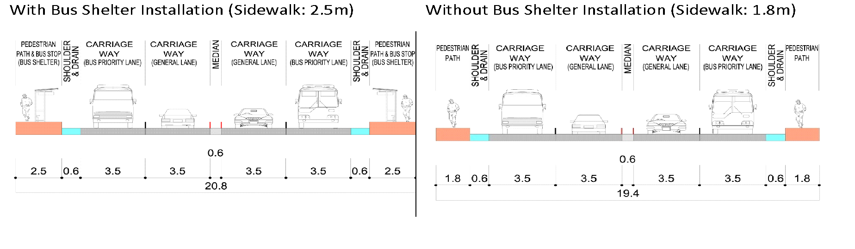
Figure 9: Design Direction for Four-Lane dual Carriageway(Option 2, Center)
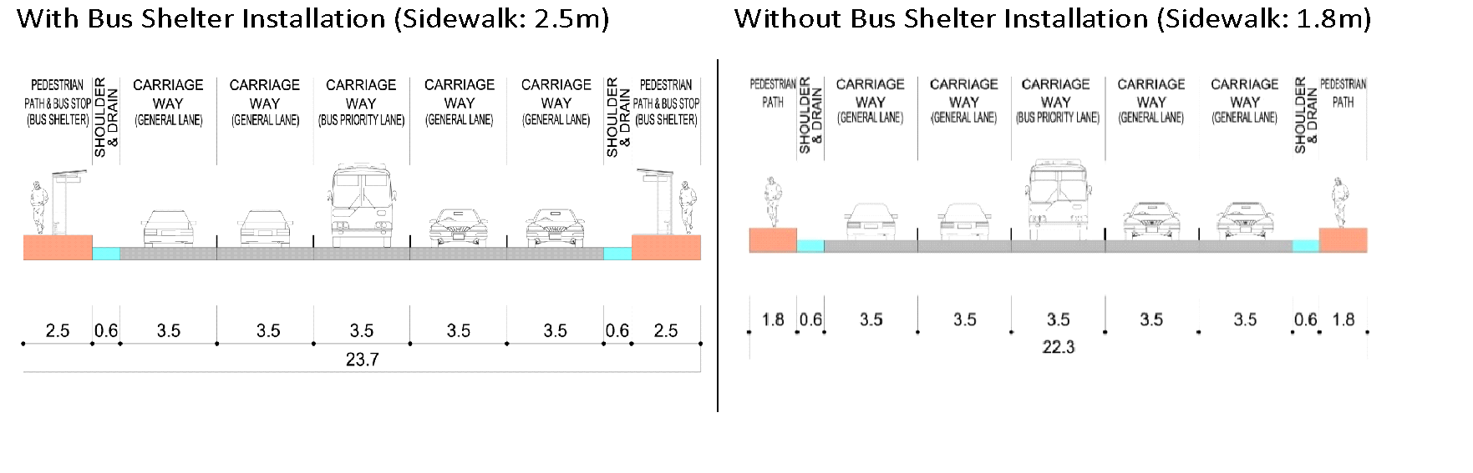

Figure 10: Bus Route Options for BGTP
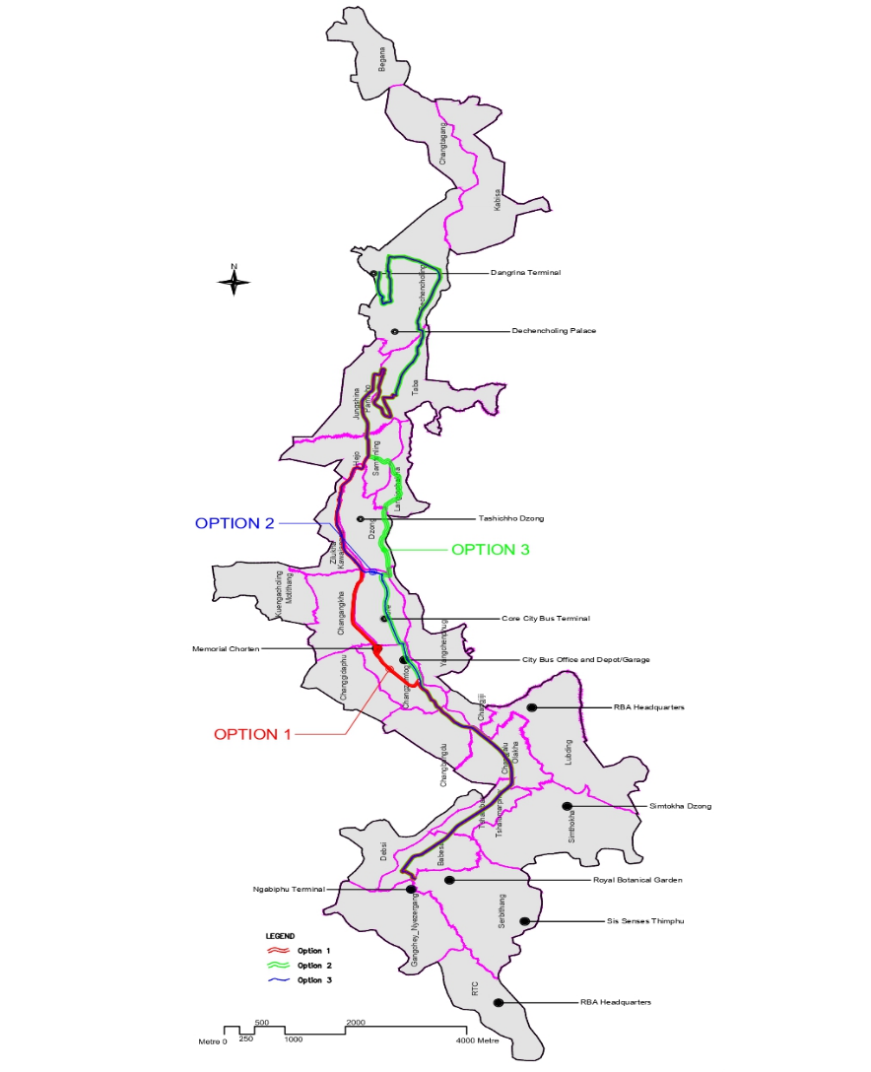

Legal, Regulatory, and Administrative Framework

Introduction
This chapter provides an overview of the national legislation of the Royal Government of Bhutan and the World Bank Environmental and Social Framework (ESF) relevant to the environmental and social assessment of the LRCP. It also outlines the actions that are taken (or to be taken) by the implementing agencies to meet these requirements. The LRCP encompasses both Urban Transport and Water Sector activities, and the framework applies to all project components.
The project requires the updating and completion of existing environmental and social assessment instruments, as well as the preparation of new ones, to ensure full compliance with national laws and the World Bank's ESF requirements. While an ESIA/ESMP, Resettlement Action Plan (RAP), and Labour Management Procedures (LMP) were developed for urban transport activities under the previous Bhutan Green Transport Project (BGTP), the LRCP has since expanded the scope of these activities (e.g., for Norzin Lam) and introduced new water supply works. This necessitates comprehensive updates to the existing instruments and the development of new ones to cover all project activities. The Royal Government of Bhutan is formally responsible for these documents.

Applicable National E&S Regulations
The environmental and social regulations relevant to the LRCP and the authorities responsible for enforcing these regulations are given in Table 4. These regulations form the national legal basis for environmental and social management of the project.
Table 4: Applicable National E&S Regulations to the LRCP
# | Name of Legislation/Regulation | Requirements of Legislation/Regulation | Relevance to the Project (LRCP - Transport & Water Components) | Regulatory Authority
A | Environmental Related
1 | Constitution of the Kingdom of Bhutan 2008 | Protect and conserve the environment, maintain a minimum of 60% forest cover, and fundamental rights, including freedom of movement and property rights. | Relevant due to potential tree clearing, land acquisition, and general environmental protection for all LRCP components (transport infrastructure, water pipelines, intakes, etc.). | Royal Government of Bhutan
2 | Environment Assessment Act 2000 | Environmental clearance (EC) is required for projects impacting the environment; procedures for securing EC. Key elements include EIAs for larger projects and IEEs for smaller projects. Emphasizes public participation, transparency, and stakeholder involvement. | While the TOR notes that for BGTP activities (now part of LRCP) falling under Thimphu’s Local Area Plan, relevant ECs were obtained, this will be re-confirmed for expanded transport scope and new water sector activities. Any new activities not covered by existing LAPs/SPs will require appropriate EC procedures. | National Environmental Commission (NEC), Department of Environment and Climate Change (DECC)
3 | Regulation for Environmental Clearance of Projects 2016 | Procedures for issuing environmental clearances, public consultation, and establishment of an environmental unit under the project. | Applicable if new ECs or amendments to existing ones are required for specific LRCP activities. | Department of Environment and Climate Change
4 | National Environment Protection Act 2007 | Framework for conserving and protecting the environment, sustainable use of resources, waste management, and accountability for environmental harm. | Compliance with resource procurement (e.g., construction materials for roads, pipelines) and waste management for all LRCP components. | Department of Environment and Climate Change
5 | Environmental Standards 2020 | Ambient water and air quality criteria, emission standards, and noise level limits. | Compliance with national standards during construction and operation of both transport (vehicle emissions, noise from BPS, construction impacts) and water (construction impacts, water quality parameters for supply) components. | Department of Environment and Climate Change
6 | Forest and Nature Conservation Act (FNCA) 2023 | Protection and management of forests, conservation of wildlife, restricted activities for protected species, permit requirements for development in State Reserved Forests (SRF). | Highly relevant as the project’s transport activities, particularly the road widening for the Bus Priority Service (BPS) route, will require the felling of trees. As portions of the BPS route pass through State Reserved Forests (SRF), the project will require written permission from DoFPS for any tree removal and must strictly adhere to all applicable park and forest management regulations and the ESMP. | Department of Forests and Park Services
7 | Forest and Nature Conservation Rules and Regulations (FNCRR) 2017 | Rules for forestry clearance, protection of species, and fishing regulations. | Permits for tree marking/extraction, compliance with conservation rules if forest areas are affected by any LRCP component. | Department of Forests and Park Services
8 | Water Act of Bhutan 2011 | Protection, management, and conservation of water resources, prioritizing drinking water and minimizing water pollution. | Highly relevant for the Water Sector Activities (intake protection, transmission, distribution, pollution prevention). Also relevant for water use during construction of all components and potential impacts from transport infrastructure (e.g., bridge construction) on water bodies. | Department of Environment and Climate Change
9 | Waste Prevention and Management Act of Bhutan 2009 | Framework for waste management, principles for reducing, segregating, and disposing of wastes, prohibition of hazardous waste products. | Management of solid and hazardous waste generated during construction and operation of all LRCP components (e.g., construction debris, old pipes, e-bus batteries, operational waste from terminals). | Department of Environment and Climate Change
10 | Waste Prevention and Management Regulation 2012 | Roles of Implementing Agency in waste management, prohibition of haphazard dumping of waste. | Disposal of waste at designated sites, initiatives for waste segregation, reuse, and recycling for all project-generated wastes. TT is the Implementing Agency. | Implementing Agency (TT)
11 | National Strategy and Action Plan for Low Carbon Development 2012 | Commitment to carbon neutrality, promotion of green growth, and maintaining forest cover. | Relevant to the e-bus procurement and BPS (transport) aiming to reduce GHG emissions. Efficient water management (water component) can also contribute to energy savings and reduced carbon footprint. Adherence to carbon neutrality goals. | Department of Environment and Climate Change
12 | Water Regulation of Bhutan 2014 | Protection and management of watersheds, minimizing environmental side effects, pollution prevention. | Critical for the Water Sector Activities, particularly concerning source water protection (Dodeyna intake within a National Park), watershed management, and pollution prevention during network construction and operation. | Department of Environment and Climate Change
13 | Bhutan Building Rules (BBR) 2017 | Rules for building construction, promotion of healthy living environment, preservation of traditional architecture. | Ensuring safe construction practices for all new structures (bus terminals, shelters, any new water supply infrastructure buildings) and promoting a healthy environment. | Royal Government of Bhutan
B | Labour and OHS
14 | Rules and Regulations on Occupational Health and Safety and Welfare 2022 | Prescribes standards and procedures on occupational health, safety and welfare for workplaces, instruments, vessels, appliances, apparatuses, tools, devices, electrical safety and other hazardous conditions. | Ensuring health and safety for all project employees (direct and contracted) and compliance with labour laws during construction and operation of all LRCP components. | Department of Labour and Ministry of Industry, Commerce, and Employment
15 | Regulation on Working Conditions 2022 | Legal requirements to ensure just and fair working conditions in all the work place(s). | Providing good working conditions for all workers involved in the LRCP. | Department of Labour; and Ministry of Industry, Commerce, and Employment
16 | Regulation on Occupational Health and Safety for Construction Industry, 2022 | Set the occupational health and safety standards and procedures on construction safety. It also prescribes the workers' and employers' roles and responsibilities in ensuring the site's health and safety. | Specific to all construction activities under LRCP (roads, NMT, water pipelines, intakes, etc.). Workers will be provided with safety and PPE. | Department of Labour
17 | Regulation on Foreign Workers Management, 2022 | Ensure just and fair recruitment process, management, deployment, repatriation, and working conditions at the workplace. Employment of foreigners shall be permitted for the occupations against which Bhutanese are either unavailable or unwilling to work. | Contractors will employ foreign workers where necessary for specialized skills or labour shortages for LRCP activities, ensuring compliance with these regulations. | Department of Labour/Department of Immigration
C | Social and Resettlement
18 | National Policy for Persons with Disabilities | Disabled persons have improved access to opportunities and services. | The BPS and NMT components will ensure accessibility for persons with disabilities (e.g., low-floor buses, accessible pathways, tactile paving). Water supply improvements aim for universal access to reliable water. | The City Bus Service and Thromde will ensure improved access for disabled persons.
19 | National Policy for Senior Citizens, 2023 | Ensures the well-being, dignity, and rights of senior citizens. Promotes age-friendly environments, accessible public services, and social security. | The project's design, especially universal access features in public transport and pedestrian areas, directly supports the creation of an age-friendly city. The project's GRM will be accessible to senior citizens. | The PEMA Secretariat, MoIT, Thimphu Thromde
20 | Child Care and Protection Act of Bhutan | Provides for the care, protection, and justice for children. Prohibits child labour, abuse, neglect, and exploitation. Outlines duties of care for all institutions. | <u>Crucially relevant to the labour section (prohibition of child labour on all construction sites) and community safety. Construction sites near schools must have specific safety protocols to protect children from harm. | National Commission for Women and Children (NCWC), Ministry of Education, Department of Labour
21 | National Gender Equality Policy 2020 | Women are to be protected from any gender-based violence. Women also have equal access to all social, economic and political institutions, processes and benefits. Update to include Domestic Violence and Prevention Act, Child Care and Protection Act, National Strategy and Framework of Action on the Elimination of GBV, Policy for Senior Citizens (as per TOR Section III.5.a) | The LRCP will implement a Gender Action Plan (GAP) and SEA/SH Prevention and Response Plan. All activities will strive for gender equality and protection from GBV. | TT will facilitate the implementation of the gender action plan.
22 | Land Act of Bhutan 2007 | The state can acquire land for public benefit. People losing land to receive fair compensation. Land can be exchanged, or those losing land can be compensated for the cost of land. Include constitutional provisions of Article 7 (14) (as per TOR Section IV.1.a). | If land acquisition is required for road widening, NMT, bus terminals, water intakes, or pipeline routes, the RAP will be implemented in accordance with this Act and the Constitution. | TT will initiate land acquisition and coordinate with the National Land Commission.
23 | Land Acquisition and Compensation Rules & Regulations 2022 (Property Assessment & Valuation Agency – PAVA) and Rates | These rules and the compensation rates are used nationwide for any compensation to be made for acquired land of private parties. Land rates need to be updated as per 2023 MoF issuance (as per TOR Section IV.1.b). Also include Rules and Regulations for Lease of Government Reserved Forest Land & Government Land (as per TOR Section IV.1.a). | Thimphu Thromde will conduct detailed surveys for any land acquisition for LRCP, using updated PAVA rates and relevant regulations for compensation and land exchange. | National Land Commission will issue new thrams. Thromde will secure compensation from MoF.

Relevant International Conventions
Bhutan is a signatory to various international conventions that are relevant to the LRCP. These include:
- Convention on the Elimination of All Forms of Discrimination against Women (CEDAW): Aims to eliminate discrimination against women and ensure their equal rights. (Applicability: The project's Gender Action Plan (GAP) and its focus on creating safe, accessible public transport and economic opportunities for women align directly with CEDAW principles.)
- The Convention on the Rights of the Child (UN, 1989) is an international treaty that protects and promotes the rights of all children under 18 by ensuring their survival, education, health care, protection from abuse, and participation in decisions affecting them, while legally requiring countries to act in their best interests and implement laws and policies that support their well-being and development. (Applicability: Relevant for ensuring the safety and well-being of children near construction zones, prohibiting child labour, and designing child-friendly public spaces and transport.)
- Convention on the Rights of Persons with Disabilities (CRPD): Promotes, protects, and ensures the full and equal enjoyment of all human rights by persons with disabilities. (Applicability: Directly relevant to the project’s commitment to universal access, including low-floor buses, ramps, tactile paving, and accessible terminals and pedestrian pathways.)
- Beijing Declaration and Platform for Action (BPfA): An agenda for women's empowerment that aims to remove all obstacles to women's active participation in all spheres of public and private life. (Applicability: Relevant to the project’s efforts to address gender-based violence (GBV) risks in public transport and to support women's economic empowerment through safer mobility and livelihood support.)
- Convention of the World Cultural and Natural Heritage (Paris 1972): Defines and provides for conserving world heritage. (Applicability: Cultural heritage sites along the BPS route, and potentially near water infrastructure sites. Water intake in Jigme Dorji National Park.)
- United Nations Framework Convention on Climate Change (UNFCCC, 1992): Aims to stabilize greenhouse gas concentrations. (Applicability: LRCP will reduce GHG emissions from bus transport and promote climate-resilient infrastructure.)
- Paris Agreement (2015): Aims to strengthen the ability to deal with climate change impacts. (Applicability: LRCP implementation will incorporate climate adaptation and mitigation measures.)
- Basel Convention on the Control of Transboundary Movements of Hazardous Wastes and their Disposal (1989): Aims to reduce hazardous waste and regulate international traffic. (Applicability: Management of e-bus batteries and other hazardous wastes from the project.)
- The United Nations Convention against Transnational Organized Crime (UNTOC), also known as the Palermo Convention, is a global treaty adopted in 2000 to foster international cooperation in combating transnational organized crime effectively. It serves as the primary international legal framework for addressing various forms of organized crime, including human trafficking, migrant smuggling, and firearms trafficking.

World Bank Environmental and Social Framework (ESF) and Guidelines

World Bank ESF
The LRCP was prepared and will be implemented in accordance with the World Bank's ESF. The ESF sets out the WB's commitment to sustainable development and mandatory requirements for Bank-financed projects. The 10 Environmental and Social Standards (ESSs) are designed to avoid, minimize, reduce, mitigate, and compensate/offset adverse environmental and social risks and impacts.
The project's environmental and social management framework includes the preparation or updating of the following key ESF instruments:
- Updated ESIA/ESMP and RAP for urban transport activities.
- An ESMP for water supply works.
- An SEP for the entire project.
- An ESCP for the entire project.
- Environmental and social capacity assessment and building requirements (to be integrated and defined in ESCP).
- Gender Action Plan (GAP).
- SEA/SH Prevention and Response Plan.
- Code of Conduct for the entire project.
The ESIA will be undertaken in compliance with ESS1: Assessment and Management of Environmental and Social Risks and Impacts, and other relevant ESSs as follows:
- ESS2: Labor and Working Conditions: Assessment of labour risks and working conditions.
- ESS3: Resource Efficiency and Pollution Prevention and Management: Assessment of resource use and pollution from all project activities (transport and water).
- ESS4: Community Health and Safety: Assessment of potential risks and impacts on community health and safety from all project activities.
- ESS5: Land Acquisition, Restrictions on Land Use and Involuntary Resettlement: Assessment of risks and impacts related to land acquisition and displacement.
- ESS6: Biodiversity Conservation and Sustainable Management of Living Natural Resources: Assessment of impacts on biodiversity, including for the water intake in Jigme Dorji National Park.
- ESS7: Indigenous Peoples: As determined previously, this standard is not considered relevant to Thimphu city. This will be re-confirmed during the ESIA update, particularly for any new areas affected by the water component, based on the four fundamental criteria in ESS7.
- ESS8: Cultural Heritage: Assessment of impacts on cultural heritage sites.
- ESS9: Financial Intermediaries: Not applicable as no financial intermediary is involved.
- ESS10: Stakeholder Engagement and Information Disclosure: A comprehensive SEP is being prepared/updated for the entire project.

WBG General and Sector-Specific EHS Guidelines
The project will adhere to the World Bank Group (WBG) General Environmental, Health, and Safety (EHS) Guidelines (2007). The ESIA/ESMP also incorporates other relevant industry-specific EHS Guidelines, including those for Toll Roads (where applicable to BPS infrastructure characteristics) and Power Transmission and Distribution (for e-bus charging infrastructure).

Comparison of WB ESSs and National Regulations
Although the ESIA is prepared based on the World Bank ESF, it is ensured that the national requirements are met. The ESIA process for LRCP has included a comparison of the ESSs with the national legislative framework and requirements to explain how the project meets both sets of standards and to identify any gaps that need to be addressed through project-specific measures.
Table 5:: Comparison of ESSs with national requirements for the Livable and Resilient City Project (LRCP)
ESS | World Bank ESS requirements | Bhutan’s policy and regulatory requirements | Gaps between ESSs and Bhutan’s regulatory requirements | Gap-Bridging Measures
ESS 1: Assessment and Management of Environmental and Social Risks and Impacts | The Borrower will (a) Conduct an environmental and social assessment of the proposed project, including stakeholder engagement; (b) Undertake stakeholder engagement and disclose appropriate information in accordance with ESS10; (c) Develop an ESCP and implement all measures and Actions set out in the legal agreement, including the ESCP; and (d) Conduct monitoring and reporting on the environmental and social performance. | Environmental Assessment Act 2000, Regulation for Environmental Clearance of Projects 2006 | There are no clear guidelines for developing EIAs. The scope of EIA may not cover all WB ESS requirements for both transport and water components. Does not emphasize a hierarchy of measures in ES risk management planning. National EIA process may not fully cover new water sector activities or expanded NMT scope. | ● The following documents are prepared/updated to comply with ESS1 for the entire LRCP: ESIA, RAP,SEP, ESCP. ● A specific ESMP for Water Supply Works will be prepared.  ● ESIA is prepared/updated in compliance with government requirements and World Bank ESF.  ● The ESMP (overall and component-specific) will be made an integral part of the bidding document so that the Contractor shall adhere to the provisions prescribed in the ESMP during project execution.  ● An Environmental and Social Capacity Assessment will be undertaken to evaluate current capabilities. Based on the findings, additional staffing and targeted training will be implemented to ensure full compliance with relevant standards.
ESS 2: Labour and Working Conditions | The Borrower will (a) Develop and implement procedures to manage labour issues, (b) Ensure fair and favourable working conditions for workers, (c) Implement measures to prevent accidents and injury to health, (d) Respect the rights of workers to form and join workers' organizations, (e) Promote non-discrimination and equal opportunity in employment practices, and (f) ensure that primary suppliers are aware of and comply with national labour laws and regulations. | Rules and Regulations on Occupational Health and Safety and Welfare 2022, Regulation on Working Conditions 2022, Regulation on Occupational Health and Safety for Construction Industry, 2022, Regulation on Foreign Workers Management, 2022 | While national regulations require non-discrimination (e.g., through Internal Service Rules - ISR) and provide a framework for addressing sexual harassment, gaps can exist in the consistent and effective implementation and enforcement of these rules at the contractor and subcontractor level.  There are still potential inadequacies in the practical application of GBV/SEA/SH prevention and response mechanisms on construction sites. Siting and management of contractor camps near sensitive receptors for LRCP needs careful planning. | ● Labour Management Procedures (LMP) for the LRCP will be implemented, which will include specific requirements for contractors to develop and enforce robust Internal Service Rules (ISR) with dedicated chapters on non-discrimination and equal opportunity, and ensure these are effectively communicated to all workers.  ● A specific SEA/SH Prevention and Response Action Plan will be developed and implemented, including for project workers, to ensure a survivor-centric response mechanism is in place.  ● A Code of Conduct for all project personnel, with a zero-tolerance policy for SEA/SH, will be enforced.  ● Contractor facilities/camps will be sited and managed as per ESMP to minimize social risks.
ESS 3: Resource Efficiency and Pollution Prevention and Management | The Borrower will (a) Promote efficient and sustainable use of resources such as energy, water, and materials, (b) Implement measures to avoid or minimize pollution from project activities, and (c) Properly manage the handling, storage, and disposal of hazardous materials and waste. | Water Act of Bhutan 2011, Waste Prevention and Management Act of Bhutan 2009, Waste Prevention and Management Regulation 2012 (amendment 2016), Environmental Standards 2020 | Lack of suitable enforcement mechanisms for legislation on resource use efficiency in projects. Specific considerations needed for sustainable water abstraction for the water supply component (e.g., intake in National Park). | ● Resource efficiency and pollution prevention for all LRCP activities (transport and water) are captured in the ESIA and respective ESMPs.  ● WBG EHS guidelines or/ National standards (depending on which one is stricter) related to environmental protection and resource efficiency will be complied with by the project.  ● ESMP for Water Supply Works will detail measures for sustainable water abstraction, energy efficiency in pumping (if applicable), and minimizing pollution.
ESS 4: Community Health and Safety | The Borrower will (a) Assess and address potential risks and impacts on the health and safety of local communities, (b) Develop and implement emergency response plans, and (c) Ensure that security personnel respect human rights and are trained in the appropriate use of force. | The EIA/IEE process identifies direct and indirect human health impacts. The Local Government (LG) Act of Bhutan tasks Local Governments with the responsibility to ensure the health, safety, and well-being of communities within their jurisdiction. | There is limited coverage as the EIA/IEE’s scope does not necessarily include all community safety issues, particularly for dense urban construction (e.g., transport and water pipelines), risks to schools, flood risks, and material storage risks. | ● The project's approach to community health and safety is aligned with the Local Government Act of Bhutan. Thimphu Thromde, as the responsible Local Government and key implementing agency, will take the lead in enforcing and monitoring community health and safety measures.  ● The ESIA/ESMP for the LRCP will address all community health and safety issues identified.  ● Specific traffic management plans will be developed for construction.  ● Measures will be implemented to address risks from material storage, flood events, and safety for communities near construction sites (especially schools).  ● A SEA/SH Prevention and Response Action Plan will address community-related SEA/SH risks.
ESS 5: Land Acquisition, Restrictions on Land Use and Involuntary Resettlement | The Borrower will (a) Explore alternatives to avoid or minimize physical or economic displacement, (b) Prepare and implement resettlement and compensation plans where displacement cannot be avoided, and (c) Engage with persons affected by land acquisition or resettlement. | The primary legal framework includes:  ● The Constitution of the Kingdom of Bhutan, 2008: Article 7(14) establishes the right to property and allows for acquisition for public purposes with fair compensation.  ● The Land Act of Bhutan, 2007: Provides the legal basis for land administration and acquisition.  ● Land Acquisition and Compensation Rules & Regulations, 2022: Details the procedures for acquisition.  ● Property Assessment & Valuation Agency (PAVA) Rules and Rates: Specifies the methodology for asset valuation, with rates updated periodically (e.g., 2023 MoF issuance). | While Bhutanese law provides for compensation to titleholders for acquired assets, key gaps exist when compared to WB ESS5:  ● Scope of Eligibility:  National law primarily focuses on the compensation of legally titled landowners. It lacks explicit, detailed provisions for resettlement and livelihood restoration assistance for non-titleholders, such as informal land users (squatters/ encroachers), tenants (residential and commercial), and employees of affected businesses.  ● Standard of Compensation: The national framework requires "fair compensation," which may not always align with the ESS5 standard of "full replacement cost," which includes transaction costs and avoids deductions for depreciation.  ● Focus on Livelihood Restoration: The national framework is centered on asset compensation rather than the broader ESS5 objective of restoring or improving the livelihoods and standards of living of all affected persons. | ● A draft Resettlement Action Plan (RAP) has been prepared in accordance with the requirements of ESS5 to bridge these gaps. The document is currently undergoing review by the Royal Government of Bhutan and the World Bank.  ● The RAP's eligibility criteria are expanded to cover all project-affected persons, ensuring that non-titleholders are entitled to receive resettlement assistance and livelihood restoration support.  ● The RAP explicitly commits to compensating all lost assets at full replacement cost, as required by ESS5. This valuation includes market costs for replacement materials and labour, plus any transaction costs (e.g., taxes, fees), ensuring that compensation is sufficient to replace lost assets without depreciation or financial burden for the affected person.  Land will be acquired and compensation paid before the commencement of implementation of the RAP and before construction works can commence  ● The RAP's Entitlement Matrix details specific measures for livelihood restoration and provides targeted assistance for vulnerable groups.
ESS 6: Biodiversity Conservation and Sustainable Management of Living Natural Resources | The Borrower will (a) Avoid, minimize, or mitigate adverse impacts on biodiversity and ecosystems and (b) Promote sustainable management of natural resources and ecosystems. | Forest and Nature Conservation Act (FNCA) 2023, Forest and Nature Conservation Rules and Regulations (FNCRR) 2017 | Does not specifically require a Critical Habitat Assessment (CHA) and Biodiversity Management Plan (BMP) even where biodiversity impact is found significant in the EIA. Specific assessment needed for water intake within Jigme Dorji National Park. | ● The project's ESIA has conducted a specific biodiversity assessment which confirms that no Critical Habitats will be affected by the project activities.  ● The ESMP includes specific mitigation measures to address impacts on biodiversity, such as:  - Strict adherence to the Forest and Nature Conservation Act for any required tree felling, including a compensatory plantation program.  - Protocols to minimize construction impacts on aquatic habitats during bridge construction  - Measures to control the spread of Invasive Alien Species (IAS)
ESS 7: Indigenous Peoples | (Specific requirements for projects affecting Indigenous Peoples) | Not applicable (based on previous ESIA findings for Thimphu). | TOR requires re-assessment of ESS7 applicability for LRCP based on the four criteria. | ● The ESIA for LRCP will include an explicit screening to re-assess the applicability of ESS7 based on the four criteria for all project areas, including those newly affected by the water supply component. This screening and its findings will be undertaken in close consultation with the World Bank.  The final determination on the applicability of ESS7, a responsibility of the World Bank, will be made based on this collaborative assessment. If ESS7 is determined to be applicable, an Indigenous Peoples Plan (IPP) or equivalent measures as per ESS7 will be prepared, in accordance with World Bank requirements.
ESS 8: Cultural Heritage | The Borrower will (a) Identify, protect, and preserve cultural heritage affected by the project and (b) Implement procedures to address chance finds of cultural or archaeological significance. | Movable Cultural Property Act of Bhutan 2005, Movable and Immovable Property Act 1999, and Cultural Heritage Act of Bhutan 2016. | Does not explicitly include intangible cultural heritage in all aspects. | ● ESMP includes chance-finding procedures for all LRCP components. ● If impacts on known cultural heritage are unavoidable, a Cultural Heritage Management Plan (CHMP) will be developed in consultation with relevant authorities and affected communities.
ESS 10: Stakeholder Engagement and Information Disclosure | The Borrower will (a) Identify stakeholders and analyze their interests and concerns, (b) Develop and implement a framework for stakeholder engagement throughout the project cycle, and (c) Establish a mechanism for stakeholders to raise concerns and receive responses. | Environmental Assessment Act 2000 (features some consultative activities) | No comprehensive provisions for ongoing stakeholder engagement documentation and grievance redressal throughout the project lifecycle. Previous consultations noted in TOR as needing expansion for LRCP. | ● The project has an updated Stakeholder Engagement Plan (SEP) for the entire LRCP to ensure effective and meaningful consultation, including guidelines for a comprehensive GRM with clear, safe, and accessible procedures, including for SEA/SH cases. SEP addresses gaps by including broader public outreach and targeted engagement with CSOs, vulnerable groups, and schools for all project components.

Environmental and Social Baseline
This chapter describes the project area's baseline physical and biological environment, as well as its social and community profile for the LRCP. It also defines the project area, describes the methodology used for collecting the baseline environmental and social conditions relevant to the urban transport component, and outlines the existing conditions.

Methodology for Baseline Data Collection

Project Area of Influence:
The LRCP is primarily focused on enhancing infrastructure and service delivery within Thimphu Thromde, the capital city of Bhutan. The project's Area of Influence (AoI) for the purpose of this assessment is defined by the locations of its physical components and the areas directly affected by their construction and operation.
The overall project AoI therefore comprises:
- The Thimphu Thromde Municipal Area: The entire municipal area (approximately 26 km²), which encompasses the majority of the project's urban transport and public space interventions, including the Bus Priority Service (BPS) routes, Norzin Lam, bus terminals, and depots.
- Associated Off-Site Facilities: While the project will not develop any new quarry sites, the AoI includes the city-approved spoil disposal sites and the transport routes used to access these sites and any approved material source locations. These are considered part of the project's footprint for managing construction-related impacts.

Direct Impact Areas
Within the broader project area, the Direct Impact Areas for this ESIA are more narrowly defined as the footprint of all physical works. This includes not only the primary construction corridors but also any associated off-site facilities, such as worker camps, material storage yards, and access routes, where direct and immediate environmental and social effects are anticipated. These areas include:
- For the Low-Emission Public Transport Component:
  - The direct construction footprint along the entire 18.7 km Bus Priority Service (BPS) route, including the required Right-of-Way (RoW) for road widening (with a maximum width of 20.8m in expanded sections), drainage works, and utility shifts.
  - The specific land parcels for the new bus terminals at Ngabiphu and Dangrina.
  - The locations for the 75 new bus shelters and bays.
- For the Resilient Urban Public Spaces Component:
  - The entire area designated for the complete street and urban placemaking improvements on Norzin Lam.
  - The footprint of the five key alleyways slated for comprehensive reconstruction and enhancement.
Direct Impact Areas within this broader project area include:
- For Urban Transport Activities:
  - The direct construction footprint along the 18.7 km Bus Priority Service (BPS) route. This is defined by the project's Right-of-Way (RoW), which has a maximum width of 20.8 meters in the sections requiring expansion, and includes the physical sites for the new terminals and depots.
  - The Norzin Lam area designated for complete street and urban placemaking improvements, including the main thoroughfare and the five connecting alleyways.

Methodology
The project area's baseline environmental and social conditions have been collected following the multiple approaches described below. This process builds upon data collected for the original Bhutan Green Transport Project (BGTP) and includes additional data gathering to address the expanded scope of the LRCP's urban transport component, particularly the extended NMT works.
- Desk Review of Secondary Information: Analysis of existing project-related documents (masterplans, feasibility studies, technical designs, BGTP ESIA/ESMP, RAP, LMP, gap analyses as per Annexure A of the TOR), environmental reports, scientific publications, Quarterly Labour Force Survey, Bhutan Living Standard Survey, Population Projection of Bhutan, Economic Census of Bhutan, and relevant government records (from MoIT, Thimphu Thromde, DECC, DoFPS, NLC, etc.) was undertaken. This review provides historical and current data on the area's environmental and social conditions, including compliance requirements with legal and regulatory frameworks (national laws, World Bank ESF).
- Fieldwork, Surveys, and Consultations (as per TOR Task 1.iii):
  - BPS Route & Urban Placemaking Area Walk-Throughs/Surveys: Systematic observations along the entire BPS route and Norzin Lam improvement areas were conducted to identify and document environmental and social features. Key observations include natural habitats, water bodies, flora, land use patterns, culturally significant sites, and existing infrastructure.
  - Social Baseline Survey for RAP Update: As part of the update for the Resettlement Action Plan (RAP) in May-June 2025, a detailed socio-economic survey was conducted for all potentially affected persons and businesses along the BPS route and Norzin Lam. This survey collected disaggregated data to identify vulnerable individuals and establish a baseline for managing resettlement and livelihood restoration impacts.
  - Stakeholder Consultations: A comprehensive consultation program was undertaken, including:
    - Focus Group Discussions (FGDs): Conducted with specific stakeholder groups, such as business owners on Norzin Lam, informal vendors, and residents of affected areas, to understand their specific concerns and gather detailed feedback.
    - Key Informant Interviews (KIIs): Conducted with representatives from government agencies, community leaders, and civil society organizations to gather expert input on technical, social, and institutional aspects of the project.
  - Preliminary baseline data for air and noise quality were established in December 2022 through 24-hour monitoring at ten strategically chosen sites along the BPS route and city center, capturing parameters such as TSP, PM₁₀, PM₂.₅, CO, SO₂, and NO₂. While this dataset provides an initial reference, the selected Contractor must conduct a comprehensive and updated round of baseline monitoring—including air, noise, and water quality—at all designated sensitive receptor locations immediately prior to civil works. This monitoring must be completed and formally approved by the supervising agency before construction can begin, ensuring that pre-construction conditions are accurately documented.
  - Water Quality Monitoring: Surface water quality data was collected at seven locations along the BPS route for DO, pH, TDS, conductivity, turbidity, BOD, COD, and bacterial contamination (March 2023).
  - Flora and Fauna Survey: Baseline flora and fauna data was collected in March 2023 through field surveys within the project's direct impact area. This involved documenting trees, shrubs, herbs, wildlife signs, and bird species in plots along the BPS route, near terminal sites, and in adjacent forest areas to establish the existing biological conditions.
  - Stakeholder Consultations: Stakeholder engagement has been a cornerstone of the LRCP's development, conducted in multiple rounds to ensure a participatory approach. An initial round of consultations in August 2023 established a foundational understanding of stakeholder perspectives on the urban transport components. A comprehensive second round was undertaken in May-June 2025, which specifically addressed the refined and expanded scope of the project. These later engagements included detailed discussions on the complete street improvements for Norzin Lam and the Bus Priority Service, involving project-affected parties, community leaders, CSOs (representing groups such as persons with disabilities and senior citizens), and educational institutions. The findings from these consultations are detailed in the project's Stakeholder Engagement Plan (SEP) and are elaborated further in the Stakeholder Engagement chapter of this ESIA.

Physical Environment

Terrain
The LRCP is situated within Thimphu, a city nestled in a valley characterized by the Wang Chhu River. The project components traverse a variety of terrains that reflect Thimphu's diverse topography.
The Urban Transport component, particularly the Bus Priority Service (BPS) route, extends from the Ngabiphu bus terminal in the south to the Dangrina bus terminal in the north. A significant portion of this route (approximately 13.0 km) passes through the relatively flat terrain of the Thimphu Valley, with elevations ranging from 2,250 to 2,350 meters above sea level. The northern section of the BPS route (approximately 5.7 km) gradually ascends into more sloped and hilly terrain towards the Dangrina terminal, reaching elevations between 2,257 and 2,505 meters above sea level.
The urban placemaking and complete street improvements along Norzin Lam are located within the core urban area, which is characterized by the relatively flat to gently sloping terrain of the main Thimphu valley floor.

Land Use

Land Use along the BPS Route
The land use surrounding the BPS route is characterized by a mix of residential, commercial, institutional, and forested areas:
- Ngabiphu Terminal to CSI Junction (approx. 5.7 km): This southern section of the corridor begins with the proposed terminal on vacant Thromde-owned land at Ngabiphu. It then passes through a mix of residential areas, vehicle showrooms, hotels, private schools, and retail stores along the Thimphu Expressway.
- CSI Junction to Pamtsho Bridge (approx. 7.4 km): This central urban section features a high concentration of commercial and institutional uses, including hotels, schools, the Jigme Dorji Wangchuck National Referral Hospital, corporate offices, and major shopping centers around the Memorial Chorten.
- Pamtsho Bridge to Dechencholing Bridge (approx. 1.7 km): This stretch is characterized by a mix of residential areas (approximately 0.9 km) and State-Reserved Forest land (approximately 0.8 km).
- Dechencholing Bridge to Dangrina Terminal (approx. 4.0 km): This northern section consists of semi-urban residential areas, with notable landmarks including the Royal Body Guards' campus and Dechencholing Palace.

Land Use for Norzin Lam Improvements:
Norzin Lam is the primary commercial and cultural hub of Thimphu, characterized by a high density of commercial establishments, including shops, restaurants, hotels, and significant pedestrian activity. The five alleyways targeted for improvement are also located within this vibrant commercial core.

Overall Land Use Context of Thimphu City
Approximately 41% of Thimphu's municipal area is dedicated to residential, commercial, and institutional uses. Forest cover, mainly on the surrounding hill slopes, accounts for about 18% of the area. Agricultural land, which comprises over 15%, is gradually being converted to urban uses. The Wang Chhu River and its tributaries remain significant environmental features within the city's landscape.

Climate
Temperature: Thimphu's climate is characterized by warm summers and cold, dry winters. Data from the Meteorological Station at Semtokha (January 2013-December 2022) reveals that Thimphu experiences a cool and temperate climate. The annual average minimum and maximum temperatures range from 6°C to 23°C. The highest recorded temperature was 29.68°C in July 2018, while the lowest was -4.72°C in January 2020. The monthly average maximum and minimum temperatures of Thimphu are given in Figure 11.
Figure 11: Average maximum and minimum temperatures of Thimphu
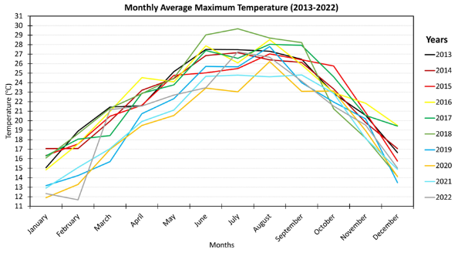 | 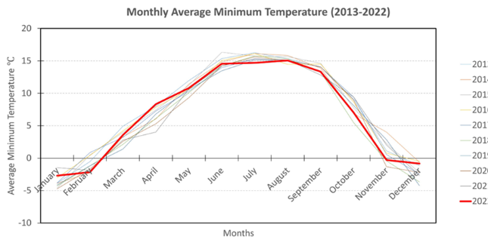
Rainfall: The monsoon season and local micro-climatic conditions significantly influence the rainfall pattern. From mid-June to September, the southwest monsoon brings substantial rainfall, often accompanied by lightning, thunder, and light showers. The maximum monthly average rainfall recorded was 250mm in July 2017. Rainfall is typically low in January, February, March, November, and December. The average monthly and annual rainfall data is given in Figure 12.
Figure 12: Average monthly and annual rainfall data (in mm) in Thimphu
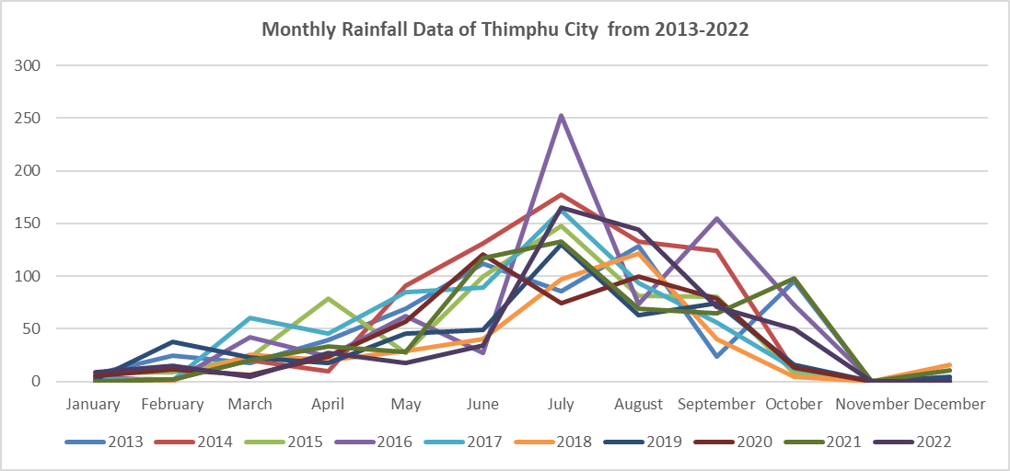 | 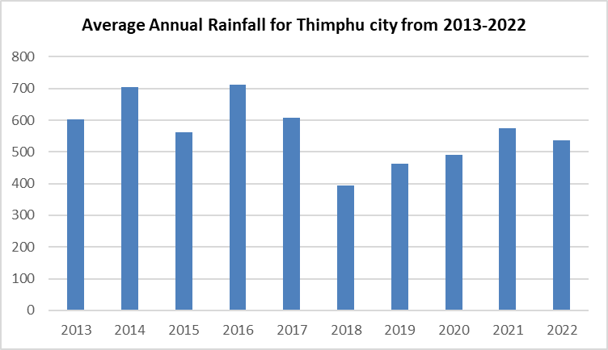

Hydrology
The hydrology of the project area is primarily influenced by the Wang Chhu River and its tributaries, which form the essential water system for Thimphu and its surrounding regions.

Wang Chhu River and its Major Tributaries
Wang Chhu River: The Wang Chhu River is one of the major rivers in Bhutan, originating from glaciers and snow-capped mountains in the north. It flows south through the Thimphu valley and exhibits significant seasonal flow variations, with low flows from November to March and peak flows influenced by monsoon rains and snowmelt from June to September.
Tributaries: The Wang Chhu is joined by several major tributaries, including the Chhuba Chhu, Olarong Chhu, Ngabirong Chhu, Samteling Chhu, Taba Chhu, and Dechencholing Chhu. These tributaries also exhibit seasonal flow variations.

Water Crossings along the BPS Corridor
The BPS route intersects with the Wang Chhu River at the Changjiji, Pamtsho, and Dechencholing bridges. It also crosses several of the tributaries listed above at various points along its 18.7 km length.

Drainage Systems of Norzin Lam
Norzin Lam itself is not directly adjacent to a major river but is traversed by a network of engineered and natural drainage systems designed to manage stormwater runoff from the city core and surrounding hillsides. These include:
- Chubachu Stream: This is the most significant water body influencing the northern end of the Norzin Lam area. It flows from the hills above, passes under the Chubachu roundabout, and discharges into the Wang Chhu River. It is a critical component of the city's urban drainage network.
- Subsurface Culverts and Drains: A network of underground culverts and covered concrete drains runs beneath or adjacent to Norzin Lam and its connecting alleyways. These channels collect surface runoff from roads, buildings, and paved areas, conveying it towards the main river.
- Alleyway Drainage: The five alleyways targeted for improvement under the project currently have rudimentary or degraded drainage channels that are often blocked or insufficient, contributing to localized waterlogging during heavy rainfall.
The project’s urban placemaking activities on Norzin Lam will include significant upgrades to this drainage infrastructure, connecting it to Sustainable Urban Drainage Systems (SuDS) to improve stormwater management and enhance climate resilience. The locations of river crossings are shown in Figure 13.
Figure 13: Locations of River Crossings along the BPS Route
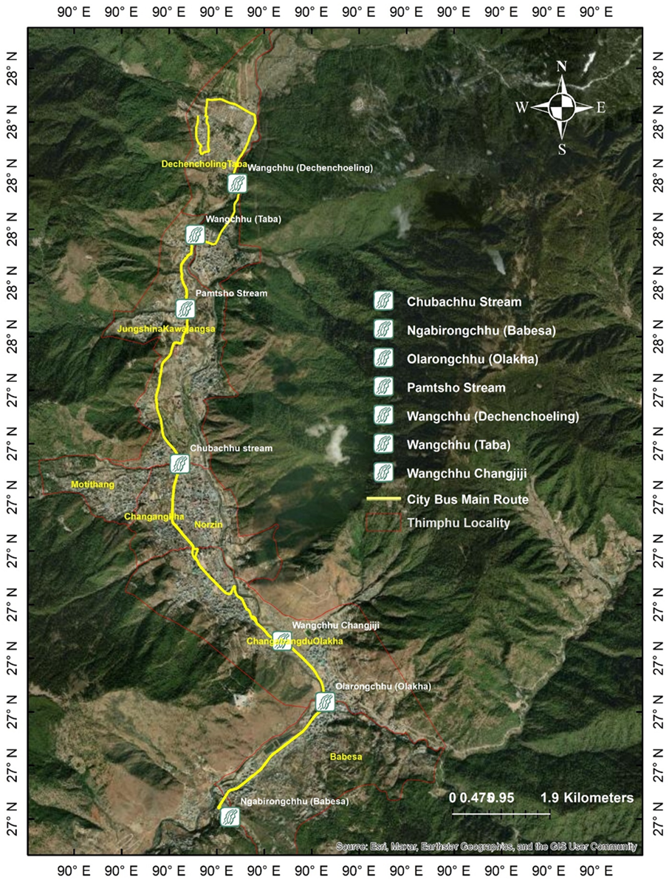

Geology
The project area geology consists of the Thimphu Formation, characterized by highly metamorphosed pre-Cambrian rocks such as gneisses, schist, subordinate quartzite, and calcium silicate. The bedrock is mainly comprised of granite gneiss and different types of schists. The hilly areas on the northern side of the rock exhibit landslides at some locations and landslide zones along the bus route between Zilukha and Supreme Court at Hejo and near Dechencholing bridge. The project activities in these areas will be limited to within the existing right of way.
The hydrogeology of Thimphu is characterized by its mountainous terrain and the presence of the Wang Chhu River, along with its tributaries, which play a pivotal role in the region's groundwater dynamics. The city's groundwater resources are primarily recharged by precipitation and melting snow from the surrounding highlands. The permeable subsurface formations, mainly consisting of weathered and fractured rocks, facilitate the infiltration and storage of groundwater. The city's water supply largely depends on surface water sources, with groundwater as a supplementary resource for domestic and industrial uses.

Natural Hazards
The LRCP project area, encompassing Thimphu Thromde and its critical infrastructure catchments like Dodeyna, is susceptible to a range of natural hazards. These primarily include earthquakes, Glacial Lake Outburst Floods (GLOFs), and flash floods, all of which pose risks to the project's infrastructure (both transport and water systems) and the safety of the community. The recent flooding event of August 2024 further underscores the increasing vulnerability of the region to hydro-meteorological disasters.

Seismicity
Bhutan's geographical location in the seismically active Himalayan region makes it prone to earthquakes. Thimphu City is classified within a high-risk seismic zone (Zone V or IV according to the Bureau of Indian Standards - BIS), indicating a high probability of significant seismic events.
- Historical Context: The region has experienced significant earthquakes in the past. The 1897 earthquake (8.7 magnitude) with its epicenter at the Shillong plateau caused the destruction of Tashichhodzong. More recently, a 6.3 magnitude earthquake near Sikkim in 1980 resulted in reported cracks in buildings within Thimphu. The September 2009 earthquake in eastern Bhutan, though its epicenter was further away, also caused extensive damage and serves as a reminder of the country's vulnerability.
- Implications for LRCP: Earthquakes are considered one of the most potentially damaging natural hazards for Thimphu. All new infrastructure developed under the LRCP—including BPS lanes, bridges, and terminals—must be designed and constructed to withstand seismic forces as per the prevailing Bhutan Building Rules and Regulations (BBR). These regulations reference specific seismic design codes (based on BIS standards for Zone IV and V). This ensures the structural integrity of all project assets, particularly transport infrastructure that is critical for emergency response.

Analysis of GLOF Risk to the LRCP based on the BGLI 2021 Report
Glacial Lakes in the Wang Chhu Basin
The BGLI 2021 report provides a definitive inventory of glacial lakes in Bhutan. For the Wang Chhu basin (Figure 14), which is the river system that flows through Thimphu and is therefore directly relevant to the LRCP, the findings are as follows:
- Low Number of Glacial Lakes: The Wang Chhu basin has the lowest number of glacial lakes among the major river basins in Bhutan. The report identifies only 13 glacial lakes in the entire basin, which includes the Pa Chhu, Haa Chhu, and Thim Chhu sub-basins (page 24).
- Small Lake Size: The report explicitly states that "Most glacial lakes in this region are smaller" (page 24) compared to those in other basins like the Punatsang Chhu.
- Low GLOF Potential: Crucially, the report identifies only one Potentially Dangerous Glacial Lake (PDGL) within the entire Wang Chhu basin (specifically in the Pa Chhu sub-basin, upstream of the LRCP project area).
Direct Implications for the LRCP Project Area
The data from the BGLI 2021 report suggests that the direct risk of a catastrophic GLOF event impacting the LRCP project area in Thimphu is relatively low compared to other parts of Bhutan.
- The Thimphu sub-basin itself, where the project is located, does not contain any of the country's major, historically problematic glacial lakes like Luggye Tsho or Thorthormi Tsho, which are located far away in the Punatsang Chhu basin.
- The small number and size of the lakes in the upstream catchment of the Wang Chhu mean that the potential volume and peak discharge from a GLOF event would likely be significantly less than what could be expected in other major river basins.
Key Consideration and Residual Risks
Despite the relatively lower risk profile, it would be incorrect to conclude that there is no GLOF risk. The BGLI report itself provides important context:
- Climate Change Impact: The report's Foreword and Introduction state that climate change is causing "accelerated melting," an "increasing number of glacial lakes," and that some lakes "have become more of a source of natural disaster." This means the situation is dynamic, and the risk profile could change in the future.
- Cascading Hazards: A GLOF is not the only flood risk. As the LRCP ESIA correctly identifies, intense rainfall and landslide-induced floods (like the 2024 Dechenchholing event) pose a more frequent and perhaps more immediate threat to the project infrastructure. A smaller GLOF event could potentially trigger landslides downstream, creating a complex, cascading hazard.

Conclusion
GLOF Risk Assessment: According to the official Bhutan Glacial Lake Inventory (BGLI) 2021 published by the National Center for Hydrology and Meteorology (NCHM), the Wang Chhu basin, in which the LRCP is located, contains only 13 small glacial lakes and just one lake classified as potentially dangerous. This is the lowest number among Bhutan's major river basins.
Implications for LRCP: This data indicates that the direct risk of a large-scale, catastrophic GLOF originating from the headwaters of the Wang Chhu and impacting Thimphu is considered relatively low. However, the risk is not zero. Climate change is altering the cryosphere, and even a smaller outburst flood could exacerbate local flash floods or trigger landslides. Therefore, all LRCP infrastructure located near the Wang Chhu and its tributaries, such as bridges, terminals, and water intake structures, must be designed with high resilience to general flood and scour risks, which will inherently provide a degree of protection against a potential, low-to-moderate GLOF event.

Figure 14: GLOF Hazard Context for the Livable and Resilient City Project (LRCP)
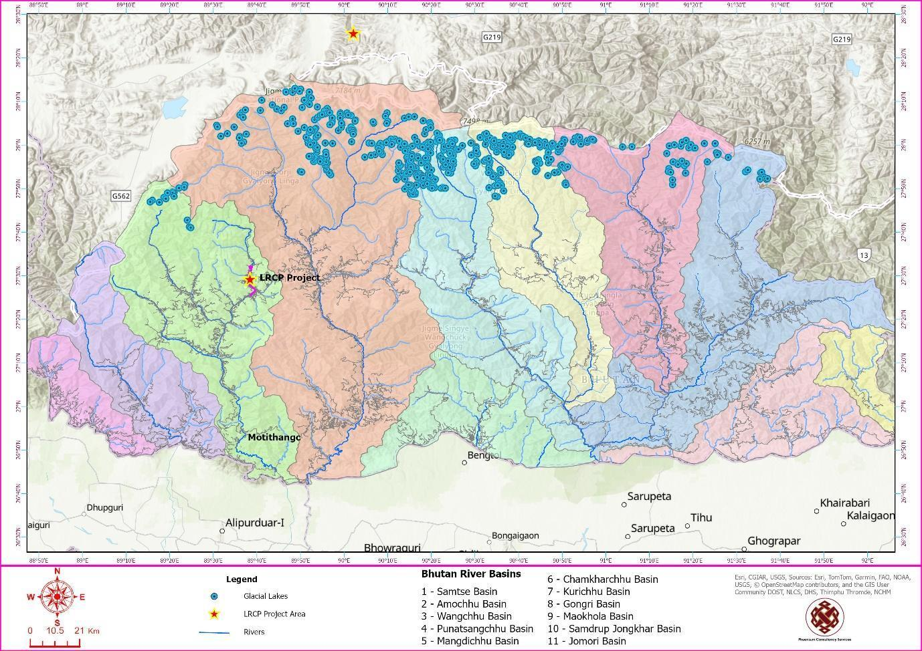

Flash Floods and Riverine Flooding
Thimphu is highly vulnerable to flash floods and riverine flooding, particularly during the monsoon season (typically June to September). This risk is due to a combination of factors including intense rainfall events, the steep topography of the surrounding catchment areas, geological instability, and the capacity of the Wang Chhu River and its numerous tributaries.
- The Dechencholing Flash Flood of August 10, 2024: A stark illustration of this vulnerability was the catastrophic flash flood that ravaged Dechencholing on August 10, 2024. As detailed in a joint assessment by the National Centre for Hydrology and Meteorology (NCHM) and the Department of Geology and Mines (DGM), this event was not due to a single cause but a "confluence of natural factors."
  - Meteorological Factors: The primary trigger was identified as an intense convective thunderstorm, a phenomenon common yet difficult to predict in mountainous regions. While overall rainfall for the year was within usual ranges, a concerning rise in temperature likely contributed to the storm's intensity, leading to heavy rainfall over a short period (estimated 45-60 minutes on August 10). The Dechencholing Chhu, which drains a catchment of approximately 17 square kilometers and is typically rainwater-fed without significant upstream lakes for flow regulation, was overwhelmed. Peak discharge was estimated at a dramatic 120 cumecs, a massive increase from its average lean flow of 0.134 cumecs.
  - Geological and Topographical Factors: The steep slopes and deep valleys characteristic of the Dechencholing region exacerbated the situation, significantly increasing the velocity of water flow and the stream's capacity to transport large boulders and coarse sediment. The geological instability of the area, with slopes prone to erosion (particularly toe erosion along riverbanks), played a critical role.
  - Landslides and Temporary Damming: A significant finding of the post-flood assessment was the role of landslides. At the confluence of two major tributaries of the Dechencholing Chhu, a substantial landslide carried loose debris, boulders, and logs into the main river, forming a temporary artificial dam. The eventual failure of this dam unleashed a powerful surge of water downstream, greatly amplifying the destructive force and extent of the flooding. Several such landslide-induced temporary damming events at key confluence points were identified as contributing to the flood's overall severity. High turbidity in some tributaries indicated them as primary sources of floodwaters and debris.
- Historical Context: Beyond this recent major event, historical records point to previous significant flood events, such as those following Cyclone Aila in 2009 which caused extensive damage in the wider region. Earlier reports also documented a Chubachu stream flood in 1968 indicating a persistent vulnerability to various forms of flooding.
- Climate Change Considerations: The NCHM report on the 2024 Dechencholing flood also hinted at climate change as a possible contributing factor, noting that global climate change is expected to increase both temperatures and precipitation levels, leading to more frequent and severe weather events. This necessitates a forward-looking approach to infrastructure design and settlement planning.
- Implications for LRCP:
  - Resilient Infrastructure Design: The design of all LRCP components must incorporate robust flood risk mitigation and resilience measures informed by events like the August 2024 Dechencholing flood. This is critical for BPS road sections, drainage systems, urban placemaking infrastructure along Norzin Lam, and bus terminals located near watercourses or in potentially flood-prone zones. Culverts and bridges (including the new ones planned at Pamtsho and Dechencholing) must be designed with adequate hydraulic capacity to handle peak flows, debris, and potential changes in river morphology, considering recent flood experiences and future climate projections.
  - Slope Stability and Erosion Control: Given the role of landslides in exacerbating the 2024 flood, construction activities for the LRCP (e.g., road widening for transport), especially on slopes or near riverbanks, must implement stringent erosion and sediment control measures and appropriate bioengineering or structural solutions for slope stabilization.
  - Siting of Critical Facilities: The location of new critical infrastructure, such as bus depots and terminals, must carefully consider updated flood hazard mapping informed by recent events. Where avoidance of risk areas is not possible, flood-proofing and resilient construction methods will be paramount.
  - Early Warning and Monitoring: The recommendations from the NCHM/DGM report regarding the installation of manual early warning systems (sirens) and the establishment of hydro-meteorological observatories in vulnerable catchments like Dechencholing should be noted. While the LRCP may not directly implement these, project infrastructure should be designed to be compatible with such systems and benefit from improved local forecasting.
  - Updated Risk Assessments: The ESIA and subsequent ESMP updates have fully integrated the lessons learned from the August 2024 flood and other recent events, building on updated feasibility studies and other technical assessments conducted for the project. This included:
- Re-evaluating flood risk assessments for all project sites.
- Ensuring drainage designs are adequate for both current and projected future climate scenarios.
- Adapting mitigation measures to enhance the overall resilience of the LRCP infrastructure against flood hazards.
Figure 15: Damages from Dechencholing flash flood of August, 2024 (Source: BBS & Social Media) and Cyclone Aila, 2009 (Source: Karma Chogyel, PCS)
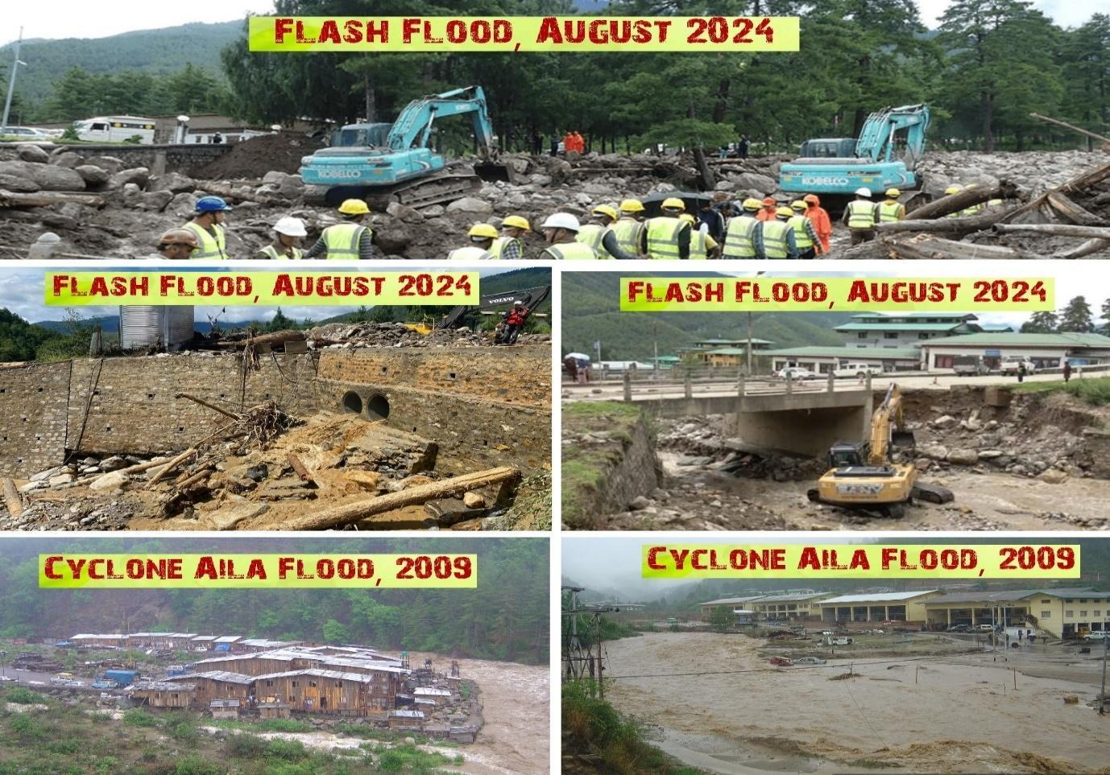

Environmental Quality

Air Quality
As an urban center undergoing development and experiencing traffic pressures, Thimphu's air quality is a significant environmental consideration. The LRCP aims to contribute positively in the long term, particularly through the promotion of cleaner transport options.
To understand the existing atmospheric conditions, preliminary baseline air quality monitoring was undertaken in December 2022 as part of the initial project preparation. This section describes the air quality status from that survey across key project areas, including bus terminals, the BPS route, and the city center. It focuses on critical parameters such as Particulate Matter (PM₁₀ and PM₂.₅), Nitrogen Dioxide (NO₂), Sulphur Dioxide (SO₂), and Carbon Monoxide (CO), comparing the measured levels with Bhutan's National Environmental Standards (NES) 2020 and World Health Organization (WHO) Air Quality Guidelines.
It should be noted that the Contractor will be required to conduct an updated, comprehensive baseline monitoring survey for these parameters prior to the commencement of any construction works to ensure the most current data is used for impact management.
Table 6: Air Quality Monitoring Data along the BPS Route
Location | TSPM (µg/m³) 24-hr mean | PM10 (µg/m³) 24-hr mean | PM2.5 (µg/m³) 24-hr mean | NO2 (µg/m³) 24-hr mean | SO2 (µg/m³) 24-hr mean | CO (µg/m³) 24-hr mean
Dangrina | 23.32 | 16.18 | 6.36 | 32.41 | 5.39 | 2.83
Hejo | 23.96 | 32.58 | 9.05 | 34.54 | 4.97 | 3.36
Taba | 29.79 | 20.44 | 9.36 | 28.47 | 4.87 | 2.83
Referral Hospital | 24.72 | 20.04 | 9.73 | 32.36 | 2.9 | 3.25
Norzin Lam | 42.19 | 33.44 | 8.74 | 33.04 | 4.36 | 2.55
Doebum Lam | 46.6 | 28.87 | 17.32 | 42.22 | 3.05 | 3.96
Olakha Workshop Area | 41.25 | 31.56 | 9.67 | 43.9 | 3.41 | 4.76
Ngabephu Bus Terminal | 50.197 | 35.31 | 14.89 | 30.13 | 1.79 | 3.99
Near Dr. Tobgyal school | 35.923 | 23.62 | 12.46 | 21.87 | 2.45 | 3.16
Centenary Farmer's Market | 32.45 | 22.55 | 9.89 | 29.78 | 3.51 | 2.99
Standard, NES 2020 | 200 | 100 | 60 | 50 | 80 | 2000 µg/m³ (8-hr mean)
WHO AQG 2021 (24-hr) | N/A (no guideline) | 45 | 15 | 25 | 40 | 30 (8-hr mean)

Comparison and Analysis:
- Total Suspended Particulate Matter (TSPM):
- NES 2020 Standard: 200 µg/m³
- WHO AQG 2021: No specific 24-hour guideline for TSPM (focus is on PM10 and PM2.5).
- Analysis: All measured TSPM values (ranging from 23.32 to 50.197 µg/m³) are well below the NES 2020 standard.
- Particulate Matter (PM10):
- NES 2020 Standard: 100 µg/m³
- WHO AQG 2021 (24-hr mean): 45 µg/m³
- Analysis:
  - All measured PM10 values (ranging from 16.18 to 35.31 µg/m³) are well below the NES 2020 standard.
  - All measured PM10 values are also below the more stringent WHO AQG 2021 24-hour mean guideline of 45 µg/m³.
- Particulate Matter (PM2.5):
- NES 2020 Standard: 60 µg/m³
- WHO AQG 2021 (24-hr mean): 15 µg/m³
- Analysis:
  - All measured PM2.5 values (ranging from 6.36 to 17.32 µg/m³) are well below the NES 2020 standard.
  - However, one location, Doebum Lam (17.32 µg/m³), slightly exceeds the WHO AQG 2021 24-hour mean guideline of 15 µg/m³. Ngabephu Bus Terminal (14.89 µg/m³) is very close to the WHO limit. Other locations are below the WHO guideline.
- Nitrogen Dioxide (NO2):
- NES 2020 Standard: 50 µg/m³
- WHO AQG 2021 (24-hr mean): 25 µg/m³
- Analysis:
  - All measured NO2 values (ranging from 21.87 to 43.9 µg/m³) are below the NES 2020 standard.
  - However, all measured locations exceed the more stringent WHO AQG 2021 24-hour mean guideline of 25 µg/m³, except for "Near Dr. Tobgyal school" (21.87 µg/m³) which is below. Locations like Olakha Workshop Area (43.9 µg/m³), Doebum Lam (42.22 µg/m³), Hejo (34.54 µg/m³), Norzin Lam (33.04 µg/m³), Dangrina (32.41 µg/m³), Referral Hospital (32.36 µg/m³), Ngabephu Bus Terminal (30.13 µg/m³), Centenary Farmer's Market (29.78 µg/m³), and Taba (28.47 µg/m³) are all above the WHO guideline.
- Sulphur Dioxide (SO2):
- NES 2020 Standard: 80 µg/m³
- WHO AQG 2021 (24-hr mean): 40 µg/m³
- Analysis:
  - All measured SO2 values (ranging from 1.79 to 5.39 µg/m³) are significantly below both the NES 2020 standard and the WHO AQG 2021 guideline. This indicates that SO2 is not currently a major air quality concern at these locations based on this dataset.
- Carbon Monoxide (CO):
- NES 2020 Standard: The National Environmental Standards 2020 specify standards for ambient Carbon Monoxide based on an 8-hour and 1-hour averaging time, which vary by area type. The relevant standards for the project area are:
  - 8-hour average: 2,000 µg/m³ (Mixed Area); 1,000 µg/m³ (Sensitive Area)
  - 1-hour average: 4,000 µg/m³ (Mixed Area); 2,000 µg/m³ (Sensitive Area)
- WHO AQG 2021 (8-hr mean): 4 mg/m³ (which is 4000 µg/m³). There isn't a direct 24-hr mean guideline for CO from WHO as acute effects are more relevant.
- Analysis:
Although the available baseline data is presented as a 24-hour average, both the National Environmental Standards (NES) 2020 and the WHO Air Quality Guidelines (AQG) 2021 set standards for Carbon Monoxide over shorter periods (8-hour and 1-hour) to regulate acute health effects. Despite this difference in averaging time, a comparison of the magnitudes clearly demonstrates compliance:
- The highest measured 24-hour average CO concentration (4.76 µg/m³) is more than 200 times lower than the most stringent applicable national standard of 1,000 µg/m³ (NES 2020, 8-hour average for sensitive areas).
- Similarly, the measured values are nearly 840 times lower than the international health-based WHO AQG 2021 guideline of 4,000 µg/m³ (8-hour mean).
Given this substantial margin, it is certain that the 8-hour average concentrations at these locations would also be well within the compliance limits of both national and international standards. Therefore, the analysis confirms that Carbon Monoxide is not a pollutant of concern in the project area.
Summary of Findings:
- Compliance with NES 2020: Based on the provided standards, the air quality at all monitored locations generally complies with Bhutan's National Environmental Standards (2020) for TSPM, PM10, PM2.5, NO2, and SO2. CO also complies if the standard is indeed 200 µg/m³ (though this value is questionable for CO).
- Compliance with WHO AQG 2021:
  - PM10: All locations meet the WHO 24-hr guideline.
  - PM2.5: Doebum Lam (17.32 µg/m³) slightly exceeds the WHO 24-hr guideline of 15 µg/m³. Ngabephu Bus Terminal is very close.
  - NO2: Most locations significantly exceed the WHO 24-hr guideline of 25 µg/m³. Only "Near Dr. Tobgyal school" is below this guideline. This suggests NO2 is a pollutant of concern when compared to international health-based guidelines.
  - SO2: All locations are well within the WHO guideline.
  - CO: All locations are well within the WHO 8-hr guideline (assuming the measured 24-hr averages are indicative).
- Key Pollutants of Potential Concern (vs. WHO):
  - NO2 appears to be the most widespread pollutant exceeding WHO guidelines at almost all monitored locations. This is common in urban areas with traffic.
  - PM2.5 exceeds WHO guidelines at one location (Doebum Lam) and is close at another.
- Areas of Higher Pollution:
  - Locations like Doebum Lam, Olakha Workshop Area, and Norzin Lam show relatively higher concentrations for some pollutants (PM2.5, NO2, TSPM) compared to other sites, which is expected given their likely proximity to traffic and commercial activities.
  - Ngabephu Bus Terminal shows the highest TSPM and is close to the WHO PM2.5 limit.
Recommendations based on this analysis:
- Verify CO Standard: Clarify the NES 2020 standard for CO (unit and averaging time) to ensure accurate comparison.
- Focus on NO2 and PM2.5: Given that NO2 exceeds WHO guidelines at most locations and PM2.5 at some, mitigation measures for the LRCP should prioritize reducing emissions of these pollutants from construction and operational phases (e.g., promoting electric vehicles, traffic management to reduce congestion, dust suppression during construction).
- Targeted Monitoring: For locations like Doebum Lam and Olakha Workshop Area, which show higher concentrations, continued or more frequent monitoring might be considered during the project lifecycle.
- Health Implications: While complying with national standards, the exceedances against more stringent WHO guidelines, particularly for NO2 and PM2.5, indicate potential health risks that the project should aim to minimize further.
Figure 16: Locations of Air, Noise and Water Quality Monitoring sites
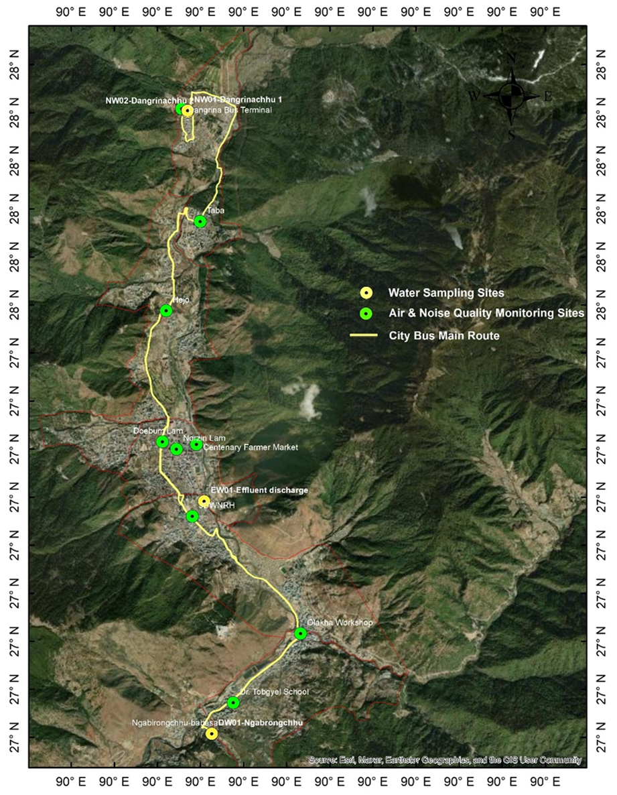

Analysis of Baseline Noise Quality Data
Ambient noise levels are a significant environmental factor affecting the quality of life in urban areas. This analysis reviews the baseline noise quality data collected at various locations within Thimphu Thromde relevant to the LRCP. The data, presumably collected over a 24-hour period and averaged for daytime and nighttime, is compared against Bhutan's National Environmental Standards (NES) 2020 and the World Bank Group (WBG) Environmental, Health, and Safety (EHS) Guidelines for noise.

Monitored Noise Levels:
The following table summarizes the measured ambient noise levels (in dBA):
Table 7: Noise levels at Various Locations
Location | Day (dBA) | Night (dBA) | Predominant Area Type (Assumed for NES comparison)
Dangrina Bus Terminal area | 59.22 | 53.43 | Mixed/Commercial
Hejo | 62.64 | 55.45 | Mixed/Residential
Taba | 68.69 | 61.44 | Mixed/Residential
Referral Hospital | 59.82 | 51.21 | Sensitive
Norzin Lam | 68.77 | 59.84 | Commercial/Mixed
Doebum Lam | 64.22 | 56.86 | Mixed/Commercial
Olakha Workshop Area | 71.67 | 55.12 | Industrial/Commercial
Ngabephu Bus Terminal | 69.1 | 59.39 | Mixed/Commercial
Near Dr. Tobgyal school | 59.41 | 53.90 | Sensitive/Residential
Centenary Farmer's Market | 71.42 | 55.85 | Commercial/Mixed
Standard, NES 2020
Industrial Area | 75 | 65
Mixed Area | 65 | 55
Sensitive Area | 55 | 45
WBG EHS Guidelines
Industrial/Commercial | 70 | 70
Residential/Institutional/Educational | 55 | 45
Comparison with Standards and Analysis:
- Daytime Noise Levels (dBA):
- NES 2020 Standards:
  - Industrial Area (75 dBA): Olakha Workshop Area (71.67 dBA) is within this limit.
  - Mixed Area (65 dBA):
    - Exceedances: Taba (68.69 dBA), Norzin Lam (68.77 dBA), Olakha Workshop Area (71.67 dBA - also fits industrial), Ngabephu Bus Terminal (69.1 dBA), and Centenary Farmer's Market (71.42 dBA) exceed the Mixed Area limit.
    - Within limits: Dangrina Bus Terminal (59.22 dBA), Hejo (62.64 dBA), Doebum Lam (64.22 dBA).
  - Sensitive Area (55 dBA):
    - Exceedances: Referral Hospital (59.82 dBA) and Near Dr. Tobgyal school (59.41 dBA) exceed the Sensitive Area limit.
- WBG EHS Guidelines:
  - Industrial/Commercial (70 dBA):
    - Exceedances: Olakha Workshop Area (71.67 dBA) and Centenary Farmer's Market (71.42 dBA) exceed this limit.
    - Within limits: Taba (68.69 dBA), Norzin Lam (68.77 dBA), Ngabephu Bus Terminal (69.1 dBA) are close but within. Dangrina Bus Terminal (59.22 dBA), Hejo (62.64 dBA), Doebum Lam (64.22 dBA) are comfortably within.
  - Residential/Institutional/Educational (55 dBA):
    - Exceedances: All monitored locations already significantly exceed the WBG EHS residential guideline of 55 dBA. This includes sites with clear residential, institutional, or educational components such as Hejo (62.64 dBA), Referral Hospital (59.82 dBA), and the area Near Dr. Tobgyal school (59.41 dBA). Furthermore, even predominantly commercial areas like Norzin Lam (68.77 dBA) and the Centenary Farmer's Market (71.42 dBA) also exceed this sensitive receptor guideline due to their proximity to residential areas and the mixed-use nature of the urban environment.
- Nighttime Noise Levels (dBA):
- NES 2020 Standards:
  - Industrial Area (65 dBA): All measured locations are below this.
  - Mixed Area (55 dBA):
    - Exceedances: Taba (61.44 dBA), Norzin Lam (59.84 dBA), Doebum Lam (56.86 dBA), Olakha Workshop Area (55.12 dBA - marginally), Ngabephu Bus Terminal (59.39 dBA), and Centenary Farmer's Market (55.85 dBA) exceed the Mixed Area limit.
    - Within limits: Dangrina Bus Terminal (53.43 dBA), Hejo (55.45 dBA - marginally above if strictly applied, but close), Referral Hospital (51.21 dBA), Near Dr. Tobgyal school (53.90 dBA).
  - Sensitive Area (45 dBA):
    - Exceedances: All locations assumed to be Sensitive, including Referral Hospital (51.21 dBA) and Near Dr. Tobgyal school (53.90 dBA), significantly exceed this limit. Many other locations also exceed this stringent limit.
- WBG EHS Guidelines:
  - Industrial/Commercial (70 dBA): All measured nighttime levels are well within this guideline.
  - Residential/Institutional/Educational (45 dBA):
  - Exceedances: All monitored locations significantly exceed this stringent nighttime guideline. The lowest recorded, Referral Hospital (51.21 dBA), is still well above 45 dBA.
Key Findings and Observations:
- General Compliance with NES 2020 (Daytime Industrial): The highest noise levels (Olakha Workshop, Centenary Farmer's Market) are close to or within the NES Industrial Area daytime limit.
- Common Exceedances of NES 2020 (Daytime Mixed & Sensitive, Nighttime Mixed & Sensitive):
  - Several commercial/mixed areas (Taba, Norzin Lam, Ngabephu Terminal, Centenary Farmer's Market, Olakha Workshop) exceed the NES Mixed Area daytime limit.
  - Sensitive areas (Referral Hospital, Near Dr. Tobgyal school) exceed NES Sensitive Area limits for both day and night.
  - Many locations exceed the NES Mixed Area nighttime limit.
- Widespread Exceedances of WBG EHS Guidelines (Residential/Institutional/Educational):
  - Daytime: Almost all locations, when considered against the stricter WBG guideline for residential/institutional/educational areas (55 dBA), show exceedances.
  - Nighttime: All monitored locations significantly exceed the WBG EHS nighttime guideline of 45 dBA for residential/institutional/educational areas. This indicates a potentially widespread issue of elevated nighttime noise levels across Thimphu.
- Highest Noise Levels: Olakha Workshop Area and Centenary Farmer's Market record the highest daytime noise levels. Taba records the highest nighttime noise level.
- Lowest Noise Levels: Dangrina Bus Terminal (daytime) and Referral Hospital (nighttime) recorded the lowest values, though even these are high relative to WBG nighttime guidelines for sensitive areas.
- Traffic as a Likely Dominant Source: The higher noise levels in areas like Norzin Lam, Centenary Farmer's Market, and along main routes (Taba, Hejo) suggest that traffic is a major contributor to ambient noise. Industrial/commercial activities also contribute (e.g., Olakha Workshop).
Implications for LRCP:
- Construction Noise: Construction activities for both transport and water components will invariably add to the existing noise levels. Given that many areas already exceed or are close to NES Mixed/Sensitive area limits and significantly exceed WBG residential/sensitive area guidelines, careful management of construction noise will be critical, especially near sensitive receptors like schools and hospitals.
- Operational Noise (BPS): While electric buses are quieter than diesel buses, increased frequency of bus movements, station announcements, and associated activities at terminals could contribute to noise. The design of terminals and routes should consider noise mitigation.
- Water Sector Construction: Trenching and other construction activities for water pipelines and SCADA installation will also generate noise, requiring mitigation in urban and residential areas.
- Need for Mitigation: The baseline data highlights the importance of robust noise mitigation measures in the ESMP for both construction and operational phases of the LRCP to avoid exacerbating existing noise issues and to strive towards meeting at least national standards, and where feasible, aiming for WHO guidelines in sensitive areas.
- Sensitive Receptors: Particular attention is needed for areas near schools (Dr. Tobgyal school) and hospitals (Referral Hospital) which already experience noise levels above sensitive area guidelines.
Conclusion:
The baseline noise monitoring indicates that while some areas comply with specific NES 2020 categories, there are notable exceedances, particularly when compared to the stricter WBG EHS Guidelines for residential, institutional, and educational areas, especially during nighttime. Traffic and commercial/industrial activities appear to be significant contributors. The LRCP will need to implement effective noise management and mitigation strategies during both construction and operation to avoid further degradation of the acoustic environment and to protect sensitive receptors.

Analysis of Water Quality Monitoring Data Along the BPS Route
This analysis reviews the provided water quality monitoring data collected from various streams and Wang chhu River along the proposed Bus Priority Service (BPS) route in March 2023. The data is compared against Bhutan's Environmental Standards 2020 to assess the current water quality conditions.
Table 8: Water Quality Monitoring Data along the BPS Route
Sample Location | Parameters
Sample Location | pH | Conductivity  µS/cm | DO (Mg/L) | TDS (Mg/L) | Water Temp °C | Colour Hz | TSS (mg/L) | BOD (Mg/L) | COD (Mg/L) | Faecal Coliform (CFU/100ml) | Total Coliform (CFU/100ml) | Chloride (mg/L) | Turbidity (mg/L) | Oil & grease
Babesa Chhu | 8.96 | 165.3 | 9.1 | 78.4 | 16.4 | Clear | - | 1 | 9 | - | - | - | - | -
Chuba Chhu | 9.05 | 158.6 | 9.3 | 75.2 | 13.1 | Clear | - | 2.1 | 9.3 | - | - | - | - | -
Ngabirong Chhu | 7.36 | 68.9 | 7.7 | 58.7 | 12.6 | 0.68 | 2.4 | 2.9 | 5.6 | 6 | 11 | 0.045 | 0.58 | -
Dangrina Chhu 1 (left side of bus terminal) | 7.53 | 63.21 | 7.6 | 56.8 | 12.82 | 0.63 | 1.8 | 2.2 | 5 | BDL | BDL | 0.021 | 0.67 | -
Dangrina Chhu 2 (right side of bus terminal) | 7.51 | 64.1 | 7.4 | 53.4 | 12.04 | 0.63 | 1.7 | 2.4 | 4.2 | BDL | BDL | 0.024 | 0.72 | -
Wang Chhu (Pangrizampa) | 9.02 | 162 | 8.6 | 76.8 | 10.5 | Clear | - | 1.8 | 1.1 | 0 | - | - | - | -
WangChhu (Ramtokto) | 8.57 | 157.5 | 8.7 | 74.7 | 11.1 | Clear | - | 1.5 | 1.1 | 0 | - | - | - | -
Environmental Standards 2020 | 6.0-9.0 | 1000 | 4 | 1500 | - | 50 | 100 | 5 | 5 | 2000 | 5000 | 200 | 5 | 5
Key Observations and Analysis by Parameter:
- pH:
  - All monitored locations (Babesa Chhu, Chuba Chhu, Ngabirong Chhu, Dangrina Chhu 1 & 2, Wang Chhu at Pangrizampa and Ramtokto) show pH values within the acceptable range of 6.0-9.0 as per the Environmental Standards 2020.
  - Values range from a slightly acidic 7.36 (Ngabirong Chhu) to a more alkaline 9.05 (Chuba Chhu). The Wang Chhu sites also show slightly alkaline conditions. This suggests generally good buffering capacity in these water bodies.

- Conductivity:
  - Conductivity levels are well below the standard limit of 1000 µS/cm at all sites.
  - The larger Wang Chhu sites (Pangrizampa and Ramtokto) and the Babesa and Chuba Chhus show higher conductivity (157.5 - 165.3 µS/cm) compared to the Ngabirong and Dangrina Chhus (63.21 - 68.9 µS/cm). This difference could be due to variations in dissolved solids content influenced by geology, land use in their respective catchments, or urban runoff.
- Dissolved Oxygen (DO):
  - All sites exhibit DO levels significantly above the minimum standard of 4 mg/L, indicating healthy aquatic conditions capable of supporting aquatic life.
  - Values range from 7.43 mg/L (Dangrina Chhu 2) to 9.29 mg/L (Chuba Chhu), which are generally good to excellent levels for surface waters.
- Total Dissolved Solids (TDS):
  - TDS levels are considerably lower than the 1500 mg/L standard at all monitored locations.
  - Similar to conductivity, the Wang Chhu, Babesa Chhu, and Chuba Chhu show slightly higher TDS values (74.7 - 78.4 mg/L) compared to Ngabirong and Dangrina Chhus (53.4 - 58.7 mg/L), reflecting the dissolved ion content.
- Water Temperature:
  - No specific standard is provided for comparison, but the temperatures (ranging from 10.5°C to 16.4°C) are typical for water bodies in the region, influenced by season and altitude.
- Colour:
  - The Wang Chhu, Babesa Chhu, and Chuba Chhu are reported as "Clear," which is well within the standard of 50 Hz.
  - Ngabirong Chhu and both Dangrina Chhu sites show very low color values (0.63 - 0.68 Hz), also well within the limit and indicating minimal coloration.
- Odour:
  - All sites are reported as "Unobjectionable," meeting the standard.
- Total Suspended Solids (TSS):
  - Data is only available for Ngabirong Chhu (2.38 mg/L) and Dangrina Chhu 1 & 2 (1.84 mg/L and 1.73 mg/L respectively). These values are well below the 100 mg/L standard, indicating low levels of particulate matter in these streams at the time of sampling.
- Biochemical Oxygen Demand (BOD):
  - All sites show BOD levels significantly below the 5 mg/L standard, ranging from 1.0 mg/L (Babesa Chhu) to 2.87 mg/L (Ngabirong Chhu). This suggests low levels of biodegradable organic pollution and good self-purification capacity.
- Chemical Oxygen Demand (COD):
  - Most sites meet the 5 mg/L standard for COD, with values like 1.11 mg/L (Wang Chhu at Pangrizampa) and 1.5 mg/L (Wang Chhu at Ramtokto).
  - However, Babesa Chhu (9.01 mg/L), Chuba Chhu (9.29 mg/L), and Ngabirong Chhu (5.61 mg/L) exceed the 5 mg/L standard. Dangrina Chhu 1 (5.03 mg/L) is marginally above. This indicates a higher presence of oxidizable organic and inorganic substances in these specific tributaries compared to the main Wang Chhu, possibly due to localized pollution sources or natural organic matter.
- Fecal Coliform:
  - Wang Chhu sites show 0 CFU/100ml, well within the 2000 CFU/100ml standard.
  - Dangrina Chhu 1 & 2 are reported as BDL (Below Detection Limit), also meeting the standard.
  - Ngabirong Chhu shows a low count of 6 CFU/100ml, well within the standard.
  - Data is missing for Babesa Chhu and Chuba Chhu.

- Total Coliform:
  - Wang Chhu data is missing.
  - Dangrina Chhu 1 & 2 are BDL, meeting the 5000 CFU/100ml standard.
  - Ngabirong Chhu shows 11 CFU/100ml, well within the standard.
  - Data is missing for Babesa Chhu and Chuba Chhu.
  - The low or absent coliform counts in the tested streams suggest minimal recent fecal contamination at these specific sampling points and times.
- Chloride:
  - Data is only available for Ngabirong Chhu (0.045 mg/L) and Dangrina Chhu 1 & 2 (0.021 mg/L and 0.024 mg/L respectively). These values are extremely low and well within the 200 mg/L standard, indicating no significant chloride pollution.
- Turbidity:
  - Data is only available for Ngabirong Chhu (0.58 NTU) and Dangrina Chhu 1 & 2 (0.67 NTU and 0.72 NTU respectively). These values are very low and well within the 5 NTU standard. This indicates clear water in these streams at the time of sampling.
- Oil & Grease:
  - Data is missing for all locations. This is an important parameter to assess, especially in urban areas where runoff can carry oil and grease from roads and workshops.
Overall Conclusion:
Based on the available data from March 2023 and previous monitoring for some sites:
- The water quality along the BPS route, particularly in the main Wang Chhu and the smaller tributaries tested, is generally good and meets most of Bhutan's Environmental Standards 2020. Parameters like pH, DO, TDS, color, odour, and in most cases BOD, are well within acceptable limits.
- Areas of Concern:
  - COD levels in Babesa Chhu, Chuba Chhu, and Ngabirong Chhu exceed the standard, suggesting a higher load of oxidizable matter that warrants further investigation into potential sources (e.g., urban runoff, small-scale industrial discharges, or natural organic inputs).
- Data Gaps:
  - Missing TSS, Fecal Coliform, Total Coliform, Chloride, Turbidity, and Oil & Grease data for several locations (Babesa Chhu, Chuba Chhu, and Wang Chhu sites for some parameters) limits a complete assessment for these specific streams.
  - The absence of Oil & Grease data for all sites is a notable gap, especially for urban water bodies.
- Smaller Tributaries vs. Main River: The smaller tributaries (Babesa Chhu, Chuba Chhu, Ngabirong Chhu) show some higher pollutant indicators (like COD) compared to the larger Wang Chhu, which is expected as smaller water bodies have less dilution capacity and can be more immediately impacted by localized inputs.
Recommendations:
- Investigate COD Sources: Further investigation is recommended for Babesa Chhu, Chuba Chhu, and Ngabirong Chhu to identify the sources of elevated COD levels and implement appropriate management measures if they are anthropogenic.
- Complete Data Collection: Future monitoring should aim to collect data for all parameters at all relevant sites, particularly filling the gaps for TSS, coliforms, and crucially, Oil & Grease.
- Regular Monitoring: Continue regular monitoring, especially before, during, and after the construction phase of the LRCP, to detect any changes in water quality due to project activities (e.g., increased turbidity or pollutants from construction runoff, especially at bridge construction sites).
- Consider Seasonal Variations: While this data is from March 2023 (typically a lower flow season), future monitoring should ideally cover different seasons (e.g., monsoon) to capture variations in water quality due to changes in flow and runoff.
- Specific Monitoring for Water Sector: For the water sector component of LRCP, dedicated baseline monitoring for the Dodeyna intake and other relevant points in the water supply chain (raw water, treated water) will be essential, distinct from this BPS route monitoring.

Biological Environment

Forests
The LRCP is primarily situated within the urban and peri-urban landscape of Thimphu Thromde. While most project activities are within developed areas, certain elements of the Urban Transport component, specifically a section of the Bus Priority Service (BPS) route, will pass directly through state-reserved forest land, for which primary field observations were made.
- Forest Cover in Thimphu and along Project Alignments:
- Thimphu Dzongkhag Context (from NFI 2023): According to the National Forest Inventory (NFI) 2023 (Volume I: State of Forest Report), Thimphu Dzongkhag has an estimated forest area of 81,571.41 hectares, which accounts for approximately 45.18% of its total land area (NFI Table 3.3). This is lower than the national average forest cover of 69.71%. The NFI also notes that the sapling density in Thimphu Dzongkhag (62 saplings/ha) is among the smallest in the country (NFI Table 4.6), which might indicate challenges in natural regeneration in certain areas.
- BPS Route: The BPS route predominantly traverses urbanized areas. However, a specific section of approximately 0.8 km between Taba and Dechencholing Bridge passes through state-reserved forest land. Based on site observations for this project, this forest land primarily consists of Blue Pine (Pinus wallichiana) mixed with oak species, and some areas of pure Blue Pine forests.
  - Overall, Thimphu Thromde itself hosts approximately 629.2 hectares of forest cover, accounting for about 18% of the Thromde's administrative area.
  - Notable tree species observed along or near the BPS route and terminal areas include Blue Pine (Pinus wallichiana) in Ngabiphu, Dangrina, and Taba, and Walnut (Juglans regia) in the forest near the bus route between Taba and Dechencholing Bridge.

Conservation Status of Species:
- LRCP Specific Surveys (Transport Component): Surveys conducted in March 2023 within the project area for the BPS route, including near bus terminals, found no plant species listed on the IUCN Red List or the Bhutan Red List. This indicates that the immediate BPS corridor, within its surveyed sections, does not host critically endangered or threatened plant species.
- Nationally Protected Species: While not IUCN Red Listed, Blue Pine (Pinus wallichiana) and Walnut (Juglans regia), observed along the BPS route, are listed under Schedule II of the Forest and Nature Conservation Act of Bhutan 2023, indicating they have a degree of national protection or regulation regarding their use. Oak species (Quercus spp.), also noted, are significant components of Bhutan's forest ecosystems and are often important for local biodiversity and ecosystem services. The NFI 2023 report notes that Quercus spp. have the second-highest total basal area among tree species nationally (NFI Table 5.10).

Considerations from NFI 2023:
- The NFI 2023 indicates an overall decrease in national forest cover from 71.13% (1st NFI) to 69.71% (2nd NFI), partly attributed to developmental activities and conversion of private forest lands. This broader trend underscores the importance of minimizing forest impact from projects like the LRCP.
- The NFI also notes that while Broadleaved Forests constitute the majority of Bhutan's forest area (67.99%), Coniferous Forests have a greater volume per hectare. Cool Broadleaved Forest is the dominant forest type in Bhutan (28.18% of total forest). These general statistics provide context for the types of forest ecosystems prevalent in the wider Thimphu region.

Implications for LRCP:
The limited extent of direct forest impact along the BPS route (0.8 km) is noted. However, any tree felling required will need to adhere to the Forest and Nature Conservation Act 2023 and associated rules. Mitigation measures, including compensatory plantation where applicable, is detailed in the Environmental and Social Management Plan (ESMP).
Figure 17: Forest Types in Bhutan (Source: NFI, 2023): Thimphu Valley is predominantly covered by Blue Pine Forest.
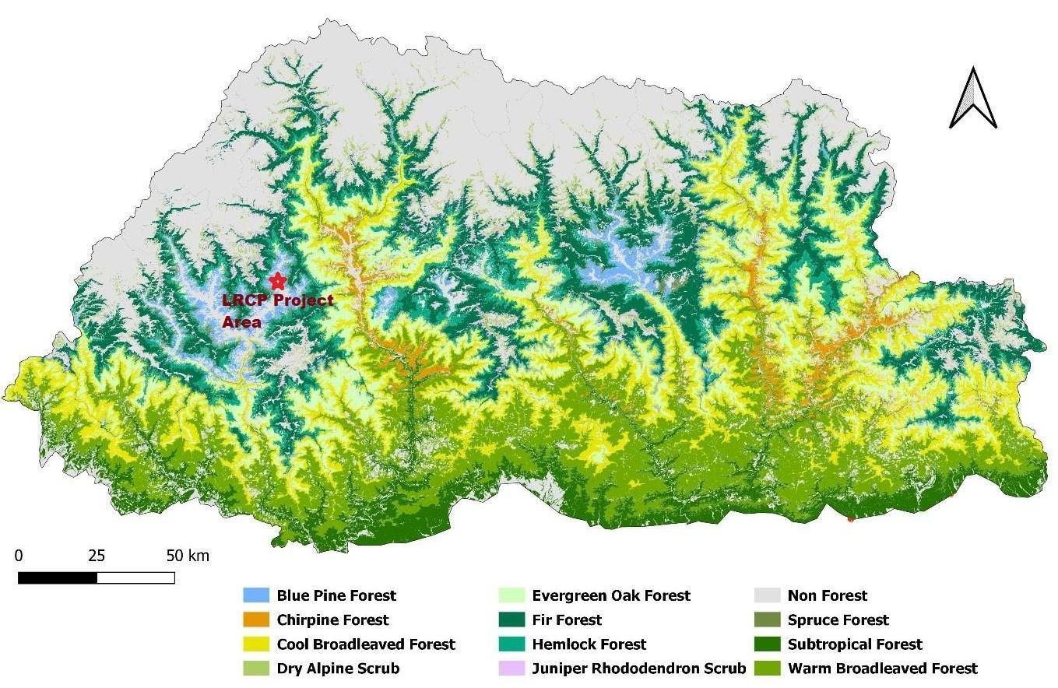

Fauna
The faunal assessment within the LRCP area primarily relies on observations from targeted surveys conducted in March 2023 along the Bus Priority Service (BPS) route alignments, as part of the Urban Transport component. At this stage, no new comprehensive primary faunal surveys have been conducted specifically for other areas.

Observations along the Urban Transport Corridors:
Sample surveys conducted in March 2023 along the Bus Priority Service (BPS) route, particularly near the proposed terminal sites at Ngabiphu and Dangrina, and in the forested areas near Taba, provided evidence of local wildlife presence. Key findings include:
- Wild Pig (Sus scrofa): Burrows indicative of Wild Pig activity were found in the forests near Ngabiphu, Dangrina, and Taba. The National Forest Inventory (NFI) 2023 report also documents the widespread distribution of Wild Boar (Sus scrofa) throughout Bhutan, noting their opportunistic feeding habits which can lead to crop damage (NFI 2023, p. 126).
- Barking Deer (Muntiacus muntjak): Pellets of Barking Deer were observed in the forest above the Dangrina bus terminal. The NFI 2023 also models the distribution of Barking Deer throughout Bhutan, indicating their presence in diverse ecosystems ranging from subtropical to temperate regions (NFI 2023, p. 123).
These findings confirm the presence of these common mammal species in the vicinity of the BPS route. Both the Barking Deer and Wild Pig are protected under Schedule III of the Forest and Nature Conservation Act of Bhutan 2023. According to the project-specific surveys from March 2023, neither of these species, nor any other fauna signs observed directly along the BPS route, are listed on the IUCN Red List or the Bhutan Red List as threatened species. Furthermore, there have been no reported vehicle accidents involving wildlife in the existing bus terminal areas or along the primary bus routes within the city.

Overall Assessment:
The faunal diversity directly impacted by the urban transport components within the built-up areas of Thimphu appears to be limited to common, adaptable species. However, the presence of state-reserved forest along parts of the BPS route necessitates careful environmental management.

Avifauna
The avian diversity of Thimphu Valley, the primary project area for the LRCP, has been documented by Thimphu Thromde in their 2022 publication, Birds in and Around Thimphu Valley. This pictorial guidebook serves as a valuable baseline reference, cataloging 141 bird species found across the city and its surrounding landscapes. Beyond its role as a scientific record, the book is an essential educational resource for students, researchers, and away from the direct BPS route, it indicates the presence of species with conservation significance in the broader urban ecosystem. Other species noted in this general area, and also listed under Schedule III of the Forest and Nature Conservation Act (FNCA) 2023, include the Ruddy Shelduck (Tadorna ferruginea) and Eurasian Coot (Fulica atra).
Potential impacts on birdlife from the LRCP could include temporary habitat disturbance and noise during construction activities along the BPS route and Norzin Lam. The ESMP will include measures to mitigate these disturbances, such as minimizing vegetation clearance, controlling construction noise where feasible, and ensuring proper site management.

Fish
The primary aquatic ecosystem relevant to the LRCP is the Wang Chhu River and its tributaries, which flow through Thimphu city and its surroundings. These water bodies are pertinent to the Urban Transport component, particularly where the Bus Priority Service (BPS) route involves bridge construction or proximity to riverbanks.
Common fish species reported in the Wang Chhu include the native Snow Trout (Schizothorax plagiostomus), also known as snow carp, and the introduced, invasive Brown Trout (Salmo trutta). Both are cold-water species, with Snow Trout being a short-distance migrant.
Within the urban limits of Thimphu city, formal fishing activity in the rivers is generally not observed. Fishing in Bhutan is a tightly regulated activity, managed by the Department of Forests and Park Services (DoFPS). Engaging in fishing typically requires a special permit, and activities are often restricted to specific designated areas, usually outside major urban centers, to ensure sustainable management of fish stocks and conservation of aquatic biodiversity.
Urban Transport Component: The urban transport and public space components of the LRCP include several activities that may impact aquatic habitats, such as the widening of two bridges at Pamtsho and Dechencholing involving in-stream and near-stream works; corridor upgrades like road widening and drainage improvements along sections of the BPS route adjacent to the Wang Chhu River and its tributaries; and urban placemaking efforts along Norzin Lam and its connecting alleyways, which could affect the Chubachu stream and urban drainage systems. These interventions pose potential risks including increased sedimentation from earthworks, changes in water quality due to construction runoff, and physical disturbances to riverbeds and banks.
Figure 18: Wildlife observed in and around Thimphu valley
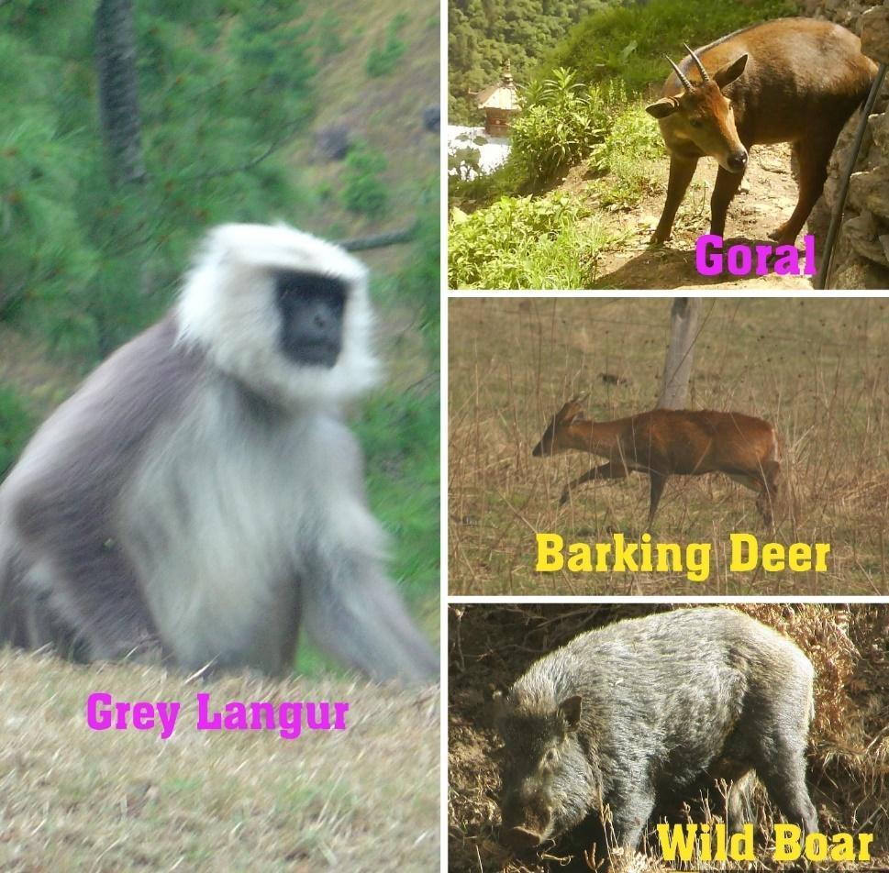

Figure 19: Frequently Observed Bird Species in Thimphu Valley (June 2025)
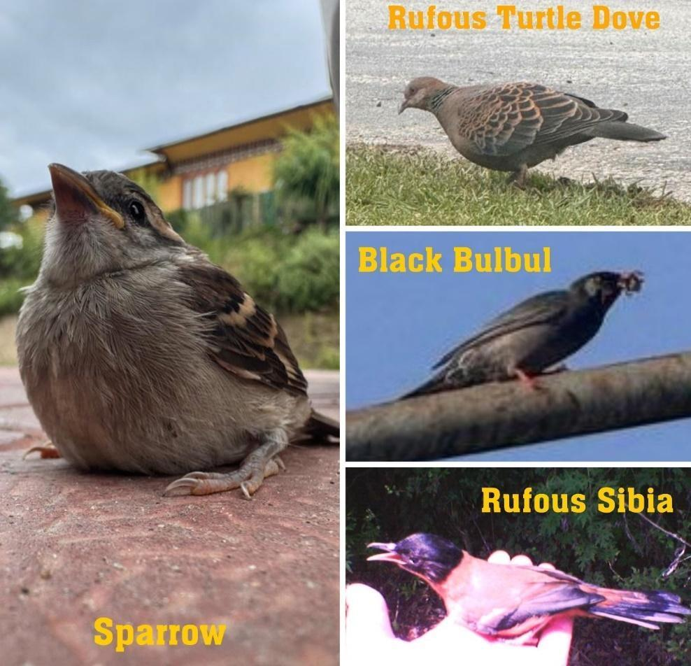

Legally Protected Areas and Internationally Recognised Areas of High Biodiversity Value
Bhutan is globally recognized for its exceptional biodiversity and its unique status as a carbon-negative country. The nation's commitment to conservation is reflected in its extensive protected area network, which comprises five National Parks, four Wildlife Sanctuaries, one Strict Nature Reserve, eight Biological Corridors, and one Botanical Park. This network covers approximately 51.44% of Bhutan's territory (equating to 19,750.57 sq. km), with a total forest coverage of around 71% (NFI 2023).
For the LRCP, an assessment of proximity to and potential interaction with Legally Protected Areas and Internationally Recognised Areas of High Biodiversity Value (KBAs) has been undertaken, including reference to tools such as the Integrated Biodiversity Assessment Tool (IBAT) and national data.
The Thimphu Wetlands, designated as a Key Biodiversity Area (KBA), represent an important protected area relevant to the LRCP (Refer figure 20):
- Significance: As identified in the baseline assessment and shown on the project map (Figure 18), an area in the central Thimphu valley is designated as the Thimphu Wetlands Key Biodiversity Area (KBA). These wetlands were identified in 2005 as supporting a significant population of the Wood Snipe (Gallinago nemoricola), a species classified as "Vulnerable" on the IUCN Red List.
- Location Relative to LRCP: The KBA is located to the west of the Wang Chhu River, adjacent to the central "Core Area" of the city. As illustrated on the map, the proposed Bus Priority Service (BPS) route runs parallel to the wetlands on the opposite side of the river and does not physically encroach upon the designated KBA boundaries.
- Context: Urban expansion and habitat alteration in Thimphu have historically posed challenges to conserving these wetland habitats and the Wood Snipe. Government efforts to create new bird habitats in areas like Tshalumaphey, Babesa, and Shaba in Paro are noted.
Figure 20: Strategic Urban Transport Development in the Context of Key Biodiversity Areas (KBA)
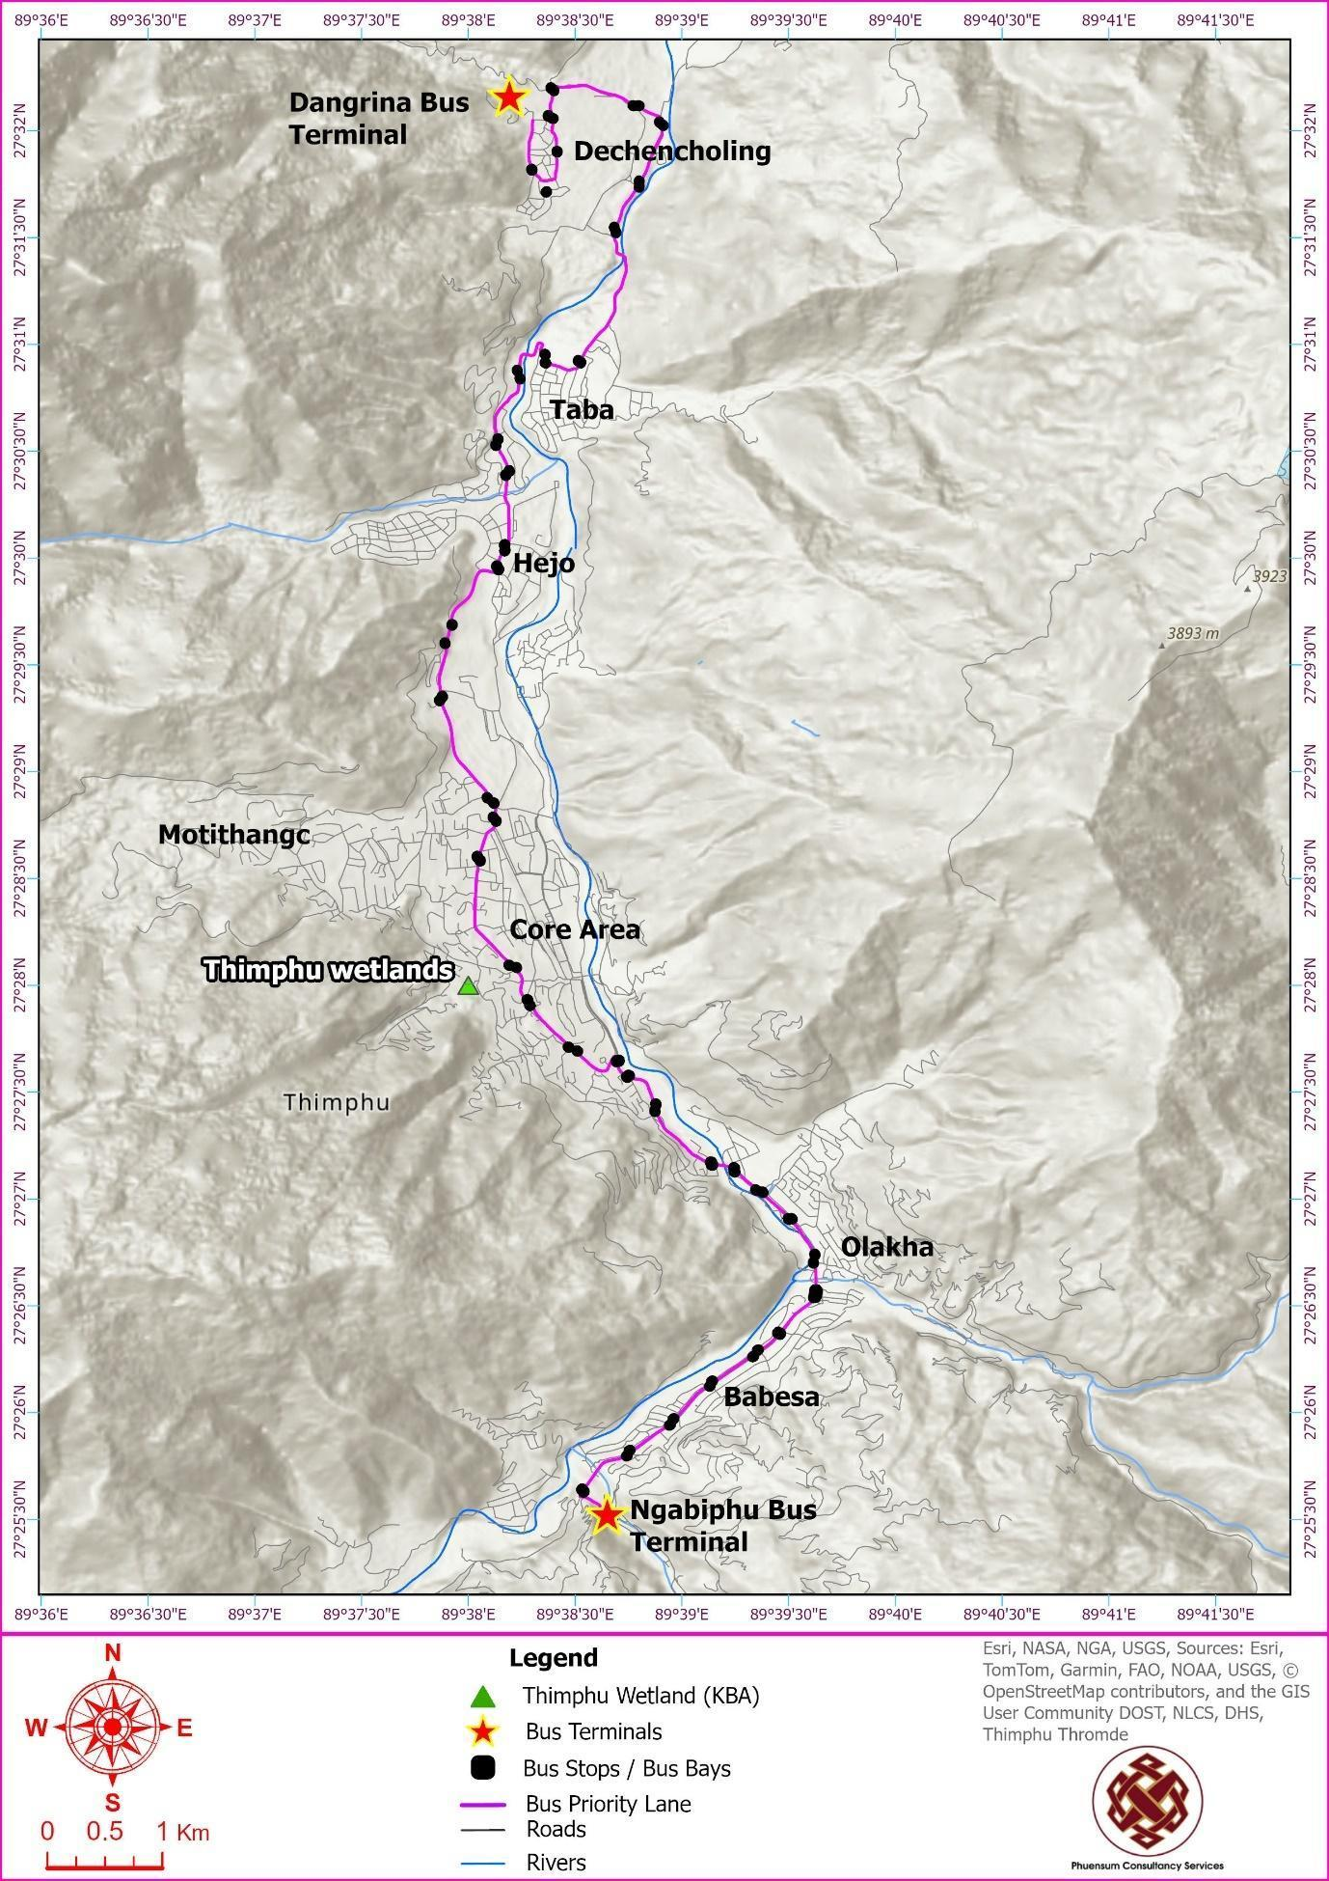

Social and Community Profile
This section provides a summary of the baseline social and community profile within the LRCP's area of influence. The information presented is drawn from both national-level secondary sources, such as the Bhutan Living Standards Survey (BLSS) 2022, and, more importantly, from the project-specific census and socio-economic surveys conducted for the Resettlement Action Plan (RAP) in May-June 2025 along the BPS corridor and Norzin Lam.
The comprehensive findings from these surveys, including the detailed analysis of affected persons, assets, and livelihood impacts, are presented in the project's Resettlement Action Plan (RAP). Following its final clearance by the Royal Government of Bhutan and the World Bank, the RAP is expected to be publicly disclosed in November 2025 on the websites of the Ministry of Infrastructure and Transport and the World Bank.

Demography and Household Characteristics
Thimphu is Bhutan's capital and its largest and most dynamic urban center. According to the Population and Housing Census of Bhutan (PHCB) 2017, which is the most recent official census, the population of Thimphu Thromde (the core urban area) was 114,551, while the greater Thimphu Dzongkhag had a population of 138,736.
To reflect the city's ongoing growth, more recent secondary data from the National Statistics Bureau's (NSB) "Population Projection of Bhutan 2017-2027" provides an updated estimate. These projections confirm a significant growth trend since the last census. The city's role as the nation's administrative and economic hub continues to drive this population growth, placing increasing pressure on urban infrastructure and services.
Thimphu, in addition to its resident population, accommodates a substantial daily influx of commuters, students, and temporary visitors—collectively referred to as the "floating population"—whose numbers, though not officially tracked, are estimated in the tens of thousands. As Bhutan’s primary destination for internal migration, with nearly 40% of lifetime migrants residing in the capital (PHCB 2017), this dynamic movement places considerable strain on urban infrastructure, especially the transport network. The Livable and Resilient Cities Project responds to these pressures by introducing a high-capacity Bus Priority Service (BPS) to offer faster, more reliable, and affordable transit alternatives, while enhancing connectivity to key administrative, commercial, and educational zones. This initiative highlights the urgent need for a robust public transport system that equitably serves both permanent residents and the transient urban population.
A project-specific socio-economic baseline survey earlier in 2023 engaged a significant number of stakeholders within the direct impact zones. For the Resettlement Action Plan (RAP) which focused on a census of affected persons in 2024 (under BGTP) and May-June 2025 covered 539 respondents in the Norzin Lam area and 130 along the BPS corridor. These were the total number of individuals who were available in their shops for interviews and do not include those who were absent or who refused to be interviewed.
A key demographic finding from these surveys, particularly in the dense commercial core of Norzin Lam, is the high proportion of female-headed households (FHH). Among the 374 respondents who identified as heads of household, 192 (51%) were female. This figure is significantly higher than the national average of 25.8% for female-headed households (PHCB 2017), indicating a specific social dynamic and potential vulnerability within the project's core impact area that requires targeted consideration in the social management plans.
According to the RAP survey, in the BPS component, in total there are 433 residents living in the 130 households. The average household size is 3.3 persons. Several categories of PAPs living and affected along the BPS by road section were interviewed. By far, the majority, 118 (91%), those who are operating businesses were interviewed along the CSI-Chorten Lower Road section.
Of the total respondents, 77 (59%) are female and 53 (41%) are males (figure 1). Data on household composition shows that families in the sample are nuclear rather than extended with mostly parents and their children living together. Respondents’ age ranged from 21 years to 76 years with the mean age being 40.61 years while the mean age of household heads was 50.83 years.
At Norzin Lam, In total, 2,394 persons are family members of the surveyed 539 respondents’ households with an average household size of 4.44 members, slightly higher than the national household size of four members. The data shows that the proportion of females exceeds that of males in most of the productive age categories, namely from 21 to 40 years after which between the sexes it is almost proportionate. Except for females between 11 to 15 years who are more than boys, there are more male children below 11 years.

Land and Property Ownership
A critical aspect of the socio-economic profile is land and housing tenure, as it directly relates to vulnerability from displacement and economic disruption.
According to the Population and Housing Census of Bhutan (PHCB) 2017, a large majority of households in urban areas of Bhutan (77.1%) live in rented accommodations. This high tenancy rate is a defining characteristic of Thimphu's urban fabric and has significant implications for the project, particularly concerning the influx of non-local construction workers.
While the project's primary strategy is to house the workforce in dedicated, contractor-managed camps to minimize pressure on the local housing market, this high tenancy rate underscores the vulnerability of local residents to rental price inflation. This is a potential risk if any project workers or subcontractors seek private accommodation. Therefore, the project's Environmental and Social Management Plan (ESMP) includes measures for the contractor to manage these risks, prioritizing local hiring where feasible to reduce the overall number of non-local workers requiring accommodation.
The findings of the project-specific Resettlement Action Plan (RAP) survey are consistent with this national trend. The survey identified that the vast majority of affected business operators along both the BPS corridor and Norzin Lam are tenants, not property owners. This makes them particularly vulnerable to economic displacement, as their livelihoods are tied to a physical location they do not own.
While the project's direct impact on private land is limited to 0.16 acres, the high rate of tenancy among affected parties underscores the importance of the RAP's provisions for livelihood restoration assistance for tenants and other non-titleholders.
According to the land and assets inventory carried out for the RAP, a total of 19 land plots in the BPS component will be impacted. This is comprised of 10 plots owned by private landowners and 9 plots owned by government institutions.
The institutional plots total an area of 39,430.12 square feet (0.9 acres). In addition, 0.16 acres of private land will be acquired by the project through a land adjustment process, where owners will be provided with equivalent parcels of adjacent government land.
In the BPS, 23 entities’ structures will be affected, composed of both private landowners and institutions who will lose structures.
The redevelopment at Norzin Lam will not affect any private land, as it will all take place on government land. However, the redevelopment will impact structures belonging to 15 private landowners and one institution. The private structures will be acquired, and affected persons compensated at replacement costs. The public amenities will be relocated to sites provided by Thimphu Thromde and reconstruction costs included as part of the construction estimates and budget.

Schools, Education, and Literacy Level
Thimphu City functions as the primary educational center for Bhutan. According to the Annual Education Statistics (AES) 2023, Thimphu Thromde hosts a total of 58 schools, serving approximately 35,337 students. This high concentration of educational activity underscores the critical importance of safe and reliable transport for a significant portion of the city's population.
Annual Education Statistics, 2024 has the following records i n Thimphu Thromde:
- Total ECCD enrolment was 1831, with 962 boys and 869 girls.
- Primary school children enrolment per the Annual Education Statistics, 2024 was 14,920 with 7277 male and 7643 female students.
- In secondary education (Cl. VII-XII), 10,116; 5295 female and 4821 male students.
- There is one private tertiary education institute, Royal Thimphu College at Ngabibhu, South Thimphu with 1491 students as of 2025.
The general education level in the city is relatively high, with the urban adult literacy rate recorded at 78.4% (BLSS 2022). However, this also indicates that a significant portion of the adult population (21.6%) remains non-literate. This is a crucial factor for the project's communication and awareness campaigns, which must utilize accessible formats beyond written text.
The large student population represents both a key vulnerable group to be protected during construction and a primary beneficiary of the safer, more efficient public transport system the LRCP aims to provide.
The project corridor itself passes in close proximity to several key educational institutions, including Changzamtog Middle Secondary School, Zilukha Middle Secondary School, Etho Metho Primary School, and Dechencholing High Secondary School. Critically, some of these schools, such as Changzamtog Middle Secondary School, Dechencholing Higher Secondary School and Sherubgatshel Primary School, designated Special Education Needs (SEN) schools where children with disabilities ranging from mild to severe come for schooling here. These institutions are considered highly sensitive receptors due to the daily presence of a large number of children, requiring careful management of construction safety, traffic, and noise.

Table 9: Schools along the BPS route
Sl. No. | Name/Type of School | No. of students |  | Teachers |  | Total strength  of the school
Sl. No. | Name/Type of School | Boys | Girls | Male | Female | Total strength  of the school
1 | Changzamtog Middle  Secondary School (SEN School/  Government School) | 768 | 808 | 36 | 55 | 1667
2 | Dechencholing Higher  Secondary School (SEN school/  Government School) | 736 | 765 | 56 | 53 | 1610
3 | Sherabgatshel Primary School  (SEN School/  Government School) | 293 | 278 | 12 | 22 | 605
4 | Etho Metho Primary School  (Private School) | 134 | 123 | 05 | 12 | 274
5 | Zilukha Middle Secondary School  (Government School) | 609 | 639 | - | - | 1248 students

All five schools are along the BPS route. Changzamtog Middle Secondary School and Dechencholing Higher Secondary School in particular, are along the road widening sections of the route but have alternative access. Etho Metho Primary School’s main entrance and exit are right on the BPS route and in close proximity to a proposed bus bay. Sherabgatshel Primary School is beside a narrow road stretch in close proximity to the proposed Dangrina (Northern) Terminal.

Health Facilities and Situation
Thimphu City, as the national capital, is served by the country's most comprehensive healthcare infrastructure, anchored by the Jigme Dorji Wangchuck National Referral Hospital (JDWNRH), the nation's apex medical institution. This central hospital is supplemented by a network of satellite clinics and private clinics across the urban area.
However, Thimphu's urban population faces a growing "double burden" of disease. While communicable diseases remain a concern, there is a significant and rising prevalence of Non-Communicable Diseases (NCDs). According to the Ministry of Health's Annual Health Bulletin (AHB) 2023, NCDs are a leading cause of morbidity and mortality nationwide. Key statistics highlight the urban health challenge:
- Hypertension and Diabetes: These are among the most prevalent NCDs. According to the AHB 2023, 12,654 new cases of hypertension and 2,902 new cases of Diabetes Mellitus were diagnosed nationwide in 2022, with urban areas like Thimphu showing higher rates due to lifestyle factors.
- Respiratory Ailments: Acute Respiratory Infections (ARI) consistently rank as the leading cause of morbidity in the country, with 204,499 cases reported in 2022. This is particularly relevant to the project, as these conditions are exacerbated by environmental factors like air pollution, which project-specific baseline data has shown to be a concern in Thimphu, particularly for NO₂ and PM₂.₅.
Furthermore, project consultations have highlighted specific occupational health issues among vulnerable groups that are not captured in national statistics. For example, female parking fee collectors reported a high incidence of Urinary Tract Infections (UTIs), a direct consequence of inadequate access to public toilet facilities during long work hours. This indicates that while major health infrastructure is in place, gaps in basic public and occupational health amenities persist and have tangible health impacts. The project's focus on improving public amenities and promoting active mobility aligns with the Ministry of Health's increasing emphasis on health promotion and wellness to address these emerging urban health challenges.
    - Water and Sanitation
Thimphu’s water and sanitation situation is comparatively better than other dzongkhags around the country. The Water Act, 2011 and the Water Regulations 2014 mandates that any institution must identify an alternative source of water to stay prepared for disasters. While Thimphu Thromde has been trying hard to ensure 24/7 water supply to its residents, it is still a challenge given the growing infrastructure and population in the Capital City. There are 5 Water Treatment Plants to ensure safe drinking water and the water source at Dodeyna, potentially the biggest source for the North Thimphu areas. For South Thimphu, Thromde has looked for alternative sources at Chamgang. Although the mountain spring waters are considered relatively clean, few water tests have been reported containing bacteria E-Coli, especially in the Wangchhu river water. Our houses are still not connected with safe drinking water in the taps although Thromde and MoIT are trying their best to disinfect water at source.
As for sanitation, organizations like UNICEF and others in the Capital City have worked on ensuring public safety through proper sanitation measures in place, but we still see sewage issues in the core city during rainy days. The common sight of manholes oozing out dirty water of human waste and clogged drains are becoming a more common and frequent sight these days.
    - Crime and Policing
Crime rates in Bhutan are generally low but in urban areas like Thimphu, petty thefts like burglaries are increasing by the year. Royal Bhutan Police(RBP) recorded battery cases including domestic violence continue to be a major issue in Thimphu. Drug related offenses also have taken the headlines of national newspapers lately. Substance abuse and trafficking are recorded as major areas of concern in crime related cases. In 2024, RBP reported over 5700 individuals arrested with substance related offenses. In the non-criminal cases, house fires are seen commonly with sporadic cases of induced forest fires. Dzongkhag wise crime rates shows Thimphu having the highest recorded cases in 2024 with 692 cases (The Bhutanese Issue, 11th January 2025). From the International figures, the said number is insignificant. Throughout the country reports of child molestation saw 39 cases in 2024. Other forms of crime reported in 2024 were voluntary manslaughter (12 cases) and theft (23 cases), rape of a child above 12 years (53 cases) in 2024.
In the International Crime Index, Bhutan stands a good record of low crime rate with stable governments and political scenario. RBP conducts active awareness raising campaigns with the public to curb crime and in 2024, it was reported that they sensitized 21, 596 individuals in their drive to reduce criminal records.

Livelihoods, Income, and Employment
Thimphu's economy is predominantly non-agricultural, with a mean annual urban household income of Nu. 838,620 (BLSS 2022). While the official urban poverty rate is low at 2.2%, many households operate on modest incomes. The project is expected to have significant impacts on local livelihoods, particularly for business establishments operating along the BPS corridor and Norzin Lam.
The Multi Poverty Index, 2022 has found that the urban poor constitutes 17.7% of the population but in Thimphu, it is reported that there is the lowest level of moderate poverty at 6.8%. Higher levels of poverty are found in Dzongkhags like Samtse, Dagana, and Zhemgang, just to mention a few. The finding can be attributed to the fact that there are plenty of income opportunities in Thimphu and also the high cost of living in the City may be urging everyone to earn unlike in other dzongkhags.

Profile of Affected Businesses
The 2025 Resettlement Action Plan (RAP) survey collected detailed data on the businesses that will be directly affected by the project's civil works.
- Total Affected Businesses: A total of 130 business establishments were identified along the BPS corridor, and an additional 539 businesses will be affected by the improvements on Norzin Lam.
- Ownership and Gender: A key finding of the survey along the BPS corridor is the high prevalence of women-led businesses. Of the 118 affected businesses, a significant majority are owned or operated by women (70 female vs. 48 male), underscoring the project's disproportionate potential impact on women's economic activities and livelihoods. Many of these are small, family-run enterprises.
- Type of Businesses: The affected businesses represent a diverse cross-section of Thimphu's urban economy. Along the BPS corridor, particularly in the CSI-Memorial Chorten section where the highest concentration of impacts is expected, the businesses include:
  - Retail Shops: Small grocery stores, clothing shops, and electronics retailers.
  - Service Industries: Restaurants, hotels, vehicle workshops, and fabrication units.
  - Informal Vending: Roadside vendors, such as the members of BAOWE, operating micro-food stalls.
- Geographic Concentration of Impacts: The highest concentration of affected businesses along the BPS corridor was identified in the CSI-Memorial Chorten and Memorial Chorten-Pamtsho Bridge zones, which are dense commercial and mixed-use areas.
This detailed profile highlights the need for carefully sequenced construction and targeted livelihood restoration support, as outlined in the RAP, to mitigate the economic disruption to these vital local enterprises.

Employment Profile
According to the Labour Force Survey (LFS) 2023, the majority of employed persons in Bhutan are regular paid employees (53.6%), with a significant portion being self-employed (22.8%). The national data reveals a notable gender disparity in employment, with the unemployment rate for females (6.7%) being significantly higher than for males (5.2%).
This national gender dimension is strongly reflected in the project's direct impact zones. Project-specific surveys conducted in 2025 found that:
- Female respondents constituted a majority of those interviewed in both the Norzin Lam area (290 of 540) and along the BPS corridor (76 of 130).
- More critically, women represent a majority of the affected business owners along the BPS corridor.
This high representation of women as entrepreneurs and workers in the project area highlights their crucial role in the local economy and underscores their particular vulnerability to project-induced economic disruptions. This finding reinforces the importance of the gender-sensitive mitigation and engagement strategies outlined in the project's Gender Action Plan (GAP) and Resettlement Action Plan (RAP).
According to the RAP Census, a household census of impacted persons along the BPS route revealed that less than half (46%) of the household members claimed to be employed with a third (33.5%) stating that they are self-employed. Also, 7.5% are regular employees and 2% are casual workers and only 1 person is unemployed. Members are distributed among business sectors such as retail trade (9%), hotels and restaurants (8%). The majority of respondents (91%) were business operators which also included building owners who were operating businesses from their own buildings. The next group are 11 respondents who are owners whose private assets are affected but who do not operate any businesses.
At Norzin Lam, from the total population of 2,394 persons, of the total population, 27 (3.1%) are reported to be unemployed, with the number of females unemployed almost double that of unemployed males. Minors, students and elderly together consisted of 248 (10%) of persons who also are not employed owing to characteristics other than being of employable age. Fifteen percent are regularly employed while 30.3% are self-employed because they operate their own businesses. Also, 2% were employers.

Disadvantaged and Vulnerable Groups
For the purpose of this project, vulnerability is not defined by broad national categories but by specific socio-economic conditions that could cause certain groups to be disproportionately affected by project impacts or less able to access project benefits. The following key vulnerable groups were identified through the project's Resettlement Action Plan (RAP) surveys and direct stakeholder consultations.

Residents and Businesses in Temporary Structures
- Description: This group includes households and micro-businesses operating from temporary or semi-permanent structures (locally known as bagos) located along the BPS corridor. These include long-term residents, such as a Thromde waste worker living in a self-built hut for 17 years, and several woman-led micro-businesses.
- Vulnerability: They are highly vulnerable to both physical and economic displacement. Lacking formal tenure, they face significant uncertainty regarding relocation options and have limited assets to absorb the shock of losing their home or business location. One household in this category will be physically displaced by the project.
- Key Characteristics
Shopkeeper 1: One of the owners of the shop in the temporary shed: opposite to Changzamtog Middle Secondary School is a widow with a senior citizen mother as dependent. Her son, working in tourism also lives with her. She had been operating her grocery cum restaurant and bar shop for about 18 years in the same place. Her monthly rental expenditure Nu. 9,000/month for the shop and Nu. 16,000 for residence. Her business was found to be doing quite well with a steady flow of customers. As she was aware of the impending effects of BPL development; she proactively booked a new space to shift her shop and was said to have already paid Nu. 15,000 in advance to book it.
Shopkeeper 2: Originally from Mongar is married and her husband and two children live with her. Her husband, a taxi driver before, has no other source of income currently. He was driving a taxi on hire before but had to surrender as the income was not good enough to pay the monthly hiring charges. The monthly rent for the shop was Nu. 7,000 and the house rent, Nu. 5,500. Unlike Shopkeeper 1, the latter had been running this business only for the last 6 months and being new in the business, she expressed no idea of what to do next in case she gets relocated from her current place.
- This group also includes a potential vulnerable group who is a family/long-term resident, such as a Thromde waste worker’s family living in a self-built hut for 17 years, and families dependent on a single, often unstable, income source (e.g., a truck driver with reduced work has now become, a non-working spouse). In one case, a household member is a non-citizen living on a Special Resident Permit, adding a layer of administrative vulnerability.

Livelihoods Dependent on Street-Level Activities
This is the most significant vulnerable group, whose income is directly tied to the daily use of the roadside corridors.
- Parking Fee Collectors:
  - Description: Individuals, predominantly women, whose income is entirely commission-based and dependent on the daily availability of on-street parking spaces.
  - Vulnerability: They face a direct and certain loss of livelihood as the project will reconfigure and reduce on-street parking. They have limited transferable skills and face significant challenges in finding alternative employment. They also face occupational health risks, such as a high incidence of UTIs due to a lack of access to public toilets.
- Roadside Vendors (e.g., BAOWE Members):
  - Description: Women operating micro-food stalls and other small businesses in informal, shared sheds directly adjacent to the road, particularly near the JDWNRH hospital.
  - Vulnerability: Their businesses are highly exposed to economic disruption from construction noise, dust, and access restrictions. Most operate on subsistence-level income and are highly susceptible to financial stress from any loss of customers.

Senior Citizens
- Description: Elderly individuals who frequent public spaces like the Memorial Chorten and rely on public transport for mobility. The population aged 65 and over is projected to increase significantly in Thimphu.
- Vulnerability: They may face mobility and accessibility challenges. Their primary concerns raised during consultations were the affordability of public transport and the lack of accessible public amenities, such as safe pedestrian crossings and clean drinking water facilities.

Persons with Disabilities (PWDs)
- Description: Individuals with physical, sensory, or intellectual impairments.
- Vulnerability: PWDs face significant barriers to accessing public transport and navigating the urban environment due to a lack of universal design in current infrastructure. This severely limits their ability to participate in economic and social life.

Women-Headed Households with Low Income
Description: While not all women-headed households are vulnerable, the project surveys identified a high proportion (51%) in the Norzin Lam area. Those with low or unstable incomes are considered a vulnerable sub-group.
Vulnerability: These households may have limited economic resilience to withstand temporary disruptions to their livelihoods or changes in access to services caused by the project.
According to the RAP Census finding on vulnerable people, there are in total - 16 HH who face food insufficiency, 6 who are elderly persons with disabilities, 8 persons with disabilities requiring assistance for daily functioning, 16 resource-poor women heading households and 4 HH who are earning less than Nu. 6,204/household member/month (living below the poverty line).
From the total persons identified as vulnerable above, at the BPS Component, there are no persons with disabilities. At Norzin Lam, eight respondents had members with disabilities, most of whom require a full-time attendant. The data suggests that these individuals are the most vulnerable among various levels of disability, as hiring an attendant replaces the productive work that the attendant could have performed. Norzin Lam also has 11 parking ticket collectors who are at risk of losing their jobs due to restriction of parking spaces during the construction period.
Within the BPS component, 1 household led by a woman also falls below the poverty line. Similarly, at Norzin Lam, there are 15 women-headed households who have incomes below the poverty line.
To address these specific vulnerabilities, the Resettlement Action Plan (RAP) includes a set of targeted measures designed to provide additional support to these groups. This includes specific financial allowances, tailored livelihood restoration assistance, and priority access to project-related support to ensure that these households and individuals are not disproportionately affected and are able to restore their pre-project standard of living.
5.6.10 Gender issues under the Project’s Context
In Bhutan, women play a crucial role in water, sanitation, and hygiene (WASH) practices, often shouldering the primary responsibility for securing water and managing household sanitation needs. This role, shaped by traditional gender norms, makes them particularly vulnerable to WASH-related challenges, especially in rural and remote communities where access to clean water and adequate facilities remains limited.
This pattern reflects a broader gender dynamic in Bhutan, where women continue to shoulder the majority of unpaid household and caregiving responsibilities. According to the National Commission for Women and Children’s (NCWC) 2019 report, Accounting for Unpaid Care Work in Bhutan, women perform around 71% of all unpaid care work—approximately 2.5 times more than men. This unequal division of labour contributes to “time poverty,” severely limiting women’s opportunities to engage in education, paid employment, and community or civic life. Consequently, women’s economic empowerment and decision-making power remain constrained, reinforcing structural gender inequalities. While gender equality is gaining recognition in national policy and public discourse, deeply entrenched cultural norms continue to influence the distribution of time and responsibilities within households.
These gendered patterns extend into the transport sector as well. Women’s participation in transport-related employment in Bhutan remains low, though there are encouraging examples of women working as bus drivers and in administrative roles. Despite the transport sector not being a primary focus of Bhutan’s gender equality strategies, efforts are underway to promote more gender-inclusive policies and infrastructure. An ADB publication—Bhutan Gender Equality Diagnostic of Selected Sectors—highlighted that women are significantly underrepresented in technical and engineering roles within the transport sector. This finding underscores the persistent gender gaps in employment and career advancement in traditionally male-dominated fields.
Over the years, the Royal Government of Bhutan (RGoB) has made commendable progress through legislation, policies, and programs aimed at promoting gender equality and women's empowerment. However, despite these efforts and Bhutan’s strong constitutional commitment to equality, persistent gender disparities—deeply rooted in traditional norms and societal values—continue to challenge inclusive and sustainable development in the country (NCWC 2020; World Bank 2019).
5.6.11 GBV/SEA/SH Risk Assessment in Project Areas
According to the World Bank’s Environmental and Social Framework, the project has been assessed as having a “moderate” risk for Gender-Based Violence (GBV) and Sexual Exploitation and Abuse/Sexual Harassment (SEA/SH). This rating reflects broader national trends, where 33% of women in Bhutan aged 15-64 have experienced some form of physical, sexual, or emotional violence in their lifetime (NCWC, 2022). Despite the prevalence, only 4% of survivors seek help from formal institutions, primarily due to stigma, fear of retaliation, and limited trust in law enforcement and justice mechanisms.
These concerns are further compounded in sectors such as transport and construction which are key components of the project - where gender-based risks are already elevated. A 2023 NCWC study reported that 28% of women working in these sectors experienced workplace harassment. However, many incidents remain unreported due to structural power imbalances, fear of job loss, and the absence of effective grievance redressal systems.
In the context of LRCP, civil works particularly during the construction phase may heighten the risk of GBV, SEA, and SH, especially as a result of increased interaction between migrant workers and local communities, including women, adolescent girls, and persons with disabilities. Proactive mitigation measures, such as awareness programs, codes of conduct, and accessible complaint mechanisms, are therefore essential to address and manage these risks effectively.
5.6.11.1 Identified Risks and Vulnerabilities
- Labor Influx and Community Interaction: The project’s reliance on skilled and potentially expatriate labour will require the establishment of temporary labour camps near residential areas, schools, and community centers frequently used by women and children. This proximity may elevate the risk of sexual harassment and sexual abuse.
- Health and Societal Implications: The influx and settlement of mobile labourers may lead to a heightened risk of Sexually Transmitted Infections (STIs), including HIV/AIDS, and other communicable diseases. Social tensions may arise between local residents and migrant workers due to cultural differences, perceived inequalities, or inappropriate conduct. Additionally, an increase in sex work in Thimphu, linked to economic hardships, presents a further risk factor for disease transmission involving the project workforce and the community.
- Sustained Impact: These risks are likely to persist beyond the construction period, emphasizing the need for ongoing community engagement, monitoring, and established response mechanisms throughout the project lifecycle and into post-construction operations.
These risks collectively highlight the urgent need for a trusted, confidential, and survivor-centric reporting mechanism within the project—one that acknowledges and addresses the complex social barriers to help-seeking behaviour.
Project Measures to Mitigate Public Health Risks
To proactively address the heightened health risks associated with labour influx, the project will implement a multi-pronged public health strategy in coordination with local health authorities and community organizations. This will be a core component of the project's Community Health and Safety Plan, with specific actions including:
- Community Sensitization and Awareness: Targeted campaigns will be conducted to educate vulnerable populations and the wider community on the risks associated with unprotected sexual behaviour and the prevention of STIs/HIV. These campaigns will be culturally sensitive and delivered through trusted community channels.
- Capacity Building for Frontline Health Workers: The project will support the training and equipping of public health workers, community health volunteers, and peer educators. These individuals will be empowered to lead sensitization sessions, conduct outreach to at-risk populations, and serve as trusted sources of information on STI/HIV prevention and care.
- Access to Preventive Resources: In collaboration with the Ministry of Health, the project will work to ensure that preventive tools, such as condoms, are consistently available at local Basic Health Units (BHUs) and at the project's own worker clinics and offices.

Cultural Heritage
Thimphu City and its surrounding valley, the primary operational area for the LRCP, are rich in both tangible and intangible cultural heritage. This includes dzongs, lhakhangs (temples), chortens (stupas), traditional houses, and sacred natural sites. The project's activities will be implemented in proximity to several of these cultural resources, as shown in the map provided in [Figure 21].
5.7.1 Tangible Cultural Heritage
The project corridor contains numerous physical cultural resources, ranging from major national landmarks to smaller, locally significant sites.
Major Heritage Sites
Based on site assessments, the following major cultural heritage sites are located near or along the project's BPS corridor and the Norzin Lam improvement area:
- Dangrim Chorten: Located in the southern part of the city, this chorten is situated along an early section of the BPS route.
- National Memorial Chorten: A prominent national landmark in the city center, the Memorial Chorten is a major site for daily worship. The BPS route passes directly alongside it, and it is also in close proximity to the urban placemaking improvements planned for Norzin Lam, making it a highly sensitive receptor.
- Hejo Chorten: Located in the Hejo area along the BPS route.
- Dechencholing Palace: A significant historical structure built in 1953 that has served as a royal residence. It is located near the northern extent of the BPS route.
- Dolma Lhakhang / Pangrizampa: Known as the Druk Phodrang Ding, this historically significant temple complex was built in 1529 and currently serves as the National Centre for Traditional Astrology. It is located near the northern end of the BPS route.
Other Potential Physical Cultural Resources
In addition to the major landmarks, the project corridors contain many smaller, yet culturally significant, physical cultural resources. These include:
- Mani Dangrims, Chortens, and Prayer Wheels: Numerous smaller chortens and clusters of prayer wheels are situated along the roadside, within private properties, or at community gathering points. These are active sites of local worship.
- Traditional Architecture: While not formally protected, many older buildings along the project corridors exhibit traditional Bhutanese architectural elements that contribute to the unique aesthetic character of Thimphu's living heritage.
- Sacred Natural Features: It is common in Bhutanese tradition for specific old trees (Lhashing), large rocks (Luus), or other natural features to be considered sacred. Road widening or excavation could potentially encounter such features.
- Places of Local Historical Significance: The corridors may include unmarked sites of local historical importance, such as old walls, traditional water spouts, or remnants of historical pathways.
5.7.2 Intangible Cultural Heritage
The project corridor is also a venue for significant intangible cultural heritage, which is deeply embedded in the daily life and spiritual practices of the community. Key examples include:
- Daily Religious Practices: The daily circumambulation (kora) by residents around major religious sites like the National Memorial Chorten is a fundamental spiritual practice that requires a peaceful and respectful environment.
- Religious Festivals and Processions: Norzin Lam serves as a vital venue for annual festivals (Tshechus), most notably the Thimphu Tshechu. During this event, the street is closed to traffic for approximately three days and transformed into a vibrant public space with stalls and communal gatherings.
- Social and Community Gatherings: Public and informal spaces along the project corridor are used for social interaction that contributes to the city's cultural vibrancy and community cohesion.
5.7.3 Potential Impacts and Mitigation
Construction activities pose several potential indirect and temporary impacts on both tangible and intangible cultural heritage. These risks include:
- Disruption of Access and Ambiance: Construction noise, dust, traffic diversions, and access restrictions could disrupt the peace and sanctity of religious sites, interfere with daily rituals like kora, and affect the experience of visitors and worshippers.
- Interference with Cultural Events: If not carefully scheduled, construction could disrupt traditional festival practices, alter procession routes, and diminish the festive atmosphere of events like the Thimphu Tshechu.
- Risks to Structural Integrity: Ground vibrations from heavy machinery could pose a risk to the structural integrity of older buildings and heritage sites.
The Environmental and Social Management Plan (ESMP) includes specific mitigation measures to address these risks. These include a Chance Finds Procedure for undiscovered resources and robust plans for managing access, noise, dust, and vibration. This will involve careful scheduling of disruptive works in close consultation with religious authorities and the community to minimize impacts on these vital cultural heritage practices.
Figure 21: Religious and Cultural Sites along the BPS route from Ngabirong (South) to Dangrina (North)
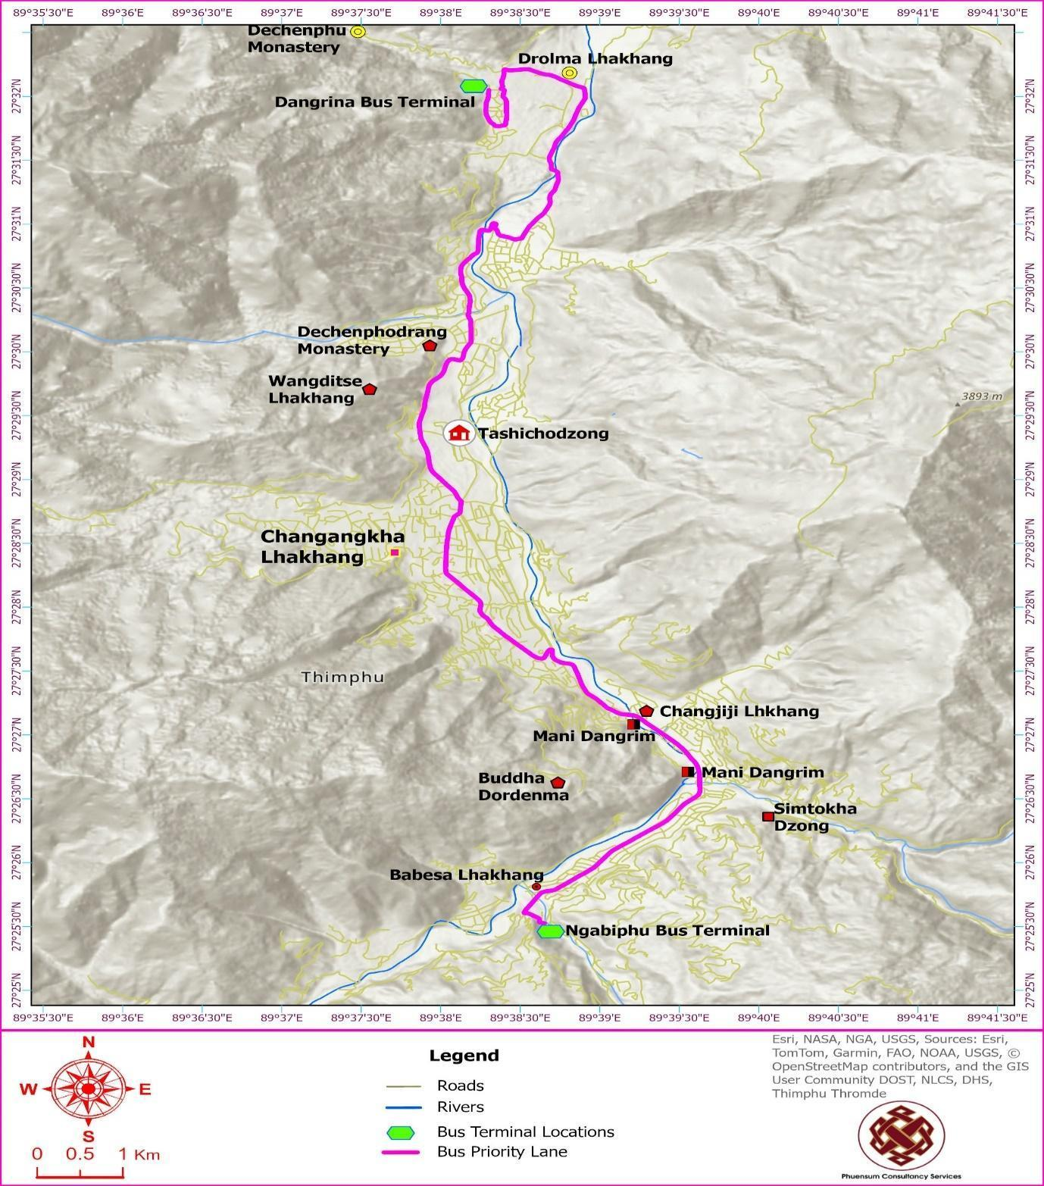

Indigenous Peoples and Diversity (ESS7)
World Bank Environmental and Social Standard 7 (ESS7) acknowledges that Indigenous Peoples and Sub-Saharan African Historically Underserved Traditional Local Communities possess unique identities, cultures, and aspirations that differ from mainstream national populations. These groups are often marginalized in development processes, and ESS7 aims to ensure that their human rights, dignity, and natural resource-based livelihoods are fully respected. The standard emphasizes the importance of avoiding adverse project impacts on these communities, or where avoidance is not feasible, minimizing, mitigating, or compensating for such effects.
ESS7 also promotes inclusive and culturally appropriate development benefits, encouraging meaningful participation and sustainable outcomes for affected communities. It requires ongoing engagement through meaningful consultation throughout the project lifecycle and mandates Free, Prior, and Informed Consent (FPIC) in specific circumstances. Additionally, the standard seeks to preserve and respect the cultural heritage, traditional knowledge, and practices of Indigenous Peoples and underserved communities, thereby enhancing project design and fostering local support.

Definition of Indigenous Peoples/Sub-Saharan African Historically Underserved Traditional Local Communities under ESS7:
There is no single, universally accepted definition of "Indigenous Peoples." For the purposes of ESS7, the term refers to distinct social and cultural groups that possess the following characteristics in varying degrees:
- Self-identification as members of a distinct indigenous social and cultural group and recognition of this identity by others;
- Collective attachment to geographically distinct habitats, ancestral territories, or areas of seasonal use or occupation, as well as to the natural resources in these areas;
- Customary cultural, economic, social, or political institutions that are distinct or separate from those of the dominant society or culture; and
- A distinct language or dialect, often different from the official language or languages of the country or region in which they reside.
The term "Sub-Saharan African Historically Underserved Traditional Local Communities" refers to social groups with identities that are distinct from mainstream society and that make them vulnerable to being disadvantaged in the development process.

Assessment of Indigenous Peoples Status in Bhutan and for the LRCP Area:
The RGoB does not officially categorize any specific group within its population as "Indigenous Peoples" in the manner often understood in international contexts where distinct minority groups have historically faced marginalization by a dominant colonizing or majority population. Bhutan has a unique history and a relatively homogenous national identity rooted in Drukpa Kagyu Buddhism and a shared cultural heritage, although regional variations exist.
The population of Thimphu, as the capital city, is particularly diverse and cosmopolitan. It is a melting pot where individuals and families from all Dzongkhags (districts) and various ethnic and linguistic backgrounds across Bhutan migrate for education, employment, and economic opportunities. This migration contributes to a rich tapestry of cultural, religious, and social expressions within the city.
Applying the four characteristics outlined in ESS7 to the context of Thimphu and the LRCP project area:
- Self-identification and Recognition by Others: While Bhutan has various linguistic and cultural subgroups (e.g., Ngalop, Sharchop, Lhotshampa, and smaller indigenous communities in specific remote regions of the country), within the cosmopolitan urban context of Thimphu, these groups are generally integrated into the broader national society and identify as Bhutanese citizens. There are no groups within Thimphu that distinctly self-identify as "Indigenous Peoples" separate from the national identify. Furthermore, there are no groups within the project area that are recognized by others as having a distinct identity separate from the dominant society. Therefore, this criterion is not met in the project context.
- Collective Attachment to Geographically Distinct Habitats/Territories in the Project Area: The LRCP project area is primarily urban Thimphu and specific infrastructure sites like the Dodeyna water intake. There are no known communities within the direct LRCP footprint that maintain a collective attachment to specific habitats or ancestral territories within the urban project area in a manner distinct from other urban residents or that would make them uniquely vulnerable as an "indigenous" group in the context of the project's impacts. The Dodeyna intake is within Jigme Dorji National Park, an area with significant natural and cultural value for all Bhutanese, rather than being an exclusive ancestral territory of a specific, marginalized indigenous group impacted by the project.
- Customary Cultural, Economic, Social, or Political Institutions Separate from Dominant Society: While diverse cultural practices exist, the overarching governance, legal, and social institutions are national and apply to all citizens. There are no groups within the LRCP project area operating under entirely separate customary institutions that would be differentially impacted by the project due to their indigenous status.
- Distinct Language or Dialect: Bhutan has multiple languages and dialects. Dzongkha is the national language, and English is widely used. The communities in the project area do not have a distinct language from the national language or other widely spoken language in Bhutan. The presence of different languages does not in itself define a group as "Indigenous Peoples" under ESS7, especially within the integrated urban environment of Thimphu, unless it is linked to the other characteristics and results in specific vulnerabilities related to the project.

Conclusion on Applicability of ESS7 for LRCP:
Based on the assessment against the ESS7 criteria and understanding of Bhutan's socio-cultural context, particularly within the urban and peri-urban project area of Thimphu (including the Dodeyna intake area within a National Park context rather than a specific indigenous territory claim affected by the project):
- There are no distinct social and cultural groups within the LRCP's direct area of influence that meet all the characteristics of Indigenous Peoples/Sub-Saharan African Historically Underserved Traditional Local Communities as defined under ESS7, who would be made specifically vulnerable as such a group by the project activities.
- The project's impacts are expected to affect the diverse urban population more broadly, based on factors like proximity to construction, land use, economic activities, and general vulnerability criteria (e.g., low income, disability, female-headed households), rather than distinct indigenous identity.
Therefore, as concluded in previous assessments and re-affirmed to cover the expanded scope of the project, ESS7 is not considered relevant for the LRCP.
Engagement with all affected communities, including any minority groups or vulnerable individuals within the diverse population of Thimphu, have been conducted through the project's Stakeholder Engagement Plan (SEP) in line with ESS10, ensuring inclusive participation and attention to the needs of all affected people.

Potential Environmental and Social Impacts and Risks and their Mitigations
Effectively managing the environmental and social dimensions of the LRCP is essential. This chapter provides a comprehensive analysis of the potential impacts and risks across all urban transport and public space improvement activities (sub-components 1.2 and 1.3).
It also outlines the mitigation strategies designed to address these challenges, ensuring responsible implementation. These measures are structured in alignment with the relevant World Bank Environmental and Social Standards (ESS) to maintain compliance and sustainability.

Impact Assessment Methodology
Potential environmental and social impacts and risks for the LRCP were identified based on a review of design engineering reports, field visits, baseline data collection, stakeholder consultations, and experience from similar urban infrastructure projects. The significance of these impacts and risks is assessed based on the following two factors:
- Magnitude of Impact: Evaluates the intensity, extent, and duration of a potential impact, considering factors like its reversibility and frequency.
- Sensitivity of Receptor: Considers the receptor's ability to absorb change without significant harm, factoring in its rarity, resilience, legal protection, cultural significance, and ecological importance.

Impact Magnitude:
The potential impacts of the project have been categorized as major, moderate, minor or negligible based on the criteria:
- Extent: Localized vs. widespread impacts.
- Duration: Short-term vs. long-term or permanent impacts.
- Reversibility: Whether the impact is reversible or irreversible.
- Intensity: The severity of the impact on the affected environment or community.
- Frequency: How often the impact is likely to occur.
Using the defined criteria, the identified impacts are evaluated into different categories outlined in Table 10. This evaluation often requires a combination of quantitative data, qualitative analysis, and expert judgment.
Table 10: Classification of Impact Magnitude
Category | Description
Major Impact | Substantial impact with long-term or irreversible consequences, demanding significant mitigation or potentially leading to project redesign
Moderate Impact | Noticeable impact that requires mitigation to prevent significant harm.
Minor Impact | Small impact that is easily mitigated or reversed.
Negligible Impact | No or minimal impact

Sensitivity of Receptor
Sensitivity is specific to each aspect and the environmental resource or population affected, with criteria developed from baseline information. Using the baseline information, the sensitivity of the receptor is determined by factoring in proximity, number exposed, vulnerability and the presence of receptors on site or in the surrounding area. Generic criteria for determining the sensitivity of receptors are outlined in Table 11 below. Each detailed assessment will define sensitivity in relation to its environmental or social aspect.
Table 11: Criteria for Determining Sensitivity
Sensitivity Determination | Definition
Very High Sensitivity | Receptors that are irreplaceable or have no known mitigation measures that can satisfactorily offset impacts.  Unique cultural heritage or archaeological sites of international significance.  Endangered species or ecosystems in decline, for which any additional pressure could lead to extinction or collapse.
High Sensitivity | Areas or communities that are highly vulnerable due to socio-economic, cultural, or health-related factors.  Critical habitats or ecosystems that provide essential services (e.g., water filtration, flood protection) or are of high biodiversity value, where impacts could lead to irreversible loss.
Medium Sensitivity | Receptors that are less common or have moderate importance to the ecological or social environment.  Areas or communities with moderate resilience to change and some vulnerability to project activities.  Ecosystems that provide important but not critical services, where impacts might require specific mitigation measures to manage effectively.
Low Sensitivity | Receptors that are widely available or common and have a high ability to recover from disturbances.  Areas or communities with high resilience to change and low vulnerability to project activities.  Ecosystems that are not unique or critical for biodiversity conservation, where impacts can be easily mitigated.

Assigning Significance
To assess the significance of each potential environmental and social impact, a systematic approach is employed, considering two key factors:
- Magnitude of the impact – how extensive, widespread, and enduring the effects may be.
- Sensitivity of the receptor – the vulnerability of the affected environment or community.
By combining these elements, the overall impact significance is determined, enabling a prioritized approach to mitigation that directs efforts toward the most critical issues. The Impact Significance Matrix in Table 12 illustrates how these factors interact to classify and evaluate the significance of an impact.

Table 12: Criteria for Determining Significance of Impacts
Receptor Sensitivity | Impact Magnitude
Receptor Sensitivity | Negligible Impact | Minor Impact | Moderate Impact | Major Impact
Low Sensitivity | Negligible Significance | Low Significance | Moderate Significance | Moderate Significance
Medium Sensitivity | Low Significance | Moderate Significance | Moderate Significance | Substantial Significance
High Sensitivity | Low Significance | Moderate Significance | Substantial Significance | High significance
Very High Sensitivity | Moderate Significance | Substantial Significance | High significance | High significance

Sensitive Receptors
The LRCP encompasses activities within Thimphu's urban core and along its key transport corridors. The identification of sensitive receptors is crucial for understanding potential impacts and designing appropriate mitigation measures for the Urban Transport component.

Sensitive Receptors Relevant to the Urban Transport Component (BPS Route and Norzin Lam NMT):
The Bus Priority Service (BPS) route and the Norzin Lam Non-Motorised Transport (NMT) improvement areas are strategically planned through key urban and commercial zones, serving a significant portion of the city's population. These corridors include a variety of important structures, amenities, and sensitive receptors. Details of receptors primarily associated with the BPS route were identified in previous assessments and are summarized below:
- Educational Institutions: The BPS route passes in proximity to several schools, including Changzamtog Middle Secondary School, Zilukha Middle Secondary School, and Dechencholing High Secondary School. These are sensitive due to the presence of children and potential disruptions to access and safety.
- Healthcare Facilities: The Jigme Dorji Wangchuk National Referral Hospital and Kidu Medical Center are key healthcare institutions situated along the BPS route. Their proximity makes accessibility a critical factor, while ambient conditions such as noise and dust require careful mitigation to ensure a conducive environment for patients and medical staff.
- Cultural and Heritage Sites: The BPS route and Norzin Lam area pass in close proximity to significant cultural and religious heritage sites, including Dangrim Chorten, the National Memorial Chorten, Hejo Chorten, Dechencholing Palace, and Dolma Lhakhang/Pangrizampa. These sites are highly sensitive to disruptions to access for worshippers and visitors, as well as to impacts on their ambiance from construction noise, dust, and visual intrusion.
- Public Recreational Facilities: The project corridors are located near several important public recreational facilities used by the community for sports, leisure, and well-being. These sites are sensitive to noise, dust, and temporary restrictions on access that could affect their usability and the experience of visitors. (Note: A detailed list and description of these facilities, including the national golf course, swimming pool complex, public parks, and open-air gyms, is provided in Chapter 5, Section 5.6: Social and Community Profile, under "Community Infrastructure").
- Commercial Establishments: The project routes, particularly along the BPS corridor and Norzin Lam, pass through areas with a high concentration of commercial establishments, including shops, hotels, restaurants, and financial institutions. These businesses are highly sensitive to economic disruptions resulting from temporary access restrictions, loss of parking, reduced customer footfall, and nuisances from construction noise and dust.
- Public Offices and Amenities: The project corridors are also located near several key public offices and community amenities. These include major government buildings, the Indian Embassy complex, the Centenary Farmers' Market, and various public playgrounds. These locations are sensitive to disruptions in access for staff and the public, as well as to construction-related nuisances that can affect their daily operations and the experience of users.
- Rivers and Streams: The BPS route crosses the Wang Chhu River and its tributaries at several locations, including the sites for proposed bridge expansions (e.g., Pamtsho, Dechencholing, Dangrina). These aquatic ecosystems are sensitive to pollution, sedimentation, and habitat alteration.
- Forest Areas: A 0.8 km section of the BPS route between Taba and Dechencholing Bridge passes through state-reserved forest land, which is ecologically sensitive.
- Landslide-Prone Areas: Portions of the BPS route (approximately 0.48 km north of Supreme Court and near Dechencholing bridge, and a 0.68 km section along a mountain slope) are identified as being near or in landslide-prone or erosion-susceptible areas.

Figure 22: Sensitive Locations along the BPS Alignment
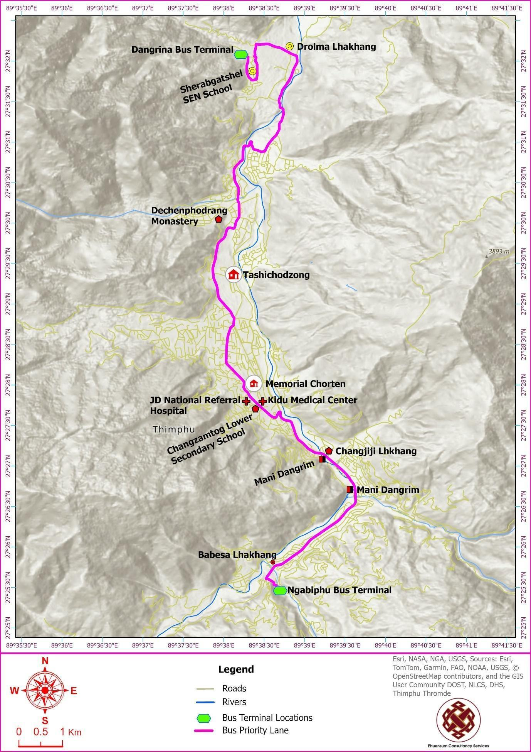

General Considerations:
- Vulnerable Groups: Disadvantaged and vulnerable individuals or groups (as identified in the SEP and social baseline) residing or working within the project's area of influence are considered sensitive receptors to various impacts, including economic disruption, access difficulties, and health and safety risks.
The identification and detailed mapping of these sensitive receptors are foundational to the impact assessment process and the development of targeted mitigation measures in the Environmental and Social Management Plan (ESMP) for the LRCP.
Table 13: List of Sensitive Receptors
# | Category | Receptor Type | Name | From, Chainage in KM | To, Chainage in KM | Key Unique Mitigation Measures
Urban Transport Component (Primarily BPS Route)
1 | Social | School | Changzamtog Middle Secondary School | 6.08 | 6.165 | Strict prohibition of high-noise activities during school hours. Enhanced safety measures (e.g., flag persons) during student arrival/departure times.
2 | Social | School | Etho Meto Primary School | 7.150 | 7.250
3 | Social | School | Zilukha Middle Secondary School | 9.555 | 9.705
4 | Social | School | Dechencholing High Secondary School | 14.94 | 15.125
5 | Social | School | Sherub Gatshel Primary School | 18.285 | 18.355
6 | Social | Healthcare | Kidu Medical Center | 6.00 | 6.15 | Maintain emergency vehicle access at all times. Consultation with hospital management to schedule disruptive works to avoid sensitive periods.
7 | Social | Hospital | JDW National Referral Hospital | 6.175 | 6.68
8 | Social | Heritage Site | Dangrim Chorten | 3.99 | 4.04 | Vibration monitoring and pre-construction condition surveys. Scheduling of works to avoid major religious events/prayer times.
9 | Social | Heritage Site | Memorial Chorten | 6.76 | 6.88
10 | Social | Heritage Site | Hejo Chorten | 10.86 | 10.86
11 | Social | Heritage Site | Dechencholing Palace | 14.75 | 14.94
12 | Social | Heritage Site | Dolma Lhakhang / Pangrizampa | 16.09 | 16.16
13 | Social | Temporary sheds | BAOWE Sheds at JDWNRH | 6.68 | 6.88 | Provision of safe, alternative, and visible temporary vending locations during construction. Targeted livelihood support as per the RAP.
14 | Social | Temporary house shops | Opposite to Changzamtog School area/ below Hoten Tashi Yidwong | 5.820 | 5.840 | Phased construction to maintain customer access. Livelihood restoration support as per the RAP.
15 | Environmental | Stream Crossing | Dangrina | 17.16 | 17.18 | Use of silt fences and check dams along all work areas adjacent to the river. Prompt stabilization of exposed banks.
16 | Environmental | River Crossing and New Bridge | Wang Chhu River (Dechencholing Bridge) | 14.68 | 14.72
17 | Environmental | River Crossing and New Bridge | Wang Chhu River (Pamtsho bridge) | 12.95 | 12.996
18 | Environmental | Stream | Hejo Bridge | 11.12 | 11.16
18 | Environmental | Stream | Chubachhu Bridge | 8.52 | 8.54
19 | Environmental | River | Wang Chhu River (Changjiji Bridge) | 4.28 | 4.36
20 | Environmental | Stream | Olakha Stream (Olarogchhu Bridge) | 2.96 | 3.02
21 | Environmental | Stream | Babesa stream (Babesa bridge) | 0.5 | 0.6
22 | Environmental | Stream | Babesa Stream (Ngabiphu bridge) | 0.08 | 0.1
23 | Environmental | Landslide | Landslide near the Dechencholing Bridge | 14.4 | 14.56 | Implementation of specific bioengineering and structural stabilization works (e.g., rock anchorage, retaining walls) as per the design.
24 | Environmental | Landslide | Landslide north of Supreme Court | 10.74 | 10.78
25 | Environmental | Landslide | Exposure surface at Zilukha | 10.24 | 10.52
26 | Environmental | Forest | Forests (State Reserved Forest between Taba & Dechencholing Bridge) | Approx. 14.61 | Approx. 15.41 | Strict enforcement of a worker Code of Conduct prohibiting hunting/disturbance of wildlife. Pre-construction screening to repel fauna.
27 | Environmental | Soil Erosion Prone Area | Mountain slope (specific section near Dechencholing bridge) | 14 | 14.68 | Implementation of specific bioengineering and structural stabilization works (e.g., rock anchorage, retaining walls) as per the design.
28 | Environmental | River | Along the Wang Chhu River (various sections adjacent to BPS route) | a12.95 / 5.68 / 3.04 | 13.26 / 6.04 / 3.338 | Use of silt fences and check dams along all work areas adjacent to the river. Prompt stabilization of exposed banks.

Summary of Assessed Impacts
A comprehensive assessment of the potential environmental and social impacts and risks associated with the LRCP's urban transport and public space improvement activities has been conducted. This evaluation followed the impact assessment methodology outlined in the preceding sections.
The identification and significance rating of these impacts are based on a multi-faceted approach, including:
- A review of the project's design and engineering specifications.
- An analysis of baseline environmental and social data.
- Feedback and concerns gathered through extensive stakeholder consultations conducted between September 2022 and June 2025.
- Lessons learned from comparable urban development projects in Bhutan and the region.
The significance of each potential impact was determined using the impact significance matrix (refer to Table 11), which considers both the magnitude of the impact and the sensitivity of the affected receptors. The summary table that follows (Table 14) provides a consolidated overview of these impacts, their significance, and the principal mitigation measures proposed.
A more detailed discussion of these impacts and the full suite of mitigation measures is presented in the subsequent sections of this chapter. To provide a clear, chronological understanding of the risks, this discussion is structured according to the project lifecycle: the Pre-construction Phase (covering planning, design, and preparatory activities), the Construction Phase (covering all civil works and installation), and the Operational Phase (covering the long-term functioning and maintenance of the new systems).
The environmental and social specialists for the LRCP applied their expert judgment—considering the project's specific context, baseline conditions, and the scale and intensity of potential effects—to arrive at these impact classifications.
Table 14: Potential Impacts and Their Significance for Urban Transport Component
# | The impact of various activities | Receptor Sensitivity | Impact Magnitude | Impact Significance | Key Mitigation Measures | Significance of Residual Impacts
A | Pre-Construction Phase Impacts and Mitigation
1 | Overall Project E&S Risk Management: The World Bank's Environmental and Social Risk Classification categorizes the Project risk as ‘Substantial.’ |  |  |  | Implementation of the ESCP, ESIA, ESMP, RAP, LMP, and SEP to manage impacts associated with the project. The PIU will include E&S Specialists to oversee implementation, supported by the PMSC. The Contractor will engage dedicated E&S and OHS officers.
2 | Land Acquisition and Resettlement Planning: Acquisition of 1.048 acres of land for construction works and road widening for the BPS Component. | High Sensitivity | Moderate Impact | Substantial Significance | Implementation of the Resettlement Action Plan (RAP): All compensation and resettlement assistance must be completed before the start of any civil works in the affected area, as a prerequisite for land possession. The specific mitigation measures include:  ● For Affected Land: Thimphu Thromde will implement a land-for-land adjustment, providing affected landowners with equivalent parcels of adjacent government land. The impacts of land loss are therefore considered temporary.  - Security of Tenure: As a critical prerequisite, the formal transfer of land titles for these new parcels must be legally completed, and the new, officially registered land titles must be issued in the names of the affected persons before any construction works commence on their previously held land.  ● For Affected Structures: The impact on non-permanent structures like boundary walls and fences is considered permanent. Owners will be provided with cash compensation at full replacement cost for the loss of these structures. This compensation will enable them to rebuild the structures on the realigned plot boundaries. | Low
B | Construction Phase Impacts and Mitigation
B.1 | Labor and Worker Welfare Impacts
3 | Potential labour risks: Discrimination in employment and pay, child and forced labour. | High Sensitivity | Minor Impact | Moderate Significance | Contractor to provide and maintain all necessary accommodation and welfare facilities compliant with project standards. The project's Worker Grievance Redress Mechanism (GRM) will be accessible to all workers to raise any work-related concerns, including those related to accommodation and welfare facilities. | Negligible
4 | Occupational safety risks for workers: Hazards from live traffic, working at heights, in rivers, with heavy machinery, etc. | High Sensitivity | Moderate Impact | Substantial Significance | Contractor to develop and implement a site-specific OHS Plan. Includes regular training, provision and use of PPE, and implementation of emergency response procedures. | Low
5 | Potential health risks for foreign workers: Inadequate housing and welfare facilities for ~200 workers. | High Sensitivity | Minor Impact | Moderate Significance | Contractor to provide and maintain all necessary accommodation and welfare facilities compliant with project standards. A worker-specific GRM for lodging issues will be established. | Negligible
6 | Labor influx and cultural conflicts: Potential social friction between communities and the workforce. | High Sensitivity | Minor Impact | Moderate Significance | Implementation of a Contractor's Code of Conduct promoting respectful interaction with the local community. | Negligible
7 | Risk of Gender-Based Violence (GBV), SEA, and SH: Increased risk due to interaction between workforce and local communities. | High Sensitivity | Minor Impact | Moderate Significance | Implementation of proactive GBV/SEA/SH prevention measures, including training for workers and a confidential, survivor-centric uptake mechanism within the Project GRM. | Negligible
B.2 | Environmental Pollution and Resource Management Impacts
8 | Improper sourcing of construction materials: Use of 51,000 m³ of aggregates, stone, and sand. | Medium Sensitivity | Moderate Impact | Moderate Significance | Use of approved and licensed quarries (e.g., NRDCL). Procurement of energy-efficient equipment and vehicles for construction. | Negligible
9 | Soil erosion from land clearing and earthwork. | Medium Sensitivity | Minor Impact | Moderate Significance | Implementation of erosion and sediment control plans, including stormwater management and prompt stabilization of cleared areas. | Negligible
10 | Potential landslides from works near hill slopes. | Medium Sensitivity | Moderate Impact | Moderate Significance | Bioengineering and structural measures for slope stabilization are included in the project design. | Negligible
11 | Wastewater discharges from construction sites. | High Sensitivity | Minor Impact | Moderate Significance | Onsite treatment of wastewater through sedimentation tanks and oil-water filters. | Negligible
12 | Risk of soil and water pollution from spills and storage. | High Sensitivity | Minor Impact | Moderate Significance | Contained storage for fuels and chemicals. Availability of spill kits and trained personnel for immediate cleanup. | Negligible
13 | Pollution of rivers from in-stream construction. | High Sensitivity | Moderate Impact | Substantial Significance | Scheduling bridge construction works during the low-flow season (November to March). | Negligible
14 | Air and noise pollution from construction activities. | Medium Sensitivity | Moderate Impact | Moderate Significance | No construction during the night (9 pm to 8 am) near sensitive residential areas. Use of buffer zones and equipment mufflers.  ● Work Scheduling for Sensitive Receptors:  - For works near schools, high-noise activities will be strictly avoided during school hours  - For works near hospitals and major cultural/religious sites like the Memorial Chorten, the contractor must consult with the facility management to identify specific sensitive times (e.g., visiting hours, prayer times, specific ceremonies) and schedule disruptive activities to avoid these periods. | Negligible
15 | Generation of construction spoils: ~21,000 m³ of excess earth materials. | High Sensitivity | Minor Impact | Moderate Significance | Maximize reuse of excavated material. Transport remaining spoils to city-approved disposal sites. | Negligible
16 | Generation of solid and hazardous waste. | High Sensitivity | Moderate Impact | Substantial Significance | Implementation of a Waste Management Plan for waste segregation, collection, and disposal, using licensed services for hazardous waste. | Negligible
B.3 | Community Health, Safety, and Access Impacts
17 | Impact on existing public utilities (water, power, telecom). | High Sensitivity | Moderate Impact | Substantial Significance | Use of appropriate tools to locate utilities. Coordinate with utility companies for any necessary relocations prior to works. | Negligible
18 | Increased traffic congestion on busy roads. | High Sensitivity | Moderate Impact | Substantial Significance | Implement a comprehensive Traffic Management Plan (TMP) with detours, lane closures, speed limits, and flag personnel. | Low
19 | Safety hazards for the community (open trenches, vehicle movements, and unsecured material storage sites/stockpiles). | High Sensitivity | Moderate Impact | Substantial Significance | ● Site Security:  - Barricade all excavations and open trenches with hard fencing to prevent falls.  - Ensure all material storage sites and stockpiles (e.g., piles of sand, aggregate, pipes) are located in designated, secure areas away from public pathways and are properly fenced or cordoned off to prevent access, particularly by children.  ● Traffic Management: Implement the TMP with a focus on public safety, including clear signage for vehicle movements and designated pedestrian routes.  ● Public Awareness: Conduct awareness-raising campaigns on the dangers of construction sites. | Negligible
20 | Restriction of access to hospitals, schools, and other essential services. | High Sensitivity | Moderate Impact | Substantial Significance | ● Provide and clearly mark safe, temporary access paths and crossings to maintain pedestrian access to all essential facilities.  ● Universal Access for Sensitive Locations: For access paths leading to hospitals and other facilities frequently used by the elderly or persons with disabilities, the contractor must ensure that temporary routes comply with universal design principles. This includes providing non-slip, level surfaces, handrails where necessary, and ramps instead of steps to ensure safe passage for wheelchair users, people with mobility aids, and the infirm. | Negligible
21 | Dust from construction activities. | High Sensitivity | Moderate Impact | Substantial Significance | Frequent water sprinkling on haul roads and worksites to control dust emissions. | Negligible
B.4 | Biodiversity and Cultural Heritage Impacts
22 | Removal of 309 trees (73 mature, 72 poles, 164 saplings). | Medium Sensitivity | Moderate Impact | Moderate Significance | Compensatory plantation of 1,000 native species (ratio >3:1). | Negligible
23 | Direct Impact on fauna from vegetation clearing and construction activities. | High Sensitivity | Negligible Impact | Moderate Significance | Conduct pre-construction screening to repel/relocate fauna. Enforce Code of Conduct with a ban on hunting. | Negligible
24 | Indirect Impact: Sensory disturbance to adjacent habitats. | High Sensitivity (KBA, SRF) | Minor Impact | Moderate Significance | Enhanced noise and light control measures for works adjacent to the State-Reserved Forest and opposite the Thimphu Wetlands (KBA), as detailed in the Community Health & Safety Plan. | Low
25 | Cumulative Impact: Contribution to urban habitat fragmentation. | Medium Sensitivity | Minor Impact | Moderate Significance | This is a long-term, strategic impact primarily managed through improved urban planning. The project contributes positively by promoting a compact, transit-oriented development model that reduces the need for further road network expansion. No additional site-level mitigation is required. | N/A (Positive Contribution)
26 | Spread of Invasive Alien Species (IAS). | Medium Sensitivity | Minor Impact | Moderate Significance | Use designated roads only. Ensure construction vehicles are brought to the site clean and free of seed-bearing soil. | Negligible
27 | Indirect impacts on cultural heritage sites from construction (vibration, dust, access). | High Sensitivity | Negligible Impact | Low Significance | Implement traffic and access management around sites. Implement dust and noise control measures. | Negligible
28 | Risk of chance finds during construction. | High Sensitivity | Negligible Impact | Low Significance | Adoption of a Chance Finds Procedure: stop work, secure the site, and report to the Department of Culture. | Negligible
C | Operational Phase Impacts and Mitigation
29 | Workers' health and safety during O&M of roads and BPS infrastructure. | High Sensitivity | Moderate Impact | Substantial Significance | Establishment of safe work zones and implementation of a comprehensive traffic management plan for maintenance activities. | Low
30 | Workers' health and safety during O&M at terminals and buses. | High Sensitivity | Moderate Impact | Substantial Significance | Use of relevant PPE. Firefighting and first-aid facilities will be provided and maintained at terminals. | Low
31 | Reduction in greenhouse gas emissions from transitioning to electric buses. | High Sensitivity | Negligible Impact | Negligible Significance | Positive Impact: The project's transition to 50 electric buses presents a substantial opportunity to reduce Thimphu's greenhouse gas emissions. | High Positive
32 | Wastewater discharges during bus maintenance. | High Sensitivity | Minor Impact | Moderate Significance | Regular maintenance and proper operation of the wastewater treatment facility at the City Bus service facility. | Negligible
33 | Resource efficiency in operation. | High Sensitivity | Minor Impact | Moderate Significance | Use of energy-efficient lighting/HVAC. Install water-efficient fixtures. Procure environmentally friendly products. | Low
34 | Waste generation from e-buses and terminals (batteries, solid waste). | High Sensitivity | Moderate Impact | Substantial Significance | Supplier take-back program for used batteries. Use of city waste services for solid waste and licensed services for hazardous waste. | Low
35 | Community health and safety risks during routine bus service operation. | High Sensitivity | Moderate Impact | Substantial Significance | Implement comprehensive traffic management and safety plans. Maintain universal access features. Implement the Gender Action Plan. | Negligible
36 | Risk of SEA/SH towards commuters, particularly women and vulnerable groups, during bus operation. | High Sensitivity | Moderate Impact | Substantial Significance | Implement the project's SEA/SH Prevention and Response Action Plan and the Gender Action Plan (GAP) during operations. Key measures include:  - Continuous training for all bus drivers and staff on the Code of Conduct, gender sensitivity, and SEA/SH prevention.  - Ensuring all buses are equipped with functional CCTV cameras and emergency alert systems.  - Displaying clear signage on buses and at terminals about the zero-tolerance policy for SEA/SH and providing information on how to report incidents through the project GRM. | Low
37 | Community health and safety during routine maintenance of BPS infrastructure. | High Sensitivity | Low Impact | Moderate Significance | Barricade work areas with hard fencing. Provide safe pedestrian corridors. Place adequate signage and flagmen. | Low
37 | Maintenance of commuter facilities (drinking water, toilets) at terminals. | High Sensitivity | Moderate Impact | Substantial Significance | Establish and implement a regular maintenance and cleaning schedule. Seek regular feedback from users to ensure quality. | Negligible

Pre-construction Phase: Risks, Impacts, and Mitigation Framework
This phase covers all planning, design, and preparatory activities that occur before the commencement of civil works. The focus is on integrating E&S considerations into project frameworks and contracts to prevent and minimize adverse impacts.

Climate Change Adaptation and Resilience
A central objective of the LRCP is to build Thimphu's resilience to the impacts of climate change. The project design incorporates a range of targeted strategies to adapt to potential climate-related challenges, such as the increased frequency and intensity of rainfall, extreme weather events, rising temperatures, and potential water stress.
- Learning from Past Events: The New Flood Risk Profile
The long interval between the Chubachu stream flash flood in 1968 and the Dechencholing stream flash flood in August 2024 is not an indication of a predictable, long-term cycle. Instead, it highlights a profound and dangerous shift in the city's risk profile, driven by the interplay of climate change and rapid urbanization. The 2024 flood, triggered by a short, high-intensity convective thunderstorm that led to landslides and a catastrophic debris flow, serves as a stark warning of a "new normal." It underscores that historical meteorological data is no longer a sufficient predictor of future risk and validates the necessity of a forward-looking, climate-informed approach to infrastructure development.
The lessons learned from this recent disaster, alongside technical assessments such as the NCHM's 2021 flood modeling for the Dechencholing-Taba Bridge, have been critical drivers in shaping the project's resilience-focused engineering and design standards. The LRCP moves beyond conventional design to proactively address the following key climate risks:
- Resilient Infrastructure Design (Flood and Landslide Mitigation)
Recognizing that a warmer atmosphere holds more moisture and can produce more intense, localized rainfall, all new infrastructure developed under the project will be designed to withstand projected climate impacts. The design approach is informed by lessons learned from recent extreme weather events, such as the 2024 Dechencholing flash flood.
- Bridges and Drainage: The design of bridges (at Pamtsho and Dechencholing) and associated culverts will be based on updated hydrological models that account for projected increases in peak flood flows. The bridge designs will incorporate higher freeboards to safely pass debris flows and will feature enhanced scour protection for abutments and piers to ensure structural integrity during extreme events.
- Climate-Resilient Urban Drainage: The project will strengthen urban drainage along the corridors by combining gray infrastructure upgrades with green solutions. This includes:
  - Expanding the hydraulic capacity of drains and culverts (incorporating a 25-30% safety margin for intensified precipitation).
  - Integrating nature-based interventions such as permeable surfaces and bioswales to enhance infiltration and reduce system overload.
- Roads and Slopes: Road designs in hilly and landslide-prone areas will incorporate enhanced slope stability and erosion control measures. This will be achieved through a combination of robust bioengineering solutions (e.g., deep-rooting native grasses, live staking) and structural measures.

Mitigating Urban Heat Island Effect (Heat Stress Mitigation)
To address the projected rise in urban temperatures and mitigate heat stress for commuters and residents, the project will integrate green infrastructure and climate-smart materials:
- Green Shade and Cooling: The project will mandate the planting of native, hardy, and climate-appropriate shade trees at all new and upgraded bus stops and within terminal areas. This will provide natural cooling, improve commuter comfort, and enhance urban biodiversity.
- Heat-Resistant Materials: The project will specify the use of heat-resistant asphalt mixes for road surfacing in critical areas to reduce pavement degradation and minimize the absorption and re-radiation of heat.

Climate Mitigation Co-benefits
The LRCP's emphasis on transitioning to 50 electric buses and promoting non-motorised transport not only builds urban resilience but also directly contributes to climate change mitigation. By reducing greenhouse gas emissions from the transport sector, the project strongly supports Bhutan's national commitment to remain carbon-negative. Similarly, enhancing the efficiency of the water system reduces energy consumption, further lowering the city's carbon footprint.
By integrating these comprehensive adaptation and resilience measures into its core design, the LRCP is positioned not only to address Thimphu's current infrastructure deficits but also to ensure its investments are sustainable, secure, and effective in the face of future climate challenges.

ESS5: Land Acquisition, Restrictions on Land Use and Involuntary Resettlement – Related Impacts and Mitigation Measures
This section addresses potential impacts related to land acquisition, restrictions on land use, and involuntary resettlement that may arise from the implementation of the LRCP, in accordance with World Bank Environmental and Social Standard 5 (ESS5).

Resettlement Impacts of the Project
The potential for land acquisition and resettlement impacts under the LRCP is primarily associated with the urban transport and public space improvement components, specifically the road widening required for the Bus Priority Service (BPS) and the complete street and urban placemaking improvements along Norzin Lam.
A comprehensive Resettlement Action Plan (RAP) has been prepared to identify all impacts from the urban transport and public space components and establish mitigation measures. The following is a summary of the key impacts identified in the draft RAP.
Readers are directed to the full RAP for a comprehensive assessment of all impacts and associated entitlements. The final, cleared version of the document will be publicly disclosed on the official website of the Ministry of Infrastructure and Transport (MoIT), under the section for the Livable and Resilient Cities Project.
- Land Acquisition: A total of approximately 1.06 acres of land are required for the BPS component's road widening activities. This will affect around 19 plots owned by 10 private individuals/entities and 9 government institutions.
- Impact on Structures: The road widening is anticipated to affect approximately 74 structures, owned by 23 private persons and 9 government institutions. Affected structures primarily include boundary walls, fences, water tanks, and utility poles that will require relocation. At Norzin Lam, the structures of 17 private landowners and 1 institution will be affected.
- Impact on Livelihoods:
  - BPS Route: Approximately 130 people (including property owners, business operators, employees, and tenants) are expected to be affected by land acquisition and temporary restrictions on customer access to businesses during road widening.
  - Norzin Lam Improvements: Approximately 539 people (including business owners, residential tenants, and employees) will be potentially affected by the improvements on Norzin Lam, primarily through temporary disruption during construction and permanent changes to business access or operations.
- Physical Displacement: The project will not cause any physical displacement.

Mitigation
A comprehensive Resettlement Action Plan (RAP) has been prepared to mitigate these impacts. The RAP outlines the eligibility criteria, entitlement matrix, and compensation and rehabilitation provisions for all affected persons. Key categories of impacts for which assistance is provided include:
- Loss of land due to road widening.
- Loss of structures (e.g., boundary walls, fences, temporary structures).
- Loss of income or livelihood (for businesses, building owners and other affected parties).
The implementation of the RAP—including timely and adequate payment of compensation and provision of resettlement assistance—is a critical component of the project's social management and a prerequisite for the commencement of any civil works in the affected areas. This process will be overseen by Thimphu Thromde's Project Implementation Unit (PIU) and the Project Management and Supervision Consultant (PMSC).

Construction Phase: Risks, Impacts, and Mitigation Framework
This phase encompasses all civil works and installation activities for the urban transport and public space components and presents the most significant potential for direct, temporary environmental and social (E&S) impacts.

ESS2: Labor and Working Conditions – Related Impacts and Risks

6.6.1.1 Potential Labor Risks
The LRCP's civil works will require a significant workforce, estimated at around 200 workers per day during the project's construction period. A substantial portion of this workforce may be foreign. Workers will be housed in either contractor-established camps at designated sites (such as the new bus terminal locations) or in private rental accommodations.
Potential labour risks, applicable across all project components, include:
- Discrimination in recruitment and hiring.
- Unfair or non-compliant terms and conditions of employment.
- Risks of child labour and forced labour.
- Inadequate occupational health and safety (OHS) conditions.
- Poor standards of worker accommodation and welfare.
These risks are associated with the hiring and management of all contracted workers of Contractors and Supervision Consultants.
Mitigation
The following mitigation measures will be implemented for all project activities. These measures are defined within the project's Labor Management Procedures (LMP), which serves as the primary benchmark for all labour and working conditions. The LMP will be prepared to be fully consistent with the project's Environmental and Social Commitment Plan (ESCP), Bhutan's Regulation on Occupational Health, Safety and Welfare, 2022, and the relevant standards of the World Bank's Environmental and Social Framework.
- Contractor's Labor Management Plan: As a key component of their C-ESMP, each contractor will be required to prepare and implement a Labor Management Plan (LMP). This plan will detail their procedures for managing all project workers in compliance with national law and World Bank ESS2.
- Terms and Conditions of Employment: Contractors will provide all workers with clear, written employment contracts in an understandable language. These contracts will detail terms and conditions, including rights related to work hours, wages (compliant with national minimum wage laws), overtime, benefits, and leave, in full compliance with Bhutan's Regulation on Working Conditions, 2022.
- Prohibition of Child and Forced Labor:
  - Child Labor: No person under the age of 18 shall be employed. Contractors must implement robust age verification procedures for all workers.
  - Forced Labor: All workers shall be recruited voluntarily, and no worker shall be forced or coerced into work.
- Worker's Grievance Redress Mechanism (GRM): To address all labour and working condition concerns, the Contractor will establish and operate a dedicated Worker Grievance Redress Mechanism (GRM), which will be separate from the project's community-facing GRM. This mechanism will be accessible to all project workers, including those employed by subcontractors, for raising work-related grievances. The Contractor will ensure all workers are informed about the Worker's GRM, including its procedures and the confidential channels available for reporting sensitive issues such as Sexual Exploitation and Abuse/Sexual Harassment (SEA/SH).
- Code of Conduct (CoC): All project workers will be required to sign and adhere to a project-specific Code of Conduct as a condition of employment. The CoC will include strict provisions on respectful interaction with local communities and a zero-tolerance policy for Sexual Exploitation and Abuse/Sexual Harassment (SEA/SH).

Occupational Health and Safety (OHS) Risks in Construction
The management of Occupational Health and Safety (OHS) for all LRCP construction activities will be guided by both national law and international good practice. The primary legal and technical foundation for all OHS measures is the Royal Government of Bhutan's Regulation on Occupational Health, Safety and Welfare, 2022 (hereafter "the Regulation").
This national law will be supplemented by the World Bank Group's (WBG) Environmental, Health, and Safety (EHS) Guidelines.
In accordance with the World Bank's Environmental and Social Framework, all project activities will adhere to the more stringent provisions where there are differences between the national Regulation and the WBG EHS Guidelines. This ensures that all OHS management on the project meets or exceeds international standards.

Identified OHS Risks
The construction activities under the LRCP, spanning both transport and water sectors, present a range of OHS risks that the Regulation is designed to manage. These include, but are not limited to:
- Traffic Hazards: Working near active roadways (BPS lane construction, NMT improvements), requiring systematic traffic management plans.
- Physical & Mechanical Hazards: Use of heavy machinery and cranes (Chapter 7); working at height on bridges, buildings, and WTPs; work near or on water bodies (Chapter 5); and trenching/excavation risks (trench collapse).
- Exposure to Harmful Agents (Chapter 6 & 9): Exposure to dust, excessive noise, and electrical hazards. Handling of hazardous materials like fuels, lubricants, and water treatment chemicals will be governed by the chemical safety and GHS standards in the Regulation.
- High-Risk Work Environments (Chapter 11): Specific risks associated with entry into confined spaces (manholes, pipelines) are explicitly covered and will require strict permit-to-work systems as mandated by the Regulation.
- Emergency Situations: Potential emergencies include construction accidents, fires, extreme weather events, and drowning risks, all of which must be addressed through a formal Emergency Action Plan as required by the Regulation.
Mitigation Framework: Operationalizing OHS Requirements
To mitigate these risks, all contractors will be required to develop and implement a site-specific Occupational Health and Safety (OHS) Plan. This Plan must ensure full compliance with both Bhutan's Regulation on Occupational Health, Safety and Welfare, 2022 ("the Regulation") and the relevant sections of the World Bank Group's Environmental, Health, and Safety (EHS) Guidelines. Where differences exist, the more stringent standard will apply.
The following measures, which are both contractual and legal obligations, will be supervised and enforced by the PIU and PMSC:
- Mandatory OHS Management System (as per Chapter 4 of the Regulation):
- Contractor OHS Plan: Contractors will prepare and implement a site-specific OHS Plan that functions as their formal OHS Management System. This Plan must directly address the requirements of Chapter 4 of the Regulation, including:
- A formal Health and Safety Policy (Sections 26-29).
- A proactive Health and Safety Program (Sections 50-51).
- A thorough Risk Assessment for all work activities (Sections 52-60), which will be a living document updated for new tasks or every six months. Job Hazard Analyses (JHAs) for high-risk tasks will be a core component of this.
- Appointment of a Certified Safety Officer (as per Sections 39-41):
- Each main work site will be assigned a qualified OHS Supervisor in accordance with Section 40 of the Regulation, with the Contractor responsible for submitting the CVs and credentials of proposed key OHS personnel to the PIU/PMSC for review; these will then be forwarded to the World Bank for its "No Objection" prior to formal appointment, ensuring that all personnel meet the required competency and certification standards for effective on-site OHS management and reporting.
- Emergency Response Procedures (ERP) (as per Sections 63-67):
- Contractors must develop and implement a formal Workplace Emergency Action Plan that aligns with the requirements of the Regulation. This plan will specifically address fire prevention (Chapter 13), response to natural disasters, and detailed protocols for high-risk scenarios like drowning, including the provision of life jackets, rescue teams, and specific training.
- Provision and Use of Personal Protective Equipment (PPE) (as per Sections 72-78 and Schedule II):
- The provision, use, and maintenance of PPE will strictly follow the mandates of the Regulation. The contractor's OHS Plan will include a PPE matrix specifying the required equipment for each job, ensuring it conforms to the standards listed in Schedule II. This includes specialized equipment like breathing apparatus for confined space entry.
- Worker Training and Consultation (as per Chapter 3 & 4):
- A systematic training program, including daily toolbox talks and monthly sessions, will be implemented. This program will inform all workers of their rights and duties under Sections 16 & 18 of the Regulation. The contractor will also facilitate the establishment of a Health and Safety Committee or appoint an H&S Representative (as required by Chapter 4) to ensure worker participation.
- Site Inspections, Audits, and Records Management:
- Compliance will be monitored through regular inspections by the Contractor's Safety Officer, PMSC E&S specialists, and the PIU. These inspections will specifically check against the provisions of the Regulation.
- All occupational accidents, diseases, and dangerous occurrences will be recorded and reported to the Chief Labour Administrator using the official forms (Forms 7 & 8) as mandated by Chapter 16 of the Regulation.
- Site Facilities (as per Chapter 15 - Welfare):
- The provision of safe drinking water, gender-segregated toilets, and first-aid facilities at all worksites and camps will comply with the specific requirements laid out in Chapter 15 of the Regulation.
By ensuring that all contractor OHS plans and activities are directly mapped to the clear and comprehensive articles of the Regulation on Occupational Health, Safety and Welfare, 2022, the LRCP will not only protect its workers but also actively contribute to strengthening the culture of compliance and enforcement of national law. With the rigorous implementation of this framework, the residual OHS impacts are assessed as Low.

Potential Health Risks to Workers in Construction
The health and well-being of the workforce are paramount and will be managed in strict accordance with the welfare provisions outlined in the Regulation on Occupational Health, Safety and Welfare, 2022. Potential health risks to workers on LRCP sites (for both transport and water components) stem primarily from inadequate living and working conditions if not managed correctly. These risks include communicable diseases from poor sanitation, health issues from unsafe drinking water, and stress from substandard accommodation.
Mitigation Framework: Ensuring Compliance with the Regulation's Welfare Standards
The project will enforce the specific legal requirements for worker welfare as detailed in Chapter 15 (Welfare) and other relevant sections of the Regulation. Contractors will be legally and contractually obligated to implement the following measures:
- Safe Drinking Water (as per Sections 445-447):
- Contractors will ensure an adequate and continuous supply of safe drinking water at all work sites and labour camps.
- Drinking water points will be conveniently located, clearly marked as "Drinking Water," and situated at least 6 meters away from any sanitation facility or drain, as mandated by Section 446.
- Provisions for cool drinking water will be made during hot weather conditions.
- Sanitary Conveniences (as per Sections 448-450):
- Sufficient numbers of clean, gender-segregated, and disability-friendly toilets will be provided at all work sites and camps. These facilities must be appropriately located and spaced to ensure sufficient privacy and accessibility for all workers.
- The number of toilets provided will adhere to the minimum ratios specified in the table under Section 448 of the Regulation.
- All facilities will be properly maintained, spaced/designed to ensure sufficient privacy, and marked with appropriate signage (e.g., "For Men" / "For Women").
- Temporary Living Accommodation (as per Section 457):
- Where contractors provide temporary accommodation, these camps will be constructed in the safest possible locations, free from risks of flooding, landslides, or falling boulders, as required by the Regulation.
- The living quarters will be designed to provide decent, safe, and hygienic conditions for all workers. This includes providing adequate space, ventilation, and protection from the elements. Key safety measures for the accommodation must also be included, such as ensuring safe electrical wiring, providing adequate lighting in and around the camp, and establishing clear emergency evacuation routes and procedures.
- Washing and Changing Facilities (as per Sections 455-456):
- Contractors will provide and maintain adequate and suitable facilities for washing, including soap and other cleaning aids. These facilities must be designed and located to ensure both the privacy and safety of all users.
- For any site employing 20 or more employees, dedicated changing rooms with locker facilities must be provided. These rooms must be gender-segregated, lockable, and secure to ensure workers have a safe and private place for their personal belongings.
- First Aid and Medical Care (as per Chapter 14 - Health):
- To ensure a prompt and effective response to injuries and medical emergencies, the following measures will be implemented in strict compliance with national regulations:
- First Aid Facilities: All worksites will be equipped with fully-stocked First Aid Boxes as per the specifications in Schedule X of the Regulation. The contents will be regularly inspected and replenished.
- Trained Personnel: A sufficient number of workers will be trained in first aid. As prescribed in Sections 425-427 of the Regulation, these trained personnel will be available on-site during all working hours to provide immediate assistance. (Note: This wording is more flexible than "certified First Aiders" while still meeting the legal requirement for trained personnel).
- Emergency Response and Transport: The contractor will establish and maintain clear procedures for medical emergencies. This includes having dedicated, readily available transport to take injured or ill workers to nearby health facilities, such as the JDW National Referral Hospital. Emergency contact numbers for hospitals and ambulance services will be clearly posted at all worksites.
- Local Hiring and Grievance Redressal:
- To minimize the need for large-scale labour camps, contractors will be required to maximize the hiring of local workers.
- A Worker Grievance Redressal Mechanism (GRM), as outlined in the project's Labour Management Procedures (LMP), will be established. This provides a formal channel for workers to raise concerns about living and working conditions without fear of retaliation, reinforcing their rights under the Regulation.
By enforcing these legally mandated welfare standards from the Regulation on Occupational Health, Safety and Welfare, 2022, the project ensures that worker health is protected not just as a matter of good practice, but as a non-negotiable legal obligation. With the implementation of these measures, the residual health risks to workers are assessed as Low.

Impacts of Labour Influx
The overall LRCP activities will require a significant workforce, estimated to be around 200 workers per day or more during peak construction, with a substantial portion (potentially 80%) being foreign workers. Some will be housed in contractor-established camps, while others may be in rented accommodation. The influx of a large workforce, particularly in or near communities and sensitive areas (like those near the Dodeyna intake if future works were to occur there), can lead to:
- Social tension between local communities and construction workers due to cultural and linguistic differences.
- Increased risk of communicable diseases, including Sexually Transmitted Infections (STIs) like HIV/AIDS, and other infectious diseases (e.g., COVID-19 considerations).
- Strain on local resources and services.
Mitigation
The following mitigation measures will be implemented for all project components:
- Contractor's Code of Conduct: The CoC will include programs to promote awareness among construction workers on respecting local culture, customs, and social norms.
- Community Awareness and Health: Awareness campaigns will target the risk of interaction between the resident population and the construction workforce, including the spread of STIs/HIV/AIDS. Health screening for expatriate workers will comply with Bhutanese regulations.
- Cultural Sensitivity Training: The Contractor's training program will cover cultural sensitivity and awareness for both local and incoming workers.
- Health Protocols: Measures like COVID-19 protocols (if still relevant and as per national/WHO guidelines) will be detailed in the ESMP and complied with.
With the above mitigation measures, the residual impacts of labor influx are assessed as Negligible.

Risk of Gender-Based Violence (GBV), Sexual Exploitation and Abuse (SEA), and Sexual Harassment (SH)
The interaction between the project's construction labour force and local communities—especially women and girls—can increase the risk of SEA/SH and other forms of GBV. This risk is relevant to ESS 4 (Community Health and Safety). A related risk of SEA/SH also exists within the workforce itself, which is addressed under ESS 2 (Labor and Working Conditions). The project is rated as Moderate Risk for SEA/SH.
To manage these risks, a comprehensive SEA/SH Prevention and Response Action Plan has been developed for the project. This plan will be a binding requirement for all contractors. Key mitigation measures include:
- Zero-Tolerance Policy and Contractual Obligations:
  - All employment contracts for project workers (including contractor and subcontractor staff) will include binding clauses on the project's zero-tolerance policy for SEA/SH.
  - A Code of Conduct (CoC), explicitly prohibiting SEA/SH, will be a mandatory, signed condition of employment for all project workers.
- Awareness and Prevention Training:
  - Mandatory and continuous awareness training will be provided to all project personnel (from management to laborers) on what constitutes SEA/SH, the project's zero-tolerance policy, and their responsibilities for prevention.
  - Public awareness campaigns will be conducted in communities near project sites to inform them of project risks, the CoC, and the available support mechanisms.
- Survivor-Centric Grievance and Response Mechanism:
  - Confidential GRM: The project will establish a safe, confidential, and survivor-centric pathway within the Grievance Redress Mechanism (GRM) for reporting SEA/SH incidents without fear of retaliation.
  - Referral Pathway: A clear and functional referral pathway has been mapped to link survivors with specialized national service providers. This includes:
    - Engaging with GBV Service Providers and CBOs: The project will establish formal links and partnerships with key national service providers like RENEW (for shelter and psychosocial support), JDWNRH (for medical and forensic services), the Royal Bhutan Police (for legal action), and The PEMA Secretariat (for mental health support) to ensure survivors receive timely and comprehensive care.
- Contractor and Supervision Capacity:
  - The capacity of contractors to manage SEA/SH risks will be a key criterion in the bidding process.
  - The PIU and PMSC will conduct robust supervision to ensure all prevention and response measures are effectively implemented on the ground.

ESS3: (Resource Efficiency and Pollution Prevention) – Related Impacts and Mitigation Measures

Impacts from Sourcing of Construction Materials (Quarry and Borrow Activities)
Construction for both the transport and water components will require sourcing materials such as soil, aggregates, and stone. While specific quantities for the water sector will be finalized during detailed design, preliminary estimates for the urban transport activities alone project a need for approximately 1,800 cubic meters of soil, 32,000 cubic meters of aggregates, and 17,000 cubic meters of stone. Improper sourcing of these materials could significantly impact the physical and biological environment of quarry and borrow sites.
Mitigation:
The following mitigation measures will be implemented for all materials sourced for the LRCP:
- Contractors will use approved quarries of the Natural Resource Development Corporation Ltd. (NRDCL), aggregate from private crushing plants, and sand from the NRDCL quarry at Wangdue, or other licensed and approved sources.
- Contractors will submit details of proposed quarries and borrow areas for approval by TT/PMSC prior to procurement. TT's environmental specialist will conduct due diligence to ensure these facilities are operated in compliance with environmental permits and good practices.
- The project will not develop any new quarry sites.
With the above mitigation measures, the residual impacts from material sourcing are assessed as negligible.

Soil Erosion from Construction Activities
Land clearing and earthwork activities for both road widening (Urban Transport) will result in soil erosion, particularly during the rainy season. Exposed soil can be washed away by runoff, leading to sedimentation in natural drainage systems and water bodies.
The risk of significant soil erosion and sedimentation will be most acute in the following specific areas:
- 3.9 km Road Widening Segment: The extensive earth-moving, slope cutting, and re-profiling required to widen this 3.9 km section will expose large areas of soil. This creates a high risk of erosion, particularly on any newly formed embankments, and increases the potential for sediment-laden runoff to enter adjacent drains and tributaries.
- New Bus Terminal Sites (Ngabiphu and Dangrina): The construction of the new terminals will involve the complete clearing and grading of the entire site footprint. This large-scale, concentrated land disturbance will expose a significant surface area to erosion from rainfall and wind, creating a high-risk "hotspot" for generating sediment-laden runoff that could impact nearby watercourses if not managed with robust, site-specific erosion and sediment controls.
- Construction of New Transport Infrastructure: While smaller in scale, the localized excavations required for developing new pedestrian pathways, bus shelters, and bus bays will also create pockets of disturbed soil that contribute to the overall erosion risk along the corridor.

Mitigation:
To manage the risks of soil erosion and sedimentation, the Contractor will be required to prepare and implement a detailed, site-specific Erosion and Sediment Control Plan (ESCP) as part of their C-ESMP. This plan must be approved by the PIU/PMSC before any land-clearing activities begin. The ESCP will be a dynamic document, updated as the project progresses, and will include the following minimum measures:
- General Site-Wide Measures:
- Phased Land Clearing: Implement a phased approach to land disturbance to limit the area of exposed soil at any one time.
- Prompt Stabilization: Stabilize all exposed soil areas as soon as practicable through re-vegetation, mulching, or the use of erosion control mats, with particular urgency before the onset of the monsoon season.
- Drainage Management: Design and construct effective temporary drainage systems to manage surface water runoff and reduce flow velocity across disturbed areas.
- Monitoring and Maintenance: Regularly inspect and maintain all erosion and sediment control measures, especially before and after rainfall events, to ensure their effectiveness.
- Enhanced Measures for High-Risk Areas: The ESCP must include specific, enhanced mitigation measures for the areas identified with the highest erosion risk:
- For the 3.9 km Road Widening Segment:
  - Installation of robust perimeter controls (e.g., continuous silt fences, strategically placed check dams in drains) along the entire down-slope boundary of the worksite to prevent sediment from entering adjacent properties and watercourses.
  - Use of temporary diversion drains (catch drains) upslope of all new cut faces to prevent clean water from flowing over exposed soil.
- For the New Bus Terminal Sites (Ngabiphu and Dangrina):
  - Establishment of larger-scale sediment control structures, such as sediment basins or traps, at the main drainage outlets of the sites. These must be designed to capture and treat sediment-laden runoff before it is discharged off-site.
  - A clear plan for the phased grading and stabilization of the terminal footprint, ensuring that no more land than is necessary for immediate construction activities is exposed at one time.

Risks of Landslides from Construction
The BPS route passes through areas with geological conditions prone to landslides (e.g., between Zilukha and Supreme Court, Hejo, near Dechencholing bridge. Integration of ESMP into Bidding and Contract Documents and appropriate precautions during construction in these areas are essential.
Mitigation:
Project designs and bid documents will include the following bioengineering and structural measures, as appropriate for both transport and water component sites:
- Direct Seeding: (e.g., ~6,000 sqm for transport) for soil stabilization and erosion control on slopes.
- Live Stacking/Palisade and Brush layer/Hedge Brush Layer: (e.g., ~6,000 sqm for transport) bioengineering techniques to stabilize slopes.
- Grass Slips Planting: (e.g., ~2,500 sqm for transport) to stabilize soil and prevent erosion.
- Rock Anchorage: (e.g., 1500 sqm for transport) geotechnical methods for slope stabilization.
- Site-specific geotechnical assessments and slope stability measures for water pipeline alignments and facility locations in steep terrain.

Wastewater Discharges from Construction Sites
Potential sources of wastewater include construction yards (batching plants, vehicle cleaning areas, often located at proposed bus terminals or designated contractor yards) and dewatering of trenches for water pipeline installation. Wastewater from batching plants may contain high sediment loads and altered pH. Vehicle/equipment washing can introduce oils and grease.
Mitigation:
The following mitigation measures will be implemented:
- Sedimentation ponds/tanks of adequate size and capacity will be used to treat wastewater from batching plants and other sediment-laden construction site runoff, ensuring discharges comply with Bhutan's Environmental Standards 2020. Settled sediments will be disposed of at approved city disposal sites.
- Use temporary diversion drains, catch drains, and silt traps to manage surface runoff from construction sites.
- Contractors will provide oil-water separators for vehicle and equipment washing areas.
- The Contractor will take appropriate measures to avoid and contain any spillage and pollution of water.
- Proper management and disposal of water pumped from trenches during pipeline construction to prevent sediment and contaminant release into watercourses or onto land.
With the above mitigation measures, the residual impacts are assessed as Negligible.

Risk of Soil and Water Pollution from Construction Works
Primary sources of soil and water pollution from construction activities for both transport and water components include:
- Accidental Spills: Use of equipment (hot mix plants, bitumen sprayers, concrete mixers, generators, pumps) raises the risk of spills of hazardous materials like fuel, oil, lubricants, and concrete mix. Spills can contaminate soil and nearby water bodies, including the Wang Chhu River and its tributaries.
- Improper Storage of Materials: Handling and storage of construction materials, especially hazardous substances (fuels, oils, lubricants, water treatment chemicals if handled during rehabilitation), pose a risk of soil and water pollution if not managed correctly.
Mitigation:
The Contractor(s) will implement the following measures:
- Implement strict protocols for storing, handling, and transporting hazardous materials, including secondary containment for fuel and chemical storage areas.
- Storage of fuels and chemicals in contained facilities, at least 100m away from water bodies (or as per national guidelines, whichever is stricter).
- Establish and maintain spill response procedures and kits, including immediate containment and cleanup measures, with trained personnel.
- Conduct regular inspections of storage areas, equipment, and construction sites.
- Train construction personnel on best practices in material handling, spill prevention, and emergency response.
With the above mitigation measures, the residual impacts have been assessed as negligible.

Pollution from Instream Construction Works
Widening of bridges for the BPS route and any in-stream works required for water intake rehabilitation or pipeline crossings can impact river water quality and aquatic ecology. Potential impacts include:
- Sedimentation: Increased sediment load affecting water clarity and harming aquatic habitats.
- Chemical Pollution: Accidental spills of construction materials or fuels.
- Habitat Disturbance: Physical alterations of riverbeds and banks.
Mitigation:
The following mitigation measures will be implemented:
- Construction Timing: Schedule in-stream works during the low flow season (November to March) where feasible.
- Sediment Control: Implement robust erosion and sediment control measures (e.g., silt curtains, coffer dams, sediment basins) for all in-stream and near-stream works.
- Containment of Pollutants: Use containment measures for hazardous materials.
- Reduced Instream Work: Minimize the footprint and duration of in-stream activities.
- Monitoring Water Quality: Regularly monitor water quality parameters (turbidity, pH, DO, pollutants) upstream and downstream of work sites.
With the above mitigation measures, the residual impacts are assessed as negligible.

Generation of Spoils
Project construction will generate an estimated 58,000 cubic meters of spoil material, including approximately 35,000 m³ from road widening and 23,000 m³ from dismantling existing structures, with around 21,000 m³ requiring safe disposal. The 3.9 km road widening segment will be the primary source of spoil, presenting a significant logistical challenge due to its linear nature and concentrated excavation activities. Uncontrolled disposal could result in soil and water pollution, obstruct natural drainage, and create public nuisance. To mitigate these risks, the Contractor must implement a detailed Spoil Management Plan and Traffic Management Plan, emphasizing the reuse of suitable material for project needs and ensuring all surplus spoil is transported exclusively to Thimphu Thromde’s designated disposal sites.
Mitigation:
To ensure the environmentally sound management of all excavated material, the Contractor will be required to prepare and implement a comprehensive Spoil Management Plan (SMP) as a key component of their Contractor-ESMP (C-ESMP). This plan must be approved by the PIU/PMSC before any earth-moving activities commence. The SMP must detail the following procedures:
- Spoil Reuse and Minimization:
- The plan must identify all potential opportunities for reusing suitable excavated material within the project footprint, such as for backfilling, landscaping, and as aggregate in base subbase.
- It will include an estimated materials balance, quantifying the volumes of spoil to be generated, reused, and disposed of, with the primary objective of minimizing the final disposal volume.
- Haulage and Traffic Management:
- The plan must detail the specific haulage routes from major spoil generation areas, particularly the 3.9 km road widening segment, to the designated disposal sites.
- It will be developed in coordination with the project's overall Traffic Management Plan (TMP) to schedule truck movements to avoid peak traffic hours and minimize disruption and safety risks to communities.
- Environmental Controls:
- The plan will outline specific measures for dust suppression on haul routes and at stockpile locations (e.g., mandatory water sprinkling, speed limits for trucks).
- It will mandate that all trucks transporting spoil must have their loads securely covered with tarpaulins to prevent spillage and dust emissions.
- Designated Disposal and Verification:
- The plan must confirm that all surplus spoil will be transported and disposed of exclusively at Thimphu Thromde's approved and designated disposal sites.
- The Contractor will be required to maintain detailed records, disposal receipts, to provide a verifiable chain of custody for all disposed material. This documentation will be subject to review by the PIU/PMSC.

Generation of Waste During Construction
Construction activities for the LRCP will generate various types of waste streams that require systematic management. These include:
- Domestic Waste: Solid waste generated by the construction workforce (e.g., food waste, packaging), primarily originating from worker camps and site offices.
- Construction Debris: Non-hazardous waste such as concrete, wood, metal scraps, and excavated soil (if not reusable as spoil). The largest volumes of this debris are expected from the demolition of existing structures along the 3.9 km road widening segment and from the construction of new buildings at the bus terminal sites.
- Hazardous Waste: This includes used oils, lubricants, solvents, bitumen, contaminated soils from spills, and empty chemical containers. The primary sources for hazardous waste will be the contractor's material yards and equipment maintenance areas, which are likely to be co-located with the new bus terminal sites.
Mitigation:
As part of their C-ESMP, the Contractor(s) will be required to prepare and implement a comprehensive Waste Management Plan for approval by the PIU/PMSC before commencing any work. This plan will detail procedures for the proper handling, storage, and disposal of all waste streams in compliance with national regulations. Key mitigation measures will include:
- Waste Segregation: Implementing a system for the collection and segregation of all waste into distinct streams (e.g., domestic, recyclable, construction debris, hazardous).
- Waste Disposal:
  - Using municipal waste collection services for domestic waste.
  - Transporting construction debris and non-hazardous waste to Thimphu Thromde-approved disposal sites.
  - Using licensed and approved facilities for the disposal of all hazardous waste.
- Recycling and Reuse: Prioritizing the recycling and reuse of materials (e.g., metal scraps, wood) where feasible to minimize the final volume of waste.
- Hazardous Waste Management: Ensuring proper and secure storage of all hazardous materials and waste at least 100m away from water bodies, with secondary containment for liquid wastes to prevent spills.
With the implementation of these mitigation measures, the residual impacts are assessed as Negligible.

ESS4: Community Health and Safety – Related Impacts and Mitigation Measures

Impact on Public Utilities
The proposed road widening works for the BPS may impact existing public utilities such as drinking water supply pipelines, electrical poles, power lines, and telephone lines. The impact is particularly significant in sections requiring excavation near dense utility corridors.
Mitigation (Applicable to all components involving excavation/ground disturbance):
- Coordination and Identification: Contractors, with the support of Thimphu Thromde (TT) and the Project Management and Supervision Consultant (PMSC), will coordinate with all relevant utility authorities (power, telecom, water, sewerage) to accurately identify and map the location of existing utilities before commencing any excavation work.
- Safe Excavation Practices: Contractors will use appropriate "dial before you dig" services and safe excavation techniques (e.g., manual trial pitting) to precisely locate utilities and avoid accidental damage during trenching.
- Relocation Planning: Where impacts are unavoidable, contractors will coordinate with the relevant utility companies for the timely and safe relocation of utilities before major construction begins in the affected section.
- Contingency and Repair Planning: Contractors will develop and implement contingency plans for the rapid repair of any accidentally damaged utilities to minimize service disruption.
- Emergency Preparedness and Response: As part of their site-specific Health and Safety Plan, contractors will develop an Emergency Response Plan (ERP) specifically for utility-related incidents. This ERP will include:
  - Risk Identification: Procedures to identify risks of fire, explosions, leaks, or spills associated with damaging gas lines, fuel lines, or electrical cables.
  - Response Protocols: Clear, step-by-step procedures for immediate actions in case of an emergency, including site evacuation, notifying emergency services (Fire Brigade, Police), and informing the relevant utility company.
  - Coordination: Established communication channels with local emergency responders to ensure a swift and coordinated response.

Air, Noise, and Vibration Pollution from Construction
Construction activities—including excavation, material transport, operation of machinery, and use of asphalt/batching plants—will generate temporary adverse impacts on the community.
- Air Pollution: Construction activities are expected to generate particulate matter (PM₂.₅, PM₁₀) and gaseous pollutants, temporarily degrading local air quality along the corridor, where baseline data (Section 5.4.1) already show Nitrogen Dioxide (NO₂) levels exceeding WHO guidelines, heightening community vulnerability. Impacts will be especially acute along the 3.9 km road widening segment due to sustained excavation, grading, and paving, which will produce continuous dust and emissions affecting nearby residences and businesses. Similarly, the Ngabiphu and Dangrina bus terminal sites will become localized air quality hotspots during construction, with large-scale earthworks, potential concrete batching, and heavy vehicle movement contributing to concentrated emissions. To mitigate these risks, the Environmental and Social Management Plan (ESMP) mandates enhanced dust suppression measures, including frequent water sprinkling and rigorous machinery maintenance.
- Noise Pollution: Construction activities involving heavy machinery are expected to significantly elevate ambient noise levels, compounding existing exceedances of national and WBG EHS guidelines for sensitive areas as recorded in baseline monitoring (Section 5.4.2.1), particularly during nighttime hours. This increase poses serious risks of disruption to schools, hospitals, and residential communities. Noise impacts will be especially prolonged along the 3.9 km road widening segment, where excavation, compaction, and paving will create a moving yet persistent source of disturbance. At the Ngabiphu and Dangrina bus terminal sites, intensive earthworks, structural construction, and potential concrete batching operations will generate concentrated and continuous noise, affecting nearby homes and sensitive receptors. To mitigate these effects, the Environmental and Social Management Plan (ESMP) will enforce daytime-only work schedules and require temporary noise barriers near residential zones, especially around stationary equipment.
- Vibration: The use of heavy equipment such as compactors and rock breakers during construction will generate ground vibrations that may threaten the structural integrity of older and culturally significant buildings near the worksites, including the National Memorial Chorten. Along the 3.9 km road widening segment, vibratory rollers and compactors used for base preparation pose particular risks to traditionally built structures adjacent to the alignment. At the Ngabiphu and Dangrina bus terminal sites, vibration impacts will arise from site compaction and possible rock-breaking during excavation. To mitigate these risks, the Environmental and Social Management Plan (ESMP) mandates pre-construction condition surveys of nearby sensitive structures and requires continuous vibration monitoring to ensure levels remain within internationally accepted safety thresholds.
These impacts are of Moderate to Substantial significance for sensitive receptors such as the JDWNRH, Kidu Medical Center, Special Education Needs (SEN) schools (e.g., Sherubgatshel Primary), residential areas, and cultural heritage sites, requiring robust and targeted mitigation.
Mitigation:
The Contractor will be required to develop and implement a detailed Air, Noise, and Vibration Management Plan as part of their C-ESMP. This plan must be approved by the PIU/PMSC prior to the start of any civil works and will include the following binding measures:
General Measures:
- Provide advance public notification to communities about the timing and duration of activities likely to generate high levels of dust, noise, or vibration.
- Ensure the project's Grievance Redress Mechanism (GRM) is accessible for public complaints, with contact information clearly posted at all worksites.
- All machinery will be maintained in good working order to comply with national emission and noise standards.
Dust and Air Quality Control:
- Implement dust suppression on all haul roads, excavation areas, and material stockpiles by sprinkling with water at least twice daily, with increased frequency during dry, hot, or windy conditions.
- Ensure all trucks transporting loose materials (sand, soil, aggregate) are fitted with securely fastened tarpaulin covers.
- Situate asphalt and concrete batching plants at least 500m from the nearest sensitive receptors and equip them with dust/emission suppression systems (e.g., baghouses, water sprays).
Noise Control:
- Restrict all construction activities to daytime hours (e.g., 08:00 to 18:00). No work will be permitted during nighttime hours (18:00 to 08:00) in or near residential areas.
- For works near schools (especially SEN schools), high-noise activities will be prohibited during school hours.
- For works near hospitals and religious sites, the Contractor will consult with facility management to schedule disruptive activities to avoid sensitive times (e.g., visiting hours, prayer times).
- Utilize modern, well-maintained equipment fitted with effective noise suppressors (mufflers).
- Install temporary noise barriers around stationary high-noise equipment (e.g., generators, compressors) located near sensitive receptors.
Vibration Control:
- The Contractor will conduct pre-construction condition surveys of sensitive structures (e.g., National Memorial Chorten, older residential buildings) identified in proximity to high-impact works.
- During activities with high-vibration potential (e.g., compaction, rock breaking) near these sensitive structures, the Contractor will conduct vibration monitoring to ensure levels remain below internationally recognized limits for structural damage (e.g., German DIN 4150-3).
- Where feasible, use low-vibration construction methods, such as hydraulic splitters instead of pneumatic breakers for rock.
With the rigorous implementation of these mitigation measures, residual impacts from air, noise, and vibration are assessed as temporary and will be managed to acceptable levels.

Traffic Congestion and Road Safety (Construction Phase)
Construction activities for the urban transport and public space improvements, particularly the road widening for the BPS and the redevelopment of Norzin Lam, are anticipated to temporarily impact traffic flow and road safety. Key urban corridors, including the Expressway and the city core, which witness high daily vehicle volumes, are expected to experience increased congestion and disruptions, particularly during peak hours.
Mitigation:
The Contractor, under the supervision of the PIU and PMSC, will be required to prepare and implement a detailed, site-specific Traffic Management Plan (TMP) for each construction zone before the commencement of any civil works. The TMP will incorporate the following measures:
- Lane Management and Diversions: Strategic implementation of lane closures and well-signed detour routes, using barriers, cones, and signs to safely direct traffic while minimizing disruption.
- Work Zone Safety and Control:
  - Speed Limits: Establishment and strict enforcement of reduced speed limits within and approaching all construction zones.
  - Traffic Controllers: Employing trained flaggers or traffic controllers to safely guide vehicles, especially where two-way traffic is maintained on narrowed sections or at site access points.
  - Traffic Calming: Using temporary traffic calming measures like speed bumps or rumble strips where appropriate to slow down traffic.
- Work Scheduling: Planning construction activities to minimize the extent of simultaneous disruption. Where feasible and agreed with authorities, disruptive work in highly congested areas will be scheduled during off-peak hours or nighttime (with appropriate noise mitigation).
- Pedestrian Management:
  - Ensuring that safe, clearly marked, and accessible temporary pedestrian pathways are established and maintained around all work zones, particularly on Norzin Lam.
  - Managing access for business deliveries and customers in active construction zones through careful sequencing of works.
- Coordination and Communication:
  - Maintaining close liaison with the Royal Bhutan Police (Traffic Division) throughout the construction period.
  - Providing advance public notification through various media channels about planned disruptions, lane closures, and alternative routes.
  - Ensuring all project drivers are trained in defensive driving and strict adherence to the TMP.
With the rigorous implementation of these TMP measures, residual impacts from traffic congestion are expected to be manageable but will remain a temporary inconvenience for commuters.

Figure 23: Traffic Management at the Construction Sites
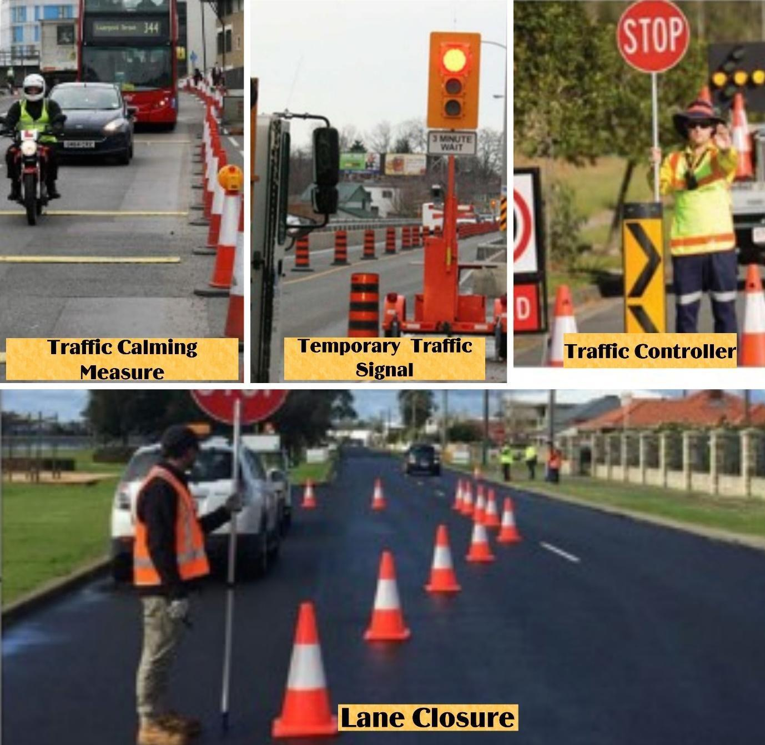

Safety Hazards from Construction Works
Construction activities present several community health and safety risks, particularly to the local community, road users (including pedestrians and cyclists), students at nearby schools, and patients and visitors to healthcare facilities. Key risks are associated with:
- Road widening and urban placemaking works.
- The construction of new terminals and other transport infrastructure.
- Increased movement of heavy construction vehicles and machinery.
- Open excavations, material stockpiles, and changes to familiar routes.
Key areas of concern include schools, healthcare facilities (like JDWNRH), cultural heritage sites, and commercial areas near any construction zone.
Mitigation:
The following mitigation measures, to be detailed in the Contractor's Community Health and Safety Plan, will be implemented:
- Site Security and Access Control:
  - Barricade all excavations (e.g., trenches, foundations) with hard fencing and clear warning signs to prevent accidental falls.
  - Secure construction sites, material stockpiles, and storage yards to prevent unauthorized public access, particularly by children.
- Traffic and Pedestrian Safety:
  - Strictly implement the Traffic Management Plan (TMP) as described in Section 6.6.4.2, focusing on the safety of all road users.
  - Provide safe, clearly marked, and well-lit temporary pedestrian pathways and crossings, especially near schools and hospitals. These paths must be designed with universal access principles where they lead to sensitive facilities like hospitals.
  - Implement and enforce strict speed limits for all construction vehicles both on-site and on public roads.
- Public Awareness and Engagement:
  - Conduct public awareness campaigns to inform the community about construction activities, associated hazards, and safety measures in place.
  - Schedule disruptive construction activities during off-peak hours or school holidays where feasible, following consultation with affected sensitive receptors like schools and hospitals.
- Monitoring and Supervision:
  - Regularly monitor the effectiveness of all safety measures and adjust them as needed to respond to emerging issues or public feedback received through the Grievance Redress Mechanism (GRM).

Restriction of Access
Civil works associated with road widening for the BPS and the urban placemaking improvements on Norzin Lam will temporarily hinder or restrict access to essential facilities, including hospitals, schools, businesses, and residential areas. These impacts will be particularly significant in densely developed urban zones.
Mitigation:
To manage and minimize access-related disruptions, the following mitigation measures will be implemented:
- Maintaining Access:
  - Pedestrian Access: Provide and maintain safe, clearly marked, and accessible temporary pedestrian paths and crossings to ensure continuous access to all facilities, especially schools, hospitals, and businesses.
  - Vehicular Access: Where feasible, maintain vehicular access for residents and business deliveries through carefully sequenced construction. Emergency vehicle access to critical facilities like hospitals will be maintained at all times.
- Coordination and Scheduling:
  - Coordinate closely with Thimphu Thromde and the Royal Bhutan Police (Traffic Division) to plan and manage any necessary access restrictions.
  - Schedule activities that severely restrict access during off-peak hours or in segments to minimize the duration and extent of the disruption. The scheduling will consider the specific needs of the community, such as avoiding major disruptions during festivals or other important local events.
- Stakeholder Communication and Engagement:
  - Implementation of the SEP: The contractor, under the supervision of the PIU, will implement all relevant measures outlined in the project's Stakeholder Engagement Plan (SEP).
  - Proactive Information Disclosure: Engage in continuous and proactive communication with the management of all affected facilities (hospitals, schools) and directly with affected businesses and residents. Provide information well in advance regarding construction schedules, planned access changes, alternative access arrangements, and the timing of any potential service disruptions.
  - Dedicated Liaison: A dedicated Community Liaison Officer (CLO) will be appointed by the contractor. The CLO's contact information will be publicly disclosed at all worksites and through community channels, serving as the primary point of contact for all public queries and concerns related to construction activities.

ESS6 (Biodiversity Conservation and Sustainable Management of Living Natural Resources) – Related Impacts and Mitigation Measures
The project's strategy for managing impacts on biodiversity is explicitly structured around the Mitigation Hierarchy (Avoid, Minimize, Restore, Offset) as required by the World Bank's Environmental and Social Standard 6 (ESS6).
Application of the Mitigation Hierarchy
- Avoidance: The project actively sought to avoid biodiversity impacts during the design phase. The BPS corridor was aligned along the existing road network to avoid clearing pristine habitats, and the engineering design was specifically adjusted in locations like Dechencholing to preserve a large, mature Oak tree.
- Minimization: Where impacts could not be avoided, their scale was minimized by reducing the construction footprint to the absolute necessary for safe and efficient work.
- Restoration: The project includes mandatory restoration of all temporarily disturbed areas and a significant landscaping component with native species at the new bus terminals and along Norzin Lam.
- Offset (Compensation): For the unavoidable residual impact of tree loss, a robust compensatory afforestation program will be implemented, as detailed below.

Site-Specific Impacts on Biodiversity
- Terrestrial Habitats and Flora:
  - Along the Road Corridor: The primary direct impact on flora is the required removal of 309 trees (73 mature, 72 poles, 164 saplings) for road widening. While no trees will be removed from within the State-Reserved Forest, vegetation clearing in other urban and peri-urban areas will result in a localized loss of habitat.
  - At New Bus Terminal Sites: The construction of the Ngabiphu and Dangrina terminals will involve the complete clearing of existing vegetation, representing a permanent conversion of semi-natural land to an industrial facility and a direct loss of local habitat.
  - Adjacent to the State-Reserved Forest: The 0.8 km section of road widening between Taba and Dechencholing is of particular sensitivity. Construction noise, dust, and light pollution in this area can cause temporary disturbance to the behaviour of common local fauna like Wild Pig and Barking Deer that inhabit the adjacent forest.
- Aquatic Ecosystems:
  - At bridge Locations (Pamtsho and Dechencholing): The widening of the two bridges will involve direct in-stream works (e.g., for piers and abutments). These activities can physically disturb the riverbed and banks, which are habitats for native fish species like the Snow Trout. This can also lead to increased sedimentation and turbidity, negatively impacting aquatic life downstream.
  - Along the Entire Corridor: Land clearing and earthworks for road widening, especially on slopes, can lead to soil erosion. Runoff from these areas can increase sedimentation in the Wang Chhu River and its tributaries, degrading water quality and harming aquatic habitats.
Mitigation
To address these impacts, the Contractor will be required to develop and implement a site-specific Biodiversity Management Plan (BMP) as part of their C-ESMP. The BMP must be approved by the PIU/PMSC before any site clearing begins and will include the following integrated mitigation measures:
- Vegetation Management (Responsibility: Contractor for Felling; Thimphu Thromde for Plantation)
- Tree Removal Protocol: The Contractor will only fell trees that have been officially marked by the Department of Forests and Park Services (DoFPS) and for which all permits have been obtained.
- Compensatory Afforestation: Thimphu Thromde will implement a compensatory plantation of at least 1,000 native and ecologically appropriate trees (a >3:1 offset ratio). The program will include a minimum 80% survival rate target, with long-term monitoring and maintenance to ensure the offset is effective.
- Fauna and Habitat Protection (Responsibility: Contractor)
- Habitat Disturbance Control: For works near the State-Reserved Forest, the Contractor will implement enhanced noise and light pollution control measures.
- Pre-Construction Screening: Before clearing vegetation at the terminal sites, a qualified specialist will conduct field screenings to repel or safely relocate any fauna.
- Worker Code of Conduct: A strict, zero-tolerance ban on hunting or disturbing wildlife will be enforced for all project personnel.
- Aquatic Ecosystem Protection (Responsibility: Contractor)
- In-stream Works Protocol: All in-stream works at the bridge sites will be conducted strictly during the low-flow season (November to March) using robust sediment controls like silt curtains and coffer dams.
With the implementation of these comprehensive mitigation measures, the residual impacts on biodiversity are assessed as Minimal to Low.

Impact on Fauna from Construction and Installation Activities
Based on baseline information, construction activities could temporarily impact local fauna, primarily through habitat disturbance. The potential impacts from the Urban Transport component include temporary disturbance from noise, vibration, and light, which could affect the natural behaviour of fauna and bird species.
- Site-Specific Considerations:
  - The risk of disturbance is highest at the new terminal sites at Ngabiphu and Dangrina and along the forested section of the road near Taba. These areas support populations of common, adaptable wildlife such as Wild Pigs and Barking Deer.
  - While these species are not nationally or internationally threatened, they are protected under national law, and the habitats they occupy are considered sensitive.
Mitigation
To manage these impacts, the Contractor will be required to implement a Fauna Management Plan as part of their C-ESMP. This plan will detail the following mitigation measures, to be applied particularly in the sensitive areas identified above:
- Habitat Disturbance Control:
- Utilize best practices to minimize noise and light pollution during construction. This includes fitting all machinery with effective silencers and reducing the duration and intensity of artificial lighting, especially for any works near the State-Reserved Forest.
- Pre-Construction Screening:
- Prior to any site clearing at the Ngabiphu and Dangrina terminal locations, conduct pre-construction field screenings to repel, rescue, or safely relocate any fauna from the immediate work site.
- Worker Code of Conduct:
- Enforce a strict, project-wide Code of Conduct for all workers that includes a zero-tolerance policy and an absolute ban on hunting, poaching, and unnecessary disturbance to wildlife. Any violation of the Code of Conduct will lead to strict penalties, including termination of employment.
With the implementation of these mitigation measures, the residual impacts on fauna have been assessed as minimal.

Potential Indirect and Cumulative Impacts on Biodiversity
In addition to the direct impacts from construction, the project has the potential to contribute to indirect and cumulative impacts on the broader biodiversity of the Thimphu valley, in alignment with the holistic assessment requirements of ESS6.
Indirect Impacts
Indirect impacts are those not caused by the project's physical footprint but result from project-induced activities. The primary indirect impacts from the urban transport components are:
- Sensory Disturbance to Adjacent Habitats (Edge Effects):
  - State-Reserved Forest: Construction activities along the 0.8 km section adjacent to the State-Reserved Forest near Taba can create significant "edge effects." Increased noise, dust, and human presence can deter sensitive fauna from using the habitat immediately bordering the construction corridor, effectively reducing the usable habitat area even without direct encroachment.
  - Thimphu Wetlands (KBA): Although the BPS route runs on the opposite side of the river and downslope from the Thimphu Wetlands Key Biodiversity Area (KBA), intense construction noise and activity could cause sensory disturbance to bird species within the KBA, particularly the vulnerable Wood Snipe for which the area is designated.
Cumulative Impacts
Cumulative impacts result from the incremental effect of the LRCP's impacts when combined with other past, present, and reasonably foreseeable future developments in Thimphu.
- Urban Habitat Fragmentation: While the LRCP's individual contribution to habitat fragmentation is minor as it largely follows existing alignments, it is part of a broader trend of urban expansion. The cumulative effect of the LRCP, combined with ongoing private construction and other infrastructure upgrades, contributes to the gradual fragmentation of green corridors within the city. This can isolate small pockets of habitat and impede the movement of common, adaptable urban wildlife.
Mitigation for Indirect and Cumulative Impacts
While the project's direct mitigation measures will also help to reduce these broader impacts, specific actions include:
- For Indirect Impacts: The Community Health & Safety Plan for the works near the State-Reserved Forest and opposite the KBA will include enhanced noise control measures (e.g., use of temporary noise barriers where feasible, scheduling of the noisiest activities) to minimize sensory disturbance to adjacent habitats.
- For Cumulative Impacts: The LRCP contributes positively to mitigating cumulative impacts by promoting a more sustainable, compact urban growth model centered on public transport. By enhancing the viability of public transit, the project helps to reduce the pressure for sprawling road networks that would otherwise lead to greater habitat fragmentation.

Spread of Invasive Alien Species (IAS)
Potential Impacts
Invasive alien species (IAS) present a significant risk to local biodiversity by outcompeting native flora. The primary vectors for the unintentional introduction or spread of IAS on this project are the movement of construction machinery and the transport of excavated soil from one area to another.
- Site-Specific Considerations: The risk is particularly relevant when machinery and soil are moved from potentially infested peri-urban areas (such as the new terminal sites) into or through more ecologically sensitive areas, like the corridor adjacent to the State-Reserved Forest near Taba.
Mitigation
To prevent the spread of IAS, the Contractor will be required to implement the following mitigation measures:
- Vehicle and Machinery Hygiene Protocol:
- All construction vehicles and machinery must be thoroughly cleaned to remove soil and vegetative debris and certified as "clean" by the Contractor's Environmental Officer before being brought to the project area for the first time.
- Regular cleaning protocols will be established for all equipment moving between different major work sites within the project area to prevent cross-contamination.
- Soil Management Protocol:
- Excavated soil will be reused as close to its source as possible. Any soil transported for use or disposal at another location must be visually inspected for signs of IAS.
- Topsoil from areas known to have IAS infestations will be stockpiled separately and will not be used for landscaping in other areas.
- Site Rehabilitation and Monitoring:
- All disturbed areas will be rehabilitated promptly using native, non-invasive species.
- The Contractor's Environmental Officer will be responsible for regularly monitoring all work sites, material stockpiles, and construction vehicle parking areas for the emergence of any new IAS infestations, and for implementing immediate control measures if any are found.
With the implementation of these mitigation measures, the residual impacts from the spread of IAS have been assessed as minimal.

ESS8: Cultural Heritage – Related Impacts and Mitigation Measures

Potential Impacts on Cultural Heritage
The project is designed to avoid direct physical impacts on known cultural heritage sites. However, construction activities for the urban transport and public space components will occur in close proximity to several important sites. The primary impacts are indirect and temporary, stemming from construction activities near identified cultural heritage sites, including:
- Dangrim Chorten (near KM 3.99)
- National Memorial Chorten (near KM 6.76)
- Hejo Chorten (near KM 10.86)
- Dechencholing Palace (near KM 14.75)
- Dolma Lhakhang / Pangrizampa (near KM 16.09)
Potential indirect impacts on these sites include:
- Disruption of Access and Ambiance: Temporary access restrictions, traffic diversions, construction noise, and dust can affect the experience of visitors and worshippers.
- Vibrations and Structural Integrity: The use of heavy machinery near sensitive areas—such as the Memorial Chorten, located over 50 meters from the planned road widening near JDNR Hospital—could generate ground vibrations that may threaten the stability of older buildings.
- Visual Intrusion: The presence of construction equipment and worksites may temporarily impact the aesthetic setting of these heritage sites.
The project is designed to avoid direct physical impacts on known cultural heritage sites. However, construction activities for the Urban Transport component will occur in proximity to several important sites, and the associated excavation carries a risk of encountering unknown resources.
The primary impacts are indirect and temporary, stemming from construction activities near identified cultural heritage sites, including:
- Dangri Chorten (KM 3.99)
- National Memorial Chorten (KM 6.76, and near Norzin Lam)
- Hejo Chorten (KM 10.86)
- Dechencholing Palace (KM 14.75)
- Dolma Lhakhang / Pangrizampa (KM 16.09)
Potential indirect impacts on these sites include:
- Disruption of Access and Ambiance: Temporary access restrictions, traffic diversions, construction noise, and dust can affect the experience of visitors, worshippers, and residents, potentially disrupting cultural and religious practices.
- Vibrations and Structural Integrity: While unlikely, heavy machinery operating in close proximity could cause ground vibrations, posing a negligible but monitored risk to older structures.
- Visual Intrusion: The presence of construction equipment and worksites may temporarily impact the aesthetic setting of these heritage sites.
Mitigation Measures
As part of their C-ESMP, the contractor will be required to prepare and implement a Cultural Heritage Management Plan. This plan will detail the following measures:
- Access Management: In consultation with site authorities (e.g., management of the Memorial Chorten) and the Department of Culture and Dzongkha Development (DCDD), the contractor will implement traffic and pedestrian management plans to ensure safe and clearly marked alternative access routes are maintained for visitors and worshippers at all times.
- Control of Construction Nuisances: Strict dust suppression and noise reduction protocols will be enforced in the vicinity of all heritage sites, including scheduling high-noise activities to avoid prayer times or other sensitive periods, as identified through consultation.
- Vibration Monitoring and Control:
  - Pre-Construction Survey: Before starting work near sensitive structures like the Memorial Chorten, the contractor will conduct a pre-construction condition survey to document the existing state of the structure.
  - Vibration Limits: The contractor will adhere to internationally recognized vibration limits for sensitive and heritage structures to prevent any structural damage.
  - Monitoring: During works with high-vibration potential (e.g., rock breaking, heavy compaction) near these sites, the contractor will conduct vibration monitoring to ensure that levels remain within the prescribed safe limits.
  - Control Measures: If monitoring indicates that vibration levels are approaching the limits, the contractor will be required to modify construction methods (e.g., using smaller equipment, alternative rock-breaking techniques) to reduce the impact.
- Stakeholder Engagement: Proactive communication with religious bodies, site managers, and the public will be maintained to provide advance information on construction schedules and mitigation measures.

Risk Management of Chance Finds
Given that excavation will occur for both transport (road widening) and water (pipeline trenching) components, there is a risk of discovering previously unknown Physical Cultural Resources (PCR). A formal Chance Finds Procedure (CFP) will be included in all contractor bidding documents and contracts.
The contractor is mandated to train all staff, especially equipment operators and those involved in excavation, on how to recognize potential artifacts and on the procedures to follow. This training will be supported by the DCDD.

Chance Finds Procedure:
- Immediate Actions Upon Discovery:
- Halt Work: Immediately stop all construction activities in the vicinity of the find.
- Secure the Area: The site supervisor will secure the location to prevent unauthorized access, damage, or theft.
- Notify: The PIU and the Department of Culture and Dzongkha Development (DCDD) must be notified immediately.
- Assessment and Evaluation:
- Do Not Disturb: The discovered object(s) shall not be removed or altered by project staff.
- Expert Evaluation: The DCDD will dispatch a designated expert to assess the significance of the find.
- Develop Action Plan: Based on the expert's evaluation, the DCDD will determine the appropriate course of action, which may include professional excavation, relocation, or reservation in-situ, requiring an adjustment of project plans.
- Resumption of Work:
- Construction activities may only resume in the area after the DCDD has provided official clearance.
- Reporting and Documentation:
- A detailed report, including photographs and GPS coordinates of the find, will be prepared and submitted to the PIU and DCDD. This will be included in the project's regular environmental and social monitoring reports.

Operational Phase: Risks, Impacts, and Mitigation Framework

Workers' Health and Safety during Infrastructure Maintenance Works (O&M Phase)
Routine and periodic maintenance of the BPS road corridor, urban placemaking infrastructure, drainage systems, and bus shelters will expose maintenance workers to OHS risks. These include hazards from working in or near live traffic, noise exposure, handling materials, and working at height.
Mitigation
The responsibility for O&M of this infrastructure lies with TT, either through its in-house teams or appointed maintenance contractors. The following mitigation measures, which are compliant with Bhutan's OHSW Regulation, 2022, will be implemented:
- O&M Phase Health and Safety Plan: TT will ensure that a comprehensive, site-specific OHS Plan is developed and implemented for all maintenance activities. This plan will include risk assessments for all routine tasks.
- Safe Work Zone Procedures: For any works on or near active roadways, the following will be mandatory:
  - Traffic Management: Implementation of a clear traffic management plan, including the use of proper signage, barriers, cones, and flag persons to regulate traffic flow and protect workers.
  - Work Zone Demarcation: Establishment of clearly delineated and protected safe work zones to separate workers from live traffic.
  - Worker Training: All maintenance staff will receive regular training on the specific hazards of working in operational environments and on the correct procedures for establishing safe work zones.
- Personal Protective Equipment (PPE): All maintenance workers will be provided with and required to use appropriate PPE, including high-visibility safety apparel, helmets, and safety boots.

Workers' Health and Safety during Bus Services Operation (O&M Phase)
Potential OHS risks for bus drivers and maintenance staff include handling electric buses and charging infrastructure, traffic management hazards, and emergency situations at terminals or along routes.
Mitigation
The following mitigation measures will be implemented for Bus Services:
- Implementation of traffic control measures (signals, signage) to manage traffic flow and enhance safety.
- Design of bus stops, terminals, and pedestrian pathways for accessibility and safety.
- Installation and maintenance of fire safety and emergency facilities at terminals and on buses.
- Training programs for staff and drivers on safe operation and maintenance, environmental standards, and emergency response.

Resource Efficiency during O&M
Resource efficiency is crucial for the long-term sustainability of both the transport and water components of the LRCP.
Mitigation (Transport Component):
- Energy-Efficient Technologies: Use energy-efficient lighting (LEDs) for streetlights, terminals, and depots; energy-efficient HVAC systems in buildings.
- Water Conservation (Transport Facilities): Install water-efficient fixtures in terminals and maintenance facilities. Implement rainwater harvesting where feasible.
- Eco-Friendly Maintenance Practices: Use biodegradable lubricants and fluids for bus maintenance. Proper handling and disposal of hazardous maintenance waste.
- Green Procurement: Favor environmentally friendly and sustainable products for construction and O&M.
- Monitoring and Improvement: Regularly assess resource usage and environmental performance.
With these measures, the residual impacts on resource efficiency during O&M are expected to be positive (for water loss reduction) or negligible to low for other aspects.

Greenhouse Gas Emissions
Transportation plays a major role in Bhutan’s greenhouse gas (GHG) emissions and air pollution, contributing 30% of total emissions in 2015, with projections rising to 47% by 2030—primarily from road vehicles. The LRCP’s move from diesel to 50 electric buses offers a valuable chance to cut these emissions. The evaluation of the GHG impact of the introduction of the fleet of electric buses is summerized in below.
Baseline GHG Emissions
For the purpose of estimating net GHG reductions, the baseline scenario assumes the operation of 50 new Euro-6 (BSVI) compliant diesel buses, rather than the older, pre-BSIV buses currently in service. This provides a conservative and modern comparison point. These emissions, estimated based on the following parameters, are given in Table 15.
- Daily Mileage per Bus: 180 km
- Number of Buses: 50
- Total Daily Mileage: 7,200 km
- Fuel Efficiency (km/liter): 2.49
- Daily Fuel Consumption (liter): 2,892
Table 15: Estimated Baseline Air Emissions from BPS Operations
Parameter | CO | NOx | THC | CO2
Emission Factor (g/km) | 1.885 | 1.613 | 0.025 | 1,037.85
Daily Mileage (50 buses@180 km/day) | 9000 | 9000 | 9000 | 9000
Yearly working days | 365 | 365 | 365 | 365
Emissions  (tonne/year) | 6.12 | 5.3 | 0.8 | 3,409
Source: Adapted from Detailed Design Report of BGTP, 2023
Project GHG Emissions
The electric buses procured under the LRCP run on electricity, producing zero tailpipe emissions of CO, NOx, PM, and methane. The daily electricity consumption of the 50-bus fleet is estimated to be about 7,500 kWh (with 1.2 km/kWh electricity efficiency). As the power source in Bhutan is predominantly hydropower, the emissions from the generation of electricity supplied to the buses are considered negligible.
Net Emissions
The project's net emissions are calculated as the project emissions minus the baseline emissions. Therefore, the project will result in a net reduction of all the emissions quantified in the baseline scenario presented above.
Significance of Residual Impact: High Positive for transport.

Generation of Waste During Operation
During the operational phase, the urban transport components will generate several types of waste streams that require proper management.
. Waste Streams
- Hazardous Waste:
  - E-Bus Related: Spent lithium-ion batteries.
  - Maintenance Related: Used oil, filters, solvents, and other hazardous materials from vehicle maintenance.
- Non-Hazardous Solid Waste:
  - Maintenance Related: Used tires, scrap metal, and other non-hazardous parts.
  - Operational Waste: General solid waste from bus terminals and depots (e.g., office waste, packaging, passenger-generated waste).
Mitigation Measures
The following mitigation measures will be implemented by the responsible agencies (CBS for fleet and terminals, TT for infrastructure).
- Hazardous Waste Management:
- Sustainable Battery Management: The procurement contract for electric buses will include a mandatory clause requiring the supplier to establish a battery take-back program for the responsible recycling or disposal of end-of-life batteries.
- Maintenance Waste: All hazardous waste from vehicle maintenance will be collected in designated, properly labelled, and contained storage areas. Disposal will be handled exclusively by licensed hazardous waste management contractors.
- Solid Waste Management:
- Waste Reduction and Segregation: Waste segregation bins will be installed and maintained at all bus terminals, depots, and major bus stops to encourage the separation of recyclable materials.
- Collection and Disposal: A regular schedule for waste collection will be established in coordination with Thimphu Thromde's municipal waste services to ensure proper disposal.
- Infrastructure Materials: A system will be established to collect and sort waste from infrastructure maintenance (e.g., old signage, damaged shelter parts) for recycling or reuse where feasible.
- General Measures:
- Public Awareness: Educational campaigns will be conducted to encourage passengers and staff to practice proper waste disposal and segregation.
- Regular Waste Audits: Periodic waste audits will be conducted at depots and terminals to identify opportunities for waste reduction and to improve the efficiency of the waste management system.

Wastewater Discharges during Operation
Transport Component: Routine cleaning and maintenance of buses and facilities at the central bus station/depots could generate wastewater containing oils, grease, detergents.
Mitigation:
- A wastewater treatment facility (including oil-water separators and filtration) designed for the bus maintenance facility at CBS will be constructed/operational.
- Use of eco-friendly cleaning products.
- Staff training on wastewater management. Regular monitoring and maintenance of treatment systems.
- Water conservation measures during washing.
With the above mitigation measures, the residual impacts are assessed as negligible.

Community Health and Safety during O&M
During the operational phase of the LRCP, potential community health and safety risks will primarily stem from the increased public transportation activity and new traffic dynamics introduced by the project.

Specific Risks during Operation
- Traffic Accidents: Increased bus traffic along the BPS corridor and changes to road layouts may increase the risk of accidents, particularly at intersections and new pedestrian crossings.
- Safety of Vulnerable Groups: Pedestrians, especially children, the elderly, and persons with disabilities, may face heightened risks from the new traffic patterns if not managed properly.
- Gender-Based Risks and SEA/SH: Overcrowding on buses and poorly lit or monitored areas at bus stops and terminals can increase the risk of discomfort, harassment, and SEA/SH for commuters, particularly women and girls.
Mitigation Measures
General Mitigation Measures for Traffic and Community Safety:
- Comprehensive Safety Plans: Implementing and enforcing comprehensive traffic management and safety plans, including clear signage, traffic signals, speed limits, and regular safety audits of the BPS network.
- Safe Pedestrian Crossings: Ensuring all 23 signalized pedestrian crossings are properly maintained and functional.
- Capacity Building: Conducting continuous training programs for bus drivers and staff on defensive driving, safety protocols, and customer service.
- Emergency Collaboration: Maintaining strong collaboration with the Royal Bhutan Police and emergency services to ensure rapid response to any incidents.
- Public Awareness: Implementing ongoing public awareness campaigns on road safety and the proper use of the new transport infrastructure.
Specific Mitigation for Vulnerable Groups and Gender-Related Risks:
A comprehensive Gender Action Plan (GAP) has been prepared for the project to ensure a gender-sensitive and inclusive approach to community safety. The implementation of the GAP, overseen by the PIU and PMU, is a core mitigation strategy. Key interventions linked to the project's indicators include:
- Maintaining Universal Access: Ensuring all universal access features—such as low-floor buses, ramps, and tactile paving—are kept in excellent working order to guarantee accessibility for persons with disabilities and the elderly. This directly supports the project's objective of enhancing inclusive mobility.
- Enhancing Safety and Security: Implementing GAP actions designed to improve safety, particularly for women. This includes ensuring adequate lighting at all bus stops and terminals and maintaining functional CCTV systems on buses. Progress will be monitored against GAP indicators related to women's perception of safety in public transport.
- SEA/SH Prevention and Response: The project's SEA/SH Prevention and Response Action Plan will remain active during the operational phase. This includes ensuring the project's Grievance Redress Mechanism (GRM) is accessible to commuters for reporting any incidents of SEA/SH, with clear signage on buses and at terminals providing information on how to report.
- Feedback and Monitoring: Actively engaging with vulnerable groups through periodic surveys and consultations to monitor their access to and perception of the new services. This feedback mechanism is linked to the Project Development Objective (PDO) indicator on user satisfaction, disaggregated by gender and vulnerable groups.

Maintenance of Washrooms and Drinking Water (Primarily Transport Terminals)
Maintaining commuter facilities like drinking water and toilets in bus terminals is crucial for passengers, workers, and bus drivers.
Mitigation:
(These measures are mainly for transport terminals, but principles of hygiene and facility maintenance can apply to any worker facilities in the water sector.)
- Regular Maintenance Schedules: For terminal facilities.
- Promote Hygiene Awareness: Signage in restrooms and around water facilities.
- Adequate Facilities for Workers and Drivers: Separate, well-maintained restrooms.
- Regular Feedback and Improvement: On the condition of terminal facilities.
By adopting these comprehensive mitigation measures across both urban transport and water sector components, the LRCP aims to minimize adverse impacts on community health and safety during both construction and operation phases.

Climate Change Adaptation Measures during the Operational Phase of the LRCP
The operational phase of the LRCP is critical for ensuring that the climate resilience measures integrated during design and construction are effective and sustained over the project's lifetime. The following adaptation measures will be implemented by Thimphu Thromde (TT) and the City Bus Service (CBS) to manage ongoing and emerging climate risks.

Adaptive Management of Transport Infrastructure
- Proactive Drainage Maintenance: TT will implement a climate-focused drainage maintenance schedule, including mandatory, city-wide pre-monsoon cleaning of all project-related drains, culverts, and sediment traps by May of each year. Following any major storm event, TT maintenance teams will conduct rapid inspections to clear blockages and assess any damage.
- Slope and Bioengineering Maintenance: TT will conduct annual inspections of all slope stabilization works. Maintenance will include re-seeding bare patches, clearing debris, and making necessary structural repairs to ensure their continued effectiveness against climate-induced landslides.
- Heat-Resilient Pavement Management: TT will monitor the performance of heat-resistant pavements installed under the project through regular visual inspections, especially during peak summer months, to check for signs of heat-related degradation.

B. Institutional and Community-Level Adaptation
- Early Warning System Integration and Public Communication:
  - TT and CBS will establish protocols to receive and act upon extreme weather warnings from the National Centre for Hydrology and Meteorology (NCHM).
  - In the event of a flood or severe storm warning, a public communication plan will be activated, using social media, public announcements at terminals, and on-bus displays to warn commuters of potential service disruptions or road closures.
- Capacity Building for O&M Staff: All O&M staff from both TT and CBS will receive regular refresher training on climate-related emergency response procedures. This will include protocols for managing the BPS during extreme weather and ensuring public safety.
- Continuous Monitoring and Review: The TT/PIU will conduct an annual review of the LRCP's operational performance against climate-related events. This review will assess the effectiveness of the implemented adaptation measures, identify any new climate vulnerabilities, and recommend adaptive changes to operational or maintenance plans, ensuring the project remains resilient in a changing climate.

Positive Impacts and Project Benefits
The LRCP’s designed to generate significant, long-term positive impacts that directly address key urban challenges in Thimphu. The benefits enhance environmental quality, social equity, economic opportunity, and climate resilience, aligning with Bhutan's national development goals. The positive impacts are organized by the project's main components.

Benefits from the Urban Transport Component
The LRCP’s designed to generate significant, long-term positive impacts that directly address key urban challenges in Thimphu. The benefits will enhance environmental quality, social equity, economic opportunity, and climate resilience, aligning with Bhutan's national development goals.
Key benefits from the project's investments include:
- Enhanced Urban Mobility and Accessibility: The creation of an 18.7 km BPS corridor, serviced by a modern fleet and supported by upgraded terminals and 75 new bus stops, will provide a faster, more reliable, and efficient public transport alternative. This will directly benefit daily commuters by reducing travel times and improving punctuality. The project's focus on universal design, including accessible buses and pedestrian pathways, will significantly enhance mobility for persons with disabilities, the elderly, and caregivers with children.
- Improved Air Quality and Public Health: The replacement of conventional diesel buses with a fleet of 50 zero-emission electric buses will lead to a direct and measurable reduction in localized air pollutants (like Particulate Matter and NOx) and greenhouse gas emissions along the city's main transport artery. This contributes to improved public health outcomes by reducing respiratory irritants and supports Bhutan's carbon-negative commitment.
- Safer and More Livable Public Spaces: The urban placemaking and complete street improvements along Norzin Lam will transform the city's core into a more pedestrian-friendly space. By prioritizing people over vehicles, this intervention will enhance safety, encourage walking, and boost the vibrancy and economic vitality of local businesses. The development of dedicated bus lanes on the main corridor is also expected to reduce overall traffic congestion and erratic driving, creating a safer road environment for all users.
- Increased Social Equity and Gender Equality: An affordable, safe, and reliable public transport system is a critical service that enhances social equity. It provides essential connectivity for all residents to access jobs, education, and healthcare. The project incorporates gender-sensitive design features in terminals and buses, as outlined in the Gender Action Plan (GAP). The improved mobility will particularly empower women and other vulnerable groups by providing safer and more reliable access to economic and social opportunities.

Assessment of Cumulative Impacts

Definition and Relevance of Cumulative Impacts
A Cumulative Impact (CI) is the impact on the environment that results from the incremental impact of the project when added to other past, present, and reasonably foreseeable future actions. While a single project's impact may be considered minor, the combined effect of multiple activities can become significant. For the LRCP, assessing cumulative impacts is highly relevant for two key reasons:
- Urban Growth Context: Thimphu is a dynamic and growing capital city. The LRCP will be implemented alongside numerous other developments, including private building construction and utility upgrades. The combined effect of these concurrent activities can exacerbate temporary construction-related impacts.
- Project-Induced Growth: Successful infrastructure projects can induce further development. An efficient BPS may accelerate residential and commercial growth in certain areas, leading to long-term cumulative effects on land use, traffic patterns, and demand for services.
Potential Cumulative Impacts
- Short-Term Cumulative Impacts (Construction Phase)
These temporary impacts can become significant if multiple projects are implemented concurrently without coordination.
- Increased Traffic Congestion and Network Disruption: The LRCP will involve works on major arterial routes (BPS corridor) and within the city core (Norzin Lam). When combined with other, unrelated road works or building construction, this could lead to widespread traffic disruption and reduced accessibility across the city network.
- Degradation of Ambient Air Quality: Dust and emissions from the LRCP's machinery will combine with those from other construction sites, potentially leading to a temporary deterioration of ambient air quality in localized "hotspots."
- Elevated Noise and Vibration Levels: The cumulative effect of noise from multiple construction sites operating concurrently can create a persistent, elevated ambient noise environment, a particular concern for sensitive receptors like schools and hospitals.
- Cumulative Impacts on Cultural Heritage Sites: If other public or private construction projects occur simultaneously near major landmarks like the National Memorial Chorten, the combined, prolonged effects of noise, dust, vibration, and access restrictions could cumulatively degrade the visitor experience and ambiance of these important sites more significantly than the LRCP's impact alone.
- Combined Strain on Utilities and Services: Concurrent construction projects increase the collective risk of accidental damage to public utilities (power, telecommunications) and may strain municipal services like waste disposal.
- Long-Term Cumulative Impacts (Operational Phase)
- Induced Urban Development and Land Use Change: The enhanced accessibility provided by the LRCP may encourage new residential and commercial development, particularly near BPS terminals. This can lead to long-term changes in land use and population density, which must be managed through effective urban planning.
- Shift in City-Wide Traffic Patterns: The BPS is designed to encourage a modal shift from private vehicles to public transport, a significant positive cumulative impact. It will also alter traffic patterns on both the main corridor and adjacent feeder roads, requiring ongoing monitoring and management by city authorities.
Mitigation and Management of Cumulative Impacts
Addressing cumulative impacts requires strong inter-agency coordination. The primary mitigation strategy will be:
- Coordinated Planning and Permitting: Thimphu Thromde, as the lead Implementing Agency for key components and the city's planning authority, is uniquely positioned to manage cumulative impacts. The Project Implementation Unit (PIU) will:
  - Establish a coordination mechanism with other municipal departments to map and schedule all planned public and private construction works.
  - Review and phase permits for construction activities on major thoroughfares to avoid simultaneous disruptions in the same area.
- Enhanced Project-Level Mitigation in "Hotspot" Areas:
  - Traffic Management: The project's Traffic Management Plan (TMP) will be a dynamic document, enhanced with more robust diversion plans and intensified public communication in areas where other construction is ongoing.
  - Air and Noise Monitoring: In areas identified as cumulative impact "hotspots," supplementary air and noise quality monitoring may be undertaken to ensure that combined impacts do not excessively exceed thresholds.
- Stakeholder Communication: A coordinated communication strategy, led by Thimphu Thromde, will inform the public about all major planned construction activities across the city.
By implementing these measures, particularly the strategic coordination led by Thimphu Thromde, the potential for significant adverse cumulative impacts can be effectively managed.

Environmental and Social Management Plan (ESMP)
This chapter presents the Environmental and Social Management Plan (ESMP) for the urban transport and public space improvement components of the Livable and Resilient City Project (LRCP). This ESMP is the primary tool for implementing the project's environmental and social commitments and translates the findings of the ESIA into actionable mitigation and monitoring measures.

Scope of this ESMP:
It is important to note that this chapter specifically addresses the impacts and risks associated with the urban transport and public space improvement activities (sub-components 1.2 and 1.3). Due to the distinct nature of the water sector activities, a separate and standalone ESMP for the Water Sector Component (sub-component 1.1) has been prepared. That document will guide all works related to water infrastructure.
This ESMP is a living document, and its implementation is the responsibility of the Department of Human Settlement (DHS) and Thimphu Thromde (TT) as the lead implementing agencies, along with their appointed contractors and supervision consultants.

Objectives of the ESMP
The primary objective of this ESMP is to ensure the project is implemented in an environmentally and socially sustainable manner, in compliance with the Royal Government of Bhutan's regulations and the World Bank's Environmental and Social Framework (ESF).
The specific objectives are to:
- Provide a consolidated framework of practical and effective mitigation measures to address the potential impacts identified in the ESIA for the urban transport and public space components.
- Clearly define the roles and responsibilities for all parties involved in ESMP implementation, including the Project Management Unit (PMU), the Project Implementation Unit (PIU), supervision consultants, and contractors.
- Establish a detailed monitoring plan with specific parameters, frequencies, and responsibilities to track the implementation and effectiveness of mitigation measures.
- Outline the requirements for capacity building, training, and reporting to ensure adaptive management and continuous improvement.

Key Components of the Management Plan
The overall management framework for the LRCP is comprised of several integrated instruments, which collectively form the project's comprehensive approach to E&S management:
- Mitigation Plan: Details the specific actions to be taken to mitigate adverse impacts identified in the ESIA, linking them to project activities and responsible parties. Separate plans are provided for the construction and operational phases.
- Monitoring Plan: Outlines the parameters, methods, locations, frequency, and responsibilities for monitoring the effectiveness of mitigation measures and ensuring compliance with national standards and the ESF.
- Institutional Arrangements and Capacity Building Plan: Defines the organizational structure, roles, and responsibilities for ESMP implementation and identifies the training required to strengthen the capacity of the implementing agencies.
- Implementation Schedule and Cost Estimates: Provides an indicative schedule for the implementation of ESMP activities and a detailed budget for all E&S management, mitigation, and monitoring costs.
- Contractor Management Plans (C-ESMP): Requires contractors to prepare and implement their own detailed, site-specific management plans (C-ESMPs) in line with this overarching ESMP. The C-ESMP will include specific sub-plans such as an Occupational Health and Safety (OHS) Plan, a Traffic Management Plan, a Waste Management Plan, and others as required.
- Associated ESF Instruments: This ESMP is part of a broader suite of E&S instruments prepared for the project and should be read in conjunction with them. These include the Resettlement Action Plan (RAP), the Stakeholder Engagement Plan (SEP), the SEA/SH Prevention and Response Action Plan, and the overarching Environmental and Social Commitment Plan (ESCP).

Integration of ESMP into Bidding and Contract Documents
To ensure contractor accountability and effective implementation, this ESMP will be made a legally binding part of all bidding and contract documents for the LRCP civil works. Furthermore, the bidder's capacity and commitment to managing environmental and social (E&S) risks will be a key evaluation criterion during the procurement process.
The implementing agencies will ensure the following E&S requirements are included in the bidding documents and are assessed during bid evaluation:
- ESMP as a Core Document: The full ESMP will be included as an annex to the bidding documents, forming the basis of the contractor's E&S obligations.
- Evaluation of Past E&S Performance: Bidders will be required to submit information on their past performance on environmental, social, health, and safety (ESHS) aspects on previous projects of similar scale and complexity. This information will be a scored criterion in the technical evaluation. Bidders with a documented history of significant E&S non-compliance or contract termination for ESHS reasons may be disqualified.
- Evaluation of the Preliminary C-ESMP: Bidders are required to submit a preliminary Contractor's Environmental and Social Management Plan (C-ESMP) with their bid. This preliminary C-ESMP must demonstrate the bidder's understanding of the project's key risks and outline their proposed methodology for mitigation. The quality, specificity, and practicality of this preliminary C-ESMP will be a significant, scored component of the technical bid evaluation. Following the contract award, the successful contractor must develop a final, detailed C-ESMP for approval by the PIU/PMSC before any works commence.
- Evaluation of E&S Staffing and Resources: Bidders must propose a team of qualified and experienced Environmental, Social, and Occupational Health and Safety (OHS) officers. The qualifications and experience of the proposed personnel will be scored as part of the technical evaluation.
- Costing for ESMP Implementation: Bidders must provide a separate, itemized budget line in their financial proposal that clearly demonstrates they have allocated sufficient resources for the full implementation of all ESMP measures. The adequacy of this E&S budget will be reviewed as part of the overall bid evaluation.
- Code of Conduct for Contractor's Personnel: Bidders will be required to submit a draft Code of Conduct, which will be reviewed for compliance with project standards. The final, signed Code of Conduct will be a condition of contract.
Compliance with these E&S conditions will be a contractual obligation. Non-compliance may result in penalties, including suspension of work, as defined in the contract.
Table 16: E&S Conditions in the Bidding Documents
# | Condition | Rationale for Inclusion | Specifications to be Included in Bidding Documents | Responsibility
1 | Past E&S Performance & Disqualification | To ensure bidders have a demonstrated commitment to E&S compliance and are eligible for Bank-funded projects. | 1. Bidder Declaration (Mandatory Pass/Fail):  The Bidder must declare:  a) Any civil works contracts that have been suspended or terminated by an employer in the past five years for ESHS reasons.  b) That they are not subject to disqualification by the World Bank for non-compliance with SEA/SH obligations.  A failure to disclose or a declaration of disqualification will result in the bid being deemed non-responsive.  2. Past Performance Evaluation (Scored Criterion):  The Bidder shall provide detailed information on their ESHS performance on at least two previous projects of similar scale and complexity. This information will be a scored criterion in the technical bid evaluation. Higher scores will be awarded to bidders who can demonstrate a strong track record of successful E&S management, low incident rates, and positive client references for ESHS performance. | Bidder: To submit the required declarations and past performance documentation.  TT/PIU: To verify the declarations for eligibility and to evaluate and score the past performance information as part of the technical bid assessment.
2 | Contractor’s E&S Staffing | To ensure the contractor has qualified, on-site personnel to manage E&S risks effectively. | 1. Proposed E&S Team:  The Bidder shall propose a team of dedicated E&S staff, including at a minimum, a full-time Environmental Officer, Social Officer, and Occupational Health & Safety (OHS) Officer.  2. Submission of CVs and Qualifications:  The Bidder must submit the CVs of the proposed personnel. These staff must meet the minimum qualification criteria specified in the bidding documents (e.g., relevant degree, years of experience on similar infrastructure projects).  3. Evaluation of E&S Staff (Scored Criterion):  The qualifications and demonstrated experience of the proposed key E&S personnel will be a scored criterion in the technical bid evaluation. Bids that propose staff who exceed the minimum qualifications will be scored more highly.  The proposed staff will be named as "Key Personnel" in the final contract. | Bidder: To submit CVs and qualifications of proposed E&S staff.  TT/PIU: To review and approve the proposed staff as a condition of contract award.
3 | Code of Conduct (CoC) for Contractor’s Personnel | To ensure all project workers, including subcontractors, understand and adhere to the project's E&S standards, particularly regarding community interaction and SEA/SH prevention. | 1. Submission of a Draft Code of Conduct:  The Bidder shall submit a draft Code of Conduct (CoC) with their bid that will apply to all project personnel, including subcontractors.  2. Minimum Content Requirements: The submitted CoC must, at a minimum, include:  ● A zero-tolerance policy for SEA/SH, gender-based violence, and child abuse.  ● Rules for respectful interaction with local communities, prohibiting discrimination and harassment.  ● A ban on hunting, illegal logging, and wildlife disturbance.  ● A commitment to comply with all project OHS rules, including the use of PPE.  ● Confirmation that signing the CoC is a mandatory condition of employment and that all workers will receive training on its contents.  3. Evaluation of the CoC (Compliance Check): The submitted draft CoC will be reviewed during bid evaluation for full compliance with the minimum requirements. Bids that fail to submit a compliant CoC will be considered non-responsive. | Bidder: To prepare and submit a draft CoC with the bid documents.  TT/PIU: To review the draft CoC for compliance as part of the bid evaluation.  Contractor: To finalize, implement, and enforce the approved CoC upon contract award.
4 | Management Strategies & Implementation Plans (MSIP) / Contractor's ESMP (CESMP) | To ensure the bidder has a clear understanding of the project's key risks and has developed credible strategies to manage them. | 1. Submission of Preliminary Management Strategies (MSIP): The Bidder shall submit a set of preliminary Management Strategies and Implementation Plans (MSIP) or CESMP with their bid.  2. Content Requirements for C-ESMP: The CESMP must outline the bidder's specific methodology and resource allocation for managing the following key E&S risks, with a focus on the high-intensity impact areas:  ● Traffic Management Plan: Must include specific traffic control layouts for maintaining emergency vehicle access to JDWNRH Hospital and ensuring pedestrian safety around the schools on the BPS route.  ● Community Health & Safety Plan: Must detail enhanced noise, dust, and vibration control measures for the 3.9 km road widening segment and around other sensitive receptors.  ● Spoil and Waste Management Plan: Must include an estimated spoil balance and identify the specific haulage routes from the road widening segment.  ● Worker Accommodation Plan: Must describe the proposed location and management of worker camps, demonstrating compliance with the IFC/EBRD Guidance Note on Workers' Accommodation.  ● Site-Specific Environmental Plan: Must detail the plan for managing in-stream works at the Pamtsho and Dechencholing bridge sites and the erosion control plan for the new bus terminal sites.  3. Evaluation of CESMP (Scored Criterion): The quality, specificity, and practicality of the submitted CESMP will be a significant, scored component of the technical bid evaluation. Bids that demonstrate a superior understanding of the site-specific risks and propose more robust mitigation strategies will be scored more highly.  The awarded Contractor will be required to develop these strategies into a final, detailed Contractor's ESMP (C-ESMP) for approval by the PIU/PMSC prior to mobilization. | Bidder: To submit the preliminary MSIP along with the bid.  TT/PIU: To evaluate the MSIP as part of the bid assessment and to approve the final C-ESMP.
5 | Management Strategies & Implementation Plans (MSIP) / Contractor's ESMP (C-ESMP) | To ensure the bidder has a clear understanding of the project's key risks and has developed credible strategies to manage them. | The Bidder shall submit preliminary CESP with their bid. These plans must outline the bidder's specific approach, methodology, and resource allocation for managing the following key E&S risks for the LRCP, with a focus on the high-intensity impact areas:  1. Traffic Management Plan: Must include specific traffic control layouts for complex intersections, a plan for maintaining emergency vehicle access to JDWNRH at all times, and procedures for managing pedestrian access around the schools on the BPS route.  2. Community Health & Safety Plan: Must detail enhanced noise and dust control measures for the 3.9 km road widening segment and around sensitive receptors like SEN schools and hospitals. This includes specifying the type of noise barriers to be used and the proposed frequency of water sprinkling.  3. Spoil and Waste Management Plan: Must include an estimated spoil balance (volume generated vs. reused) and identify the specific haulage routes from the 3.9 km road widening section to the approved disposal sites, including measures to avoid peak hour traffic.  4. Worker Accommodation Plan: Must describe the proposed location and management of worker camps, demonstrating compliance with Bhutanese OHSW Regulations and the IFC/EBRD Guidance Note on Workers' Accommodation. It must also include measures to mitigate impacts on the local rental market.  5. Site-Specific Environmental Management Plan: Must include a plan for managing in-stream works at the Pamtsho and Dechencholing bridge sites (confirming work only in the low-flow season) and a robust erosion control plan for the large, exposed areas at the Ngabiphu and Dangrina terminal sites.  The awarded Contractor will be required to develop these strategies into a detailed, site-specific Contractor's ESMP (C-ESMP) for approval by the PIU/PMSC prior to mobilization. | Bidder: To submit the preliminary CESMP along with the bid.  TT/PIU: To evaluate the CESMP as part of the bid assessment and to approve the final C-ESMP.
6 | General ESMP Compliance | To legally bind the contractor to all mitigation and monitoring measures outlined in the project's overarching ESMP. | The Conditions of Contract shall explicitly state the following:  a) "The Contractor shall implement all mitigation and monitoring measures as specified in the project's overarching Environmental and Social Management Plan (ESMP) and as detailed in their own approved Contractor's ESMP (C-ESMP), both of which form an integral part of this contract.”  b) "The Contractor shall comply with both the Royal Government of Bhutan's national environmental and social laws and regulations and the World Bank Group's Environmental, Health, and Safety (EHS) Guidelines. Where there are differences, the more stringent provisions shall apply." | TT/PIU: To ensure these clauses are included in the final contract documents.

Pre-Construction Stage: Finalization of E&S Management Plans
The pre-construction stage is a critical mobilization phase that occurs after contract award but before the commencement of any civil works. During this period, the Contractor, under the supervision of the PIU/PMSC, must finalize and get approval for all site-specific management plans and mobilize the necessary resources. No physical construction activities are permitted until all conditions in this stage are met and approved by the PIU.
The key pre-construction requirements are detailed below in table 17.
Table 17 E&S Conditions and Deliverables for the Pre-Construction Stage
# | Condition / Deliverable | Rationale for the Requirement | Description of Action and Content | Responsibility
1 | Finalization and Approval of the Contractor's ESMP (C-ESMP) | The C-ESMP is the Contractor's primary tool for managing site-specific E&S risks and demonstrating how they will comply with the project's overall ESMP. | The Contractor will develop and submit a comprehensive, site-specific C-ESMP for review and approval by the PIU/PMSC. The C-ESMP must be based on the preliminary Management Strategies (MSIP) submitted with the bid and must include, at a minimum, the following detailed sub-plans:  ● Occupational Health & Safety (OHS) Plan  ● Community Health & Safety Plan  ● Traffic Management Plan (including for quarry material transport)  ● Waste Management Plan (for solid, liquid, and hazardous waste)  ● Pollution Management Plan (for air, noise, and water)  ● Labor Management Plan  ● Emergency Preparedness and Response Plan  ● Demobilization and Site Restoration Plan  The C-ESMP must be a dynamic document, subject to review and update at least every six months or as conditions change. | Implementation: Contractor  Supervision: TT/PIU, PMSC
2 | Mobilization of Contractor's E&S Staff | To ensure qualified personnel are on-site from the very beginning to oversee the implementation of all pre-construction activities and prepare for the construction phase. | The Contractor shall mobilize the E&S and OHS Officers whose CVs were approved during bidding. These personnel must be present on-site throughout the construction period and will lead the finalization of the C-ESMP.  The Environmental Officer will be responsible for pollution control, waste management, and biodiversity.  The Social Officer will oversee the Worker GRM, community engagement, SEA/SH prevention, and social impact management. | Implementation: Contractor  Supervision: TT/PIU, PMSC
3 | Finalization of Labour Management Procedures | To ensure all labour recruitment, management, and worker welfare practices are fully compliant with the project's LMP, World Bank ESS2, and Bhutan's Regulation on Working Conditions, 2022, before any hiring commences. | The Contractor will prepare a detailed Labour Management Plan as a key component of their C-ESMP. This plan must detail procedures for:  ● Fair and transparent recruitment, free from discrimination.  ● Prohibition of child and forced labour, including robust age verification.  ● Issuance of compliant employment contracts to all workers.  ● Finalization of a project-specific Code of Conduct (CoC) to be signed by all workers  ● Operationalization of the Worker's GRM. | Implementation: Contractor  Supervision: TT/PIU, PMSC
4 | Establishment of Construction Camp and Yard | To ensure that any areas required for camps, storage, and batching plants are sited and designed in an environmentally and socially responsible manner. | The Bidder shall submit preliminary Management Strategies and Implementation Plans (MSIP) with their bid. These plans must outline the bidder's specific approach, methodology, and resource allocation for managing the following key E&S risks for the LRCP, with a focus on the high-intensity impact areas:  1. Traffic Management Plan: Must include specific traffic control layouts for complex intersections, a plan for maintaining emergency vehicle access to JDWNRH at all times, and procedures for managing pedestrian access around the schools on the BPS route.  2. Community Health & Safety Plan: Must detail enhanced noise and dust control measures for the 3.9 km road widening segment and around sensitive receptors like SEN schools and hospitals. This includes specifying the type of noise barriers to be used and the proposed frequency of water sprinkling.  3. Spoil and Waste Management Plan: Must include an estimated spoil balance (volume generated vs. reused) and identify the specific haulage routes from the 3.9 km road widening section to the approved disposal sites, including measures to avoid peak hour traffic.  4. Worker Accommodation Plan: Must describe the proposed location and management of worker camps, demonstrating compliance with Bhutanese OHSW Regulations and the IFC/EBRD Guidance Note on Workers' Accommodation. It must also include measures to mitigate impacts on the local rental market.  5. Site-Specific Environmental Management Plan: Must include a plan for managing in-stream works at the Pamtsho and Dechencholing bridge sites (confirming work only in the low-flow season) and a robust erosion control plan for the large, exposed areas at the Ngabiphu and Dangrina terminal sites.  The awarded Contractor will be required to develop these strategies into a detailed, site-specific Contractor's ESMP (C-ESMP) for approval by the PIU/PMSC prior to mobilization. | Implementation: Contractor  Supervision: TT/PIU, PMSC
5 | Pre-Construction Training and Awareness | To ensure that all key personnel are fully aware of their E&S responsibilities before the project starts. | The Contractor’s E&S staff will develop and deliver a comprehensive Induction Training Program for all site personnel. The training must cover, at a minimum:  ● The OHSW Regulation, 2022  ● The project's Code of Conduct, with a focus on SEA/SH prevention.  ● The GRM process.  ● Emergency response procedures.  A clear schedule must ensure that no worker is granted site access without first completing this mandatory training. | Implementation: Contractor  Supervision: TT/PIU, PMSC

Construction Stage Mitigation Plan
This section presents the detailed mitigation plan for the construction phase of the LRCP, focusing on the specific risks associated with the urban transport and public space improvement components. The measures herein are based on the impact assessment in Chapter 6.
This plan is project-specific and, to the extent possible, site-specific. It will form a core part of the Employer’s Requirements in the bidding documents. The awarded contractor will be legally obligated to implement these measures by developing them into a detailed, site-specific Contractor's Environmental and Social Management Plan (C-ESMP). This C-ESMP must be reviewed and approved by the relevant implementing agency (DHS or TT/PIU) and the PMSC before the commencement of any civil works.
Table 18: E&S Impacts and Risks in Construction Mitigation Measures
# | E&S Aspect | Impacts | Mitigation Measures by Contractors
ESS2 (labour and Working Conditions) - Related
1 | Labour recruitment | Potential labour risks in the recruitment of workers | The Contractor's primary mitigation will be the strict implementation of the project's Labor Management Procedures (LMP). Key actions required under the LMP include:  ● Non-Discrimination and Equal Opportunity: Adhere to a zero-tolerance policy for discrimination in all aspects of employment (hiring, compensation, promotion, termination) and proactively prevent any form of harassment or exploitation.  ● Formal Employment Contracts: Provide all workers with written contracts in an understandable language, clearly specifying terms for wages, working hours, overtime, benefits, and leave, in full compliance with the Regulation on Working Conditions, 2022.  ● Prohibition of Child and Forced Labour:  ● Implement robust age verification procedures to ensure no person under the age of 18 is employed.  ● Ensure all workers are recruited voluntarily and are free to leave their employment upon providing reasonable notice.  ● Code of Conduct (CoC): Ensure all workers, including sub-contractor personnel, are trained on and sign the project's CoC as a condition of employment. The CoC will include specific provisions on respectful interaction with local communities and a strict prohibition on SEA/SH.  ● Worker's Grievance Mechanism (GRM): Establish, publicize, and maintain a GRM that is accessible to all workers for raising workplace concerns. This mechanism must include confidential and survivor-centric pathways for reporting sensitive grievances, including SEA/SH.
2 | Occupational health and Safety | General risks associated with the construction works | The Contractor will be contractually and legally required to implement a comprehensive OHS management system. This system must be fully compliant with both Bhutan's Regulation on Occupational Health, Safety and Welfare, 2022, and the relevant World Bank Group (WBG) Environmental, Health, and Safety (EHS) Guidelines. Where differences exist, the more stringent standard will apply. This system will be operationalized through the following key deliverables within the approved C-ESMP:  1. Mandatory OHS Management System:  ● OHS Plan: Prepare a site-specific OHS Plan that includes a formal Health and Safety Policy and a proactive Health and Safety Program.  ● Risk Assessment: Conduct and maintain a "living" risk assessment for all work activities, applying the hierarchy of controls as a core principle. This will include Job Hazard Analyses (JHAs) for high-risk tasks like confined space entry, work near live traffic, and work at height.  2. Appointment of Certified OHS Staff:  ● Appoint a dedicated and qualified OHS Officer/Supervisor for each main worksite, whose credentials must be approved by the PIU/PMSC and are subject to the World Bank's "No Objection."  3. Worker Training and Consultation:  ● Implement a systematic training schedule, including daily toolbox talks and regular OHS training sessions covering specific hazards, safe work procedures, emergency response, and workers' rights and duties.  ● Facilitate the formation of a Health and Safety Committee or the appointment of a Worker H&S Representative to ensure worker consultation.  4. Provision of Personal Protective Equipment (PPE):  ● Provide, at no cost to workers, all necessary and appropriate PPE based on the risk assessment. PPE will only be used after higher-level controls (elimination, substitution, engineering, administrative) have been considered.  ● Ensure all PPE meets required standards and provide training on its correct use, maintenance, and replacement.  5. Emergency Preparedness and Response:  ● Develop and implement a site-specific Emergency Response Plan covering fire, medical emergencies, environmental spills, and other potential incidents.  ● Ensure firefighting equipment and fully stocked First Aid boxes are readily available at all work sites and camps.  ● Appoint and ensure the presence of certified First Aiders during all work hours.  6. Site Monitoring and Reporting:  ● Conduct regular internal OHS inspections and audits.  ● Report all accidents and dangerous occurrences to the Chief Labour Administrator as mandated by Chapter 16 of the Regulation, and immediately report any serious incidents to the PIU/PMSC as per the project's incident reporting protocol.
3 |  | Emergencies during construction such as accidents and fire incidents | The Contractor is required to develop and implement a comprehensive Workplace Emergency Action Plan as a core component of their C-ESMP. This Plan must be fully compliant with the requirements of the OHSW Regulation, 2022 (especially Sections 63-67 and Chapter 13) and will include, at a minimum:  1. Risk-Specific Response Protocols:  ● Fire Prevention and Control: Procedures for managing flammable materials and maintaining firefighting equipment as per Chapter 13 of the Regulation.  ● Medical Emergencies: Clear protocols for responding to accidents, including first aid, emergency communication, and evacuation of injured workers.  ● Natural Disaster Response: Specific action plans for events like flash floods or landslides.  ● Drowning Risk Mitigation: For all work near or in water, the plan must include mandatory use of life jackets and protocols for a standby rescue team.  2. Emergency Resources and Systems:  ● Emergency Response Team (ERT): Form and train a specialized ERT with clearly defined roles.  ● Communication System: Establish an efficient emergency communication system (e.g., alarms, radios).  ● Rescue and First Aid Equipment: Ensure the availability and regular inspection of all necessary rescue and first-aid equipment.  3. Site Preparedness and Training:  ● Evacuation Planning: Clearly mark and maintain evacuation routes and emergency assembly points.  ● Emergency Drills: Conduct regular drills for various emergency scenarios.  4. Incident Reporting and Review:  ● Records Management: Document all incidents and conduct root-cause analyses to inform continuous improvement of the Plan, as required by Chapter 16 of the Regulation.
4 |  | Fall protection during construction of bridges, bus stops and terminals | ● Implementation of a fall protection program that includes training in climbing techniques and use of fall protection measures; inspection, maintenance, and replacement of fall protection equipment; and rescue of fall-arrested workers, among others;  ● Establishment of criteria for use of 100 percent fall protection (typically when working over 2 meters above the working surface, but sometimes extended to 7 meters, depending on the activity). The fall protection system should be appropriate for the structure and necessary movements, including ascent, descent, and moving from point to point;  ● Installation of fixtures on bridge components to facilitate the use of fall protection systems;  ● Safety belts should be not less than 16 millimetres (mm) (5/8 inch) two-in-one nylon or material of equivalent strength.  Rope safety belts should be replaced before signs of aging or fraying of fibres become evident;  When operating power tools at height, workers should use a second (backup) safety strap.
5 |  | Rotating and Moving Equipment.  Injury or death can occur from being trapped, entangled, or struck by machinery parts due to unexpected starting of equipment or unobvious movement during operations. | Establishment of work zones to separate workers on foot from traffic and equipment by:  ● Routing of traffic to alternative roads when possible  Closure of lanes and diversion of traffic to the remaining lanes if the road is wide enough (e.g. rerouting of all traffic to one side of a multi-lane highway)  ● Where worker exposure to traffic cannot be completely eliminated, use of protective barriers to shield workers from traffic vehicles, or installation of channelling devices (e.g. traffic cones and barrels) to delineate the work zone  ● Regulation of traffic flow by warning lights, avoiding the use of flaggers if possible  ● Design of the work space to eliminate or decrease blind spots  ● Reduction of maximum vehicle speeds in work zones;  ● Training of workers in safety issues related to their activities, such as the hazards of working on foot around equipment and vehicles; and safe practices for work at night and in other low-visibility conditions, including use of high-visibility safety apparel and proper illumination for the work space (while controlling glare so as not to blind workers and passing motorists).
6 |  | Chemical hazards in road construction may be principally associated with exposures to dust and paving activities;  exhaust emissions from heavy equipment and motor vehicles | The Contractor must manage all chemical hazards in strict compliance with the OHSW Regulation, 2022, particularly Chapter 9 (Chemical Safety). This will be achieved by implementing a comprehensive Hazardous Substances Management Plan within the C-ESMP, which will include:  1. Exposure Control and Monitoring:  ● Implement engineering and administrative controls to ensure worker exposure to all toxic substances (e.g., silica dust, asphalt fumes) remains below the Permissible Exposure Limits (PELs) specified in Schedule V of the Regulation.  ● Utilize equipment with appropriate ventilation systems (e.g., on pavers and millers) and maintain all machinery to minimize exhaust emissions.  ● Enforce strict engine-idling reduction policies on all sites.  2. Safe Handling and Storage Procedures:  ● Maintain a complete inventory of all hazardous chemicals on site, with corresponding Safety Data Sheets (SDS) readily available, as mandated by Chapter 9.  ● Store all fuels, solvents, and chemicals in designated, secure, and contained areas, away from water bodies.  3. Use of Personal Protective Equipment (PPE):  ● Provide and enforce the use of task-specific PPE for chemical handling, including appropriate respirators for dust/fume generating activities (e.g., cutting, paving, painting), chemical-resistant gloves, and protective clothing.  4. Worker Training and Awareness:  ● Train all relevant workers on the specific chemical hazards associated with their tasks, how to read an SDS, and the correct use of their assigned PPE.
7 |  | Lack of relevant PPEs will increase the risk of worker’s exposure to construction hazards. | The Contractor must implement a comprehensive PPE management program as a non-negotiable legal requirement under the OHSW Regulation, 2022, specifically adhering to Sections 72-78 and the detailed standards in Schedule II.  The Contractor's OHS Plan must include:  1. Hazard-Based Selection:  ● Develop a PPE Matrix for all site activities based on the risk assessment. This matrix will clearly specify the mandatory PPE required for each task (e.g., hearing protection for jackhammer operators, fall arrest systems for work at height, etc.).  2. Provision and Standards:  ● Provide all required PPE, including specialized equipment, to all workers and visitors at no cost.  ● Ensure all PPE provided conforms to recognized national or international standards as specified in the Regulation.  3. Mandatory Training and Enforcement:  ● Conduct mandatory training for all workers on the correct use, fit, limitations, and proper maintenance of their assigned PPE.  ● Strictly enforce the "No PPE, No Work" policy on all sites. Supervisors will be responsible for ensuring compliance within their teams.  4. Maintenance and Replacement:  ● Implement procedures for the regular inspection, cleaning, and proper storage of PPE.  ● Ensure that any damaged, worn-out, or defective PPE is immediately removed from service and replaced
8 | Health of workers | Inadequate facilities for workers risk in construction affect the workers’ health. | Workers’ accommodation will include all adequate facilities (safe drinking water and sanitation, kitchen, rest areas, etc.), including entertainment facilities, so that there will be minimal interaction between them and local communities.  Separate facilities will be provided to men and women workers  The Contractor shall establish a mechanism to collect the complaints from the workers and address those complaints through the approved GRM plan
9 | Labour influx | Impacts from the influx of labour on the local community from the outside areas | ● The contractors' Code of Conduct shall cover the program to promote the construction workers' awareness of respecting the local community.  ● The awareness campaign will also be aimed at the risk of interaction between the resident population and the construction workforce, including the spreading of sexually transmitted diseases such as HIV/AIDS. Bhutan has a screening system for all expatriate workers who need to do a series of tests, and only if they test negative will the workers be admitted.  ● The Contractor's training program will cover cultural sensitivity and awareness training topics for both local and incoming workers.  COVID-19 protocol measures, specified in the national and WHO guidelines, will be complied with, and these measures are specified in detail in ESMP
10 | Gender-based violence GBV/Sexual Exploitation and Abuse (SEA)/Sexual Harassment (SH) | Risk of gender-based violence GBV/Sexual Exploitation and Abuse (SEA)/Sexual Harassment (SH) | ● Inclusion of a clause on GBV/SEA/SH behaviour obligations in the employment contracts of all employees and construction workers aimed at strengthening measures to address and prevent SEA/SH in the workplace and construction areas.  ● Awareness training of PIU, consultant’s contractor, sub-contractor and service providers' staff to sensitise them about SEA, SH, and their responsibilities to prevent  ● Posting of CoC standards in public spaces at workers' residences, village information centres and public places of adjoining/neighbouring communities  ● Raising awareness that SEA/SH is prohibited  ● Awareness to explain suspicious situations and the signs of SEA/SH;  ● Provide information on the use of GRM to report cases of SEA/SH and Code of Conduct breaches and assist victims of SEA, if signs of SEA are identified/a victim approaches them to complain about SEA;  ● Comprehensive community awareness efforts will be undertaken—focusing particularly on women and children—to increase understanding of risks related to Sexual Exploitation and Abuse (SEA) and Sexual Harassment (SH), clarify stakeholder roles and responsibilities in prevention, and establish clear mechanisms for reporting and accountability throughout project implementation. Simultaneously, contractor obligations will be reinforced by enhancing their capacity to manage public health and safety risks, ensuring robust supervision systems are in place to effectively monitor and mitigate these risks.  ● Proactive GBV/SEA prevention measures will be put in place, such as GBV/SEA-related training to sensitise workers and the local population along the project implementation area and ensuring that GRM for the project will also take care of GBV-related issues, if any.  ● There will be adequate mechanisms in place to protect the local vulnerable population, especially women and minors, from risks associated with the influx of workers (harassment, underage sex). This mechanism will ensure the sensitisation and enforcement of the code of conduct by the Contractor employees and workers and all other parties that are involved in the project implementation.  Additionally, the Contractor will employ their skilled staff and apply unskilled construction labour from the local population as far as possible to minimise an influx of outsiders into the communities.
11 | Health management of workers | If Covid-19 related risks are relevant at the time of construction, appropriate protocols shall be in place to address these risks | ● Contractors should provide training to all workers on signs and symptoms of COVID-19, how it is spread, how to protect themselves (including regular handwashing and social distancing) and what to do if they or other people have symptoms, as well as policies and procedures listed here. Training of workers should be conducted regularly, providing workers with a clear understanding of how they are expected to behave and carry out their work duties. Training should address issues of discrimination or prejudice if a worker becomes ill and provide an understanding of the trajectory of the virus, where workers return to work following infection.  ● A summary of basic guidelines and COVID-19 symptoms should be displayed at all civil works sites, with images and text in relevant ethnic languages.  ● Workers who are sick or showing possible symptoms should not be allowed on work site, should be isolated and referred to local medical facilities immediately.  ● Contractors should review worker accommodation arrangements to see if they are adequate and designed to reduce contact with the community.  ● Contractors should provide workers with appropriate forms of personal protective equipment.  ● Contractors should ensure handwashing facilities supplied with soap, disposable paper towels, and closed waste bins exist at key places at the work site.  ● PIU and contractors should together implement a communication strategy with the community in relation to COVID-19 issues on the site.
ESS3 (Resource Efficiency and Pollution Prevention) -Related
12 | Quarry sites | Adverse environmental and social impacts from the use of unapproved or illegally operated quarries/borrow pits, including:  • Land degradation and deforestation.  • Noise, dust, and vibration impact on nearby communities.  • Non-compliance with national environmental laws. | The Contractor must implement a strict material sourcing protocol to ensure all materials are obtained from legally compliant and environmentally sound sources. This will be managed through the following actions:  1. Use of Approved Sources Only:  ● The Contractor shall source all aggregates, sand, and stone exclusively from quarries and crushing plants licensed by the relevant government authorities, such as those operated by the Natural Resource Development Corporation Ltd. (NRDCL) or other approved private suppliers.  ● The project will not develop any new quarry sites.  2. Pre-Procurement Due Diligence and Approval:  ● Prior to any procurement, the Contractor must submit a list of all proposed material sources (quarries, borrow pits, crushing plants) to the PIU/PMSC for review and approval.  ● This submission must be accompanied by copies of the suppliers' valid operating licenses, environmental clearances, and any other permits required by national law.  3. Compliance Verification:  ● The TT/PMSC environmental specialist will conduct due diligence, including site visits, if necessary, to verify that the proposed sources are operating in compliance with their permit conditions and good environmental practices.  ● Approval will only be granted for sources that are confirmed to be in good legal and environmental standing. This verification process will be documented.
13 | Soil erosion | Soil erosion and sedimentation from construction activities | As a core component of the C-ESMP, the Contractor will develop and implement a site-specific Erosion and Sediment Control Plan (ESCP). The plan will detail the following time-bound actions:  1. Before Commencing Earthworks:  ● Plan and Demarcate: Clearly mark the limits of all required land clearing to strictly limit the extent of soil disturbance.  ● Install Perimeter Controls: Install and secure sediment control measures (e.g., silt fences, check dams) downslope of all work areas.  - Enhanced Controls for High-Risk Areas: For the 3.9 km road widening segment and the new bus terminal sites, more robust perimeter controls, such as reinforced or double-row silt fences and sediment basins at key drainage outfalls, must be installed before any clearing or grading begins.  2. During Active Construction:  ● Progressive Stabilization: As sections of earthworks are completed, promptly stabilize them using appropriate measures (e.g., re-vegetation, mulching, erosion control blankets). This is particularly critical for newly formed embankments along the road widening segment and must be done on a rolling basis.  ● Stockpile Management: Locate all soil stockpiles away from drainage paths and water bodies. All stockpiles must be covered and/or surrounded by silt fences to prevent erosion.  ● Regular Monitoring and Maintenance: Conduct daily visual inspections of all erosion controls and perform immediate repairs. A formal, documented inspection must be conducted before and after every significant rainfall event, with a specific focus on the controls at the bus terminal sites and along the road widening corridor.  3. Upon Completion of Works:  ● Final Reinstatement: Shape all disturbed areas into stable slopes and ensure long-term stability by planting native species or using other approved methods  ● Removal of Temporary Controls: Remove all temporary erosion and sediment control measures only after the site has been fully and successfully stabilised, as confirmed by the PIU/PMSC.
14 | Landslides | Risk of construction activities triggering new landslides or exacerbating instability in identified landslide-prone areas (e.g., near Hejo, Dechencholing bridge), potentially leading to:  • Damage to project infrastructure and private property.  • Safety risks for workers and the public.  • Blockage of roads and drainage systems. | To prevent the occurrence of the landslide, the contractor must implement the following specific and enhanced mitigation measures for all identified landslide-prone areas near Hejo and the Dechencholing bridge and will detail the following measures:  1. Preventive Measures During Construction:  ● Controlled Excavation: Strictly adhere to approved engineering designs for all slope cutting and excavation. No undercutting of slopes or indiscriminate cutting beyond the designated work area is permitted.  ● Surface Water Management: Construct and maintain effective temporary drainage (e.g., catch drains, berms) upslope of all cut faces to divert runoff and prevent water from saturating and destabilising the slope.  ● Load Management: Prohibit the stockpiling of spoil, materials, or heavy equipment on or near the crest of steep or potentially unstable slopes.  2. Implementation of Engineered Stabilisation Works:  ● Mandatory Construction: The Contractor will construct all bioengineering and structural slope stabilisation works precisely as specified in the project's engineering designs and Bill of Quantities (BoQ). These works are not optional and must be completed progressively as construction advances.  ● Key Engineered Solutions: The plan will confirm the implementation schedule for solutions, including, but not limited to:  - Bioengineering: Direct Seeding, Live Stacking/Brush Layering, and Grass Slips Planting on exposed soil slopes.  - Structural Support: Installation of Rock Anchorage and other geotechnical measures (e.g., retaining or breast walls) in specified high-risk areas.  3. Monitoring and Supervision:  ● Expert Oversight: All slope-related works must be supervised by a qualified geotechnical engineer engaged by the Contractor.  ● Daily Inspections and Stop Work Authority: The Contractor's OHS Officer will conduct and formally document daily visual inspections of all work areas in landslide-prone zones for early signs of instability (e.g., tension cracks, bulging, seepage). The OHS Officer will have the explicit Stop Work Authority to halt any activity if a risk is identified, and work may only resume after clearance from the geotechnical engineer and the PIU/PMSC.
15 | Wastewater discharges from the construction sites | Pollution of surface water resources and soil from the uncontrolled discharge of:  • Sediment-laden water from batching plants and dewatering of trenches.  • Oily wastewater from vehicle/equipment washing and maintenance areas.  • Untreated sanitary wastewater from worker camps and site offices. | The Contractor will be required to develop and implement a site-specific Wastewater and Drainage Management Plan as a key component of their C-ESMP. This plan must ensure that no untreated wastewater is discharged into the environment. Key mitigation measures include:  1. Management of Construction Site Runoff and Process Water:  ● Batching Plant Effluent: Construct and maintain a dedicated treatment system for all wastewater from concrete batching plants. This system must include, at a minimum, a sedimentation pond/tank of adequate capacity to allow solids to settle before discharge. All discharges must comply with Bhutan's Environmental Standards, 2020.  ● Vehicle/Equipment Washing: Designate a specific, contained area for all vehicle and equipment washing. This area must drain to an oil-water separator to remove hydrocarbons before the water is treated or discharged.  2. Management of Sanitary Wastewater:  ● Install properly designed and maintained septic tank systems or other approved sanitary facilities at all worker camps and site offices to treat all domestic wastewater.  3. General Site Water Management:  ● Implement temporary diversion drains and silt traps to manage general surface runoff from work sites, preventing it from mixing with more contaminated process water.  ● Regularly remove and dispose of all settled sludge (from sedimentation ponds) and collected oil/grease at the city's designated disposal sites.  4. Spillage and Pollution Prevention:  ● The plan must include protocols to avoid and contain any accidental spillage of pollutants, ensuring they do not enter the wastewater management system or natural water bodies.
16 | The risk of soil and pollution from construction works | The potential risk of soil and water pollution from the storage of fuels and other hazardous waste | ● Implement strict protocols for storing and handling hazardous materials to prevent spills and leaks.  ● Storage of fuels and chemicals in contained facilities, at least 100 m away from water bodies, with secondary containment.  ● Establish and maintain spill response procedures and kits for immediate containment and cleanup.  ● Conduct regular inspections of storage areas and construction sites.  ● Train all relevant personnel on best practices in material handling, spill prevention, and emergency response.  ● The Contractor will develop a comprehensive Pollution Prevention and Spill Response Plan as part of their C-ESMP and submit it for approval to the Department of Human Settlement (DHS). The plan will detail all procedures to prevent, manage, and respond to potential pollution incidents.
17 | Pollution from instream construction works | Sedimentation and water pollution in the Wang Chhu River and its tributaries during in-stream and near-stream construction works, primarily at the bridge construction sites. | To avoid or minimise the pollution, the contractor must implement the following specific and enhanced mitigation measures for all identified sensitive receptors:  1. Strict Scheduling of In-Stream Works:  ● All construction activities that occur within the river channel (e.g., pier construction, coffer dam installation) must be scheduled strictly during the low-flow season (November to March) to minimise disturbance to aquatic life.  2. In-stream Sediment and Pollution Controls:  ● Sediment Control: Mandatory use of engineered controls such as silt curtains and coffer dams to isolate the active work area and contain sediment.  ● Pollution Containment: All machinery used in or near the river must be well-maintained and free of leaks. Spill response kits must be readily available on-site at all times.  3. Minimisation of Disturbance:  ● The construction footprint and duration of work within the river channel must be minimised to the greatest extent feasible.  4. Water Quality Monitoring:  ● The plan must include a water quality monitoring program, with regular sampling conducted upstream and downstream of the work sites. Parameters will include, at a minimum, turbidity, pH, and dissolved oxygen to verify the effectiveness of the control measures.
18 | Air and noise pollution from construction | Impacts on Sensitive Receptors:  Airborne dust (PM₂.₅, PM₁₀) and elevated noise from construction pose significant health and safety risks to the community, especially for sensitive receptors such as children, the elderly, and persons with disabilities (PWDs).  These impacts can increase caregiving burdens within households, disrupt children's learning, and threaten the livelihoods of roadside vendors (like the BAOWE members) by deterring customers.  At Special Education Needs (SEN) schools along the corridor, persistent noise can severely hinder teaching and disproportionately affect students with sensory sensitivities. | To minimise the impact, the contractor must implement the following specific and enhanced mitigation measures for all identified sensitive receptors:  1. Consultation and Scheduling Controls:  ● Direct Consultation: Before commencing work near any SEN school, other school, hospital, or major heritage site, the Contractor must consult with the facility's management to identify sensitive times (e.g., exam periods, prayer times, hospital visiting hours) and agree on a work schedule that minimises disruption.  ● Strict Work Hours: All high-noise activities (e.g., breaking, heavy compaction) are strictly prohibited during school hours and will be scheduled to avoid sensitive times at other identified locations.  2. Technical and Engineering Controls:  ● Prioritised Protection for SEN Schools: Based on the pre-work consultation, the Contractor will implement enhanced, pre-emptive noise mitigation. This may include engineering controls such as installing temporary sound-dampening windows for key classrooms and/or erecting high-performance temporary noise barriers. These controls must be in place before major noisy works commence.  ● Dust Control: Implement frequent water sprinkling (minimum twice daily, increased in dry conditions) on all haul roads and work areas, particularly along the 3.9 km road widening segment. All material transport trucks must be securely covered.  ● Noise Control: All machinery will be fitted with effective mufflers. Where feasible, temporary noise barriers will be erected around stationary equipment and other sensitive work areas. Noise monitoring will be conducted to ensure compliance with project standards.  3. Community Interface and Grievance Redress:  ● Proactive Communication: The Contractor will ensure that information about work schedules and planned disruptive activities is communicated in advance through channels that effectively reach all affected community members, including caregivers and vulnerable households.  ● Accessible GRM: The project's Grievance Redress Mechanism (GRM) will be actively publicised as the primary channel for lodging complaints related to noise and dust, with special attention to ensuring it is accessible and responsive to the needs of all community members.
19 | Generation of spoils (excess excavation) and their disposal | Indiscriminate disposal of spoils/ debris will cause nuisance and pollution of soil and water | The Contractor will develop and implement a comprehensive Spoil Management Plan as part of their C-ESMP. This plan will be approved by the PIU/PMSC before any earthworks begin and must include:  1. Spoil Minimisation and Reuse Strategy:  ● A strategy to maximise the reuse of suitable excavated material within the project for needs such as backfilling, landscaping, and as aggregate in base subbase. The goal is to minimise the final volume of spoil requiring off-site disposal.  2. Transportation and Haulage Plan:  ● A detailed plan for the transportation of all surplus spoil, with a specific focus on managing vehicle movements originating from the 3.9 km road widening segment. This will include designated haul routes and schedules designed to avoid peak traffic hours and minimise community disruption.  ● A mandatory requirement that all trucks transporting spoil must have their loads securely covered to prevent spillage and dust. <br><br> 3. Designated Disposal Protocol:  ● Confirmation that all surplus spoil will be transported and disposed of exclusively at Thimphu Thromde's approved and designated disposal sites. No other disposal locations will be permitted.  ● A system for tracking and documenting spoil disposal, using weighbridge tickets or disposal receipts to ensure all material is accounted for.
20 | Construction waste, including solid waste | Pollution from solid waste at the camp sites and construction waste | The Contractor will be required to develop and implement a comprehensive Waste Management Plan (WMP) as part of their C-ESMP, guided by the principle of Reduce, Reuse, and Recycle (3R). The plan will include:  1. On-Site Waste Management:  ● Segregation: Establish clearly labelled and designated areas at all worksites and camps for the segregation of waste into distinct streams (e.g., domestic/organic, recyclable, non-recyclable).  ● Storage: Provide covered, animal-proof containers of adequate size to store segregated waste, ensuring it does not cause a nuisance or pollute the surrounding environment.  2. Disposal and Recycling Strategy:  ● Domestic Waste: Coordinate with Thimphu Thromde's municipal services for the regular collection and disposal of all domestic waste generated at camps and offices.  ● Construction Debris: Maximise the reuse and recycling of construction debris. This is particularly relevant for concrete and metal waste generated during the demolition of existing structures along the 3.9 km road widening segment. All non-reusable debris will be transported to city-approved disposal sites.  ● Hazardous Waste: (Note: Detailed measures for hazardous waste are covered separately under Item #21. This plan will reference those measures.)
21 | Hazardous waste | Adverse health impacts and pollution due to improper management of hazardous waste | The Contractor will develop and implement a comprehensive Hazardous Waste Management Plan as part of their C-ESMP. The plan will address all hazardous materials used and waste generated, with a particular focus on the contractor's primary yards and equipment maintenance areas, likely to be located at the new bus terminal sites. The plan must include:  1. Material Handling and Training:  ● All workers handling hazardous materials will receive specific training on safe handling procedures, understanding Safety Data Sheets (SDS), and emergency spill response.  ● Appropriate Personal Protective Equipment (PPE) (e.g., chemical-resistant gloves, goggles) will be provided and its use enforced.  2. Storage and Containment:  ● All hazardous materials will be stored in designated, secure, and clearly labelled areas with impervious surfaces and secondary containment (e.g., bunds) capable of holding 110% of the volume of the largest container.  ● These storage areas must be located at least 100 meters away from any water bodies and equipped with 'No Smoking' signs and appropriate fire extinguishers.  3. Spill Response:  ● Fully-stocked spill response kits will be maintained at all key worksites and storage areas.  ● An Emergency Spill Response Procedure will be established, and relevant workers will be trained on its implementation.  4. Disposal Protocol:  ● All hazardous waste will be collected and stored separately from general waste in sealed, labelled containers.  ● Disposal will be conducted exclusively through licensed hazardous waste management contractors. The Contractor must maintain a "cradle-to-grave" manifest system to track all hazardous waste from generation to final disposal.
ESS 4 (Community Health and Safety)
22 | Utilities | Potential damages to existing utilities or disruption of services and properties from construction activities | The Contractor will be required to develop and implement a Utility Management Plan as part of their C-ESMP. This plan will be critical for work in the dense utility corridors, particularly along the 3.9 km road widening segment and Norzin Lam, and will include the following measures:  1. Pre-Construction Utility Mapping and Identification:  ● Coordination with Authorities: Coordinate with all relevant utility authorities (power, telecom, water, sewerage) to obtain all available "as-built" drawings and accurately map the location of existing utilities before any excavation begins.  ● Physical Verification: Use appropriate detection tools and safe excavation techniques (e.g., manual trial pitting) to physically verify the location and depth of underground utilities in all high-risk areas before commencing major mechanical excavation.  2. Safe Work Practices and Site Management:  ● All open excavations and trenches must be securely barricaded with hard fencing to prevent accidental falls.  ● All materials related to utility works (e.g., new pipes, poles, cables) must be stored in designated, secure laydown areas away from public access paths.  3. Relocation and Contingency Planning:  ● Planned Relocation: Where impacts are unavoidable, coordinate with the relevant utility companies for the timely and safe relocation of utilities before major construction begins in the affected section.  ● Contingency and Repair Plan: Develop and implement a contingency plan for a rapid response to repair any accidentally damaged utilities. This plan must include emergency contact lists for all utility providers and pre-approved procedures to minimize the duration of any service disruptions.
23 | Traffic Management | Traffic congestion and blocking of access to side roads, residents, including schools, hospitals and businesses | The Contractor will be required to develop and implement a comprehensive, site-specific Traffic Management Plan (TMP) as a core part of their C-ESMP. The TMP must be approved by the PIU/PMSC in consultation with the Royal Bhutan Police (Traffic Division) and will include:  1. Standard Traffic Control Measures:  ● Lane Management and Diversions: Strategic implementation of lane closures and well-signed detour routes, using barriers, cones, and signs.  ● Work Zone Safety: Strict enforcement of reduced speed limits and the use of trained flag persons (traffic controllers) to safely guide vehicles, especially in narrowed sections.  2. Public Access and Communication:  ● Maintaining Access: The TMP must detail how safe and convenient access for pedestrians, cyclists, and vehicles to residences, businesses, and public facilities will be maintained at all times.  ● Advance Public Notification: A protocol for providing advance public notification of planned disruptions and alternative routes through various media channels.  3. Special Considerations for High-Traffic and Sensitive Areas:  The TMP must include enhanced, site-specific plans for the most critical areas:  ● For JDWNRH Hospital: A dedicated sub-plan to ensure that unimpeded emergency vehicle access is maintained 24/7. This will be achieved through the use of on-site traffic controllers and coordination with hospital security.  ● For all Schools (especially SEN schools): The plan will include the placement of flag persons at all entry and exit points during student arrival and departure times and the use of additional temporary traffic calming measures (e.g., speed bumps) on all approaches.  ● For Norzin Lam and the 3.9 km Widening Segment: A detailed phasing and sequencing plan for construction to minimize the duration of disruption to any single business or residential access point.  4. Coordination and Training:  ● Coordination: The plan will outline procedures for ongoing liaison with the management of affected schools and hospitals to coordinate work schedules and minimize disruption.  ● Driver Training: All project drivers will be required to undergo specific training on the TMP, defensive driving techniques, and the heightened risks associated with working in a dense urban environment.
24 | Safety hazards from construction works | Community exposure to construction hazards | The Contractor will be required to develop and implement a comprehensive Community Health and Safety Plan as part of their C-ESMP. This plan will focus on preventing public access to hazards and ensuring community safety around all work sites. Key measures will include:  1. Site Security and Hazard Barricading:  ● Hard Fencing: All open excavations, trenches, and deep foundations must be securely barricaded with hard fencing and clear warning signs to prevent accidental falls by pedestrians or vehicles.  ● Material Storage: All construction materials and equipment must be stored in designated, secure laydown areas away from public pathways. Materials temporarily placed at the worksite must be properly cordoned off and fitted with nighttime warning lights.  2. Safe Public Access and Traffic Management:  ● Safe Pedestrian Routes: Provide and maintain safe, clearly marked, and well-lit temporary pedestrian pathways and crossings around all work zones. These must be designed with universal access principles, especially near schools and hospitals.  ● Traffic Safety: Strictly implement all public safety measures outlined in the Traffic Management Plan (TMP), including the use of flag persons near schools and the enforcement of reduced speed limits for all project vehicles.  3. Public Awareness and Communication:  ● Information Campaigns: Conduct proactive public awareness campaigns to inform the community about construction activities, associated hazards (e.g., the dangers of open trenches), traffic changes, and the safety measures in place.  ● Grievance Mechanism: Ensure the contact information for the project's Grievance Redress Mechanism (GRM) is clearly posted at all worksites so the public can report any safety concerns.
25 | Restriction of access | Restriction of access to critical facilities such as hospitals, schools, and other essential services from excavation works | The Contractor will be required to develop and implement a site-specific Access Management Plan as a key component of their Traffic Management Plan (TMP). This plan will detail the procedures to ensure that safe and reliable access to all properties and facilities is maintained throughout the construction period. Key measures include:  1. Maintaining Pedestrian and Vehicular Access:  ● Pedestrian Access: Provide and maintain safe, clearly marked, and universally accessible temporary pedestrian paths and crossings to ensure continuous access to all facilities, especially schools, hospitals, and businesses.  ● Emergency Vehicle Access: The plan must guarantee that unimpeded 24/7 access for emergency vehicles to hospitals and other critical facilities is maintained at all times. This is a non-negotiable safety requirement.  2. Coordination and Scheduling:  ● Coordination with Authorities: Coordinate closely with Thimphu Thromde and the Royal Bhutan Police (Traffic Division) to plan and manage any necessary access restrictions.  ● Scheduling to Minimise Disruption: Schedule activities that severely restrict access during off-peak hours or in segments to minimise the duration and extent of the disruption. The scheduling will consider the specific needs of the community, such as avoiding major disruptions during festivals, school hours, or other important local events.  3. Stakeholder Communication:  ● Proactive Engagement: Engage in continuous and proactive communication with the management of all affected facilities (hospitals, schools) and directly with affected businesses and residents. Provide information well in advance regarding construction schedules, planned access changes, and alternative access arrangements.
26 | Dust from vehicular movement on local roads and construction activities | Generation of dust (PM₂.₅, PM₁₀) from vehicle movement, earthworks, and material handling, causing nuisance and health risks to the community. | To prevent or minimise dust pollution, the contractor must implement the following specific and enhanced mitigation measures for all identified sensitive zones:  1. Dust Suppression at Source:  ● Water Sprinkling: Implement a regular schedule of water sprinkling on all haul roads, excavation areas, and material stockpiles. The frequency must be a minimum of twice daily, and increased during dry, windy, or high-traffic periods, especially along the 3.9 km road widening segment.  ● Vehicle Covers: Mandate that all trucks transporting loose materials (soil, sand, aggregate) must have their loads securely covered with tarpaulins at all times.  2. Site Management and Containment:  ● Barriers and Screens: Install dust screens or barriers around construction sites where they are in proximity to sensitive receptors, such as the residential areas near the Olakha bridge.  ● Speed Limits: Enforce strict, low-speed limits for all project vehicles on unpaved haul roads to minimise dust generation.  3. Community Interface:  ● Grievance Mechanism: Actively publicise the project's Grievance Redress Mechanism (GRM) at all worksites and in the community as the primary channel for the public to report concerns related to dust. All complaints must be logged and addressed promptly.
ESS6 (Biodiversity Conservation) -Related
27 | Removal of trees | Impact of vegetation removal from land clearing activities, including the loss of 309 trees. | A. Tree Felling and Vegetation Clearance (Responsibility: Contractor)  The Contractor will be responsible for all site clearing and tree felling activities, adhering to the following protocol:  ● Permitting and Marking: No tree felling will commence until the Contractor has received the official permit from the Thimphu Forest Division (DoFPS). The Contractor will only remove trees that have been officially marked for felling by DoFPS staff.  ● Safe Felling Practices: The Contractor will employ safe and controlled tree felling techniques to avoid damage to adjacent property, vegetation, and utilities.  B. Compensatory Afforestation (Responsibility: Thimphu Thromde)  Thimphu Thromde will be responsible for implementing the compensatory afforestation program in close coordination with DoFPS. The program will include:  ● Compensation Ratio: A compensatory plantation of at least 1,000 native and ecologically appropriate trees will be undertaken, achieving a replacement ratio that exceeds 3:1.  ● Site Selection: All planting sites will be selected by Thimphu Thromde and formally approved by DoFPS to ensure maximum ecological benefit.  ● Maintenance and Monitoring: Thimphu Thromde will be responsible for the maintenance of the newly planted trees to ensure a high survival rate (target of >80%).
28 | Impact on Fauna | Noise and light pollution from construction activities | The Contractor will be required to implement appropriate mitigation measures to minimise the impact on fauna. The measures will focus on disturbed and sensitive areas identified in the ESIA:  1. Targeted Mitigation for Sensitive Wildlife Habitats:  ● Noise and Light Control: For works near identified wildlife habitats, particularly the forested areas between Taba and Dechencholing and the areas adjacent to the Ngabiphu and Dangrina terminal sites, the Contractor will:  - Fit all machinery with effective silencers.  - Reduce the duration and intensity of nighttime artificial lighting to the minimum required for safety.  2. Pre-Construction Screening:  ● Before commencing any site clearing in natural habitat areas (specifically at the Ngabiphu and Dangrina terminal sites), the Contractor will engage a qualified specialist to conduct pre-construction field screenings to repel, rescue, or safely relocate any fauna from the immediate work sites. A record of these screenings will be maintained.  3. Worker Code of Conduct:  ● Enforce a strict, project-wide Code of Conduct for all workers that includes a zero-tolerance policy and an absolute ban on hunting, poaching, trapping, or disturbing wildlife. All workers will be trained on these provisions, and any violation will lead to strict penalties, including termination of employment.
29 | Invasive species | Adverse impacts due to the introduction of invasive alien species on biodiversity | To prevent or minimise the spread of the Invasive Species, the contractor will implement the following mitigation measures:  1. Vehicle and Machinery Hygiene Protocol:  ● Initial Entry: All construction vehicles and machinery must be thoroughly cleaned to remove soil and vegetative debris and certified as "clean" by the Contractor's Environmental Officer before being brought to the project area for the first time.  ● Internal Movement: A regular cleaning protocol will be established for all equipment moving between different major work sites to prevent cross-contamination.  2. Soil and Material Management:  ● Access Routes: All construction equipment, vehicles, and labour will be restricted to designated access roads. Unauthorised use of forest roads is strictly prohibited.  ● Material Sourcing: Any imported fill or topsoil must be sourced from a supplier certified to be free of IAS.  3. Site Rehabilitation and Monitoring:  ● Native Species: All site rehabilitation and landscaping, including the compensatory afforestation program, will exclusively use native, non-invasive species.  ● Monitoring and Control: The Contractor's Environmental Officer will regularly monitor all work sites, material stockpiles, and vehicle parking areas for the emergence of any new IAS infestations. If any are found, immediate control and removal measures will be implemented.
30 | Impact on Aquatic Ecosystems | Sedimentation and pollution of the Wang Chhu River and its tributaries from in-stream and near-stream construction works. | The Contractor will be required to develop and implement a site-specific Aquatic Ecosystem Management Plan for all works in or near water bodies, particularly for the bridge construction at Pamtsho and Dechencholing. This plan must be approved by the PIU/PMSC before any in-stream works commence and will include:  1. Strict Scheduling of In-Stream Works:  ● All construction activities that occur within the river channel (e.g., pier construction, coffer dam installation) must be scheduled strictly during the low-flow season (November to March) to minimise disturbance to aquatic life and reduce the risk of sediment dispersion.  2. Robust Erosion and Sediment Control:  ● In-stream Controls: Use of engineered controls such as silt curtains and coffer dams is mandatory for all in-stream work to isolate the construction area and contain sediment.  ● Near-stream Controls: A comprehensive Erosion and Sediment Control Plan, as detailed in Item #13, must be implemented for all adjacent work areas to prevent sediment-laden runoff from entering the river.  3. Pollution Prevention and Spill Response:  ● No refuelling or maintenance of machinery will be permitted within 50 meters of any water body.  ● Spill response kits must be maintained on-site at all times during in-stream works.  4. Progressive Bank Rehabilitation:  ● All disturbed riverbanks and adjacent slopes must be promptly and progressively stabilised using bioengineering or other approved methods to prevent ongoing erosion.
31 | Indirect Impact: Sensory Disturbance to Adjacent Habitats | High Sensitivity Impact: Noise, dust, and light from construction can create "edge effects," disturbing fauna in the adjacent State-Reserved Forest (SRF) and sensory disturbance to bird species in the Thimphu Wetlands (KBA). | As part of the Community Health & Safety Plan, the Contractor will implement enhanced noise and light control measures for all works adjacent to the SRF and opposite the KBA. This includes the use of temporary noise barriers where feasible and minimising nighttime lighting.
32 | Cumulative Impact: Urban Habitat Fragmentation | Moderate Significance Impact: The project contributes incrementally to the broader trend of urban habitat fragmentation in Thimphu, when combined with other past, present, and future developments. | This is a long-term, strategic impact primarily managed through improved urban planning. The project contributes positively by promoting a compact, transit-oriented development model that reduces the pressure for further road network expansion. No additional site-level mitigation is required of the contractor.
ESS8 (Cultural Heritage) -Related
33 | Cultural heritage sites | Access restrictions to these sites during the construction | The Contractor will be required to develop and implement a site-specific Cultural Heritage Management Plan (CHMP) as a key component of their C-ESMP. This plan will focus on minimizing disruption to the National Memorial Chorten and other identified heritage sites and will include:  1. Access Management:  ● In consultation with site authorities, the Contractor will plan all construction activities to maintain safe and clearly marked pedestrian access for visitors and worshippers at all times. This may involve implementing temporary, well-signed alternative routes.  2. Nuisance Control:  ● Dust and Noise: Implement enhanced dust suppression and noise reduction measures in the immediate vicinity of all heritage sites. High-noise activities will be scheduled to avoid key prayer times or other sensitive periods, as identified through consultation.  ● Vibration Monitoring: Conduct pre-construction condition surveys and implement continuous vibration monitoring for any works with high-vibration potential near sensitive structures like the National Memorial Chorten.  3. Stakeholder Engagement:  ● The Contractor will engage with cultural authorities and local community leaders before and during construction to provide advance information on work schedules and to coordinate activities to minimise impacts on religious events or festivals.  4. Site Monitoring:  ● The Contractor's E&S Officer will conduct and document regular visual inspections of the condition of the cultural heritage sites and report any issues immediately to the PIU/PMSC for prompt action.
34 | Chance finds during construction. | The risk of accidental damage to or loss of previously unknown Physical Cultural Resources (PCR) during any excavation works. | The Contractor will be required to implement a strict Chance Finds Procedure at all times. This procedure will be included in the C-ESMP, and all relevant staff, especially equipment operators, must be trained on its implementation. The procedure is as follows:  1. Immediate Actions Upon Discovery  ● Stop Work Immediately: Halt all construction activities in the vicinity of the find.  ● Secure the Area: The site supervisor will secure the location to prevent unauthorised access, damage, or theft.  ● Notify Authorities: The site supervisor will immediately notify the PIU/PMSC and the Department of Culture and Dzongkha Development (DCDD).  2. Assessment and Documentation (led by DCDD):  ● Do Not Disturb: The discovered object(s) shall not be removed or altered by project staff.  ● Expert Evaluation: DCDD will dispatch an expert to assess the significance of the find and determine the appropriate course of action (e.g., professional excavation, preservation in situ).  3. Reporting and Resumption of Work:  ● Formal Reporting: The Contractor will prepare a detailed Chance Find Report, including photographs and GPS coordinates, for submission to the PIU and DCDD.  ● Resumption of Work: Construction activities in the affected area may only resume after receiving official, written clearance from DCDD.

Construction Stage Environmental and Social Monitoring Plan
This Monitoring Plan details the activities that must be undertaken during the construction stage of the LRCP to ensure that the Contractor is complying with the ESMP and that mitigation measures are effective. The plan outlines the parameters to be monitored, the frequency of monitoring, and the responsibilities for implementation and supervision.

Roles and Responsibilities
- The Contractor: Responsible for the day-to-day implementation of this monitoring plan, including conducting daily checks, maintaining records, and submitting a comprehensive Monthly E&S Monitoring Report to the PIU/PMSC.
- The PIU and its PMSC: Responsible for supervising the Contractor's activities, conducting their own independent inspections and audits, reviewing the contractor's reports, and preparing a Quarterly E&S Monitoring Report for the PMU and the World Bank.
This plan will be included in all contract specifications.

Monitoring Framework
The monitoring activities are divided into three main categories:
- Resettlement Monitoring: This focuses specifically on tracking the implementation of the Resettlement Action Plan (RAP) to ensure that all affected persons are compensated and assisted in restoring their livelihoods before any civil works commence on the relevant sites. This includes:
  - Verifying the timely and accurate delivery of all compensation and entitlements.
  - Monitoring the progress of livelihood restoration programs.
  - Tracking the resolution of any grievances from affected persons through the GRM.
- Compliance Monitoring: This verifies that the contractor's actions, plans, and documentation are in place and adhere to the requirements of the ESMP and associated plans (e.g., Are records being kept? Is PPE being used? Is the Worker GRM functional?). This also includes regular review and reporting on the status of the project's SEA/SH Prevention and Response Action Plan and the contractor's Emergency Response Plan.
- Effects Monitoring: This measures the actual effects of the project on the surrounding environment to assess the effectiveness of mitigation measures (e.g., What are the current noise levels? What is the downstream water quality?). This is typically done through instrumental monitoring.
Table 19: Construction Stage Monitoring Plan
# | Monitoring Theme | Monitoring Parameters / Indicators to be Checked | Frequency | Responsibility
A. WORKER HEALTH & SAFETY MONITORING (ESS2)
1 | OHS Compliance | ● Records Review: Check for up-to-date OHS Plan, JHAs, training records, etc.  ● Site Conditions: Observe worksite sanitation, first-aid, and fire safety.  ● PPE Usage: Visual inspection of workers. | Daily (Visual)  Weekly (Formal) | Implementation: Contractor  Supervision: PIU/PMSC
2 | Labour & Working Conditions | ● Records Review: Check signed employment contracts, wage payment records, and age verification  ● Grievances: Review the Worker's GRM log. | Weekly | Implementation: Contractor  Supervision: PIU/PMSC
3 | SEA/SH Prevention (Workers) | ● Records Review: Review records of worker training on the Code of Conduct and SEA/SH prevention.  ● Status Reporting: Review the status of the confidential SEA/SH grievance channel within the Worker's GRM. | Monthly | Implementation: Contractor  Supervision: PIU/PMSC
B. COMMUNITY HEALTH & SAFETY MONITORING (ESS4)
3 | Traffic, Access & Site Safety | ● Traffic Management: Check for compliance with the approved TMP.  ● Public Access: Verify safe access to residences, businesses, and public facilities.  ● Site Security: Confirm worksites and excavations are securely fenced. | Daily | Implementation: Contractor  Supervision: PIU/PMSC
4 | Emergency Response Preparedness | ● Plan Review: Regular review of the contractor's Emergency Response Plan to ensure it is current and relevant to ongoing site activities.  ● Site Inspection: Verify that emergency equipment is in place and accessible. | Monthly | Implementation: Contractor  Supervision: PIU/PMSC
4 | Community Nuisance | ● Dust & Drainage: Visual observation of dust levels and drainage obstructions. | Daily | Implementation: Contractor  Supervision: PIU/PMSC
5 | Stakeholder Engagement & Grievances | ● Community Grievances: Review the log of the public GRM  ● SEA/SH (Community): Review the status of the confidential SEA/SH GRM channel and any related follow-up actions and referrals. Report on the status of the project's SEA/SH Prevention and Response Action Plan. | Weekly | PIU/PMSC (Implementation & Supervision)
C. ENVIRONMENTAL EFFECTS MONITORING (ESS3, ESS6, ESS8)
6 | Air & Noise Quality | Instrumental Monitoring: Ambient air and noise quality monitoring will be conducted twice a year and at six key sensitive locations selected to represent the areas of highest potential impact. These locations are:  1. Near JDW National Referral Hospital: To monitor impacts on a critical healthcare facility.  2. Near a designated SEN School (e.g., Sherubgatshel Primary): To monitor impacts on a highly sensitive educational environment.  3. Norzin Lam (City Core): To capture impacts in the densest commercial and pedestrian area.  4. CSI-Chorten Lower Area: To monitor a dense commercial and residential area undergoing significant road widening.  5. Near Taba / Dechencholing Residential Area: To represent impacts on residential communities along the northern corridor.  6. Ngabiphu Terminal Site: To establish a baseline and monitor impacts from a major new construction and future operational hub. | Quarterly (plus pre-construction) | PIU (to hire a lab)  PMSC (Supervision)
8 | Water Quality | ● Instrumental Monitoring: Water quality monitoring will be conducted at key watercourse crossings. Monitoring will be carried out twice a year, and for the parameters prescribed under the National Environment Commission's (NEC) Environmental Standards 2020 for assessing surface water quality. The results will be compared against the baseline data and the permissible limits set in the standard. Monitoring will be done at the locations:  1. Wang Chhu at the Pamtsho Bridge construction site.  2. Wang Chhu at the Dechencholing Bridge construction site.  3. Chubachu Stream crossing near the Norzin Lam improvement area.  ● Visual Monitoring: Daily visual checks for signs of pollution (e.g., turbidity, oil sheens, debris) will be conducted at all work sites adjacent to any water body. | Quarterly (Instrumental) Weekly (Visual) | PIU (to hire a lab)  PMSC (Supervision)
9 | Waste & Spoil Management | ● Site Inspection & Records Review: Check for proper waste segregation and verify disposal records. | Weekly | Implementation: Contractor  Supervision: PIU/PMSC
10 | Biodiversity & Heritage | ● Vegetation, Wildlife, IAS, Cultural Heritage: Visual inspections and tracking of compensatory planting. | Weekly/Monthly | Implementation: PIU  Supervision: PMSC

ESMP Reporting and Performance Review
Effective and adaptive management of environmental and social (E&S) risks relies on a clear and consistent reporting structure. The contractors, Project Implementation Unit (PIU), and Project Management Unit (PMU) will prepare and submit periodic E&S monitoring reports to document the implementation status of the ESMP, highlight challenges, and track performance. These reports will be key inputs for supervision by the World Bank.

Reporting Schedule and Responsibilities
The reporting requirements are designed to ensure a continuous flow of information from the worksite to project management and funding partners.
- The Contractor: Responsible for day-to-day monitoring and data collection on-site and must submit a detailed Monthly E&S Monitoring Report to the PIU/PMSC.
- The PIU/PMSC: Responsible for reviewing the Contractor's monthly reports, conducting its own supervision, and preparing a consolidated Quarterly E&S Compliance Report.
- The PMU (at DHS): Responsible for consolidating the quarterly reports and submitting them to the World Bank.
- Incident Reports: For any major incidents, reports must be prepared and submitted immediately by the Contractor to the PIU, which will then escalate the report to the PMU and the World Bank as per the ESCP.

Reporting Content
The following table details the required reports, their contents, frequency, and the party responsible for their preparation.
Table 20: ESMP Monitoring and Compliance Reports for LRCP
# | Title of the Report | Key Contents of the Report | Frequency of Preparation | Prepared By
1 | Contractor's Monthly E&S Monitoring Report | This report will provide a detailed account of all E&S activities and performance on the ground for the reporting month. It must include:  A. Compliance & Activities:  ● Status of implementation of all ESMP mitigation measures.  ● Summary of E&S-related trainings conducted (e.g., toolbox talks, OHS training).  ● Details on the functioning of worker accommodation and site facilities.  ● Status of any land acquisition and resettlement activities in their work area.  B. Monitoring Results:  ● Summary of all daily/weekly visual monitoring checks (dust, noise, waste, safety).  ● Results of any instrumental monitoring (air, water, noise) conducted during the month.  ● Records of waste and spoil generation and disposal (with disposal site receipts).  C. Issues & Grievances:  ● Log of all community and worker grievances received, with status of resolution.  ● Details of any E&S incidents (including accidents, spills, near misses) and corrective actions taken.  ● Details of any "chance finds" of cultural heritage.  D. Photographic Evidence:  ● Dated photographs illustrating good practices, non-compliance issues, and general site conditions. | Monthly (Submitted to PIU/PMSC within 7 days of the end of each month) | Contractor
2 | Quarterly E&S Compliance Report | This is a consolidated, project-wide report that provides a high-level overview of E&S performance. It is based on a review of the Contractor's monthly reports and independent supervision by the PIU/PMSC. It includes:  ● Executive summary of overall E&S compliance for the quarter.  ● Summary of key achievements and challenges.  ● Analysis of monitoring data trends (air, water, noise).  ● An overview of the functioning of the project's Grievance Redress Mechanisms (GRM).  ● Summary of major incidents and status of corrective actions.  ● An updated log of stakeholder engagement activities.  ● Recommendations for any adaptive management measures needed for the upcoming quarter. | Quarterly (Submitted to PMU/World Bank within 30 days of the end of each quarter) | TT/PIU (with support from PMSC)
3 | Serious Incident Report | This report is for any significant E&S incident, defined as one involving a fatality, serious injury, major environmental contamination, significant community protest, or major non-compliance with SEA/SH or labour standards. | Initial Notification: Within 24 hours of the incident.  Detailed Investigation Report: A full Root Cause Analysis (RCA) report with a Corrective Action Plan (CAP) to be submitted within 15 days. | Contractor (Submitted to PIU/PMSC immediately, who then notifies PMU/World Bank)

Operation and Maintenance (O&M) Stage - Environmental and Social Management Plan
This section details the mitigation plans for the operation and maintenance (O&M) phase of the LRCP's urban transport and public space components. These measures are designed to ensure the long-term environmental and social sustainability of the project's investments once construction is complete.
The responsibility for implementation is shared between the key operational agencies:
- Thimphu Thromde (TT): Responsible for the routine and periodic maintenance of all fixed infrastructure, including the BPS road corridor, drainage systems, and the urban placemaking improvements on Norzin Lam.
- City Bus Service (CBS): Responsible for the O&M of all mobile assets and operational systems, including the e-bus fleet, charging infrastructure, and bus terminals.
- Department of Human Settlement (DHS): Responsible for overall oversight and coordination as the host of the Project Management Unit (PMU).
These agencies will manage their responsibilities either through in-house teams or appointed O&M contractors.
Table 21: E&S Impacts and Risks in O&M and Mitigation Measures for urban transport component
# | Impact Theme | Mitigation Measures | Responsibility
1 | Occupational Health & Safety (OHS) for Workers | ● Maintenance OHS Plan: The Operations and Maintenance Division under Thimphu Thromde (TT) will oversee road safety measures, while CBS will manage terminal infrastructure safety. Each entity will develop and implement a specific Occupational Health and Safety (OHS) Plan for their respective activities, subject to TT's approval. This includes protocols for working in live traffic (such as work zones, barriers, and speed reduction measures) and working at heights.  ● Staff & Driver Safety: CBS will develop and implement safety protocols for bus drivers and maintenance staff. This includes preparing a comprehensive Emergency Response Plan and conducting training sessions. The training will cover emergency procedures, fire safety at depots, and proper handling of electric bus charging infrastructure to ensure a safe working environment. | TT / CBS / O&M Contractors
2 | Community Health & Safety | • Traffic Safety & Audits: TT and CBS will conduct regular road safety audits and implement public awareness campaigns.  • Universal Access: TT and CBS will ensure all universal access features are properly maintained.  • WASH Facilities: TT and CBS will ensure the provision and regular maintenance of clean, safe, and accessible toilets and potable water facilities at all terminals.  • Safety for Roadside Businesses: In consultation with BAOWE, the project will assess the feasibility of installing CCTVs to enhance security for vendors.  • SEA/SH Prevention and Response: CBS will continue to implement the project's SEA/SH Prevention and Response Action Plan during operations. This includes ensuring the commuter-facing GRM for reporting SEA/SH incidents remains active and visible, providing regular refresher training on the Code of Conduct for all drivers and staff, and ensuring CCTV on buses is functional. | TT & CBS
3 | Asset Management & Facility Maintenance | ● Infrastructure Maintenance: TT will ensure routine maintenance of the BPS road infrastructure, drainage, and NMT pathways.  ● Terminal Maintenance: CBS will implement a regular maintenance schedule for all bus terminals and depots, including the cleaning and upkeep of all passenger facilities like washrooms and waiting areas. A system for public feedback on facility conditions will be established. | TT & CBS
4 | Resource Efficiency | ● Energy & Water Conservation: Implement energy-efficient technologies (e.g., LED lighting) and water-saving fixtures in all terminals and depots. Monitor resource consumption to identify areas for improvement.  ● Green Procurement: Adopt procurement policies that favour environmentally friendly and sustainable products for vehicle maintenance and facility cleaning. | TT & CBS
5 | Waste Management | ● Hazardous Waste Management: CBS, in consultation with the Department of Environment and Climate Change (DECC), will implement an E-Bus Battery Management Plan, including a supplier take-back agreement for end-of-life batteries. Additionally, a comprehensive plan for the safe handling and disposal of used oils, filters, and other hazardous maintenance waste will be developed and enforced to ensure environmental and occupational safety.  ● Solid Waste: TT and CBS will manage waste segregation and collection at all bus stops, terminals, and depots, collaborating with municipal waste services for proper disposal. | TT & CBS

O&M Stage Monitoring Plan
This section outlines the monitoring plan for the Operation and Maintenance (O&M) phase of the LRCP. The purpose of this plan is to ensure the long-term sustainability of the project's environmental and social performance.
Thimphu Thromde's (TT) Environmental and Social (E&S) officers, in coordination with the City Bus Service (CBS), will be responsible for overseeing the implementation of this monitoring plan, maintaining records, and including a summary of O&M performance in their periodic reports to management and relevant authorities.
Table 22: O&M Stage Monitoring Plan for Urban Transport Component
Monitoring Theme | Parameters / Indicators to be Monitored | Means of Monitoring | Frequency | Responsibility
1. Traffic & Community Safety | ● Number and type of traffic incidents/accidents along the BPS corridor.  ● Public and passenger grievances related to safety, accessibility, and security.  ● Functionality of traffic signals, signage, and pedestrian crossings.  ● Security incidents reported by roadside businesses (e.g., BAOWE vendors), particularly in areas where new safety measures like CCTVs are installed. | ● Review of traffic police incident records.  ● Analysis of CCTV footage.  ● Analysis of public/passenger grievance logs.  ● Direct feedback from roadside business associations. | ● Continuous (CCTV)  ● Monthly (Grievance Review) ● Quarterly (Incident Data Analysis) | TT & CBS
2. Worker Health & Safety (O&M Staff) | ● Compliance of maintenance crews with the O&M Safety Plan.  ● Use of appropriate PPE during maintenance works.  ● Records of safety training and drills for drivers and maintenance staff. | ● Spot-checks during maintenance activities.  ● Review of training and incident logs. | ● Monthly (during maintenance)  ● Quarterly (Record Review) | TT & CBS
3. Asset & Facility Condition | ● Cleanliness and functionality of washrooms, waiting areas, and other terminal facilities.  ● Availability and condition of public WASH facilities (toilets, drinking water) at terminals and key public locations (e.g., Memorial Chorten).  ● Condition of urban placemaking infrastructure (footpaths, etc.).  ● Condition of universal access features (ramps, tactile paving). | ● Regular site inspections.  ● Review of public feedback and complaint logs. | ● Monthly (Terminals)  ● Quarterly (Infrastructure) | CBS (Terminals) & TT (Infrastructure)
4. Resource Efficiency & Waste Management | ● Volume of solid waste collected and disposed of from terminals.  ● Status of e-bus battery take-back/recycling program. ● Records of hazardous waste disposal (used oil, filters).  ● Energy and water consumption data for terminals and depots. | ● Review of waste disposal records.  ● Review of battery management logs.  ● Review of utility bills. | ● Monthly | CBS
5. Gender and Social Inclusion | ● Implementation status of the Gender Action Plan (GAP).  ● Feedback from women and vulnerable groups on safety and accessibility. | ● Review of GAP progress reports.  ● Targeted user feedback surveys/consultations. | ● Annually | CBS & TT

Capacity Building and Training Plan
To ensure the effective implementation of this ESMP, a comprehensive Capacity Building and Training Plan will be implemented for all relevant personnel of the LRCP. The objective of this plan is to ensure that all parties clearly understand their roles and responsibilities for environmental and social (E&S) management, are equipped with the necessary skills, and are committed to fulfilling the project's E&S requirements.
Training will be an ongoing process, starting at project induction and continuing with regular refreshers and specialized sessions throughout the construction and operation phases.

Training Program
The training program is designed with different modules tailored to the specific needs of different groups involved in the project. The Project Management Unit (PMU), with technical support from the Project Management and Supervision Consultant (PMSC), will oversee the overall implementation of the training plan. The Contractor will be responsible for developing and delivering all site-specific training to its workforce as part of their contractual obligations.
Table 23: LRCP Environmental and Social Training Program
# | Training Module | Target Audience | Key Content | Lead Trainer(s) | Schedule
A | ESF & ESMP Management (Project Leadership) | ● PIU Management & E&S Staff  ● PMSC Senior Staff | ● Detailed overview of the World Bank ESF and project-specific E&S instruments (ESIA, ESMP, RAP, LMP, SEP, SEA/SH Plan).  ● Roles, responsibilities, and legal liabilities for ESMP implementation.  ● Procedures for supervision, monitoring, reporting, and GRM management.  ● Stakeholder engagement and consultation strategies. | PMSC E&S Specialists | During Project Inception. Refresher sessions every 6 months.
B | ESMP Implementation for Supervisors | ● Contractor's Project Manager & Site Engineers ● Contractor's E&S and OHS Officers  ● PMSC Site Supervision Engineers | ● Detailed review of the Contractor's ESMP (C-ESMP) and all sub-plans.  ● Practical implementation of mitigation measures (e.g., erosion control, traffic management, waste segregation).  ● Procedures for conducting site inspections, managing non-compliance, and preparing monthly monitoring reports.  ● Implementation of the Chance Finds Procedure.  ● Management of the Worker's GRM. | PMSC E&S Specialists & Contractor's E&S/OHS Officers | Prior to construction start. Monthly review and topic-specific sessions.
C | Community Awareness: Laws of the Land & Local Customs | ● All construction workers, including subcontractor employees and drivers. | ● General orientation on the laws of Bhutan.  ● Specific awareness on regulations regarding drugs and alcohol.  ● Project's Code of Conduct, with a strong focus on zero tolerance for SEA/SH and GBV.  ● Orientation on local cultural practices and norms to foster respectful interaction. | Contractor's E&S/OHS Officers | At staff induction. To be repeated as new workers are hired.
D | Worker Induction & Code of Conduct (All Workers) | ● All construction workers, including subcontractor employees and drivers. | ● Mandatory for all new workers before accessing the site.  ● Project's Code of Conduct, with a focus on: - Zero tolerance for SEA/SH, violence, and harassment. - Respect for local communities and customs. - Basic site safety rules and worker rights.  ● Introduction to the Worker's GRM. | Contractor's E&S/OHS Officers | At staff induction. To be repeated as new workers are hired.
E | Occupational Health & Safety (OHS) (Site-Specific) | ● Construction crew, foremen, and equipment operators. | ● Daily Toolbox Talks: Focus on daily work hazards, safe work procedures, and required PPE. ● Weekly/Monthly Training: Specialized topics based on upcoming activities, such as:  - Working at heights  - Confined space entry  - Trench safety  - Electrical safety  - Emergency response and first aid drills | Contractor's OHS Officer | Daily (Toolbox Talks). Weekly/Monthly (Specialized Topics).
F | O&M Phase E&S Management | ● TT and CBS technical staff involved in the operation and maintenance of transport and water infrastructure. | ● Overview of O&M stage ESMP requirements.  ● Safety procedures for routine maintenance activities.  ● Environmental protocols for waste management (e.g., e-bus batteries, WTP sludge) and resource efficiency. | PIU/PMSC E&S Specialists | Towards the end of the construction phase and during the initial O&M period.

Training Records
The Contractor and the PIU/PMSC will maintain detailed records of all training activities, including topics covered, dates, lists of participants (with signatures), and materials distributed. These records will be a key component of the E&S monitoring reports.

ESMP Implementation Budget
The successful implementation of this Environmental and Social Management Plan (ESMP) is contingent upon the allocation of adequate financial resources. This section provides an indicative budget for the key E&S management, mitigation, and monitoring activities required for the LRCP's urban transport and public space improvement components.

Budget Principles
The costs for implementing the ESMP are covered through two primary mechanisms:
- Direct Project Costs: Costs for supervision, dedicated E&S staff within the PIU, capacity building, and instrumental environmental monitoring will be included in the overall project budget.
- Contractor's Costs: The costs for direct, on-the-ground mitigation measures (e.g., dust control, traffic management, OHS provisions, on-site E&S staff) must be factored into the contractor's bid prices as part of the civil works contract.

Estimated Budget
The total estimated budget for the implementation of this ESMP is Nu. 44,020,000. The detailed breakdown of these costs is provided in the table below.
Table 24: Indicative ESMP Implementation Budget
# | Item | Unit / Basis for Costing | Quantity | Rate (Nu) | Amount (Nu) | Remarks
A | PERSONNEL COSTS
1 | Contractor's E&S Staff | Person-Months | 72 | 200,000 | 14,400,000 | Assumes 3 required specialists (Env, OHS, Social) for a 24-month construction period. To be included in the contractor's BoQ.
2 | PIU Social Specialist | Person-Months | 30 | 100,000 | 3,000,000 | Budget for dedicated E&S staff within the Thimphu Thromde PIU.
B | DIRECT MITIGATION & MANAGEMENT COSTS (to be included in Contractor's BoQ)
3 | Worker Accommodation & Facilities | Lump Sum | 1 | - | 10,000,000 | Cost for establishing and maintaining worker camps and facilities compliant with project standards.
4 | OHS & Personal Protective Equipment (PPE) | Lump Sum | 1 | - | 4,000,000 | Includes all required PPE, first-aid supplies, safety signage, and barricading.
5 | Environmental Management Activities | Lump Sum | 1 | - | 400,000 | Covers costs for waste management (bins, disposal fees), dust suppression (water tanker operation), and pollution control measures.
6 | Traffic Management Plan | - | - | - | (Included in Civil Works BoQ) | The costs for implementing the TMP (e.g., flaggers, cones, barriers) are an integral part of the main civil works contract and priced within those items.
C | MONITORING COSTS
7 | Instrumental Environmental Monitoring |  |  |  | 3,618,000
 | - Air Quality Monitoring | Samples (6 loc x 9 rounds) | 54 | 40,000 | (2,160,000) | To be conducted by an accredited third-party lab. Includes pre-construction baseline and quarterly monitoring.
 | - Water Quality Monitoring | Samples (6 loc x 9 rounds) | 54 | 15,000 | (810,000) | "
 | - Noise Quality Monitoring | Samples (6 loc x 9 rounds) | 54 | 12,000 | (648,000) | "
D | STAKEHOLDER ENGAGEMENT & CAPACITY BUILDING
8 | SEP Implementation | Lump Sum | 1 | - | 8,000,000 | Covers costs for consultations, public disclosures, communication materials, and GRM operation. (Refer to SEP for detailed breakdown).
9 | Capacity Building & Training Programs | Events | 4 | 150,000 | 600,000 | Covers costs for conducting ESMP training workshops, including trainer fees, venue, and materials.
E | RAP Cost
 | Implementation of RAP | Lump Sum | 1 | - | Under preparation | Covers costs for implementation of the RAP
F | Gender and SEA/SH Cost
 | SEA/SH Plan | Lump Sum | 1 | - | Under preparation | Covers costs for implementation of the GAP and SEA/SH Action Plan
 |  |  |  | TOTAL | 44,020,000*
- Does not include RAP, Gender and SEA/SH Cost.

Institutional Structure, Implementation Arrangements and Capacity Review
This chapter details the institutional framework for implementing the LRCP and its Environmental and Social Management Plan (ESMP). A clear definition of roles, responsibilities, and coordination mechanisms is essential for the effective management of the project's environmental and social (E&S) aspects.

Project Implementation Framework
The LRCP will be implemented through a two-tiered structure involving a central Project Management Unit (PMU) and a dedicated Project Implementation Unit (PIU).
- Ministry of Infrastructure and Transport (MoIT): As the lead implementing ministry, MoIT provides overall guidance and oversight. The Department of Human Settlements (DHS) under MoIT will host the PMU, which is responsible for the overall project coordination and direct implementation of the transport components (BPS and e-buses).
- Thimphu Thromde (TT): As the primary beneficiary, TT is responsible for the direct implementation of the project's urban placemaking and water investment components. TT will house the PIU.
- City Bus Service (CBS): CBS is a key implementing partner for the operational aspects of the public transport components.
The organizational structure, including the Grievance Redress Mechanism, is illustrated below.
Figure 24: LRCP Project Organizational Chart
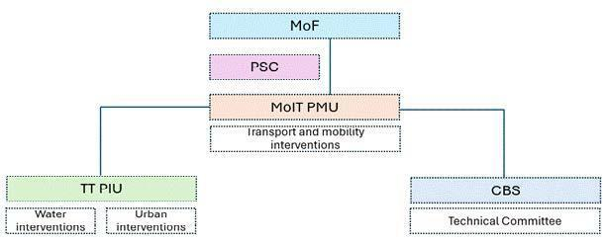

Roles and Responsibilities for ESMP Implementation

Project Management Unit (PMU) - Housed at DHS/MoIT
The PMU, headed by a Project Director, is responsible for the overall day-to-day coordination and technical oversight of the LRCP. Its key E&S responsibilities include:
- Serving as the primary liaison with the World Bank on all E&S matters.
- Ensuring overall project alignment with the ESF and national regulations.
- Directly overseeing and supervising the implementation of the ESMP for the transport components (BPS and e-buses).
- Overseeing the implementation of the ESMP for the transport components.
- Consolidating monitoring reports from the PIU for submission to the World Bank.
- Managing the Level 2 Grievance Redress Committee (GRC).

Project Implementation Unit (PIU) - Housed at Thimphu Thromde
The PIU is the core entity responsible for the direct management and supervision of the urban placemaking and water investment components. Its key E&S responsibilities, for which it is ultimately accountable, are:
- Overall E&S Compliance: Ensuring contractor compliance with the ESMP for water supply and the ESIA/ESMP for urban placemaking.
- Contractor Supervision: Providing direct, day-to-day supervision of contractors' E&S performance on its project sites.
- Plan Approval: Reviewing and formally approving Contractor's site-specific ESMPs (C-ESMPs), based on the technical review and recommendation of the PMSC's Environmental and Social Specialists.
- Monitoring & Reporting: Conducting regular compliance monitoring and preparing quarterly E&S reports for submission to the PMU, with data and analysis provided by the PMSC.
- Grievance Redress: Establishing and managing the project's Level 1 Grievance Redress Mechanism (GRM).
- Stakeholder Engagement & RAP Implementation: Leading the implementation of the Stakeholder Engagement Plan (SEP) and overseeing the full implementation of the Resettlement Action Plan (RAP).
To fulfil these responsibilities, the PIU will be staffed with a dedicated Social and Gender Focal Person. For all environmental matters, the PIU will be directly supported by the Environmental Specialist housed within the Project Management and Supervision Consultant (PMSC), who will provide the necessary technical expertise for supervision, monitoring, and plan review.
Project Management and Supervision Consultant (PMSC)
The PMSC will be engaged by the PMU to act as the "Engineer" for the contract and will provide technical and supervisory support to both the PMU and the PIU in fulfilling their E&S responsibilities. The PMSC's team will include its own dedicated Environmental Specialist and Social Specialist, who will:
- Provide daily technical supervision of the contractor's implementation of E&S mitigation measures on all worksites.
- Review all contractor submittals (e.g., C-ESMPs, monthly monitoring reports) and make recommendations for approval to the relevant implementing unit (PMU or PIU).
- Conduct regular, independent site inspections and audits to validate the contractor's monitoring reports.
- Assist the PMU and PIU in investigating any E&S incidents or non-compliances and recommend corrective actions.
Contractor(s)
The Contractor(s) hired for the civil works are directly responsible for the on-the-ground implementation of all mitigation measures specified in this ESMP and their own approved Contractor's ESMP (C-ESMP). Their key responsibilities include:
- Appointing dedicated and qualified Environmental, Social, and OHS officers.
- Developing, securing approval for, and implementing a site-specific C-ESMP and all associated sub-plans.
- Ensuring all workers and subcontractors are trained on and adhere to the project's Code of Conduct, particularly its provisions on SEA/SH.
- Conducting daily site inspections and preparing Monthly E&S Monitoring Reports for submission to the PIU/PMSC.
- Establishing and implementing the site-level GRM for workers and the community.

Environmental and Social Commitment Plan (ESCP)
The Royal Government of Bhutan (RGoB) has prepared a standalone ESCP, which is a legal agreement with the World Bank. The ESCP summarizes the material measures and actions that the project's implementing agencies - the Department of Human Settlement (DHS)/PMU and Thimphu Thromde (TT)/PIU - must undertake to meet the Environmental and Social Framework (ESF) over a specified timeframe. The full ESCP is a publicly disclosed document.
Key commitments detailed in the ESCP include:
- Implementation of E&S Instruments:
  - Implementing this ESMP, the separate ESMP for Water Supply Works, the Resettlement Action Plan (RAP), the Stakeholder Engagement Plan (SEP), and the SEA/SH Action Plan.
  - Ensuring the RAP is fully implemented (including payment of compensation) before any civil works commence in affected areas.
- Institutional Staffing and Capacity:
  - Maintaining qualified E&S specialists and consultants within the PMU and dedicated E&S focal points within the PIU.
  - Implementing a comprehensive capacity-building plan for all project staff and contractors on ESF requirements.
- Contractor Management:
  - Incorporating all ESMP requirements and the Code of Conduct into bidding and contract documents.
  - Requiring contractors to prepare and implement their own Labor Management Procedures (LMP) and a site-specific Contractor's ESMP (C-ESMP).
- Monitoring and Reporting:
  - Submission of bi-annual E&S monitoring reports to the World Bank.
  - Immediate notification (within 48 hours) of any serious incidents.
  - Maintaining a functional, accessible Grievance Redress Mechanism (GRM).

Institutional Capacity Assessment
A capacity assessment of the key implementing agencies—the Department of Human Settlement (DHS) and Thimphu Thromde (TT)—was conducted to evaluate their ability to effectively manage the E&S requirements of the LRCP. The assessment focused on staffing, past experience, and existing systems.

Department of Human Settlement (DHS) – PMU
- Experience: DHS has extensive experience in urban and infrastructure planning. However, its experience has been primarily in project preparation and design rather than the direct supervision of on-the-ground E&S compliance during construction.
- Capacity Gaps: DHS currently lacks dedicated, full-time E&S personnel. While a focal point exists, they have other primary responsibilities, representing a capacity gap for a project with a 'Substantial' E&S risk rating. The department also lacks its own environmental monitoring equipment and a dedicated budget for E&S management.

Thimphu Thromde (TT) – PIU
- Organizational Mandate & Experience: Thimphu Thromde has direct responsibility for municipal management, including the issuance of Environmental Clearances (ECs) for certain activities, landfill and waste management, and infrastructure development. TT has prior experience working on World Bank-funded projects and has an established institutional structure.
- E&S Staffing and Capacity: The PIU will be the core entity for E&S implementation. TT has designated an Urban Planner to serve as the Social and Gender Focal for the PIU. This focal person has received some training on the WB ESS. However, the Environment Division (ED) does not have a dedicated staff member who can oversee ESMP implementation or conduct compliance monitoring for a project of this scale. This represents a significant capacity gap.
- Budget and Resources: Similar to DHS, TT does not have a separate budget provisioned for E&S management, nor does it possess its own equipment for environmental monitoring (air, noise, water quality).

City Bus Service (CBS)
- E&S Capacity: CBS is an operational entity focused on bus services. Currently, it lacks dedicated environmental or social focal persons and has limited experience in developing formal E&S management plans for its operations.
- Project-Supported Capacity Building: To address this gap, the project will build the capacity of CBS to manage its own operational E&S risks. This includes:
  - Appointing a Focal Person: CBS will be required to designate a senior staff member to act as the E&S Focal Person for all project-related activities.
  - Training and Technical Assistance: This focal person and other relevant CBS staff will receive targeted training through the project's Capacity Building Plan. The project will also provide technical assistance to help CBS develop and implement its own operational E&S procedures (e.g., for waste management, OHS for drivers, and a driver's Code of Conduct).

Summary of Key Capacity Gaps
The assessment identifies the following key capacity gaps that need to be addressed to ensure effective ESMP implementation:
- Lack of Dedicated E&S Staff: Neither the PMU nor the PIU has full-time, dedicated E&S specialists. Existing focal points have other primary responsibilities, limiting their ability to provide the intensive oversight required for a "Substantial" risk project.
- Limited On-the-Ground Implementation Experience: The primary experience of the agencies lies in planning and design rather than the direct supervision of E&S compliance during construction.
- Absence of Monitoring Equipment and Budget: Neither agency has the equipment or a dedicated budget for conducting the required environmental effects monitoring (air, noise, water quality).
- Need for Specialized Plans at CBS: CBS lacks experience in developing and implementing key operational documents like SOPs for e-bus maintenance and waste management plans.

Recommended Actions to Strengthen Capacity
To address the identified capacity gaps and ensure effective E&S management for the LRCP, the following measures will be implemented as part of the project:
- Strengthening E&S Capacity through Specialized Support: The project will finance the hiring of dedicated specialists to provide technical expertise and oversight.
  - Support to the PMU: A Project Management and Supervision Consultant (PMSC) will be engaged by the PMU. The PMSC's team will include a full suite of E&S experts (Environmental, Social, Gender/GBV, and OHS) to provide overall technical guidance, training, and high-level supervision across all project components.
  - Support to the PIU: The PIU within Thimphu Thromde will be strengthened by designating a dedicated Social and Gender Focal Person. These focal points will be the primary day-to-day managers of E&S compliance for the water and urban placemaking components, receiving direct technical support from the PMSC.
  - Contractor Capacity: All contractors will be contractually required to hire their own dedicated Environmental, Social, and OHS officers.
- Comprehensive Training Program: A detailed Capacity Building and Training Plan will be implemented for all staff at the PMU, PIU, CBS, and contractor levels, covering the World Bank ESF, ESMP and RAP implementation, OHS, GRM, and other relevant topics.
- Outsourcing of Environmental Monitoring: The required physical environmental monitoring (air, noise, water) will be outsourced by the contractor to a qualified third-party firm, with the costs included in the contract's Bill of Quantities (BoQ).
- Development of SOPs for CBS: The project will provide technical assistance to CBS to develop critical operational documents, including Standard Operating Procedures (SOPs), a Code of Conduct for drivers, and a long-term waste management strategy for e-buses.

Grievance Redress Mechanism (GRM)

Commitment and Objective
The LRCP is committed to establishing and implementing a robust, transparent, and accessible Grievance Redress Mechanism (GRM). The objective of the GRM is to ensure that all complaints, queries, and concerns from project-affected persons and other stakeholders are received, evaluated, and addressed in a prompt, fair, and systematic manner, in line with the World Bank's Environmental and Social Framework (ESF).
While Thimphu Thromde has an established grievance system, for the LRCP this system will be strengthened and formalized with a clear, multi-tiered structure. The full, detailed GRM is a core component of the project's Stakeholder Engagement Plan (SEP).

Principles and Structure of the LRCP Grievance Mechanism
The project's GRM is designed based on the principles of accessibility, fairness, and efficiency. It provides a clear and predictable process for resolving issues related to all project components.
- Multiple Uptake Channels: To ensure maximum accessibility, grievances will be accepted through a variety of channels, including:
- A dedicated project hotline and email address.
- Walk-in submissions to a grievance logbook at the PIU (Thimphu Thromde), PMU (DHS), or contractor's site offices.
- Submissions through community leaders (Thuemis) or during public consultation meetings.
- Tiered Resolution Process: The GRM features a multi-step process designed to resolve issues at the lowest possible level:
- Level 1: Project Implementation Unit (PIU) Level Resolution (Target: 10-15 working days): Grievances will first be received and addressed by the GRC at the PIU level in Thimphu Thromde. This level aims to resolve most site-specific and direct implementation issues.
- Level 2: Project Management Unit (PMU) Level Mediation (Target: 15-20 working days): If a grievance is not resolved at Level 1, it will be escalated to a formal Grievance Redress Committee (GRC) established at the PMU level (DHS/MoIT). The PMU-level GRC will review the case and propose a formal resolution.
- Level 3: Project Steering Committee (PSC): For complex, cross-cutting policy issues that cannot be resolved at the PMU level, grievances can be escalated to the PSC for a final decision.
- Legal Recourse: All complainants will be informed of their right to seek legal recourse through the formal Bhutanese judicial system at any stage of the GRM process.
- Specialized Grievance Pathways: The GRM includes dedicated, confidential procedures for:
- Labor and Working Conditions: A specific Worker's GRM will be established by all contractors, as detailed in their Labor Management Plans, to address all work-related concerns.
- Sexual Exploitation and Abuse/Harassment (SEA/SH): A survivor-centric and confidential pathway will be established for receiving and referring any SEA/SH-related complaints from both workers and community members. This will be managed by trained personnel with clear, safe referral pathways to survivor support services, as detailed in the project's SEA/SH Prevention and Response Action Plan.
The full operational details, including roles, timelines, and communication protocols for the GRM, are available in the project's Stakeholder Engagement Plan (SEP).

Figure 25: Overview of the Grievance Redress Mechanism
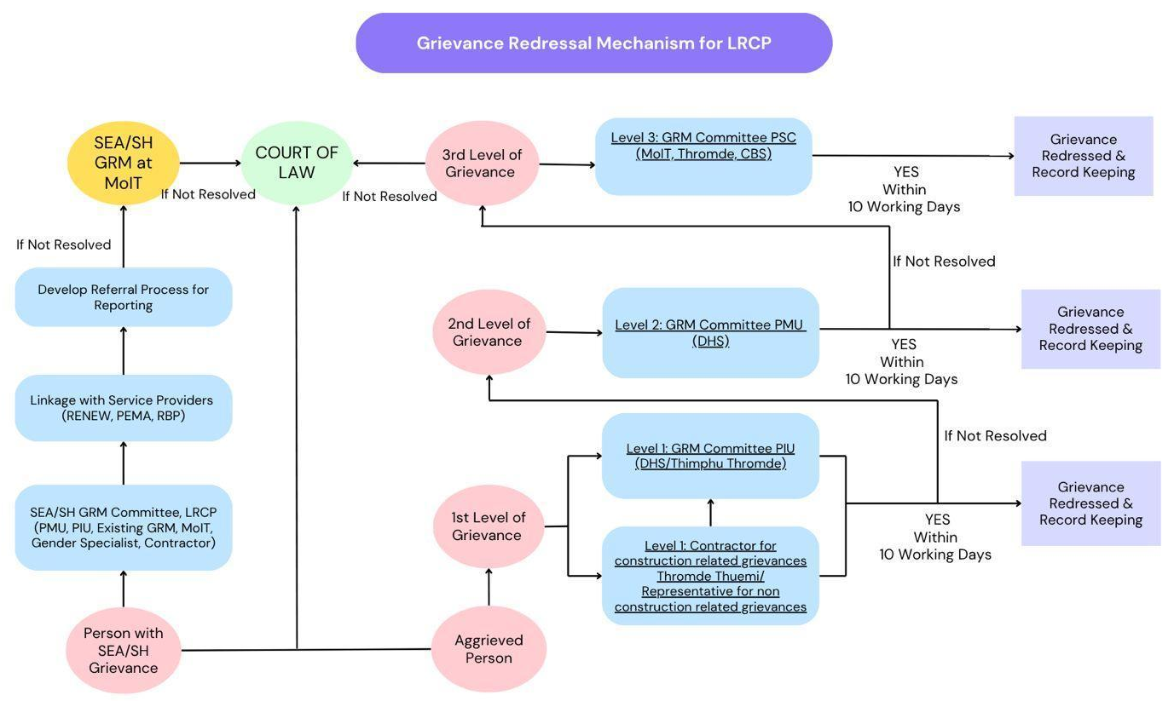

Stakeholder Engagement and Public Consultation
Effective stakeholder engagement is a cornerstone of the LRCP, ensuring that the project is implemented in a transparent, inclusive, and responsive manner. This chapter summarizes the project's engagement approach, based on the detailed framework outlined in the standalone Stakeholder Engagement Plan (SEP).
The overall objective of the SEP is to define a program for meaningful consultation and information disclosure throughout the project cycle. It outlines communication strategies and provides a formal Grievance Redress Mechanism (GRM). A key focus is ensuring the active participation of vulnerable groups who may be at risk of being excluded from project benefits.

Stakeholder Identification and Analysis
A comprehensive analysis has been conducted to identify all individuals, groups, and entities that may be affected by or have an interest in the LRCP.

Affected Parties
Affected Parties include individuals, communities, and other entities subject to direct project impacts. For the LRCP, these primarily include:
- Property and Landowners: Owners whose land and/or property will be impacted by the Bus Priority Service (BPS) Type 2 road expansion.
- Educational Institutions: The SEP identifies four schools located directly along the project corridors: Changzamtog Middle Secondary School, Etho Metho Primary School, Dechencholing Higher Secondary School, and Sherab Gatshel Primary School. These institutions are considered key affected parties due to:
  - Potential construction-related disruptions (noise, dust, traffic).
  - Direct impacts on the safety of students and staff commuting to and from school.
  - Changes in access routes and public transport availability for the school community.
- Businesses and Livelihoods: Formal businesses, informal vendors, and street-level workers (e.g., parking fee collectors) located along the BPS route and Norzin Lam who will be impacted by construction disruptions or permanent changes to access and parking.
- Residents: Persons living in close proximity to new construction sites (including bridges, terminals, and road widening areas) who will be temporarily impacted during the construction phase.
- Road and Service Users: All users of the BPS and Norzin Lam corridors, City Bus Service infrastructure (bus stops, shelters), and the current water supply system who may face temporary disruptions.

Other Interested Parties
The SEP identifies the following specific vulnerable groups that require targeted engagement strategies to ensure their meaningful participation and that their specific needs are addressed in project design and mitigation. This list is consistent with the detailed social baseline assessment in Chapter 5.
- Residents of Temporary Structures: Households and micro-businesses operating from temporary or semi-permanent structures (huts, locally known as bagos) along the BPS corridor, who are at high risk of both physical and economic displacement.
- Livelihoods Dependent on Street-Level Activities:
  - Parking Fee Collectors: Individuals whose income is entirely commission-based and directly tied to the availability of on-street parking spaces that will be reconfigured by the project.
  - Roadside Vendors: Micro-entrepreneurs, such as the members of the Bhutan Association of Women Entrepreneurs (BAOWE), operating in small, informal structures directly adjacent to the road, making them highly exposed to construction disruptions.
- Individuals Facing Specific Barriers:
  - Persons with Disabilities (PWDs): Individuals who face physical and social barriers to accessing public transport and navigating the urban environment.
  - Senior Citizens: Elderly individuals who may have mobility challenges and rely on affordable public transport.
  - Women-Headed Households with Low Income: Households that may have limited economic resilience to withstand temporary disruptions to livelihoods or access.
- Flood-Affected Communities: People living in the 2024 flood-impacted areas in Dechencholing, who have heightened vulnerability to construction-related stress and environmental changes.
(A full list of identified stakeholders is provided in Annex 3 of the SEP).

Summary of Stakeholder Engagement Activities
A multi-phase consultation program has been undertaken for the LRCP, beginning in September 2022 and continuing through June 2025, to ensure stakeholder feedback was incorporated at every stage of project design.
A diverse methodology was employed, including high-level meetings, public consultations, Focus Group Discussions (FGDs), and Key Informant Interviews (KIIs). Key rounds of consultation included:
- Scoping and Initial Design (Sept 2022 - Feb 2023): Initial meetings with government agencies to define the project scope, followed by extensive FGDs with vulnerable groups (women, PWDs, CSOs) to discuss gender and safety concerns in public transport.
- First Round of Public Consultations (Aug 2023): A series of three large public meetings for the Northern, Central, and Southern areas of Thimphu to present the draft BPS alignment and gather initial community feedback.
- Second Round of Detailed Consultations (May-June 2025): A comprehensive second round of public consultations and targeted FGDs was held with specific stakeholder groups (business owners, residents, Thuemis, vulnerable groups) along the entire BPS corridor and Norzin Lam to discuss the updated, more detailed project plans and address specific concerns.

Summary of Consultations During Project Preparation
A multi-phase consultation program has been undertaken for the LRCP, beginning in September 2022 and continuing through June 2025. This program was designed to ensure that stakeholder feedback was incorporated at every stage of project design and preparation, utilizing a diverse methodology that included high-level meetings, public consultations, Key Informant Interviews (KIIs), and targeted Focus Group Discussions (FGDs).
The engagement process was structured chronologically as follows:
- High-Level Scoping Meetings (Sept 2022): The process began with initial meetings involving key government agencies (MoIT, TT, RSTA, CBS, etc.) and development partners to define the project's initial scope and objectives.
- Vulnerable Group Consultations (Feb 2023): Early in the process, an extensive FGD was conducted with 100 participants, including women, persons with disabilities, teachers, and CSOs, to specifically identify and understand gender and safety concerns related to public transport, which helped shape the project's social inclusion features.
- First Round of Public Consultations (Aug 2023): A series of three large public meetings were held for the Northern, Central, and Southern areas of Thimphu. These meetings engaged over 257 individuals to present the draft BPS alignment and gather broad community feedback on the initial concepts.
- Second Round of Detailed Consultations (May-June 2025): As the project design became more detailed, a comprehensive second round of public consultations and targeted FGDs was conducted. This round engaged approximately including specific groups like business owners, local representatives (Thuemis), roadside vendors, and residents along the BPS corridor and Norzin Lam, to discuss the updated plans and address specific, localized concerns.
(A detailed list of all meetings, including dates, locations, and participants, is provided in the main body of the SEP).
Figure 26: Photographic Record of Thromde Thuemi Meetings and Public Consultations in Northern, Central, and Southern Thimphu of 2023 and 2025.
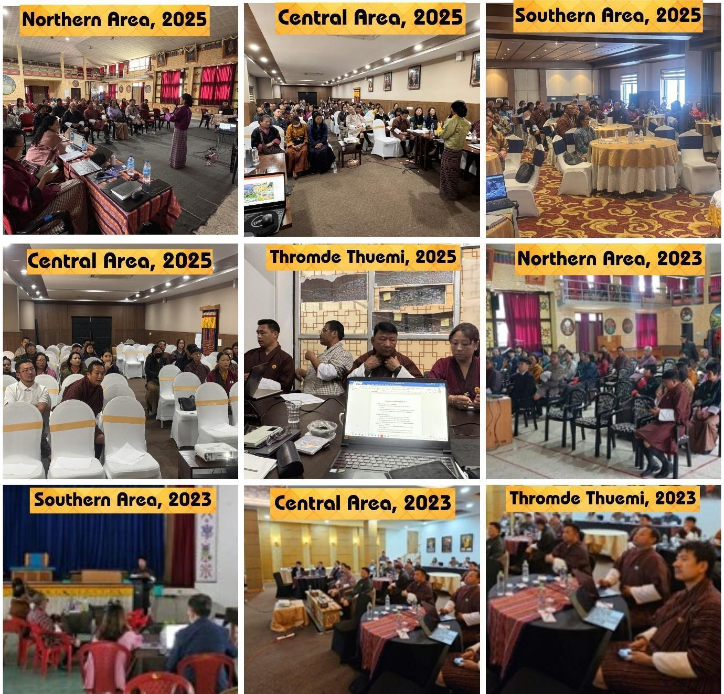

Consolidated Stakeholder Feedback, Responses, and Follow-up Actions for LRCP (From August 2023 & May-June 2025 Consultations)
During comprehensive consultations held in 2023 and 2025, stakeholders raised several key issues regarding the LRCP's design and implementation. Stakeholders, including local representatives, business owners, and residents, raised concerns about institutional roles, particularly the unclear accountability between the Ministry of Information and Technology (MoIT) and Thimphu Thromde, leading to delays and confusion. The project team clarified that MoIT oversees planning while Thimphu Thromde handles implementation, and a formal Grievance Redress Mechanism (GRM) will be established to streamline accountability.
On project design, stakeholders expressed strong opposition to the full pedestrianization of Norzin Lam, fearing negative impacts on businesses. In response, the team proposed a phased approach, starting with a single traffic lane and parking removal to assess effects before further changes. Parking concerns were acknowledged, with alternative strategies, such as multi-level car parks, under consideration. Broader traffic issues, including congestion from Bus Priority System (BPS) lanes and requests for new bridges, were noted, though some fall outside the project’s scope.
Land acquisition and compensation emerged as major concerns, with residents questioning fairness and adequacy of past payments. The project assured stakeholders that a Resettlement Action Plan (RAP) would use updated valuation rates, and consultations would continue before finalizing plans. Utility providers like Bhutan Telecom requested relocation support and infrastructure adjustments, which the team is addressing through collaboration and revised designs.
Economic impacts were highlighted, particularly by financial institutions and businesses seeking loan deferrals and tax relief for disruptions. The project team committed to discussions with the Royal Monetary Authority (RMA) and agreed to provide documentation for tax purposes. Electric vehicle (EV) integration also drew attention, with concerns over battery disposal and charging infrastructure. The project will mandate battery take-back clauses in procurement contracts and explore private-sector partnerships for charging stations.
Social inclusion and safety were recurring themes, with calls for gender-sensitive transport, disability-friendly infrastructure, and better consultation with vulnerable groups. The Gender Action Plan (GAP) includes measures like improved lighting and driver training, while universal access features will be incorporated into designs. Public amenities, such as toilets and green spaces, were requested, with commitments to include them in final plans where feasible.
Heritage preservation, particularly around the Memorial Chorten, was assured, with mitigation measures to minimize disruption. Water supply issues in Taba and past compensation delays in Kawang Gewog were acknowledged, with improvements planned under the LRCP’s water component. Finally, stakeholders expressed distrust due to past project delays, prompting the team to emphasize transparency and phased implementation starting in October 2025, with regular updates to rebuild confidence.
Overall, the project team has addressed many concerns through structured plans (GRM, RAP, GAP) while others remain in progress, such as parking studies and utility relocations. Some requests, like major road expansions, fall outside the LRCP’s scope but have been noted for future consideration. Continuous stakeholder engagement remains a priority to ensure successful implementation.
Table 25: Summary of public consultation feedback from August 2023 and May–June 2025.
Theme | Stakeholder Group(s) | Summary of Key Feedback / Issues Raised | Project Team's Response / Clarification | Follow-up Action / Next Steps | Status
1. Institutional Roles & Grievance Redress | Local Representatives; Business Owners; Residents (Dechencholing) (May/June 2025) | Concern over unclear jurisdiction and accountability between MoIT and Thimphu Thromde. When residents approach one, they are often referred to the other, leading to confusion, lack of accountability, and delays. | Response & Impact on ESIA:  In direct response to this feedback, the project has been designed with a clear, two-tiered implementation structure (PMU at MoIT for oversight, PIU at Thimphu Thromde for implementation).  Crucially, this feedback was the primary driver for designing a new, formal, and multi-tiered Grievance Redress Mechanism (GRM). The ESIA and SEP now detail this GRM, which establishes clear focal points, defined timelines, and a predictable escalation path to ensure that all future grievances are systematically logged, addressed, and resolved without confusion. | The project's Stakeholder Engagement Plan (SEP) and institutional arrangements chapter of the ESIA will clearly define the roles of the PMU and PIU and detail the new GRM structure and contact points. | Addressed in SEP/ESIA
2. Project Design & Scope | Business Owners; Residents; Local Representatives (Aug 2023 & May 2025) | Long-standing opposition to the full pedestrianization of Norzin Lam due to fears of negative impacts on business revenue. A history of opposition and petitions was noted. | Response & Direct Impact on Project Design:  Acknowledging the validity of these concerns, the project team abandoned the original plan for immediate, full pedestrianization.  In direct response to this feedback, the project design was fundamentally changed to a phased, "learn-as-we-go" approach. Phase I will now involve a more modest intervention (creating a single traffic lane and rationalizing parking) specifically to study the real-world impacts on mobility and business. The decision to proceed with any further changes will be based on the results of this initial phase and will require a new round of consultations with the affected businesses. | The phased approach will be detailed in the project design documents. Continuous consultation with Norzin Lam businesses will be a core part of SEP implementation. | Addressed
 | Business Owners (Aug 2023 & May 2025) | Opposition to removal of parking or changes to parallel parking on Norzin Lam, citing space efficiency and business needs. | Response & Direct Impact on ESIA and Design Studies:  In response to these significant concerns, the project has committed to not making any irreversible changes to parking in Phase I.  Furthermore, this feedback has directly led to the inclusion of a dedicated Parking Management Study as a key component of the project's design phase. This study will go beyond simple on-street options and will formally assess the feasibility of alternative strategies, such as shared off-street parking facilities or multi-level car parks (MLCPs), to balance the needs of both local businesses and improved pedestrian mobility. The findings of this study will be a key input for any future decisions on parking. | The phased implementation plan will include a specific study on parking needs and alternative strategies. | In Progress
 | Residents (Northern Area, Aug 2023); RBA (May 2025) | Concerns about BPS lanes causing congestion. Broader traffic concerns raised, including need for flyovers, a new bridge at Chubachu, and larger roundabouts. | Response & Direct Impact on Operational Design:  To directly mitigate the risk of increased congestion, the operational design of the BPS was modified in response to this feedback. The project will now launch with BPS lanes operating exclusively during peak morning and evening hours only. Outside of these hours, the lanes will be open to all traffic. This transitional approach is designed to balance the needs of public transport with general traffic flow. The potential for future full-time dedicated lanes will only be considered if ridership grows significantly and traffic studies confirm its feasibility.  Regarding broader infrastructure: The project team acknowledged these concerns, but noted that major new infrastructure like flyovers falls outside the immediate LRCP scope. | This transition strategy will be communicated through the SEP. Traffic flow will be monitored. The PMO has been briefed on larger traffic concerns. | Addressed
 | Businesses & Residents (May/June 2025) | Need for infrastructure not currently in scope, such as new parking lots and a new road to bypass congestion. RBG noted that recent flood-mitigation works (hume pipes) in Dechencholing are temporary and not part of LRCP, and a proper bridge is needed. | Response & Impact on Design Confirmation:  The feedback from the RBG regarding the inadequacy of the temporary works at Dechencholing was a critical validation of the LRCP's project design. This input directly reinforced the decision to include the construction of a new, permanent, climate-resilient bridge at Dechencholing as a core component of the project, ensuring a long-term solution to the flood risks in that area.  Regarding other infrastructure: The project team acknowledged the importance of new parking structures and roads for the city's overall development but confirmed that these fall outside the LRCP's specific mandate, which is focused on public transport and water network improvements. | Acknowledged as important city-wide issues but noted as being outside the direct scope of the LRCP. | Noted
3. Land and Compensation | Residents (Central BPL & Dechencholing, May 2025; Southern Area, Aug 2023) | Concerns about land acquisition and fair compensation. Questions on adequacy of compensation rates, noting that past amounts (e.g., Nu 2 lakh) are insufficient for rebuilding today (Nu 30-40 lakhs). History of unclear policies on setbacks. | Response & Direct Impact on ESIA/RAP:  To directly address these historical concerns and ensure a fair process, the project has prepared a Resettlement Action Plan (RAP) in accordance with both national law and the World Bank's ESF. The RAP was specifically designed to overcome the past issues raised by the community. It includes the following key commitments:  1. Use of Current Valuation Rates: All compensation for affected assets will be calculated based on the principle of full replacement cost, using the latest updated PAVA (Property Assessment and Valuation Agency) rates, ensuring that compensation is sufficient to rebuild or replace lost assets at current market prices.  2. Clear and Consistent Process: The RAP establishes a clear, transparent, and legally binding process for land acquisition and compensation, removing the ambiguity of past policies. Land acquisition will be minimized to the greatest extent feasible. | Implement the Resettlement Action Plan (RAP), ensuring all affected persons are fully compensated before any civil works commence in their area. | Addressed in RAP
4. Utilities & Infrastructure Relocation | Bhutan Telecom (BT) (May 2025) | BT needs to relocate two important sites and requires alternative locations. Raised the need for new utility ducts along several project routes (Norzin Lam, CSI-Chorten, etc.) and space for 3 monopoles on Norzin Lam to address network congestion. | Response & Direct Impact on Project Design and Budget:  1. Utility Ducts (In Scope): In direct response to this feedback, the project's technical designs for Norzin Lam and the CSI-Chorten corridor have been modified to include the installation of new, dedicated utility ducts. This proactive measure will facilitate BT's network upgrades and avoid future excavation.  2. Relocation Costs (In Scope): The costs associated with relocating BT's two affected sites have been assessed and have been included in the project's Resettlement Action Plan (RAP) budget, ensuring that BT is compensated for the relocation as a project-affected entity.  3. Monopoles (Out of Scope): The project team confirmed that the installation of new 15m monopoles falls outside the current scope of the LRCP. However, the provision of new underground fiber ducts is included. | 1. Finalize Relocation Sites: Thimphu Thromde and BT will finalize the new sites for relocation.  2. Update RAP Budget: The final cost estimate from BT (Nu 4.325M) for the relocation will be formally incorporated into the final RAP budget.  3. Incorporate Ducts in Designs: The final engineering designs will detail the specifications for the new utility ducts. | In Progress
5. Economic Impacts & Financial Support | Financial Institutions (BOB); Dept. of Revenue & Customs (DRC) (May 2025) | Banks are concerned about supporting businesses with loan deferrals, as RMA has directed these to cease from June 2025. DRC noted that affected businesses will need accurate documentation of asset destruction for tax deduction purposes. | Response & Project Commitments:  1. For Tax Relief (Direct Project Support): In direct response to the DRC's request, the project commits to establishing a formal system to provide all affected businesses with official, individualized documentation. This documentation will detail the nature and duration of the project's impact on their operations, serving as the necessary evidence for them to claim tax relief. This is a core mitigation measure for economic displacement.  2. For Loan Deferrals (Inter-Agency Coordination): The project team acknowledged the significant financial hardship that the inability to defer loans will cause for affected businesses. While the project cannot override an RMA directive, the team has formally raised this issue with the Ministry of Finance and the RMA. The possibility of targeted financial support or a special waiver for project-affected businesses is under discussion. | 1. The project will develop a standardized template for the impact documentation to be provided to businesses, in consultation with the DRC.  2. The PMU will continue its high-level discussions with the RMA and Ministry of Finance to advocate for a solution regarding financial support for affected businesses. The outcome of these discussions will be communicated to stakeholders via the SEP | In Progress
6. EV Infrastructure & Integration | Businesses (Aug 2023); BPL Route Stakeholders (May 2025) | Concerns about EV battery disposal from the new electric buses. | Response & Direct Impact on Procurement and ESMP:  In direct response to this feedback, the project has integrated a mandatory sustainable battery management strategy into its core design.  This will be enforced through a legally binding "Extended Producer Responsibility" clause in the e-bus procurement documents. This clause will require the supplier to establish and operate a battery take-back program for the responsible collection, recycling, or disposal of all end-of-life batteries, in full compliance with both national environmental regulations and international good practice (e.g., Basel Convention). This requirement is also a key mitigation measure in the project's ESMP. | The battery take-back clause will be included in the final bidding documents for e-bus procurement. | Addressed in Procurement Plan
 | BPL Route Stakeholders (May 2025) | EV charging stations are not in a good state. Inquired if private entities could be engaged to set up and operate charging stations. | Response & Direct Impact on Procurement Strategy:  Agreeing with the stakeholder's assessment, the project has incorporated this feedback directly into its procurement and implementation strategy for EV charging infrastructure.  MoIT is now actively exploring models for Public-Private Partnership (PPP) for the development and operation of the charging stations. This approach is intended to leverage private sector efficiency and investment to ensure the long-term sustainability and high-quality service of the charging network, a key lesson learned from the current state of public chargers. | The project's Procurement Strategy Plan will be finalized to include a detailed assessment and recommendation on the optimal model for private sector participation in the EV charging infrastructure.  The final bidding documents will be structured to facilitate this partnership. | In Progress
 | BPL Route Stakeholders (May 2025) | Requested to consider the views of EV taxi drivers, who are struggling with loan repayments and are concerned about the impact of e-bus services on their livelihood. | Response & Direct Impact on ESIA and SEP:  The project acknowledges that the introduction of an efficient BPS could cause indirect economic displacement for competing transport providers like EV taxi drivers. This is recognized as a significant social risk.  In response, this issue has been formally integrated into the project's social risk management framework:  1. Social Impact Assessment: The ESIA now includes an assessment of this specific risk.  2. Stakeholder Engagement Plan (SEP): The SEP has been updated to include EV taxi associations as a key stakeholder group requiring targeted consultation. | As a priority follow-up action, the project will conduct dedicated Focus Group Discussions (FGDs) with EV taxi associations. The purpose of these consultations will be to:  1. Better understand the potential scale of the impact.  2. Collaboratively explore potential mitigation strategies (e.g., feeder services, integration with the ITS system).  The findings will be used to inform the final project design and mitigation plans. | In Progress
7. Social Concerns & Inclusion | CBOs; Local Representatives; PWDs (Aug 2023 & May/June 2025) | Concerns for women's safety on public transport. Need for gender sensitization for drivers. Concern that vulnerable groups (elderly, youth) are often not included in consultations. | Response & Direct Impact on Design, ESMP, and SEP:  This feedback has been integrated across multiple project components and E&S instruments:  1. Impact on Gender Action Plan (GAP): In direct response to safety concerns, the GAP includes specific, measurable actions such as installing CCTV on all buses, ensuring adequate lighting at all terminals and bus stops, and establishing a confidential, commuter-facing channel in the GRM for reporting SEA/SH incidents.  2. Impact on ESMP & Procurement: The requirement for mandatory, continuous gender sensitization and safe driving training for all bus drivers has been included as a key mitigation measure in the Operational ESMP and will be a contractual obligation for the bus operator.  3. Impact on Stakeholder Engagement Plan (SEP): To address the concern about exclusion, the SEP has been specifically designed with a targeted engagement strategy for vulnerable groups. This includes conducting dedicated Focus Group Discussions with women, youth, the elderly, and PWDs, and ensuring that all public consultation materials and venues are fully accessible. | The Gender Action Plan (GAP) and the Stakeholder Engagement Plan (SEP) will be fully implemented throughout the project lifecycle.  Progress on the GAP's safety indicators will be monitored and reported. | Addressed in GAP, ESMP & SEP
 | CBOs; Southern Area residents (Aug 2023); Kidu Medical Services (May 2025) | Need for disability-friendly infrastructure ("last mile" access) and consideration for ageing population using wheelchairs. Cultural sensitivities with overhead pedestrian bridges were noted, with a preference for accessible underpasses. | Response & Direct Impact on Technical Design:  In direct response to this feedback, the project has adopted Universal Access as a core, non-negotiable design principle for all public-facing infrastructure.  This has directly influenced the technical specifications:  1. "Last Mile" Connectivity: The design for Norzin Lam and all new bus stops will include features such as ramps, tactile paving, and dropped curbs to ensure a continuous, accessible path from the street to the bus. All new buses will be low-floor models with designated wheelchair spaces.  2. Pedestrian Crossings: Based on the strong stakeholder preference, the project will prioritize at-grade, signalized pedestrian crossings and accessible underpasses over overhead bridges wherever technically feasible. | The commitment to Universal Access design principles will be a mandatory requirement in the terms of reference for the design consultants and a non-negotiable technical specification in all civil works construction contracts.  Final designs for pedestrian crossings will be shared with stakeholder groups representing PWDs for feedback. | Addressed in Technical Design Specs
8. Public Amenities, Urban Design & Environment | Residents (DechenCholing); Kidu Medical; CSI Market (May/June 2025) | Repeated requests for a public toilet in DechenCholing, with a sustainable cleaning plan. Need for greenery/trees along widened roads. Issues with waste management (at bus stops, in underpasses) and improper connection of greywater to the sewer system. | Response & Direct Impact on Project Design and ESMP:  This feedback has led to the following specific commitments being integrated into the project:  1. Public Toilet: The project has committed to including the design and construction of a new public toilet in Dechencholing, subject to the finalization of a suitable site. An Operations & Maintenance (O&M) plan will be a required deliverable.  2. Landscaping: The technical designs for the BPS corridor and Norzin Lam will now include a mandatory landscaping and tree planting component, using native species to enhance urban greenery.  3. Waste Management:  The Operational ESMP will include a detailed Waste Management Plan for all new terminals and major bus stops, specifying the provision of segregated waste bins and defining the collection schedule in coordination with Thimphu Thromde.  4. Sewerage Connections: While enforcing sewerage connections is a broader Thromde responsibility, the project will support this by including a public awareness campaign on proper sanitation and wastewater disposal as part of the project's SEP. | 1. Final site selection and design for the Dechencholing public toilet will be completed.  2. The landscaping and tree planting plan will be detailed in the final engineering designs.  3. The Operational ESMP will detail the final waste management protocols.  4. The public awareness campaign materials will be developed by the PIU. | In Progress
9. Heritage & Recreation | DCDD; DRC (May 2025) | Two key concerns were raised:  1. The proximity of the BPS route to the National Memorial Chorten and the potential for indirect impacts (vibration, dust, visual intrusion).  2. A general lack of accessible public recreational spaces, which was framed as a public health issue. | Response & Direct Impact on Design and ESMP:  1. For the Memorial Chorten: The project design ensures there will be no physical impact on the Chorten premises. To manage indirect impacts, a site-specific Cultural Heritage Management Plan (CHMP) for the Memorial Chorten will be developed as part of the C-ESMP. This plan will include measures for vibration monitoring, enhanced dust and noise control, and traffic management to preserve the site's sanctity during construction. The long-term plan to remove nearby parking and increase public transport access is expected to have a positive impact on the site's ambiance.  2. For Recreation and Health: In response to the health concerns, the project's scope for upgrading sidewalks and pedestrian pathways along the entire BPS corridor and Norzin Lam will be designed not just for transport but also to function as linear recreational spaces that encourage walking and physical activity. | 1. The specific mitigation measures for the Memorial Chorten will be finalized in direct consultation with DCDD and incorporated into the final CHMP.  2. The final designs for the pedestrian pathways will incorporate features that enhance their recreational value (e.g., rest areas, landscaping). | Addressed
10. Water and Other Services | Local Representatives/ Taba Thuemi; Kawang Gup (May 2025) | Stakeholders raised three key concerns:  1. Inconsistent water supply in the Taba area.  2. A history of delayed compensation for past water projects in Kawang Gewog.  3. Potential cumulative impacts from the future Begana hydropower project on the Dodeyna water intake. | Response & Impact on Project Design and SEP:  1. Taba Water Supply: The LRCP's Water Sector component is specifically designed to address these reliability issues by improving the network and reducing water losses in core urban areas, including Taba.  2. Past Compensation Issues: The project team acknowledged the past delays in compensation in Kawang Gewog as a critical "lesson learned." In response, the Stakeholder Engagement Plan (SEP) for the LRCP includes a strengthened commitment to transparent and continuous consultation with the Kawang Gup and local residents for any project-related activities, ensuring that past issues are not repeated. The current LRCP scope does not include new works in this area.  3. Cumulative Impacts: The project team noted the potential future development of the Begana hydropower project. While this is an external project, the LRCP's water intake designs will be finalized with consideration for potential future changes in the watershed. | 1. The Water Sector component will be implemented as designed to improve supply reliability.  2. The project commits to maintaining a proactive dialogue with the Kawang Gewog leadership throughout the project lifecycle, as detailed in the SEP, regarding any potential future project-related activities in the area. | Addressed
11. Project Implementation & Timeline | All Groups (Aug 2023 & May/June 2025) | Public distrust from past projects that were either not implemented as consulted or faced long delays. Questions on the timeline for LRCP and its relation to previous, similar plans. | Response & Direct Impact on SEP and Project Management:  Acknowledging that rebuilding public trust is a primary objective, the project has integrated the following commitments directly into its Stakeholder Engagement Plan (SEP) and overall project management approach:  1. Commitment to a Firm Timeline: The project is committed to a transparent, phased implementation schedule with the first phase of civil works planned to commence in late 2025.  2. Proactive and Continuous Communication: The project will move beyond one-off consultations to a model of continuous information sharing. This includes providing regular (e.g., quarterly) public updates on project progress, milestones, and any changes to the timeline.  3. Establishment of a "Single Point of Truth": To avoid the confusion of past projects, a dedicated project webpage on the MoIT website and a project hotline will be established as the official sources for all project information. This is a core component of the SEP. | The SEP will be fully implemented, with a specific focus on its communication and disclosure protocols. This includes:  ● Launching the project webpage.  ● Disseminating the first of the regular progress updates to all stakeholders.  ● Ensuring the GRM is fully operational to handle any queries regarding the project timeline and implementation. | In Progress

Reference
International Council on Clean Transportation. India BS VI Policy Update. ICCT, 2016.
Ministry of Infrastructure and Transport, Bhutan. 2023. Low Emission Development Strategy: Surface Transport. Thimphu: MOIT.
Zheng, Liping, et al. Bhutan Vehicle Emission Reduction Road Map and Strategy, 2017–2025. Asian Development Bank, July 2019.
European Environment Agency (EEA). 2023. EMEP/EEA Air Pollutant Emission Inventory Guidebook 2023. Luxembourg: Publications Office of the European Union. In-text citation: (European Environment Agency 2023, Table 3-2)
World Bank. 2018. Transport Emissions Toolkit. Washington, DC: World Bank Group.
United States Environmental Protection Agency (EPA). 2020. MOVES2014b Technical Guidance: Motor Vehicle Emission Simulator. Washington, DC: U.S. EPA.
Department of Forests and Park Services. (2023). National Forest Inventory Volume I: State of Forest Report. Forest Monitoring and Information Division, Department of Forests and Park Services, Ministry of Energy and Natural Resources, Royal Government of Bhutan. Thimphu, Bhutan.
Thimphu Thromde. Birds in and Around Thimphu Valley. Thimphu, Bhutan: Thimphu Thromde, 2022.
Ministry of Works & Human Settlement. Bhutan Urban Development Project II: Environmental Impact Assessment & Management Plan (Final Report). Prepared by SWI / IDRG / KCS. Thimphu, Bhutan: Ministry of Works & Human Settlement, 2009.
World Bank. Implementation Completion and Results Report: Bhutan - Second Urban Development Project (IDA 47440 and 54310 (AF)). Report No. ICR00004941. Washington, D.C.: The World Bank Group, December 27, 2019.
National Center for Hydrology and Meteorology. Report on Establishment of Interim Manual Flood Monitoring Gauges at Dechencholing-Taba Bridge on Thimchhu. Thimphu: Royal Government of Bhutan, 2021.
Nature Conservation Division, Department of Forests and Park Services. (2020). Protected Area Zonation Guidelines of Bhutan. Ministry of Agriculture and Forests, Royal Government of Bhutan.
Cryosphere Services Division. (2021). Bhutan Glacial Lake Inventory (BGLI) 2021. National Center for Hydrology and Meteorology, Royal Government of Bhutan.
Bhutan. Ministry of Labour and Human Resources. Department of Labour. Regulation on Occupational Health, Safety and Welfare, 2022. Thimphu: Ministry of Labour and Human Resources, 2022. [https://www.moice.gov.bt/wp-content/uploads/2022/05/Regulation-on-OHSW-2022.pdf].

Appendix-1: Terms of Reference (TOR)

TOR for supporting MoIT in updating ESIA and RAP, and preparing ESMP and other ESF instruments for LRCP
1. Background

The Royal Government of Bhutan is currently preparing the Liveable and Resilient City Project (the Project) with potential funding from the World Bank. The Project aims to enhance liveability and climate resilience in the project area through improved infrastructure and service delivery. It will comprise two components: (i) resilient and low-carbon service delivery, piloting key investments, and (ii) urban management, planning, and capacity building. The proposed project will be located in Thimphu Thromde, the capital city of Bhutan. The project is expected to be in operation between 2025-2030.
The Ministry of Infrastructure and Transport (MoIT) will be the main implementing Ministry hosting the PMU. During project preparation, the Department of Human Settlement under MOIT will be the focal agency to coordinate and manage the project, in coordination with Department of Infrastructure Development, Thimphu Thromde and other relevant agencies.
2. Description of the Project

Component 1 of the Project includes the following activities.
1) Urban Transport Activities

● Developing bus priority lane and complementary infrastructure: This will involve the expansion of 3.9 KM of road into a four-lane configuration, along with significant infrastructure improvements for a total of 18.7 km. This includes upgrading three key terminals, expanding three bridges, and enhancing 75 bus stops with improved bus bays, shelters, and sidewalks. These upgrades aim to enhance road capacity, public transport efficiency, and overall connectivity while ensuring safety and convenience for commuters.
● Promote non-motorised transport (NMT) of Norzin Lam: This will improve the sidewalk, pedestrian crossing and alleyways along Norzin Lam. The NMT is divided into three section – 1) from Lungten Zam till the main traffic, 2) from main traffic to handicraft market/ Taj Tashi junction, and 3) from the Taj Tashi junction to Chubachu junction along the craft bazar on left side. The phase III will only include improvements of the main road and left footpath.
● Low or Zero Carbon Public Transport Mobility: This will procure a fleet of 50 electric buses.

2) Water Sector Activities

● Enhance water supply system for core urban areas of Thimphu: This includes upgrading and rehabilitating existing water intakes, fortifying raw and clearwater transmission lines, improving connection to water tanks and storage in existing water treatment plants (WTPs), improving the distribution network in major urban areas to reduce water leakage, installing SCADA control systems and building capacity.

The proposed activities are primarily upgrading and improvements of small to medium-sized infrastructure, in view of these impacts and risks associated with diverse activities to be conducted in a crowded urban area featured with rich cultural heritage, and the capacity constraints of the implementing agencies (IA), the environmental and social risk is rated Substantial as per ESF risk

classification criteria. The SEA/SH risk is rated Moderate taking into account medium level civil works in dense urban areas with proximity of project activities to areas frequented by women and girls; limited presence of GBV service providers; and limited IA capacity on SEA/SH prevention and response.
It is proposed that the PMU/PIU will prepare the following by appraisal:
● Updated ESIA/ESMP and RAP for urban transport activities
● An ESMP for water supply works
● An SEP for the entire project
● An ESCP for the entire project

● Environmental and social capacity assessment and building requirements will be integrated into the aforementioned instruments and defined in the ESCP.

3. Objectives

The Consultancy is to support MoIT in updating and completing the existing environmental and social assessment instruments for infrastructure investments under Component 1 in compliance with national laws, regulations, and the World Bank Environmental and Social Framework (ESF) requirements. The Royal Government of Bhutan is formally responsible for these documents.
An ESIA/ESMP, Resettlement Action Plan (RAP), and Labor Management Procedures (LMP) were developed for the urban transport activities during the project preparation of the Bhutan Green Transport Project (BGTP). The LRCP has expanded the urban transport activities to include sections II and III, in addition to section I of Norzin Lam as originally proposed under BGTP. Therefore, the ESIA/ESMP and RAP need updating to reflect this expansion and other necessary adjustments in accordance with ESF requirements. Furthermore, water supply works are newly proposed under LRCP, requiring the development of appropriate environmental and social instruments.
The preparation of these instruments is a critical step toward enhancing climate resilience and managing flood and disaster risks in Thimphu, as they will guide the implementation of financed infrastructure investments. These outputs will also address key knowledge and capacity gaps related to these investments and urban resilience as well as contribute to strengthening institutional systems for climate-resilient infrastructure planning and disaster risk management.
4. Scope of Work

The Consultant shall undertake the following tasks for both the transport and water supply components, unless specified otherwise:
Task 1: Review of existing documentation and instruments to address the gaps:
i. Review all existing project documentation, including the BGTP ESIA/ESMP, RAP, LMP, feasibility studies, technical designs, and the gap analysis in which is provided in Annexure A.
ii. Identify gaps and inconsistencies in the existing ESIA/ESMP, RAP and other instruments in relation to the expanded scope of urban transport activities and the requirements of the ESF and relevant national regulations. This includes social risks and impacts of Phases II and III, and water supply activities.
iii. Collect necessary additional baseline data (environmental, social, economic, cultural) through fieldwork, surveys, and consultations to address identified gaps. This will include updating socioeconomic data disaggregated by gender and different demographic characteristics to identify vulnerable individuals and risks.

Task 2: Updating the ESIA/ESMP, RAP for Urban Transport Activities
Update the existing ESIA/ESMP and RAP based on the gap analysis (Annexure A).
Task 3: Preparing an ESMP for Water Sector Activities
The consultant is advised to refer to the ESMP for urban transport activities when developing the ESMP for water sector activities. The gap analysis on the social aspects of the transport ESIA/ESMP should be referred in developing the ESMP. The structure of the ESMP and advice is provided in Annexure XXX.
Task 4: Developing Other ESF Instruments for the Project
Develop environmental and social safeguard instruments as required by the ESF, including but not limited to a Stakeholder Engagement Plan (SEP)/Grievance Redress Mechanism (GRM), an Environmental and Social Commitment Plan (ESCP), Gender Action Plan (GAP), SEA/SH Prevention and Response Plan, and Code of Conduct for the entire project which includes bus priority lane, NMT, procurement of buses and water supply works.
Task 5: Conducting Environmental and Social Capacity Assessment: Conduct capacity assessment of the Executing Agency and Implementing Agency to address environmental and social issues, including:
i. Assess the environmental and social management capacity of the relevant EA and IA to implement the ESMP effectively. The assessment should cover staffing, expertise, current systems or frameworks, resources, among others.
ii. Recommend measures for capacity building to strengthen the capacity of EA and IA

Task 6: Stakeholder Engagement and Consultation
i. Update the existing Stakeholder Engagement Plan (SEP) for the entire project to ensure it addresses the expanded urban transport activities and the new water supply works.
ii. Facilitate and support consultations with all relevant stakeholders, including project-affected parties and other interested parties, throughout the ESIA process. The consultations should also include SEA/SH risks and referral pathways with relevant organisations.
iii. Document the consultation process, including call for consultation in public medias, list of participants, issues raised, and how they were addressed in the ESIA and other documents.
iv. Ensure the SEP includes a grievance mechanism (GM) for addressing concerns and grievances related to the project's environmental and social performance.

5. Deliverables

i. Inception report outlining the methodology, work plan, and team composition.
ii. Updated ESIA (including ESMP and updated RAP) for bus priority lane and NMT.
iii. ESMP for the water supply works.
iv. Updated SEP for the entire project.
v. ESCP for the entire project.
vi. Environmental and Social Capacity Assessment Report with recommendations.
vii. SEA/SH Prevention and Response Action Plan.
viii. Draft Code of Conduct

6. Methodology

A participatory approach, involving close consultation with the MoIT and Thimphu Thromde, relevant government agencies, PAP, and other stakeholders should be used in assessing the impact. Appropriate tools and techniques widely employed in impact assessment, including qualitative and quantitative methods should be used. The desk assessment should include review of key documents, but not limited to:
i. Legislation, policies and regulations of Bhutan governing the project activities
ii. World Bank ESF and Good Practice Note for Borrowers (ESS 1 to ESS 10)
iii. World Bank Good Practice Note on Gender and SEA/SH

MOIT will provide the consultants with access to:
i. Existing project-related documents (masterplans, feasibility studies, technical designs, BGTP ESIA/ESMP, RAP, and gap analysis).
ii. Following micro baseline data collected during the ESA of BGTP a. Population data of PAPs,
b. Sample survey data of Thimphu Thromde households,
c. Vehicular and traffic data.

iii. Anonymized administrative data or processed data from MOIT and Thimphu Thromde that will be relevant to the assignment.
iv. Records of discussion from the public consultations and anonymized interview and FDG transcripts with the stakeholders.

In addition, MOIT and Thimphu Thromde will provide logistical support as appropriate including facilitating stakeholder consultations, access to project sites, etc.
7. Timeline
Sl# | Deliverables/Activities | Deadline
1 | Inception Report Submitted | 21 April 2025
2 | SEP updated | 24 April 2025

Appendix-2: Inventory of Affected Trees
# | Location | Scientific Name | English Name/Local Name | DBH (cm) | Remarks
1 | Ngabiphu Bus Terminal | Pinus wallichiana | Blue pine/Tongphu | 48
2 | Ngabiphu Bus Terminal | Pinus wallichiana | Blue pine/Tongphu | 41
3 | Ngabiphu Bus Terminal | Pinus wallichiana | Blue pine/Tongphu | 45
4 | Ngabiphu Bus Terminal | Pinus wallichiana | Blue pine/Tongphu | 48
5 | Ngabiphu Bus Terminal | Pinus wallichiana | Blue pine/Tongphu | 56
6 | Ngabiphu Bus Terminal | Pinus wallichiana | Blue pine/Tongphu | 34
7 | Ngabiphu Bus Terminal | Pinus wallichiana | Blue pine/Tongphu | 45
8 | Ngabiphu Bus Terminal | Pinus wallichiana | Blue pine/Tongphu | 39
9 | Ngabiphu Bus Terminal | Pinus wallichiana | Blue pine/Tongphu | 39
10 | Ngabiphu Bus Terminal | Pinus wallichiana | Blue pine/Tongphu | 34
11 | Dochukha Bus shelter | Pinus wallichiana | Blue pine/Tongphu | - | 1 Sapling
12 | Janglo Lum Bus Bay/shelter | Pinus wallichiana | Blue pine/Tongphu | - | 10 Saplings
13 | Janglo Lum Bus Bay/shelter | Salix babylonica | Weeping willow | 13
14 | Startup Centre | Cupressus cashmeriana | Cypress/Tsenden shing | 23
15 | Startup Centre | Cupressus cashmeriana | Cypress/Tsenden shing | 10 | Pole
16 | Startup Centre | Cupressus cashmeriana | Cypress/Tsenden shing | 13
17 | Startup Centre | Quercus griffithii | Oak | - | 1 Sapling
18 | BPC office | Cupressus cashmeriana | Cypress/Tsenden shing | 23
19 | Norbu Bakery | Cupressus cashmeriana | Cypress/Tsenden shing | 35
20 | RBP firefighting office | Melia azederach | China berry | - | 1 Sapling
21 | RBP firefighting office | Quercus griffithii | Oak | - | 3 Saplings
22 | Changzamtog | Quercus griffithii | Oak | 10 | Pole
23 | Changzamtog | Quercus griffithii | Oak | 23
24 | Changzamtog | Quercus griffithii | Oak | - | 2 Saplings
25 | JDWNRH | Cupressus cashmeriana | Cypress/Tsenden shing | 48
26 | JDWNRH | Pinus roxburghii | Chirpine | - | 6 Saplings
27 | RBP | Cupressus cashmeriana | Cypress/Tsenden shing | 10 | Pole
28 | RBP | Pinus wallichiana | Bluepine/Tongphu | 23
29 | RBP | Pinus wallichiana | Bluepine/Tongphu | 13
30 | Changkhorlo bus bay/shelter below Etho Metho School | Cupressus cashmeriana | Cypress/Tsenden shing | 10 | 2 Poles
31 | Changkhorlo bus bay/shelter below Etho Metho School | Quercus griffithii | Oak | 11
32 | Changkhorlo bus bay/shelter below Etho Metho School | Quercus griffithii | Oak | 10 | Pole
33 | Changkhorlo bus bay/shelter below Etho Metho School | Quercus griffithii | Oak | 10 | Pole
34 | Changkhorlo bus bay/shelter below Etho Metho School | Picea spinulosa | Spruce | - | 2 Saplings
35 | Changkhorlo bus bay/shelter below Etho Metho School | Quercus griffithii | Oak | - | 1 Sapling
36 | Changkhorlo bus bay/shelter below Etho Metho School | Melia azederach | Neem | 23 | Pole
37 | Changkhorlo bus bay/shelter below Etho Metho School | Melia azederach | Neem | 19 | Pole
38 | Changkhorlo bus bay/shelter below Etho Metho School | Melia azederach | Neem | 16 | Pole
39 | Changkhorlo bus bay/shelter below Etho Metho School | Picea spinulosa | Spruce | 10 | Pole
40 | Changkhorlo bus bay/shelter below Etho Metho School | Cupressus cashmeriana | Cypress | 10 | Pole
41 | Changkhorlo bus bay/shelter below Etho Metho School | Cupressus cashmeriana | Cypress | 13
42 | Changkhorlo bus bay/shelter below Etho Metho School | Picea spinulosa | Spruce | 10 | Pole
43 | Changkhorlo bus bay/shelter below Etho Metho School | Quercus griffithii | Oak | 16
44 | Below Zilukha School Gate | Pinus wallichiana | Bluepine/Tongphu | - | 5 Saplings
45 | India House | Salix babylonica | Weeping willow | 59
46 | India House | Salix babylonica | Weeping willow | 45
47 | India House | Salix babylonica | Weeping willow | 19
48 | India House | Salix babylonica | Weeping willow | 10 | Pole
49 | India House | Cupressus cashmeriana | Cypress | 10 | Pole
50 | India House | Salix babylonica | Weeping willow | 61
51 | India House | Salix babylonica | Weeping willow | 58
52 | India House | Salix babylonica | Weeping willow | 64
53 | India House | Salix babylonica | Weeping willow | 70
54 | India House | Pinus wallichiana | Bluepine/Tongphu | 13
55 | India House | Pinus wallichiana | Bluepine/Tongphu | 13
56 | India House | Pinus wallichiana | Bluepine/Tongphu | 50
57 | India House | Pinus wallichiana | Bluepine/Tongphu | 13
58 | India House | Pinus wallichiana | Bluepine/Tongphu | 48
59 | India House | Pinus wallichiana | Bluepine/Tongphu | 13
60 | India House | Pinus wallichiana | Bluepine/Tongphu | 16
61 | India House | Melia azederach | Neem | 10 | Pole
62 | India House | Pinus wallichiana | Bluepine/Tongphu | 22
63 | India House | Pinus wallichiana | Bluepine/Tongphu | 61
64 | India House | Pinus wallichiana | Bluepine/Tongphu | 29
65 | India House | Pinus wallichiana | Bluepine/Tongphu | 32
66 | India House | Pinus wallichiana | Bluepine/Tongphu | 32
67 | India House | Pinus wallichiana | Bluepine/Tongphu | 45
68 | India House | Cupressus cashmeriana | Cypress/Tsendenshing | - | 5 Saplings
69 | India House | Pinus wallichiana | Bluepine/Tongphu | 42
70 | India House | Pinus wallichiana | Bluepine/Tongphu | 42
71 | Dechencholing Bridge to Dechencholng School | Quercus griffithii | Oak | 73
72 | Dechencholing Bridge to Dechencholng School | Pinus wallichiana | Bluepine/Tongphu | 14
73 | Dechencholing Bridge to Dechencholng School | Pinus wallichiana | Bluepine/Tongphu | 20
74 | Dechencholing Bridge to Dechencholng School | Pinus wallichiana | Bluepine/Tongphu | 23
75 | Dechencholing Bridge to Dechencholng School | Salix wallichiana | Bhutan willow | 32
76 | Dechencholing Bridge to Dechencholng School | Pinus wallichiana | Bluepine/Tongphu | 45
77 | Dechencholing Bridge to Dechencholng School | Quercus griffithii | Oak | 83
78 | Dechencholing Bridge to Dechencholng School | Pinus wallichiana | Bluepine/Tongphu | 35
79 | Dechencholing Bridge to Dechencholng School | Pinus wallichiana | Bluepine/Tongphu | 61
80 | Dechencholing Bridge to Dechencholng School | Quercus griffithii | Oak | 121
81 | Dechencholing Bridge to Dechencholng School | Pinus wallichiana | Bluepine/Tongphu | 57
82 | Dechencholing Bridge to Dechencholng School | Pinus wallichiana | Bluepine/Tongphu | 35
83 | Dechencholing Bridge to Dechencholng School | Pinus wallichiana | Bluepine/Tongphu | 26
84 | Dechencholing Bridge to Dechencholng School | Populus ciliata | Poplar | 26
85 | Dechencholing Bridge to Dechencholng School | Quercus griffithii | Oak | 57
86 | Dechencholing Bridge to Dechencholng School | Populus ciliata | Poplar | - | 2 Poles
87 | Dechencholing Bridge to Dechencholng School | Pinus wallichiana | Bluepine/Tongphu | - | 29 Saplings
88 | Dechencholing School to RBG Gate | Pinus wallichiana | Bluepine/Tongphu | - | 54 Poles
89 | Dechencholing School to RBG Gate | Populus ciliata | Poplar | - | 2 Saplings
90 | RBG Gate to Kabesa-Dangrina junction (inside RBG wall) | Cupressus cashmeriana | Cypress | 26
91 | RBG Gate to Kabesa-Dangrina junction (inside RBG wall) | Salix babylonica | Weeping willow | 26
92 | RBG Gate to Kabesa-Dangrina junction (inside RBG wall) | Salix babylonica | Weeping willow | 35
93 | Kabesa to Dangrina-Dechenphu junction | Pinus wallichiana | Bluepine/Tongphu | 80 | Inside RBG wall
94 | Kabesa to Dangrina-Dechenphu junction | Pinus wallichiana | Bluepine/Tongphu | 77
95 | Kabesa to Dangrina-Dechenphu junction | Pinus wallichiana | Bluepine/Tongphu | 73
96 | Kabesa to Dangrina-Dechenphu junction | Pinus wallichiana | Bluepine/Tongphu | 45
97 | Kabesa to Dangrina-Dechenphu junction | Pinus wallichiana | Bluepine/Tongphu | 60
98 | Kabesa to Dangrina-Dechenphu junction | Pinus wallichiana | Bluepine/Tongphu | 49
99 | Kabesa to Dangrina-Dechenphu junction | Pinus wallichiana | Bluepine/Tongphu | 67
100 | Kabesa to Dangrina-Dechenphu junction | Pinus wallichiana | Bluepine/Tongphu | 57
101 | Dechenphu-Dangrina junction to Dangrina bridge | Quercus griffithii | Oak | - | 72 Saplings
102 | Dechenphu-Dangrina junction to Dangrina bridge | Cupressus corniyana | Cypress | - | 2 Saplings
103 | Dechenphu-Dangrina junction to Dangrina bridge | Acer pictum | Maple | - | 1 sapling
104 | Dechenphu-Dangrina junction to Dangrina bridge | Pinus wallichiana | Bluepine/Tongphu | - | 19 Saplings
105 | Dechenphu-Dangrina junction to Dangrina bridge | Thuja spp. | Thuja | - | 2 Saplings

Appendix-3: Participants in Public Consultation Sessions
List of Participants of Central Thimphu Public Consultations
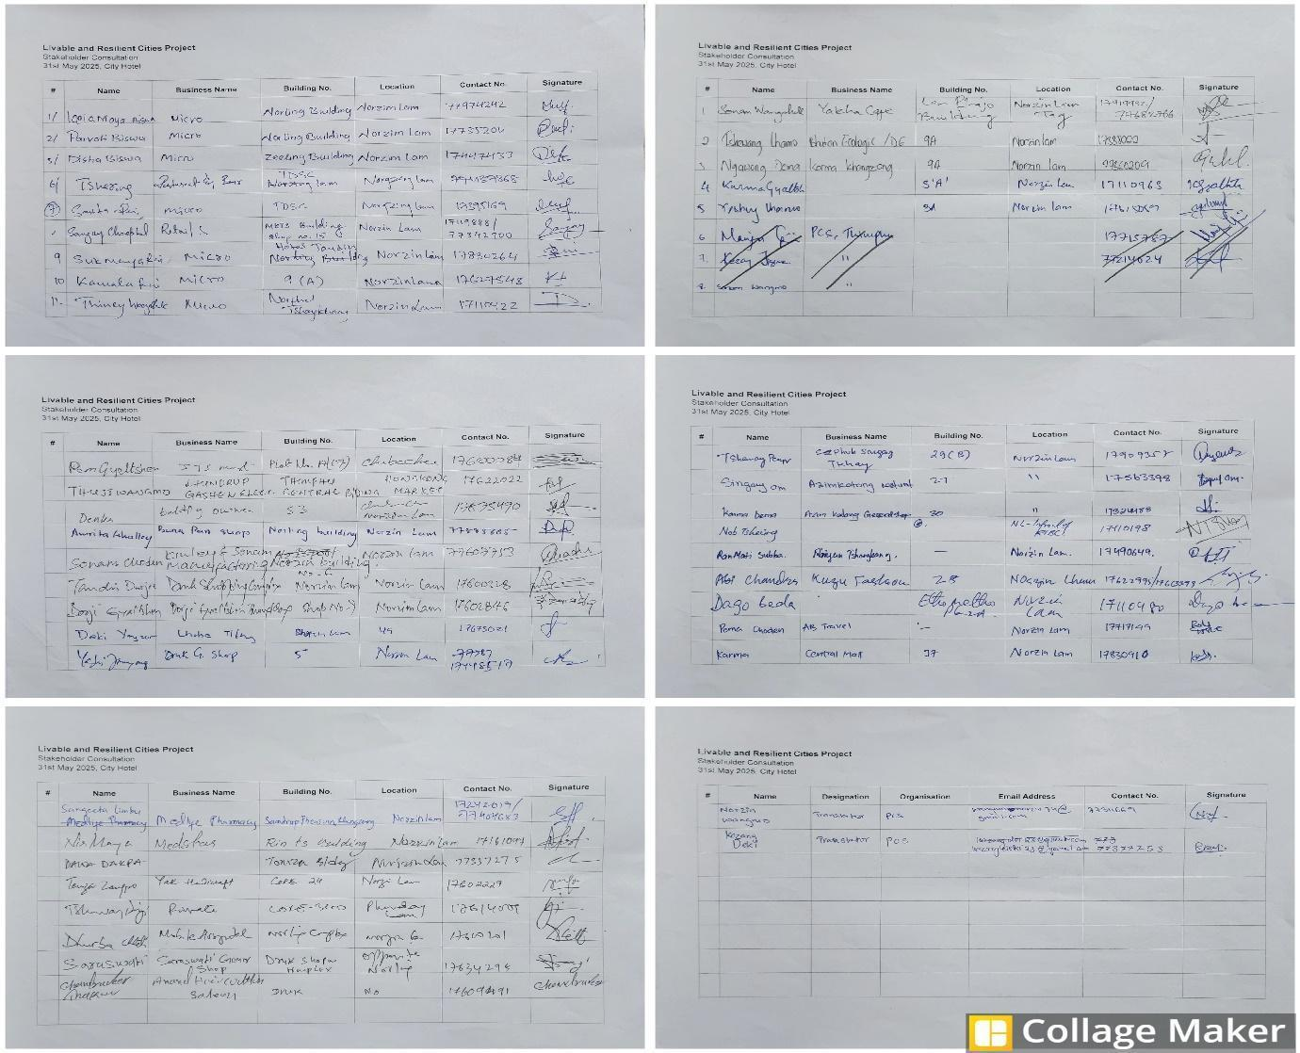
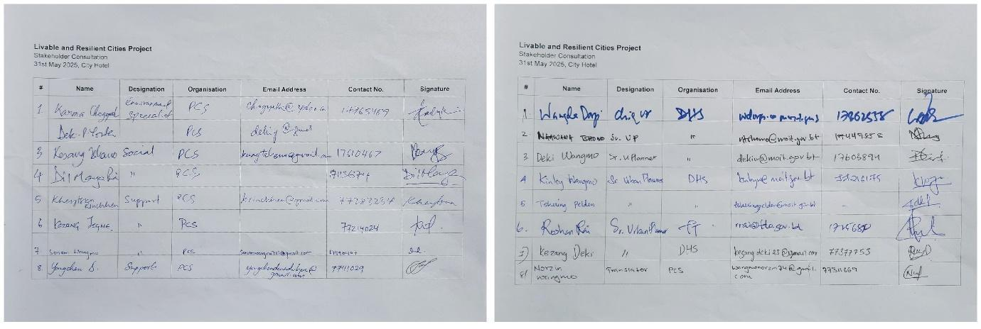

List of Participants of Central Thimphu Public Consultations – Contd.
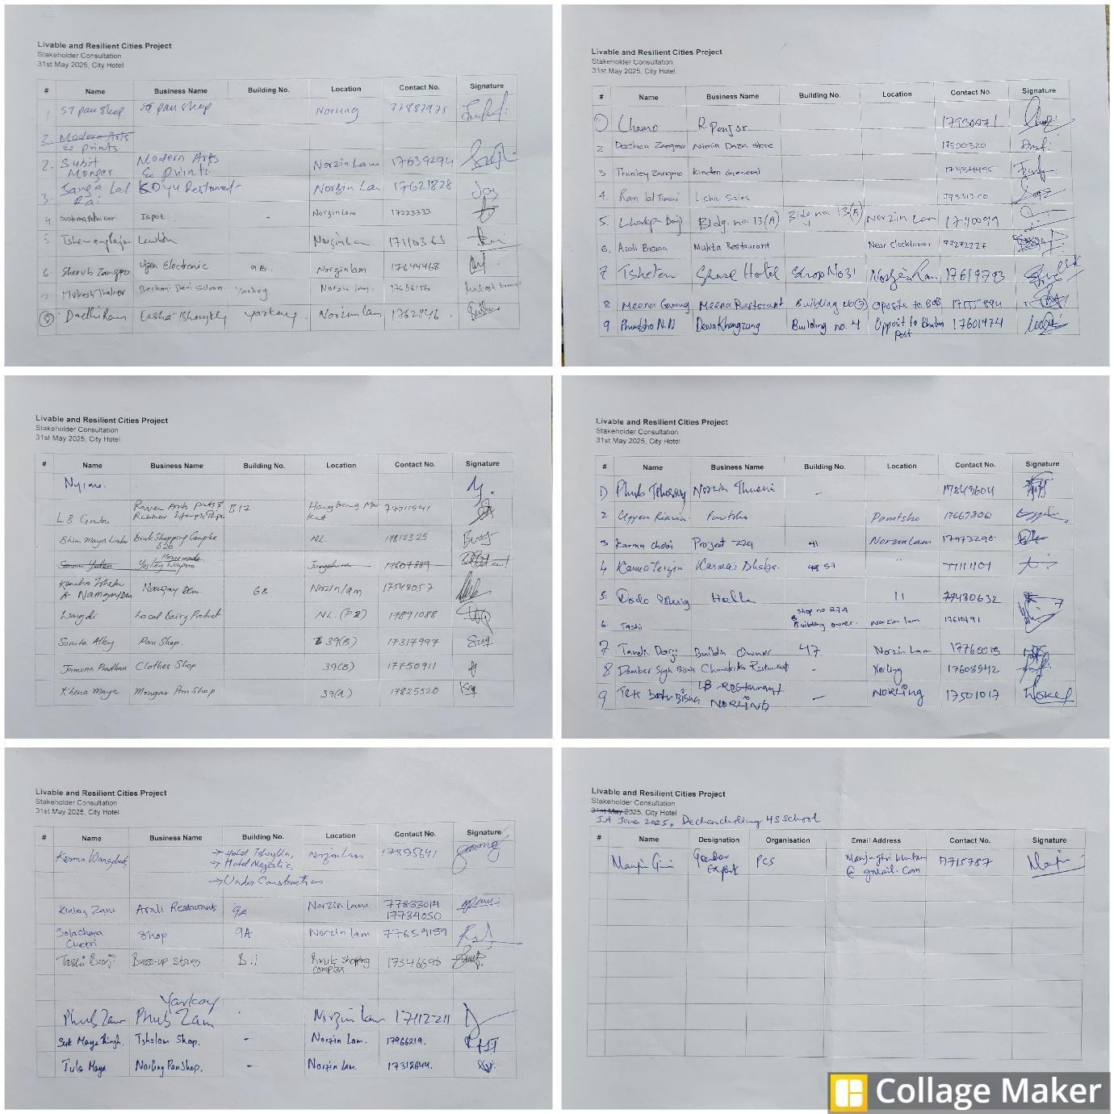

List of Participants of Northen and Central Thimphu (Changzamtog) Public Consultations
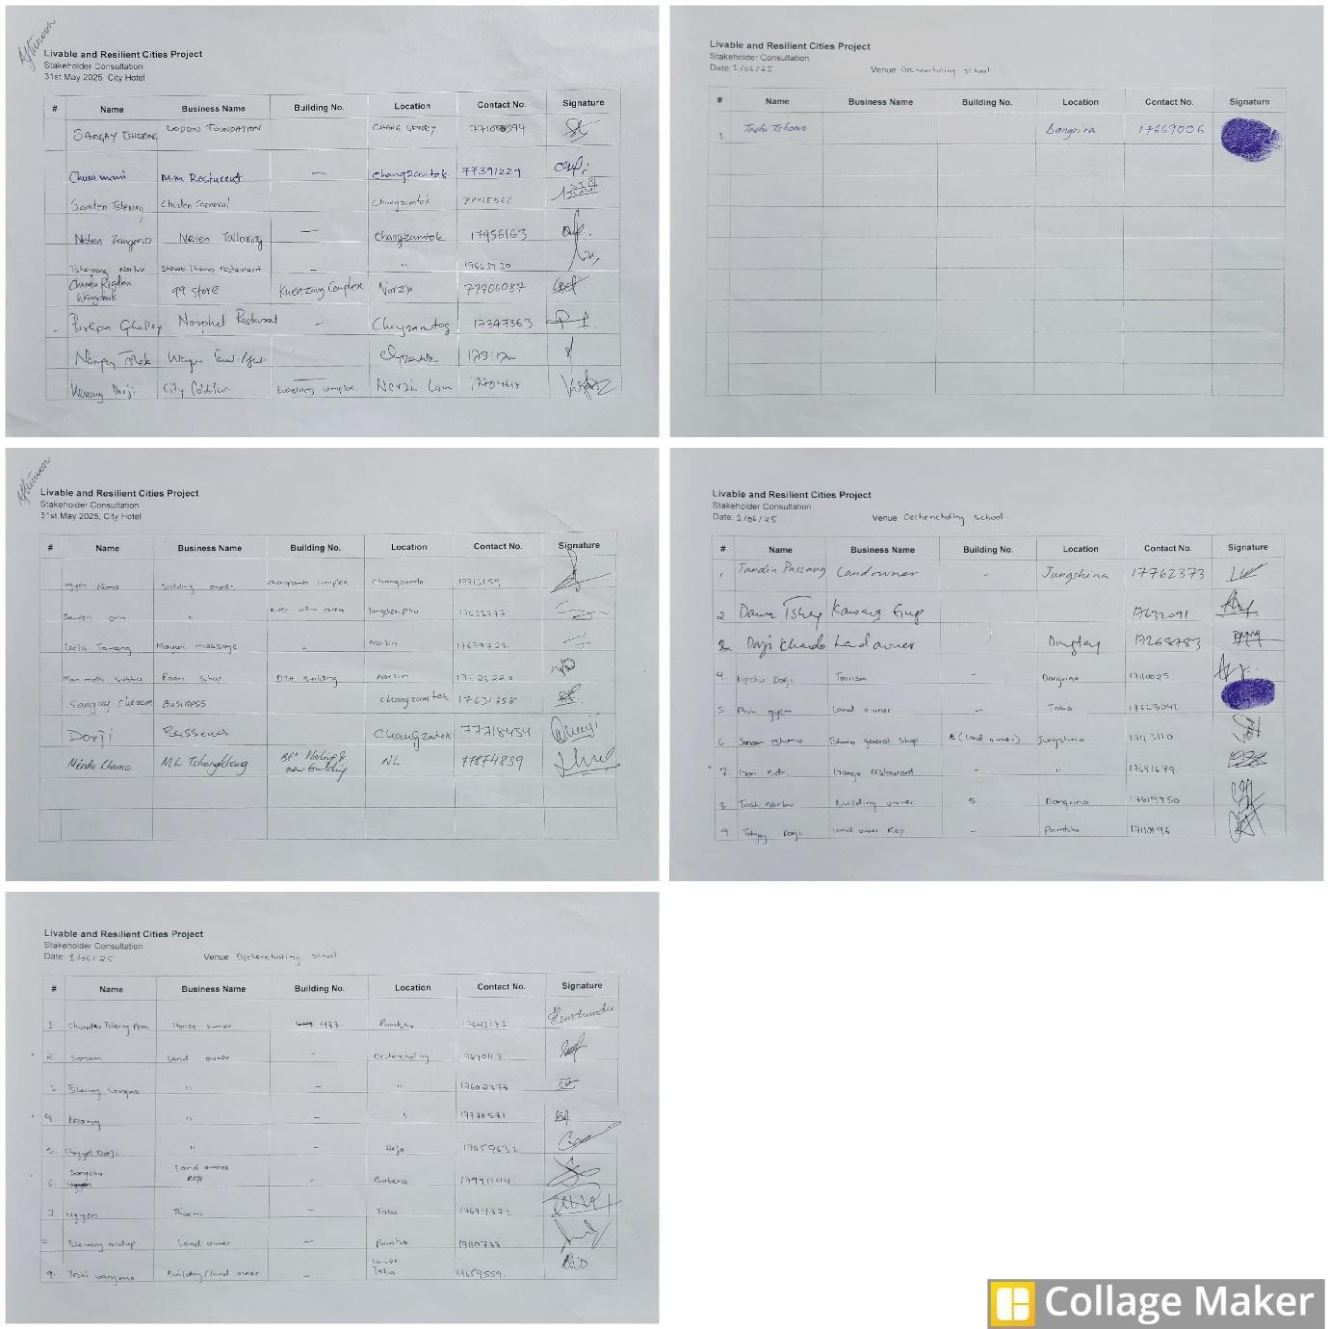

List of Participants of Southern Thimphu Public Consultations
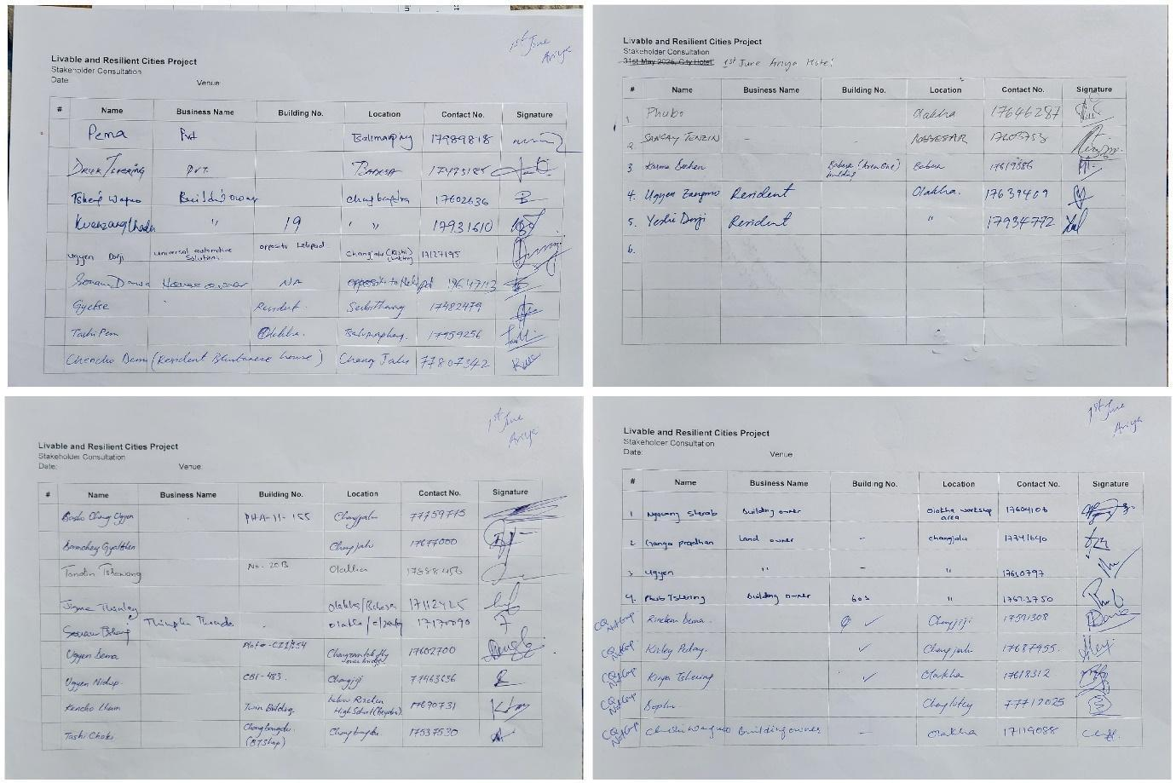
List of Participants of Baowe and Parking Fee Collectors Consultation Participants
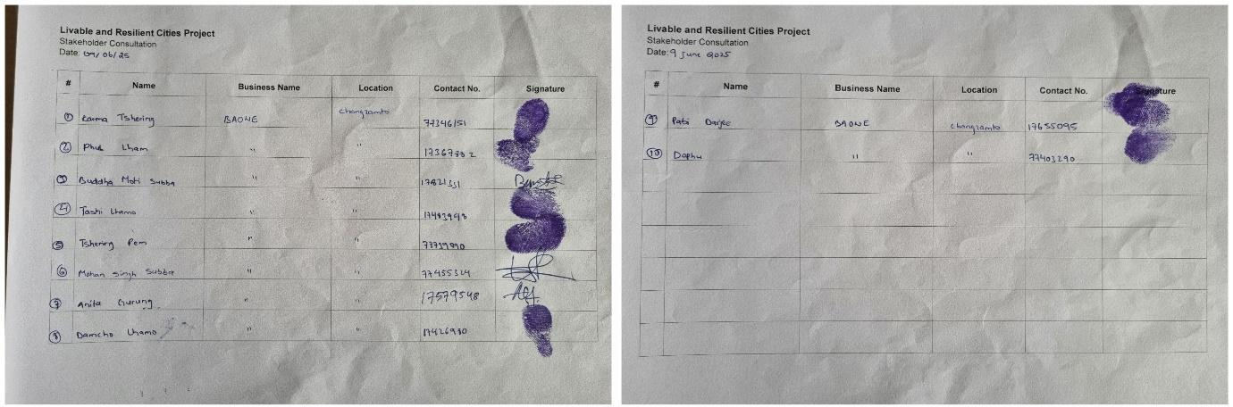
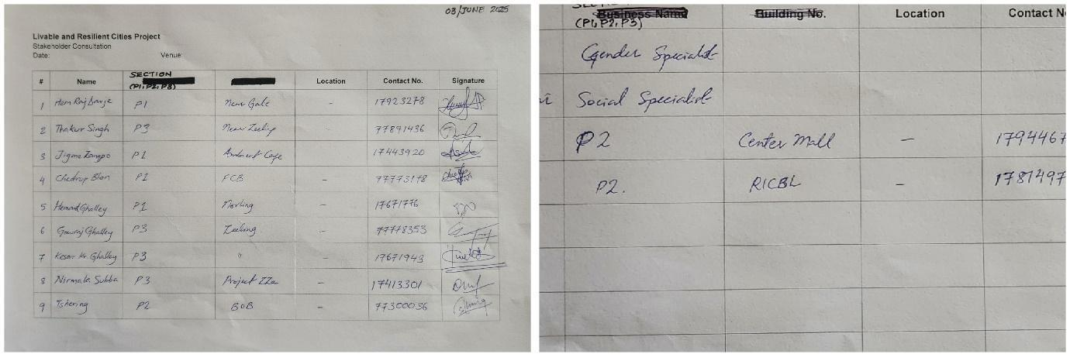

Appendix-4: Environmental and Social Screening Form (Project Concept Stage)
1. Basic Project Information
Project Name: | Livable and Resilient Cities Project (LRCP)
Country: | Bhutan
Project Location: | Thimphu City, Thimphu Thromde
Implementing Agencies: | Ministry of Infrastructure and Transport (MoIT) - PMU; Thimphu Thromde (TT) - PIU
Date of Screening: | August 15, 2025

2. Project Description
The project aims to enhance livability and climate resilience in Thimphu through improved infrastructure and service delivery. The key physical components include:
- Urban Transport:
  - Development of an 18.7 km Bus Priority Service (BPS) corridor, including the widening of 3.9 km of road from 2 to 4 lanes.
  - Construction/expansion of two climate-resilient bridges (Pamtsho, Dechencholing) and one culvert.
  - Construction of two new bus terminals (Ngabiphu, Dangrina) with administrative, maintenance, and e-bus charging facilities.
  - Redevelopment of Norzin Lam (main commercial street) and five connecting alleyways with a "complete street" design.
  - Procurement of 50 new battery-electric buses (e-buses).
- Water Sector (Separate ESMP): Upgrades to the city's water supply system.

3. Project Setting and Baseline Context
The project is located in a dense urban and peri-urban environment within the mountainous Thimphu Valley. The BPS corridor traverses a mix of commercial, residential, institutional, and state-reserved forest land. Key baseline characteristics include:
- Physical: The corridor crosses the Wang Chhu River and its tributaries. Some northern sections are in hilly, landslide-prone terrain.
- Environmental: Baseline air quality (NO₂) and noise levels frequently exceed WHO guidelines, primarily due to traffic. A section of the route passes near the Thimphu Wetlands, a designated Key Biodiversity Area (KBA).
- Social: The area is densely populated, with a high proportion of businesses operated by tenants and a significant number of women-led enterprises. The corridor passes numerous sensitive receptors, including schools (some for Special Education Needs - SEN), the national referral hospital (JDWNRH), and major cultural heritage sites like the National Memorial Chorten.

4. Initial Screening of Potential Environmental & Social Risks and Impacts
Risk / Impact Category | Description of Potential Risk
Social Risks
Land Acquisition & Livelihood Impacts (ESS5) | Involuntary acquisition of ~1.08 acres of private land and formal allocation of ~0.9 acres of government land. Temporary and permanent economic displacement impacting over 600 businesses (owners, tenants, employees) and informal livelihoods (vendors, parking fee collectors) due to access restrictions and changes in street layout.
Community Health & Safety (ESS4) | Increased risks to the public from construction traffic, open excavations, noise, dust, and vibration. Safety risks for pedestrians and commuters during both construction and operation, especially near schools and hospitals.
Labor and Working Conditions (ESS2) | Risks associated with a large construction workforce (~200 workers, mostly non-local), including OHS hazards (work at height, in live traffic), poor accommodation standards, and labor influx.
Gender-Based Violence (SEA/SH) (ESS2, ESS4) | Increased risk of SEA/SH due to the interaction between the construction workforce and local communities, particularly women and girls near worksites and labor camps. Rated 'Moderate'.
Cultural Heritage (ESS8) | Indirect impacts on major cultural heritage sites (e.g., National Memorial Chorten) from vibration, dust, and access disruption. Risk of chance finds during excavation along historic corridors like Norzin Lam. Potential disruption to intangible cultural heritage (festivals, daily rituals).
Environmental Risks
Biodiversity (ESS6) | Removal of 309 trees. Disturbance to fauna in the forested section near Taba. Temporary impacts on aquatic ecosystems from in-stream construction (or expansion) of two new bridges. Indirect risks to the Thimphu Wetlands KBA from changes in hydrology or pollution are possible, though no direct encroachment will occur.
Pollution Management (ESS3) | Contamination of soil and water from construction runoff, accidental spills of hazardous materials, spoil disposal, and vehicle maintenance at new terminals.
Climate Change | Project infrastructure is vulnerable to climate risks, including flash floods (as evidenced by the 2024 Dechencholing flood) and landslides. The project itself is designed to mitigate GHG emissions.

5. Initial Screening of Environmental and Social Standards (ESSs)
ESS | Standard | Relevance / Triggering | Justification
ESS1 | Assessment and Management of E&S Risks and Impacts | Relevant | The project involves multiple physical components with a range of E&S risks that require a comprehensive assessment and management plan.
ESS2 | Labor and Working Conditions | Relevant | The project will employ a significant number of direct and contracted workers, requiring management of OHS, labor influx, and prevention of SEA/SH.
ESS3 | Resource Efficiency and Pollution Prevention | Relevant | Construction will use significant resources and generate waste, spoil, and pollution. Operation of terminals will generate hazardous waste (batteries, oils).
ESS4 | Community Health and Safety | Relevant | Construction and operation will occur in a dense urban area, posing risks related to traffic, site safety, noise, dust, and vibration to the public.
ESS5 | Land Acquisition, Restrictions on Land Use and Involuntary Resettlement | Relevant | The project requires land acquisition and will cause economic displacement of businesses and informal livelihoods.
ESS6 | Biodiversity Conservation | Relevant | The project involves tree felling, in-stream works for bridges, and is located near a KBA and state-reserved forest land.
ESS7 | Indigenous Peoples | Not Relevant | The ESIA screening concludes that there are no distinct social/cultural groups in the project area that meet the ESS7 criteria for Indigenous Peoples. This determination is made in consultation with the World Bank.
ESS8 | Cultural Heritage | Relevant | The project corridor is in close proximity to major tangible heritage sites and is located in an area with potential for chance finds. It will also affect intangible cultural heritage.
ESS9 | Financial Intermediaries | Not Relevant | The project does not involve Financial Intermediaries.
ESS10 | Stakeholder Engagement and Information Disclosure | Relevant | The project affects a wide range of stakeholders, requiring a comprehensive and inclusive engagement process and a functional Grievance Redress Mechanism.

6. Proposed Environmental and Social Risk Classification (ESRC)
PROPOSED ESRC: SUBSTANTIAL
Justification for Rating:
The 'Substantial' risk rating is proposed due to the combined effect of several factors:
- Significant Social Impacts: The project involves involuntary land acquisition and significant, complex economic displacement of over 600 businesses and informal workers in a dense urban core, requiring a robust Resettlement Action Plan.
- Complex Urban Environment: All works will be conducted in a crowded city, posing high risks to community health and safety (traffic, access, noise, dust) and requiring complex management of multiple sensitive receptors (hospitals, SEN schools, heritage sites).
- Implementing Agency Capacity: While experienced in planning, the implementing agencies have identified capacity gaps in the direct supervision of complex E&S requirements for a project of this scale, necessitating significant capacity-building support.
- Multiple Risks Across Standards: The project triggers most of the ESF's standards, with risks related to biodiversity, cultural heritage, and labour influx that, while manageable, are significant.
7. Proposed E&S Instruments to be Prepared
Based on the screening, the following E&S instruments are required:
- Environmental and Social Impact Assessment (ESIA)
- Environmental and Social Management Plan (ESMP) (one for transport, one for water)
- Resettlement Action Plan (RAP)
- Stakeholder Engagement Plan (SEP)
- Labor Management Procedures (LMP)
- Gender Action Plan (GAP) and SEA/SH Prevention and Response Action Plan
- Environmental and Social Commitment Plan (ESCP)

Appendix-5: Guidance Note on the Preparation of the Contractor’s Environmental and Social Management Plan (C-ESMP)
1.0 Purpose
This Guidance Note provides the minimum requirements for the preparation of the site-specific Contractor's Environmental and Social Management Plan (C-ESMP) and its associated sub-plans. The purpose of this note is to ensure that all bidders understand the project's specific E&S requirements and that the awarded Contractor develops a robust, practical, and compliant C-ESMP. The C-ESMP is the primary tool for on-the-ground implementation of the mitigation measures outlined in the project's overarching ESMP.
Approval of the final C-ESMP by the PIU/PMSC is a prerequisite for the commencement of any civil works.
2.0 Overarching Principles
All sub-plans within the C-ESMP must adhere to the following principles:
- Compliance: All plans must be compliant with a) the Royal Government of Bhutan's relevant laws and regulations, and b) the World Bank's Environmental and Social Framework (ESF) and EHS Guidelines. Where differences exist, the more stringent standard shall apply.
- Site-Specificity: Plans must be tailored to the specific conditions of the work sites, with a clear focus on the high-intensity impact areas identified in the ESIA (e.g., the 3.9 km road widening segment, the new bus terminal sites, and areas near sensitive receptors).
- Roles and Responsibilities: Each plan must clearly define the roles and responsibilities for its implementation, from the Contractor's Project Manager to the E&S Officers and site supervisors.
- Resource Allocation: Each plan must be supported by adequate allocation of staff, budget, and equipment to ensure its effective implementation.
- Training and Communication: Each plan must include a component for training all relevant workers on its procedures.
3.0 Minimum Requirements for Key Sub-Plans
The C-ESMP shall be a single, comprehensive document that includes the following detailed sub-plans:
3.1 Traffic Management Plan (TMP)
- Objective: To ensure the safety of the public and workers and to minimize traffic disruption.
- Minimum Content:
  - Detailed traffic control layouts for complex work zones, particularly along the 3.9 km road widening segment and on Norzin Lam.
  - A specific, non-negotiable protocol for maintaining unimpeded 24/7 emergency vehicle access to JDWNRH Hospital.
  - Procedures for ensuring safe pedestrian access around construction sites, with enhanced measures (e.g., flag persons) for all schools, especially during student arrival and departure times.
  - A plan for advance public notification of lane closures, detours, and access changes.
3.2 Community Health & Safety Plan (CHSP)
- Objective: To prevent and manage risks to communities adjacent to construction sites.
- Minimum Content:
  - Enhanced Noise and Dust Control Measures: Specific procedures for the high-impact areas, including the required frequency of water sprinkling, use of noise barriers for stationary equipment near residences, and scheduling of high-noise activities to avoid sensitive times at schools and hospitals.
  - Vibration Management Protocol: A plan for conducting pre-construction condition surveys and implementing vibration monitoring for works near sensitive structures, particularly the National Memorial Chorten.
  - Site Security and Hazard Management: Procedures for hard-fencing all open excavations, securing material storage areas, and ensuring adequate nighttime lighting and signage.
3.3 Occupational Health & Safety (OHS) Plan
- Objective: To ensure a safe working environment for all project personnel.
- Minimum Content:
  - Site-Specific Job Hazard Analyses (JHAs): Detailed JHAs for all high-risk activities, including work at height on the construction or expansion new bridges and terminals, work in live traffic, in-stream works, and work in identified landslide-prone areas.
  - Emergency Response Procedures: A detailed plan for responding to medical emergencies, fires, spills, and other incidents, including emergency contact lists and evacuation routes.
3.4 Spoil and Waste Management Plan
- Objective: To manage all project-generated waste in an environmentally sound manner.
- Minimum Content:
  - Spoil Management: An estimated spoil balance (generated vs. reused) and a detailed plan for the haulage of surplus spoil from the 3.9 km road widening segment, including designated routes and schedules.
  - Waste Segregation and Storage: A plan for the segregation, storage, and disposal of all waste streams (domestic, construction debris, hazardous), including the location of designated waste management areas at the new bus terminal sites.
  - Hazardous Waste Protocol: Specific procedures for the handling, storage (in bunded areas), and disposal of hazardous waste via licensed contractors.
3.5 Erosion and Sediment Control Plan (ESCP)
- Objective: To prevent soil erosion and the pollution of water bodies.
- Minimum Content:
  - Site-specific drawings showing the location of erosion and sediment controls.
  - Enhanced controls for high-risk areas: This must include the design of sediment basins for the new bus terminal sites and a plan for robust perimeter controls (e.g., silt fences, check dams) along the 3.9 km road widening segment and at all bridge construction sites.
  - A plan for the prompt and progressive stabilization of all exposed soil areas.
3.6 Worker Accommodation Plan
- Objective: To ensure workers are provided with safe, clean, and decent living conditions.
- Minimum Content:
  - A rationale for the location of any proposed worker camp, demonstrating that it avoids sensitive areas.
  - A layout plan and description of facilities, demonstrating full compliance with Bhutanese OHSW Regulations and the IFC/EBRD Guidance Note on Workers' Accommodation.
  - A Camp Management Plan, including rules for workers (linked to the Code of Conduct), provision of services (water, sanitation, health), and a grievance mechanism for accommodation-related issues.
3.7 Labor Management Plan (LMP)
- Objective: To ensure all project workers are managed in a manner that is fair, safe, and compliant with national law and World Bank ESS2.
- Minimum Content:
  - Recruitment and Hiring Procedures: A commitment to fair and transparent recruitment practices, with a specific focus on prioritizing local hiring where feasible. This section must include robust age verification procedures to prevent child labour and a clear policy of non-discrimination.
  - Terms and Conditions of Employment: A template for worker contracts that is compliant with Bhutan's labour laws and details working hours, wages, overtime compensation, benefits, and leave.
  - Worker Code of Conduct (CoC): A detailed, project-specific CoC that all workers, including subcontractors, must sign as a condition of employment. The CoC must include a zero-tolerance policy for SEA/SH, GBV, child abuse, fighting, and drug/alcohol use. It will also contain rules for respectful interaction with the local community.
  - Worker Grievance Redress Mechanism (GRM): A detailed procedure for a Worker's GRM that is separate from the community GRM. It must be accessible to all workers (including those of subcontractors), have clear timelines for resolution, and include a confidential pathway for reporting sensitive grievances like SEA/SH. The plan must describe how workers will be trained on and made aware of this mechanism.
  - Subcontractor Management: A description of the procedures the main Contractor will use to ensure that all subcontractors are contractually bound to and comply with all aspects of the LMP.

BGLI – Bhutan Glacial Lake Inventory, 2021

