STAKEHOLDER ENGAGEMENT PLAN

Bhutan: Livable and Resilient Cities Project (LRCP)

Ministry of Infrastructure and Transport
March 2026

Table of Contents

1. Introduction/ Project Description 3
2. Objective/Description of the SEP 6
3. Stakeholder Identification and analysis per project component 7
4. Stakeholder Engagement Program 10
5. Resources and Responsibilities for Implementing Stakeholder Engagement 28
6. Grievance Redress Mechanism 31
7. Monitoring and Reporting 35
Annexes 37
Annex 1. Grievance Register Form 37
Annex 2. Grievance Closure Form 38
Annex 3. Resolution Notification Form 39
Annex 4. Public Notices regarding Environment and Social Assessment and RAP Survey 40

Introduction/ Project Description
  - Project Overview
The Livable and Resilient Cities Project (hereafter “LRCP” or “The Project”) aims to enhance livability and climate resilience in Thimphu Thromde, the capital city of Bhutan through improved targeted urban infrastructure and service delivery. This project will result in reduction of non-revenue water, improved user satisfaction with public spaces, reduce and avoid GHG emissions through promotion of public transport and promote institutional reforms and improved operational systems by Thimphu Thromde to deliver climate-resilient urban services.
The LRCP builds on the Bhutan Green Transport Project (BGTP) and the Thimphu Structure Plan 2023-2047. The PMU for the Project is Department of Human Settlements (DHS), Ministry of Infrastructure and Transport (MoIT). The PIU for the Project is Thimphu Thromde. The project is prepared under the World Bank’s Environment and Social Framework (ESF) for co-financing through the Green Climate Fund. The project extent is indicated in Figure 1.
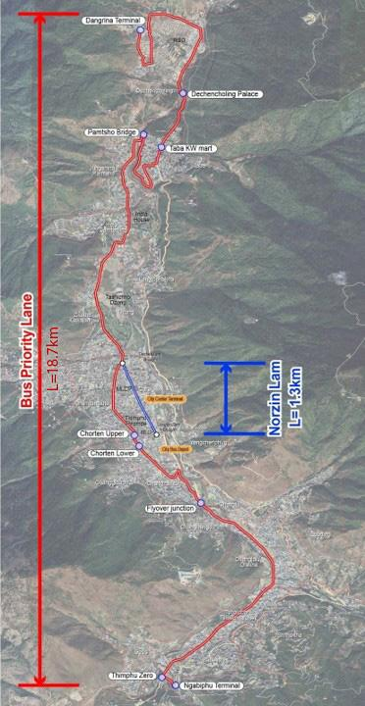

Figure 1: LRCP Project Area
LRCP will comprise two components:
Component 1: Resilient and low-carbon service delivery includes 3 sub-components
Component 1.1: Resilient water services to enhance the resilience and reliability of Thimphu’s water supply in the core city
This component strengthens urban water supply systems to be more resilient to climate impacts and to deliver reliable 24/7 service. It will install SCADA systems for improved monitoring, operational control, demand forecasting, and climate‑risk analysis. The project will climate‑proof raw water intakes and transmission infrastructure, reducing erosion and landslide risks from extreme rainfall. It will rationalize service areas under water treatment plants, optimize transmission and storage to operate at full capacity, and ensure equitable water distribution across District Metered Areas. By reinforcing distribution networks, reducing water losses, and implementing active leakage control, the component will maintain uninterrupted water supply during droughts and floods while improving overall service levels in the core city.
Component 1.2: Resilient urban public spaces and low-emission mobility
The project will upgrade Thimphu’s public spaces by applying complete street design to improve pedestrian infrastructure, safety, and accessibility. It will enhance Norzin Lam and surrounding passageways with better sidewalks, street furniture, and inclusive access for persons with disabilities, children, and the elderly, including removal of high kerbs and footpath obstructions. Improvements will support small business areas, strengthen pedestrian links along the bus priority corridor, and install continuous underground cable ducts for bus stop display boards. Designed through a participatory process, the project will also improve roadside drainage and integrate Sustainable Urban Drainage Systems (SuDS) to manage runoff and reduce flood risk.
Component 1.3: Low-emission public transport
The component will develop a low‑emission, reliable, and accessible public bus system to improve mobility and reduce greenhouse gas emissions. It will introduce an 18.7‑km bus priority corridor from Babesa to Dechencholing, including bus bays, 75 shelters, widened bridges, and climate‑resilient river protection works. The project will procure 50 electric buses, build new northern and southern terminals, and upgrade the central depot with charging, maintenance, and staff facilities using energy‑efficient and climate‑proof designs. It will deploy Intelligent Transport and Management Information Systems for real‑time service monitoring, passenger information, and journey planning, and install 23 signalized pedestrian crossings. Designed to accommodate future climate risks, the investments are expected to incentivize public transport use and reduce emissions by about 193,000 tCO₂e over 20 years.
Component 2: Urban management, planning, and capacity building for improved climate resilience includes 3 sub-components
Component 2.1: Capacity building and institutional strengthening for resilient water and urban service delivery
The component will strengthen institutions and create an enabling environment for climate-resilient and financially sustainable urban water management in Thimphu and nationally. It will establish a ring-fenced water and wastewater services division within Thimphu Thromde, supported by SCADA-based monitoring to optimize operations, maintenance, investment planning, and emergency response to climate and disaster risks, including floods and GLOFs. Day-to-day management will be enhanced through private sector engagement or external expertise, alongside technical and financial management support to meet international standards and implement the Thimphu Water Sector Master Plan. The project will improve billing systems and tariff structures to achieve full cost recovery, while providing policy and institutional support to MoIT for future project preparation, national scaling, and increased private sector participation in smaller Thromdes. It will also include public communication on water conservation and urban design benefits and undertake a diagnostic of Bhutan’s urban property valuation system to identify gaps and recommend improvements in valuation methods, regulations, and technologies, supporting better disaster risk management, resilient investment, and land-based revenue generation.

Component 2.2: Capacity building and institutional strengthening for resilient transport service delivery
The project will strengthen institutions to improve the sustainability, efficiency, and coverage of Thimphu’s public transport system by supporting City Bus Service (CBS) in its transition to a state‑owned enterprise with a national mandate for low‑emission transport. It will build CBS’s operational, financial, and governance capacity, including business planning, accounting, human resource policies, and service delivery for new electric buses, alongside technical training and capacity building. The project will actively promote women’s employment and leadership in the transport sector through targeted training, mentorship, and human resource reforms. It will support the development of climate‑resilient transport investment and maintenance plans, advance implementation of strategies under the LETMP, NAP, and CCAP, and strengthen parking and freight policies to encourage modal shift. The sub‑component will also develop national standards for intelligent transport systems and smartcard payments, support their rollout and use of data to improve services, enhance CBS’s financial sustainability through revenue and cost‑management strategies, and implement a communications campaign to promote public transport and non‑motorized transport use.
Component 2.3: Project management
The project will support the Ministry of Infrastructure and Transport (MoIT) in managing project implementation in coordination with Thimphu Thromde. This sub-component will finance the costs associated with the Project Management Unit (PMU) and the Project Implementation Unit (PIU) for coordination, procurement, financial management, environmental and social management, and Monitoring and Evaluation (M&E). It will also finance the rollout of the Grievance Redress Mechanism (GRM).

Objective/Description of the SEP
The overall objective of the SEP is to define a program for stakeholder engagement, including public information disclosure and consultation throughout the entire project cycle. The SEP outlines the ways in which the Ministry of Infrastructure and Transport (MoIT) will communicate with stakeholders and includes a mechanism by which people can raise concerns, provide feedback, or make complaints about the project and any activities related to the project. The SEP specifically emphasizes methods to engage all stakeholders throughout the project to ensure smooth implementation by minimizing incidents/reports of grievance and to ensure that all parties participate in the project process.

Stakeholder Identification and analysis per project component
  - Methodology
For the Livable and Resilient Cities Project (LRCP), the following stakeholders have been identified and analyzed per project component. These stakeholders include affected parties (as defined in section 3.2), other interested parties (as defined in section 3.3) and disadvantaged/vulnerable individuals or groups (as defined in section 3.4).
  - Potentially Affected Parties
Affected parties include local communities, community members and other parties that may be subject to direct impacts from the Project. Specifically, the following individuals and groups fall within this category:
Component 1.1: Resilient water services to enhance the resilience and reliability of Thimphu’s water supply in the core city
- All beneficiaries facing disruption during the construction phase
- Property/landowners due to the construction of Water Supply Infrastructure
- Jigme Dorji National Park since the water intake source is located there
Component 1.2: Resilient urban public spaces and low-emission mobility
- Urban public spaces and road users in the project area
- Government and corporate offices in the project area
- Property/landowners who own land and property in the project impacted areas
- Persons/agencies leasing property
- Businesses along the NMT section
- All informal vendors currently using the NMT section
Component 1.3 Low emission public transport
- All users of City Bus Service infrastructures temporarily during construction phase
- Persons living near the new construction
- Property/landowners whose land and/or property will be impacted
- Users of bridges during their widening
- Residents living near the project area of bus terminals in the north and south axis
- Users of the existing BPS route temporarily impacted during construction phase
- Property/landowners whose land and property will be impacted
- Persons/agencies leasing property that will be impacted by the BPS Type 2 road expansion
  - Other Interested Parties
The projects’ stakeholders also include parties other than the directly affected communities. For each component Interested Parties include
Parties common to all Components.
- Theumis/local representatives
- Department of Energy and Climate Change

Component 1.1: Resilient water services to enhance the resilience and reliability of Thimphu’s water supply in the core city.
- Government Agencies and Corporations: Bhutan Power Corporation, Bhutan Telecom
- Water Treatment Plant (WTP) caretakers at Taba, Motithang, Jungshina
- Environment Interest Groups and concerned government Agencies
- Royal Monetary Authority and Financial Institutions
- Department of Revenue and Customs, Ministry of Finance
- Interested Contractors
- CSOs and NGOs
- Media
Component 1.2: Resilient urban public spaces and low-emission mobility.
- Concerned Government Agencies and Corporations and private agencies
- MoF, Royal Monetary Authority and Financial Institutions
- Department of Revenue and Customs, Ministry of Finance
- Interested Contractors
- CSOs/NGOs and Media
Component 1.3 Low emission public transport.
- Government Agencies and Corporations and private agencies
- Kawang Gewog, Thimphu Dzongkhag
- Environment Interest Groups and Government Agencies
- MoF, Royal Monetary Authority and Financial Institutions
- Department of Revenue and Customs, Ministry of Finance
- Interested Contractors
- Bus supplier companies and private sector for charging stations
- Interested Contractors
- CSOs and NGOs
- CSOs/NGOs and Media
  - Disadvantaged/Vulnerable Individuals or Groups
Within the Project, the vulnerable or disadvantaged groups include the following:
BPS bus stop/shelter/bay/terminal along route :
- Dechencholing: People living in the 2024 flood-impacted buildings and structures along the Dechencholing Chhu (e.g. Drangtoe settlement––Figure 5)
- Babesa: One temporary settlement below the left lane of Thimphu Zero-Olakha expressway) falls at a proposed bus shelter (Figure 6).
BPS four lane reconfiguration section (Type 2 road)
- CSI-Chorten: Temporary settlements beside the road, including rental residents
- BAOWE Local vendors at the entrance to JDWNRH hospital
NMT: Parking fee collectors and street vendors along the NMT route at various locations.

Identification of vulnerable groups within the communities:
Vulnerable groups within the communities found in different locations of the project are as follows:
Persons living with disabilities (PwD): The survey carried out at Norzin Lam revealed that there are 73 household (HH) members reported facing some form of disability. Of this, 24 HH members had physical disability while 11 members faced intellectual disability and 31 HH members had other forms of disability which are mainly related to senility and chronic physical illnesses. Only 18 (28%) hh members faced a severe disability. Only 14 household members (22%) with disabilities required a full-time attendant. The survey carried out at the Bus Priority Service Lane revealed that there were 64 persons (4%) living with disabilities of the total members in the households with about equal composition of males and females facing disabilities. There were 24 persons (37%) who had physical disabilities, 11 (17%) lived with intellectual disability, while the rest were rendered incapacitated due to terminal illnesses and old age . Of the total 64 persons with disabilities, 18 (28%) had severe disabilities, and fourteen persons (22%) of the total persons living with disabilities require a full-time attendant.
Informal sector: Other than the BAOWE shed businesspersons, no other sector of informal vendors were interviewed. BAOWE business units are considered informal as some of them are vegetable and momo vendors operating without licenses. The BAOWE shopkeepers beside the Jigme Dorji Wangchuk National Referral Hospital gate are operating in the shed built by BAOWE to give them decent sheds to sell their products, which are mostly edibles prepared by themselves like momos (dumplings) and noodles. Even though the sheds were built and provided free of cost, the sheds are too small and one window shed has to be shared between two sellers on rotation (turn wise) basis. Most vendors shared that their income is just enough to cover basic expenses, though not sufficient for other needs. The vendors acknowledged the road widening along the hospital, Memorial Chorten area will likely affect their income(s), as they are situated just by the roadside. Most of the vendors are from poor economic backgrounds with family members to support.
Some of the challenges facing them shared were:
- Reports of petty burglaries, requesting for installation of CCTV to track the petty thieves
- Toilets: No dedicated toilet facilities for the vendors. Currently, they are using hospital toilets, which are a bit farther away and inaccessible immediately.
- The sheds are also not provided with seating arrangements for the customers.
- Some vendors have taken microloans from RENEW to set up their shops, so if they get displaced, they fear defaulting every month instalments and thereby may face emotional and mental stresses leading to other forms of domestic violence.
The description of the methods of engagement that were undertaken by the project during the BGTP preparation is provided in the following sections.

Stakeholder Engagement Program
  - Summary of Stakeholder Engagement carried out during project preparation
The Stakeholder Engagement Plan below outlines the engagement process, methods, including sequencing, topics of consultations and target stakeholders. The World Bank and the Borrower will not tolerate reprisals and retaliation against project stakeholders who share their views about Bank-financed project.
Table 1: Summary of Stakeholder Consultations
List of Meetings | Date | Type | Number of Participants | Key Issues Discussed
Introduction meeting with TT and SUNJIN | 20/09/2022 | KII | Thimphu Thromde (TT)  20 men & 2 women | Discussion of the bus system scenario. TT shared past hindrances to project implementation included inadequate stakeholder consultations and not assigning timelines for implementation. TT referred consultants to staff, agencies, and other reports for their data requirements.
Introduction meeting to explain the broad objectives of the project and proposed activities, including project components, route and conditions, pedestrianization requirements, technical, gender, and E&S | 21/09/2022 | Stakeholder/community consultations for feedback on 2023 ESIA | Ministry of Finance, MOIC, MOWHS. NLCS, GNHC, UNDP, JICA, EV Project of PMO  19 men, 2 women | Number of electric taxis already in operation and electric buses to be considered. Suitability of current bus route and characteristics of roads, GPS capabilities and readiness of project preparation to access GCF funding a possibility. Completed identifying and site leveling for north terminal and four-lane road development in preparation for this project. Dedicated bus stops away from the route, EV charging stations, parking spaces and the Transportation 2030 Report.
Introduction meeting to explain the broad objectives of the project and proposed activities, including project components, route and conditions, pedestrianization requirements, technical, gender, and E&S | 22/09/2022 | Stakeholder/community consultations for feedback on 2023 ESIA | RSTA, CBSO, RBP, BPC, TT, NEC, ABS, Thromde Thuemis  21 men, 2 women | Need to improve the bus service to enhance public adoption, considerable fuel expenses for bus services, enhance safety of women and preference seating for elderly, disabled etc. BPS to avoid congestion in rush hours. Providing dedicated bus lanes is also challenging but bus services and circulation can be improved, better audiovisual announcement and security systems. improvement of Norzin Lam for better local economy.
Consultation with stakeholders in relation to gender | 22/09/2022 | Stakeholder/community consultations for feedback on 2023 ESIA | NCWC, BAOWE, CBS, TT, SUNJIN | Use of bus services by women depends on pricing, but other improvements for safety considerations (street lighting, distance from bus stop to home, inadequate seating, behavior of bus drivers and male passengers, inadequate CCTV) were also discussed. Encouragement of women bus drivers.  Plans for Norzin Lam discussed gender, elderly, disability-friendly considerations.
Meeting to identify transport behaviors, needs and perceptions of different social groups, especially women and vulnerable | 22/09/2022 | KII | TT and City Bus Service (CBS) staff with SUNJIN Consultants  7 men and 3 women | Poor implementation of existing legal frameworks, and poor understanding of gender responsive infrastructure. Experiences of women public transport users and drivers were gauged. Need for sensitization of gender in public transport.
Information on tasks of Activity 1, review of plans of the BRT, low emission transportation plan, international transportation services of some countries | 27/09/2022 | Stakeholder/community consultations for feedback on 2023 ESIA | MOWHS, NLCS, JICA, NECS, RSTA, CBS, RBP, BPC, TT, ABS, RENEW, NCWC, Thuemis, TT  26 men and 6 women | After a presentation on international transportation services of other countries, participants split into groups and members suggested selection of BRT components: general bus, Bus Priority Service, semi-open transfer facility, bus route and bus arrival information in the BIS, payment in the bus through cash, mobile phone payments, and smart card and plug in bus charging.
Stakeholders meeting regarding BRT Line | 16/11/2022 | Stakeholder/community consultations for feedback on 2023 ESIA | MOWHS, CBS, RSTA, RBP  15 men and 2 women | Difficult terrain at Taba and built-up area. Expansion of bus stops beyond city boundary Road widening at Chorten Bus Priority Service policy discussed and more appropriate than calling it BRT.  CBS’ suggestion for a shuttle bus system at Norzin Lam will be considered after pedestrianization.
City Bus Service regarding Data Acquisition for Bus Operations | 17/11/2022 | KII | City Bus Service (CBS)  5 men and 3 women | Data requirements on travel data, passenger by load, fare collection system, annual operations data on income and expenses. CBS provided access to the data.
Taxi Association Meeting for Data Acquisition on Taxi Operations | 17/11/2022 | KII | Bhutan Taxi Association (BTA)  4 men | Understanding of the workings of BTA as a CSO and standard charges. BTA expressed the need for additional taxi stations near transit points and bus stations and terminals especially for last mile connections.
Stakeholders meeting regarding EV Supply chain, Power infrastructure for charging | 18/11/2022 | KII | EV-PMO, CBS, BPC  4 men | Electric bus on trial proposed for operation with charges at 2 terminals EV taxis, trucks being discussed EV charging stations and power supply requirements and source discussed.  Need to study international examples of EB, EB battery swap arrangement and e-waste issues.
RSTA Meeting for Regulations on Bus Priority Service and Taxi Operations | 18/11/2022 | KII | Road Safety and Transport Authority (RSTA)  4 men | Informed RSTA that BPS is designed as no entry zone for other cars. Need for prior public education before implementation, disability-friendly buses and infrastructure, and taxi stations near trunk routes and transit points.
Stakeholders meeting regarding EV Supply chain, Power infrastructure for charging | 21/11/2022 | Stakeholder/community consultations for feedback on 2023 ESIA | RSTA, DHS, MOWHS, CBS  12 men and 6 women | TSP and plans for overall development of city and need for BTTP to align Sites for additional MLCPs Pedestrianization of Norzin Lam, MLCPs and traffic need study Lane marking and road configuration for bus lane.
2nd Workshop on Stakeholders meeting regarding EV Supply chain, Power infrastructure for charging | 22/11/2022 | Stakeholder/community consultations for feedback on 2023 ESIA | MOIC, UNDP, OMO, MOWHS, CBS, RSTA, NLCS, DGPC, TT  27 men and 3 women | Selection of the final route for the Bus Priority Lane through the Stakeholders discussion and presentation will be studied by the Consultant. Changes of the traffic circulation system around the Memorial triangle for efficient operation of Bus Priority Service and reduction of the traffic delays shall be based on the traffic volume survey data
FGD on Gender Aspects to incorporate views in project design and Gender Action Plan | February 2023 | KII/FGD | Female, persons with disabilities (PwDs), NCWC, RENEW, BAOWE, teachers, parents etc.  82 women and 18 men | Perspectives of women working as bus drivers; women using city bus services, staff working at women and children organisations, persons with disabilities and their teachers, parents; female students from high school and college on 1) working conditions 2) career prospects 3) safety and security concerns in public transport 4) quality of bus services 5) safety issues for PwDs
Consultations during ESIA Phase 2023
Public consultation | 18/08/2023 | Stakeholder/community consultations for preparation of 2024 ESIA | DGPC, MOIT, BCTA, DECC, NLCS, ABS, BAOWE, RBP, Thromde | Safety needs to be considered when planning pedestrian crossings near bus bays.  Concern that feeder bus lines not considered  For Norzin Lam can also consider change in working hours, using carpool and odd-even numbered cars entry on specific days after careful examination
Public consultation | 18/08/2023 | Stakeholder/community consultations for preparation of 2024 ESIA | PMO, CBS, MOIT | EV suppliers ask for 100% payments before supplies. Need comprehensive e-bus specifications and requirements Consultant to use CBS specification or propose similar but with additional features for operators and users and standardized for Bhutan Reputed global suppliers familiar with Bhutan to be shortlisted
Public consultation | 24/08/2023 | Stakeholder/community consultations for preparation of 2024 ESIA | Thimphu Thromde Council | Suggested addressing missing gaps: measures to reduce taxi operation, supportive document for being in GCF Fund, EV promotional plan, connective feeder lines to trunk route, economic analysis and GHG emissions calculations.
Public consultation | 25/08/2023 | Stakeholder/community consultations for preparation of 2024 ESIA | Thimphu Thromde Task Force | Require an Action Plan to include women driver training and to prioritize make up the most critical activities.  Smart cards to be made available at bus shelters in vending machines  EV batteries disposal is a concern. Take-back batteries by bus suppliers to be included in contract  Shuttle bus routes to be thought out well for passengers coming to and from Norzin Lam. Suggest an online survey to collect public’s opinion
Community consultation | 26/08/2023 | Stakeholder/community consultations for preparation of 2024 ESIA | Business, residents, and other stakeholders from Northern area | No bus stop is provided for 35 shopkeepers in Dechencholing town  Taxi stands required at different areas bus stops/parking for people carrying loads  Need for underpasses and overpasses for bus as current roads will not manage increased future traffic
Community consultation | 27/08/2023 | Stakeholder/community consultations for preparation of 2024 ESIA | Business, residents, and other stakeholders from Middle area | BPS causes congestion for private cars in other lanes.  Consistent resistance to Norzin Lam pedestrianization and no justification as NL is the main economic hub with highest taxpayers in Thimphu. High financial losses of NL businesses expected. The pedestrianization project has always been opposed and participants expressed that they will continue advocating for cancellation of the project. Previous commitment for improving infrastructure along not taken up so far.
Community consultation | 27/08/2023 | Stakeholder/community consultations for preparation of 2024 ESIA | Business, residents, and other stakeholders from South area | Essential to include provisions for people with disabilities for both BPS and Norzin Lam  Acceptable and advance compensation for affected land and properties to avoid any problems
Community consultations | 31/06/ 2025 | Community consultations for project activities, including water interventions | Property owners and business owners from Norzin Lam  Property owners and business owners from CSI Market till Memorial Chorten | Concerns about potential negative impacts on businesses and inconvenience for residents to move around during construction of the route.  Concern about the removal of the current parking space and poor access and maintenance of the  the existing sidewalks.  Overflows of sewerage system, which pose serious health risks and hinder mobility  Inconsistent water supply, sometimes twice a day, and urged ensure a continuous supply.  Discussed on the need to improve water quality.
Consultations with social service provider | 01/06/ 2025 | Consultations with schools (3 total) | School principals, counsellors and other staff | Present the project components and discuss the key risks specific to schools and school children  Explain the GRM process.

4.2. Summary of project stakeholder needs and methods, tools, and techniques for stakeholder engagement
Different engagement methods are proposed and cover different stakeholder needs as stated below:
Project Stage | Target Stakeholders | Topic of Consultation | Method Used | Responsibilities | Frequency/  Tentative Timeline
Preparation | Indian Embassy  Bangladesh Embassy | Project scope and impacts | High Level G-to-G Formal consultation | MoIT through Ministry of Foreign Affairs | To be determined
Preparation | Three Schools, School principals, counsellors and other staff | - Present the project components and discuss the key risks specific to schools and students  - Explain the GRM process  - Seek input for code of conduct | Formal meeting - FGD | PMU, PIU, Consultant | July 2026
Preparation | - North region Building owners  - Business owners Government agencies  - Corporate bodies, CSO  - Dangrina-Drongtoe HHs impacted by the August 2024 flood | - Present the project components and discuss the key risks  - Explain the GRM process  - Seek input for code of conduct | Formal meeting and FGDs | PMU, PIU, Consultant | July 2026
Preparation | Central Region of the BPS  - Building owners  - Business owners  - Government agencies- RBP, Desuung HQ,  - Corporate bodies - Bhutan Insurance Limited, Bhutan Power Corporation | - Present the project components and discuss the key risks  - Explain the GRM process  - Seek input for code of conduct | Formal meeting - FGD | PMU, PIU, Consultant | July 2026
Preparation | NMT project -Building owners  - Business owners, including those along alleyways  - Government agencies  - Corporate bodies, and offices | - Present the project components and discuss the key risks  - Explain the GRM process  - Seek input for code of conduct | Formal meeting - FGD | PMU, PIU, Consultant | July 2026
Preparation | South region –  - Building owners  - Business owners  - Caretaker of Chorten near Changjiji Bridge  - Government agencies  - Corporate bodies | - Present the project components and discuss the key risks  - Explain the GRM process  - Seek input for code of conduct | Formal meeting - FGD | PMU, PIU, Consultant | July 2026
During Construction | Three schools along the BPL  - School Principals, counsellors and other staff & student or representatives | - Present the project status  - Discuss if they are experiencing any risks  - Reiterate the GRM process, wherever needed. | Formal meetings | PMU, PIU, Consultant | Bi-annual activity
During Construction | North region -  - Building owners  - Business owners  - Government agencies  - Corporate bodies, CSO  - Dangrina HHs impacted by the August 2024 flood) | - Present the project status and evaluate the situation  - Explain/reiterate GRM process  - Seek feedback on effectiveness of Code of Conduct being followed by the Contractors | Formal meetings | PMU, PIU, Consultant | Bi-annual
During Construction | Central Region: BPS/BPL:  - Building owners  - Business owners  - Government agencies- RBP, Desuung HQ,  - Corporate bodies - Bhutan Insurance Limited, Bhutan Power Corporation | - Present the project status and discuss where it can be done better  - Revisit the GRM efficiency if there were grievances  - Revisit effectiveness of Code of Conduct | Formal meetings | PMU, PIU, Consultant | Bi-annual as separate groups or together
During Construction | NMT Area:  - Building owners  - Business owners  - Government agencies- RBP, Desuung HQ,  - Corporate bodies and office | - Present the project status and get feedback on its implementation  - Discuss GRM and its effectiveness  - Solicit feedback on Code of Conduct being followed by the Contractors | Formal meeting - FGD | PMU, PIU, Consultant | Bi-annual
During Construction | South Region:  - Building owners,  - Business owners  - Caretaker of Chorten near Changjiji Bridge  - Government agencies  - Corporate bodies | - Present the project status and get feedback on its implementation  - Discuss GRM and its effectiveness  - Solicit feedback on Code of Conduct being followed by the Contractors | Formal meetings | PMU, PIU, Consultant | Bi-annual
Preparation | Parking fee collectors along Norzin Lam and CSI-Chorten (Type 2 road section) below JDWNRH | - Present the project components and discuss the key risks  - Explain the GRM process  - Seek input for code of conduct | Formal meeting - KII, FGD | PMU, PIU, Consultant | July 2026
Preparation | Street vendors | - Present the project components and discuss the key risks  - Explain the GRM process  - Seek input for code of conduct | KII | PMU, PIU, Consultant | July 2026
Project Preparation | - Vulnerable persons living in temporary settlements at Changzamtog  - Dechencholing HHs living in flood-impacted buildings  - Babesa: One temporary settlement at a proposed bus shelter  - CSI-Chorten: Temporary settlements beside the road,  - BAOWE Local vendors at the entrance to the hospital  - Senior Citizens at Memorial Chorten | - Present the project components and discuss the key risks  - Explain the GRM process  - Seek input for code of conduct | KII | PMU, PIU, Consultant | July 2026
Project Preparation | Community near the proposed Dangrina Bus Terminal | - Present the project components and discuss the key risks  - Explain the GRM process  - Seek input for code of conduct | -Stakeholder Consultation  -FGD | PMU, PIU, Consultant | Aug 2006
During Construction | Vulnerable Groups:  - Parking fee collectors, street vendors,  - BAOWE shed business houses along Norzin Lam and CSI-Chorten  - Temporary settlements near Changzamtog  - 2024 flood-impacted HHs  - Vulnerable HH below the Expressway | - Present the project status and discuss any risks/challenges facing them  - Check if they had to resort to GRM process  - Solicit feedback on CoC and its effectiveness/impact on them | KII, FGD | PMU, PIU, Consultant | Bi-annual
During Construction | Cultural heritage  - Caretakers/Lams of Chortens and Lhakhangs  - Memorial Chorten  - RBP Lhakhang | - Present the project status and get feedback  - Discuss GRM and its effectiveness  - Get feedback on CoC | KII | PMU, PIU, Consultant | Annual/Once during the entire construction phase
During Construction | Community near Dangrina Bus Terminal | - Present the project status and get feedback on its implementation  - Discuss GRM and its effectiveness  - Get feedback on CoC | -Stakeholder Consultation  -FGD | PMU, PIU, Consultant | Bi-annual
Project Preparation | - Civil Society Organizations and NGOs  - Kidu Welfare Centre  - Kidney Foundation  - RENEW and YDF  - Tarayana Foundation  - SAARC, RTA, and BCCI  - Bhutan ICT & Training Association  - Youth Welfare Office | - Present and discuss project components, key risks  - Present draft GRM process including SEA/SH risks  - Seek input for code of conduct | Formal meeting(s)- | PMU, PIU, Consultant | Aug 2006
Project Preparation | Government Agencies  - Department of Environment and Climate Change,  - Department of Water, MoENR | - Environmental Clearance Requirements for Water Supplycomponents and GRM mechanism | Formal meeting | PIU, Consultant | Aug 2006
Project Preparation | Gewog Administration | - Project components, ESIA, ESMP, RAP, SIA, GAP | Formal Meeting | PIU, Consultant | Aug 2026
Project Preparation | NCWC | - Present and discuss project components, key risks  - Present draft GRM process including SEA/SH risks,  - Seek input for code of conduct | Formal Meeting | PMU, PIU, Consultant | Aug 2006

4.3. Stakeholder engagement plan
Project Stage | Estimated Date/Time Period | Topic of Consultation/ Message | Method Used | Target Stakeholders | Responsi-  bilities
Component 1.1: Resilient water services to enhance the resilience and reliability of Thimphu’s water supply in the core city
Project implementation stage | Pre-construction | Status of the project, planned activities, affected areas, and timelines | Formal Meetings | Embassies: India House and Bangladesh Embassy | PMU
Project implementation stage | Pre-construction and During construction | - Status of the project, planned activities, and timeline, RAP implementation, Stock taking on their living conditions and other issues as PAPs and GRM procedure  - Clearly explain the project strategy of combining road/NMT work with water pipeline replacement to minimize overall disruption  - Present an integrated timeline showing how different works will be sequenced.  - Use clear visual aids (maps showing both road and pipeline alignments). | Public Consultation | Affected persons, Building owners, business owners, business employees, residential tenants | PMU, PIU, Consultant
Project implementation stage | Pre-construction | - To inform on the status of the project, planned activities, and timeline  - To disclose the RAP and GRM procedure | KII/FGD | Affected persons and Vulnerable people
Project implementation stage | Pre/during  construction | To inform on the status of the project, planned activities, and timeline review | Public Consultation | Affected parties Depending on the area of work | PMU, PIU, Consultant
Project implementation stage | Pre/during  construction | To inform on the status of the project, planned activities, and timeline and coordinate for any complementary activities (e.g. pole shifting etc.) | Coordination meeting with PMU and PIU | Interested Stakeholders | PMU, PIU, Consultant
Project implementation stage | Pre/during construction | To coordinate and schedule the project activities for water sub-components  Status and issues with WTP operations | Internal coordination meeting with PMU and PIU | Water Sector activities engineers, plumbers etc. | PMU, PIU, Consultant
Project implementation stage | Pre-construction | To discuss on environment and water related concerns and considerations for the project, GRM mechanism and for required environmental clearances. | Formal meetings | Interest parties (Government Agencies) | PMU, PIU, Consultant
Project implementation stage | Pre /during  construction | Discussion on incentive mechanism for affected stakeholders | Formal meetings | Royal Monetary Authority and Financial Institutions | PMU, PIU, Consultant
Project implementation stage | Pre-construction | Validating the genuineness of PAPs filing for loan waivers | Formal Meetings | Department of Revenue and Customs, Ministry of Finance | PMU, PIU, Consultant
Component 1.2: Resilient urban public spaces and low-emission mobility
Project implementation stage | Pre-construction | To inform on the status of the project, planned activities, and timeline and discuss draft RAP and GRM procedure | Community Consultation | Private affected persons, Building and business owners, business employees, residential tenants | PMU, PIU, Consultant
Project implementation stage | Pre-construction | Opening of bank accounts for project affected families | Formal meeting | Financial institutions | PMU, PIU, Consultant
Project implementation stage | Pre-construction | Roll out RAP, payment modes, alternatives and training options that will be made available | Community Consultation | Affected persons, Building owners, business owners, business employees, residential tenants | PMU, PIU, Consultant
Project implementation stage | Pre-construction | Livelihood restoration | Public Consultation | Affected persons, Vulnerable Group | PMU, PIU Consultant
Project implementation stage | Pre-construction | - To inform on the status of the project, planned activities, and timeline  - Explore possibilities of collaboration for livelihoods and skills development/capacity building initiatives for the PAPs/vulnerable groups who lose their livelihood/experience drastic reduction of incomes due to the Project activities. | Public Consultation | Affected institutions (Government Agencies, Corporations) | PMU, PIU, Consultant
Project implementation stage | Pre-construction | To inform on the status of the project, planned activities, and timeline and coordinate for any complementary activities (e.g. pole shifting etc.) | Coordination Meetings | Interested Stakeholders (Government Agencies, Corporate) | PIU, Consultant
Project implementation stage | Pre-construction | Discussion on incentive mechanism (loan deferrals, interest waivers) for affected stakeholders  Explore feasibilities of deferring loans and reducing interest on loans for the building/business owners who have OD against their businesses but are adversely affected due to construction works | Formal Meetings | MoF, Royal Monetary Authority and Financial Institutions | PMU, PIU, Consultant
Project implementation stage | Pre-construction | Validating the genuineness of PAPs filing for loan waivers, if required | Formal Meetings | Department of Revenue and Customs, Ministry of Finance | PMU, PIU, Consultant
Project implementation stage | Procurement Process for contractors | Sharing of bidding requirements, ESMP, compliance to national regulations, WB ESF and preparation of contractors EMP and budgeting for EMP activities | Formal Meetings | Interested Contractors | PIU
Project implementation stage | During-construction | To inform on the status of the project, timeline review against activities  Review of effectiveness of GRM procedure  Verification/soliciting feedback on the effectiveness of CoC | Public Consultation | Private affected persons Building owners, business owners, business employees, residential tenants,  Vulnerable Groups | Project implementation stage
Project implementation stage | During-construction | Status update of the project, planned activities, and timeline progress check  Report/share on the status of the PAPs and their livelihoods | Public Consultation | Affected institutions (Government Agencies, Corporations) | PMU, PIU, Consultant
Project implementation stage | During construction | To update status of the project, planned activities, and timeline and coordinate for any complementary activities (e.g. financial and other policy support) | Coordination meeting with PMU and PIU | Government Agencies, Corporations Royal Monetary Authority and financial institutions, BPC, Bhutan Telecom (BT), Bhutan Chamber of Commerce and Industry (BCCI) | PIU, Consultant
Project implementation stage | During construction | Follow up discussions on incentive mechanism (loan deferrals, interest waivers) for affected stakeholders | Formal Meetings FGD or KII | MoF, Royal Monetary Authority and Financial Institutions | PMU, PIU, Consultant
Component 1.3 Low emission public transport
Project implementation stage | Pre-construction | To inform on the status of the project, planned activities, affected areas, and timeline for approvals | Formal Meetings | Embassies: India House and Bangladesh Embassy | PMU
Project implementation stage | Pre-construction | To inform on the status of the project, planned activities, and timeline  To disclose the RAP and GRM procedure | Public Consultation | Affected persons, Building owners, business owners, business employees, residential tenants, | PMU, PIU, Consultant
Project implementation stage | Pre-construction | To inform on the status of the project, planned activities, and timeline  To disclose the RAP and GRM procedure | KII/FGD | Private affected persons (physically or economically displaced, livelihood impacted): Vulnerable people | PMU, PIU, Consultant
Project implementation stage | Pre/during-construction | To inform on the status of the project, planned activities, and timeline | Public Consultation | Affected institutions (Government Agencies, Corporations) | Project implementation stage
Project implementation stage | Pre/during-construction | To inform/update the status of the project, planned activities, and timeline and coordinate for any complementary activities (e.g. financial support, pole shifting etc.) | Coordination meeting with PMU and PIU | Interest stakeholders: Bhutan Telecom (BT)  Bhutan Insurance Limited (BIL)  Memorial Chorten, Kawang Gewog, Thimphu Dzongkhag | PIU, Consultant
Project implementation stage | Pre/during  construction | To discuss on environment and water related concerns and considerations for the project, GRM mechanism and for required environmental clearances. | KIIs/Formal Meetings | Interest Groups/Stakeholders (Government Agencies): Department of Environment and Climate Change (DECC), Department of Water (DoW) | PMU, PIU, Consultant
Project implementation stage | Pre/during  construction | Discussion on incentivize mechanisms/  arrangements for ease of interest on loans/deferrals for affected stakeholders | Formal MeetingI | Royal Monetary Authority and Financial Institutions | PMU, PIU, Consultant
Project implementation stage | Pre/during  construction | Validating the genuineness of PAPs filing for loan waivers | Formal Meetings | Department of Revenue and Customs, Ministry of Finance | PMU, PIU, Consultant
Project implementation stage | Procurement Process for contractors | Sharing of bidding requirements, ESMP, compliance to national regulations, WB ESF and preparation of contractors EMP and budgeting for EMP activities | Formal Meetings | Interested Contractors | PIU
Project implementation stage | Procurement Process for contractors | Emphasize on bus design to ensure these are gender and disability inclusive.  Material quality, and charging station designs | Formal meeting | Bus supplier companies and private sector for charging stations | PMU and CBS
Project implementation stage | During Construction | Status update of the project, stock taking of the vulnerable groups on the impacts in their lives  To enhance GRM procedures if there are some who are not aware of it | Public Consultation | Affected persons livelihood impacted Building owners, business owners, business employees, residential tenants,  Vulnerable Groups | PMU, PIU, Consultant

4.4. Reporting back to stakeholders
Stakeholders will be kept informed as the project develops, including reporting on project environmental and social performance and implementation of the stakeholder engagement plan and Grievance Mechanism, and on the project’s overall implementation progress.

Resources and Responsibilities for Implementing Stakeholder Engagement
  - Implementation Arrangement and Resources
The project is multisectoral and therefore brings together several implementing entities. These are MoIT’s Department of Human Settlements (DHS), Thimphu Thromde, and City Bus Service (CBS). The project will create a Project Steering Committee (PSC) for high-level oversight and a Technical Committee (TC) to facilitate coordination at a technical level:
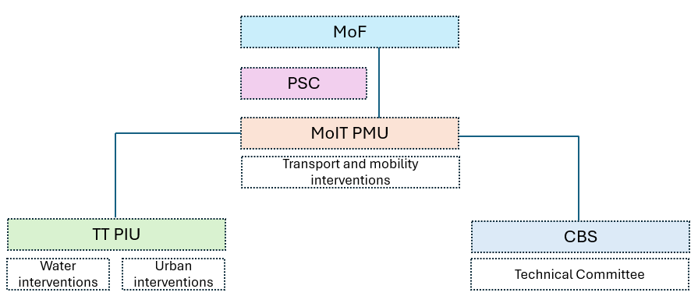
Figure 2: Institutional Arrangements

Project Steering Committee (PSC): The PSC will serve as the highest supervisory body, providing strategic oversight, resolving cross-agency issues and bring in synergies across the projects implemented.
Project Management Unit. The Department of Human Settlement, MoIT will house a Project Management Unit (PMU), that will be responsible for overall day-to-day project coordination and technical oversight. The PMU will also facilitate public, community and stakeholder engagement meetings as a part of the ESIA update process. The PMU will ensure coordination between MoIT, TT and City Bus Services (CBS) and provide support to CBS in ensuring delivery of services as planned. Any issues related to bus priority lanes, sidewalks, bus stops and shelters, terminal buildings, charging infrastructure, depot improvements, and road markings and signs will be addressed by PMU in coordination with the relevant agencies.
Project Implementation Unit. Thimphu Thromde will house a Project Implementation Unit (PIU). It will be responsible for implementing the project’s urban placemaking infrastructure and water investments. These include the improvement of road, alleyways, connecting footpaths, and the implementation of the water interventions. It will be responsible for the dissemination of information on project activities, scheduling, updating the public in case of unanticipated events and addressing project related grievances. Similarly, for the Water Supply Component, the Thimphu Thromde will be the focal agency that will inform all water users regarding the project activities and scheduling. Communities will also be kept up to date about events and news through the Thuemis (local representatives), social media, and TV.
The Social and Environmental Focal Person from Thimphu Thromde and the Environmental Focal from DHS will be responsible for all stakeholder engagement planning and implementation.
  - Indicative Budget for SEP Implementation
Table 5: Indicative Budget for SEP Implementation
Budget Category | Quantity | Unit Cost | Years | Total Cost | Remarks
- Estimated staff salaries
1.1. Staff Salaries | - | - | - | - | Included in project budget
1.2. Travel cost | - | - | - | - | Included in project budget
- Consultative Meetings
2.1. Meetings for Component 1.1: Resilient water services to enhance the resilience and reliability of Thimphu’s water supply in the core city | Lump sum | 100,000.00 | 3 | 300,000.00
2.2. Meeting for Component 1.2: Resilient urban public spaces and low-emission mobility | Lump sum | 300,000.00 | 3 | 900,000.00
2.3. Meeting for Component 1.3 Low emission public transport | Lump sum | 100,000.00 | 3 | 300,000.00
- Grievance Redressal
3.1. Verification of Grievances and GRM meetings | Lump sum | 50,000.00 | 5 | 250,000.00
3.2. Compensation (if required) | - | - | - | - | From contingency budget
- Communication Campaigns- Information brochures, posters, public announcements Project information TV,radio, social media
4.1. Component 1.1: Resilient water services to enhance the resilience and reliability of Thimphu’s water supply in the core city | Lump sum | 1,50,000 | 5 | 750,000.00 | Budget can be allocated so that it will decrease in later years.
4.2. Component 1.2: Resilient urban public spaces and low-emission mobility | Lump sum | 1,50,000 | 5 | 750,000.00
4.3. Component 1.3 Low emission public transport | Lump sum | 1,50,000 | 5 | 750,000.00
- Trainings
GRM for GRM Committee members | Lump sum | 100,000.00 | 1 | 100,000.00
Training for Gender consultations and SEA/SH | - | - | - | - | Included under GAP budget
Training for RAP, livelihood | - | - | - | - | Included under RAP budget
Training on CoC | - | - | - | - | Included under GAP
Grand total |  |  |  | 4,100,000.00

The budget estimate for implementing the SEP is USD 48,200 (Nu 4,100,000.000). The budget will be updated before the implementation of this SEP.

Grievance Redress Mechanism
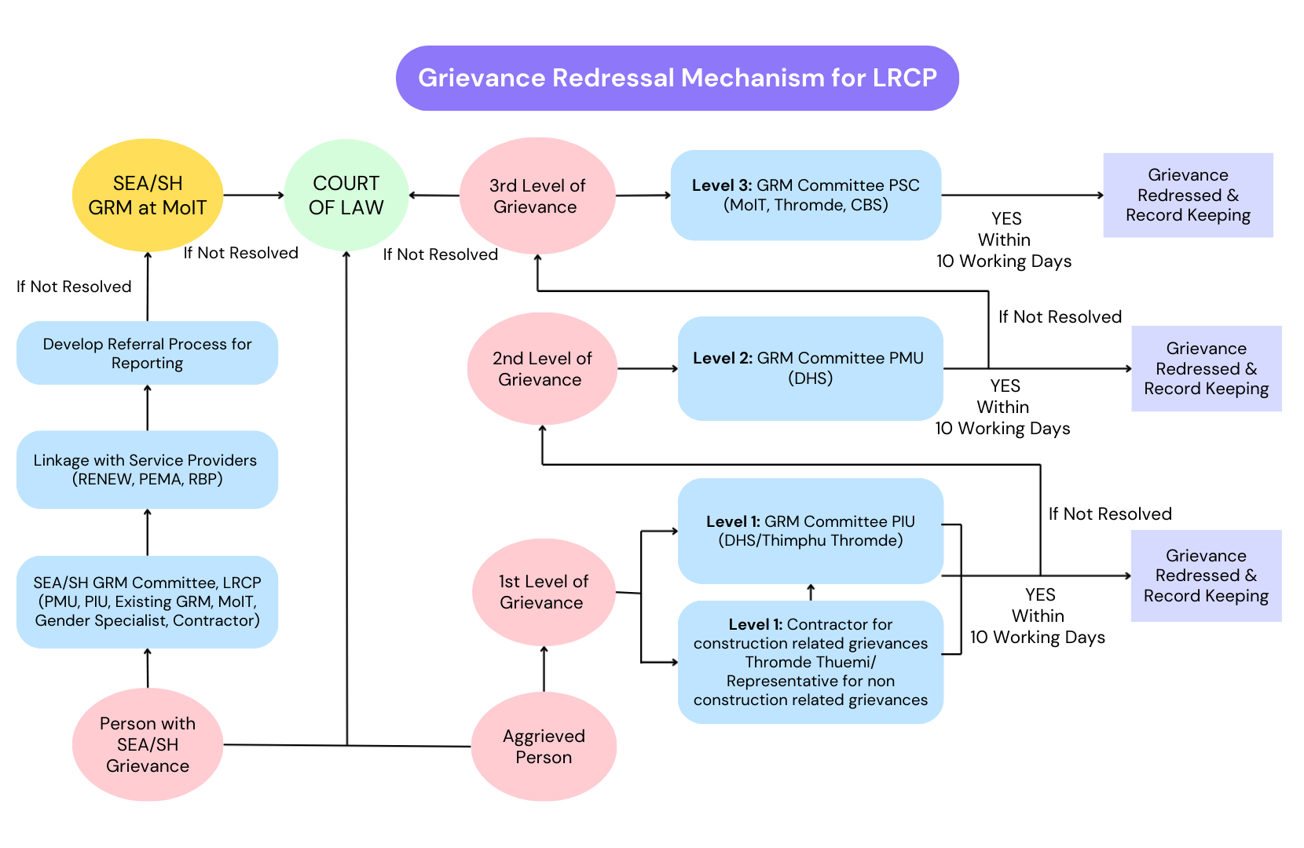
  - Grievance Redressal Process

  - GRM steps
The GRM Implementation Structure will comprise of 3 tiers, from the contractor/PIU (Thimphu Thromde and City Bus Service); PMU (Department of Human Settlements, MoIT); and, the Project Steering Committee. The Sexual Exploitation and Abuse (SEA) and/or Sexual Harassment (SH) GRM will be linked to the existing GRM at MoIT. At each level, grievances will not take more than 10 working days from the date of receipt to review of cases and resolution.
Type of grievances include:
A. Construction impacts related grievances (Contractor)
A1 - disturbance and inconvenience due to construction activities, A2 - unanticipated impacts on property and disruption of utilities, A3 - waste and pollution, A4 - health and safety, A5 - workers grievances.
B. SEA/SH related grievances (PMU)
Directly to SEA/SH GRM at MoIT.
C. Operations-related grievances (PIU - both Thimphu Thromde and City Bus Services)
C1 - Operations of bus infrastructure (terminals, bays, stops and shelters), C2 - Operations of bus services
D. RAP-related grievances (PMU, PIU, PSC)
D1 - property and land, D2 - livelihood, D3- livelihood restoration activities
Table 6: Illustrative Table on the GRM steps
Step/Stage | Description of Process | Timeframe | Responsibility
GRM Implementation Structure | The GRM structure will comprise of 3 tiers, from the contractor/Thromde representative- PIU- PMU and PSC. The contractor will only deal with issues/grievances that are listed as Construction impacts related grievances  The SEA/SH GRM will be linked to the existing GRM at MoIT. | At each level, grievances will not take more than 10 working days from the date of receipt to review of cases and resolution | Thimphu Thromde  DHS, MoIT  CBS
Grievance Uptake/Submission | Grievances can be submitted through the following channels;  - In person at the contractor’s office  - In person at the Thromde or MoIT office  - Via the means of Social Media (direct message on Thromde Facebook & Instagram Page), Emails, Thromde Complaint Management System and Toll Free Number (1009)  - Via Thromde Thuemis  - Via email to the project focal officer  - Via phone call to the project focal officer followed by a request to submit a formal letter  - The link on the project website where the aggrieved person can lodge the grievance online |  | GRM Focal Persons from PMU and PIU,  Contractor
Sorting, Processing | Submissions will be sorted into grievances or ‘information requests’.  For grievances, a grievance register will be maintained at the following offices;  - Contractor  - Thromde  - DHS  - CBS  Any grievance shall be registered with the following information:  Time, date and nature of grievance;  Type of communication (Telephone, letter, personal contact);  - Name, contact address and contact number;  - Response and investigation undertaken as a result of lodging the grievance; and  -Actions taken and name of the person taking the action  - Date of informing the complainant | For the entire duration of the project period | GRM Focal Persons from PMU and PIU, Contractor
Acknowledgement and follow-up | Receipt of the grievance is acknowledged to  the complainant  If the submission is an ‘information request’, a response will be shared to the submitter | 5 working days | GRM Focal Persons from PMU and PIU
Verification, investigation and action  Appeal to higher level GRM Committees | Prior to the GRM committee meeting, coordinate with the aggrieved person or party to obtain proper and timely information. Based on the nature of the grievance, appropriate investigation and actions to redress the grievance will be undertaken. | 5 working days | Grievance Focal  Person
 | The GRM committee at each level will seek to resolve the grievance as soon as possible and avoid escalation.  However, where a grievance cannot be readily resolved to the satisfaction of the aggrieved, then the grievance shall be immediately referred to the next level.  If the person/party is not satisfied with the resolution of the GRM committee, the person/party can appeal to the next GRM committee. | Within 10 working days | Grievance Committee
Monitoring and evaluation | For Monitoring purposes, a Grievance Register will be retained that will document all grievances lodged and actions taken.  Proper record of the minutes of the GRM committee meetings will be maintained  Data on grievances will be reported each month to the PMU and in the semi-annual EMR to WB | Semi-annually | PMU, WB
Provision of feedback/response | The aggrieved person or party will be notified of the proposed outcome through a formal letter and also informed in person or via telephone.  Information on the GRM will be widely disseminated through the local media, social chat groups and at project work sites. | Within 10 days of the grievance being resolved | GRM Focal Persons
Training | All GRM Focal Persons and GRM committee members, contractors and Theumi/ Thromde Representatives will be trained on the GRM procedures and redressal mechanism | As soon as the GRM committee members are identified and notified, supervision consultants are onboarded. | PMU
If relevant, payment of reparations following complaint resolution | Contingency budget will be retained to address reparation requirements.  Payment for this will only be made to the account number of the aggrieved person/party, based on the recommendation and decision of the GRM committee and approved by the PSC | Construction and Operation Phase | PMU
 | The contractor will be fully liable for any reparations caused by his staff/workers/trucks/machines | Construction phase | Contractor
Appeals process | The resolution of the GRM committee will be communicated to the aggrieved person/party. If the person/party is not satisfied with the resolution of the GRM committee, the person/party can appeal to the next GRM committee. | Throughout the project period | MoIT

Establish and strengthen existing mechanisms under LRCP that can respond to GBV/SEA/SH

A detailed GRM Standard Operating Procedures will be developed during implementation. Additionally,
the SEA/SH Action Plan will elaborate on how the project GRM will integrated survivor-centric response
to SEA/SH complaints.

To effectively prevent and respond to Gender-Based Violence (GBV), Sexual Exploitation Abuse and Sexual Harassment (SEA/SH), critical institutional mechanisms need to be established and strengthened. This necessitates setting up a dedicated SEA/SH Grievance Redress Mechanism (GRM) Committee for LRCP linked to existing GRM of MoIT and comprising representatives from the Project Management Unit (PMU), PIU, Gender specialist of PMU and contractors. The committee will oversee the SEA/SH case management, ensure coordination with focal points and onboard selected Partner Organizations (PO). Each implementing institution will appoint a trained SEA/SH focal person to monitor activities and facilitate confidential reporting. The SEA/SH hotline will be integrated with existing services, with strong linkages to national support systems including the Pema Secretariat, RBP helpline 113, and RENEW’s provincial networks. Standard Operating Procedures (SOPs), referral pathways, and case management flowcharts will be developed to ensure coordinated, survivor-centered responses. Awareness campaigns will promote use of grievance systems, while stakeholder consultations will address GBV concerns. Safety audits, service mapping, and assessments will guide quality assurance, and capacity building for local gender focal persons who will reinforce service delivery and coordination with relevant local authorities like Policewomen cell, Dzongkhag Committee, hospital/BHUs (Basic Health Unit), school committee, local Government office. If the matter is not resolved at this level, it will be referred to the court of law by the SEA/SH GRM committee.

A comprehensive capacity-building package will be developed for administrative staff, contractors, and Project Management Unit (PMU) to strengthen safeguarding mechanisms. This will include training on ethics, rights and responsibilities, positive discipline, GBV prevention, reporting and referral procedures. Specialized trainings will deepen understanding of Codes of Conduct (CoC), grievance redress mechanisms, and case handling protocols. CoCs will be developed, signed by all personnel on-site, and disseminated through orientations and visual materials to both workers and surrounding communities. Gender responsive infrastructure will be prioritized with safe, separate, and accessible facilities for men and women, childcare options, and well-lit public areas. Visible signage will reinforce the project’s zero- tolerance approach to GBV, SEA/SH incidences.

Monitoring and evaluation will include regular field visits, quarterly reviews of the SEA/SH Prevention and Response Action Plan and performance reporting to ensure effective implementation and oversight.

Monitoring and Reporting
  - Summary of how SEP will be monitored and reported upon (including indicators)
The PMU will take the overall responsibility for SEP monitoring and reporting. Bi-annually, all implementing agencies - Thimphu Thromde, DHS and CBS will submit a report/update on the number and types of consultations undertaken, target stakeholders consulted, the number of participants and the types of topics discussed and issues requiring attention (future/next steps). Any issues that need to be discussed at the project management level will be included in the bi-annual project review meeting.
Table 7. Reporting format for consultations carried out by implementing agencies
Date | Type of Consultation | Stakeholders/Participant/Agency | Number of participants |  |  | Issues discussed/raised | Future steps
Date | Type of Consultation | Stakeholders/Participant/Agency | Male | Female | Total | Issues discussed/raised | Future steps
All data, consultation, stakeholder engagement activities, information disclosure and grievances will be maintained in a database maintained at the PMU. If required, relevant data will be anonymized and made available for public review upon request. The information on the database can be stored as shown in table 8.
Table 8. Reporting format on the status of grievances by implementing agencies
Date | Month | Number of grievances received | Number of grievances for which actions have been initiated for resolution | Number of grievances addressed | Level of Resolution  Level 1  Level 2  Level 3 | Number of Pending grievances
Monitoring Reports documenting the environmental and social performance of the Project will include a section regarding stakeholders’ engagement and grievances management. The section below proposes a set of indicators relating to the SEP performance.
  - SEP Performance Indicators
Monitoring Reports documenting the environmental and social performance of the Project will include a section regarding stakeholder engagement and grievances management. The set of indicators relating to the SEP performance is listed in Annex 2.
  - Reporting back to Stakeholders/Interest Groups
The Stakeholder Engagement Plan (SEP) will undergo periodic revisions and updates throughout project implementation . These updates will encompass all stakeholder engagement activities conducted to date, including inquiries, concerns, recommendations, or grievances, along with corresponding responses, decisions made, or corrective actions implemented. The revised SEP will be accessible on the Project website and at the project offices at DHS, TT and CBS.

For stakeholder consultations, the Project will circulate the minutes to stakeholders for their review and input prior to finalization. When actions are required, responsible individuals or agencies will be identified within the implementing agencies as focal persons and these focal persons will be the link within key stakeholders, keeping them informed regarding the LRCP project.
Thimphu Thromde will use the Thuemis/Representatives to be the primary link to report back to the local community/businesses/residents on project activity updates, activities and actions taken.

Annexes

Annex 1. Grievance Register Form
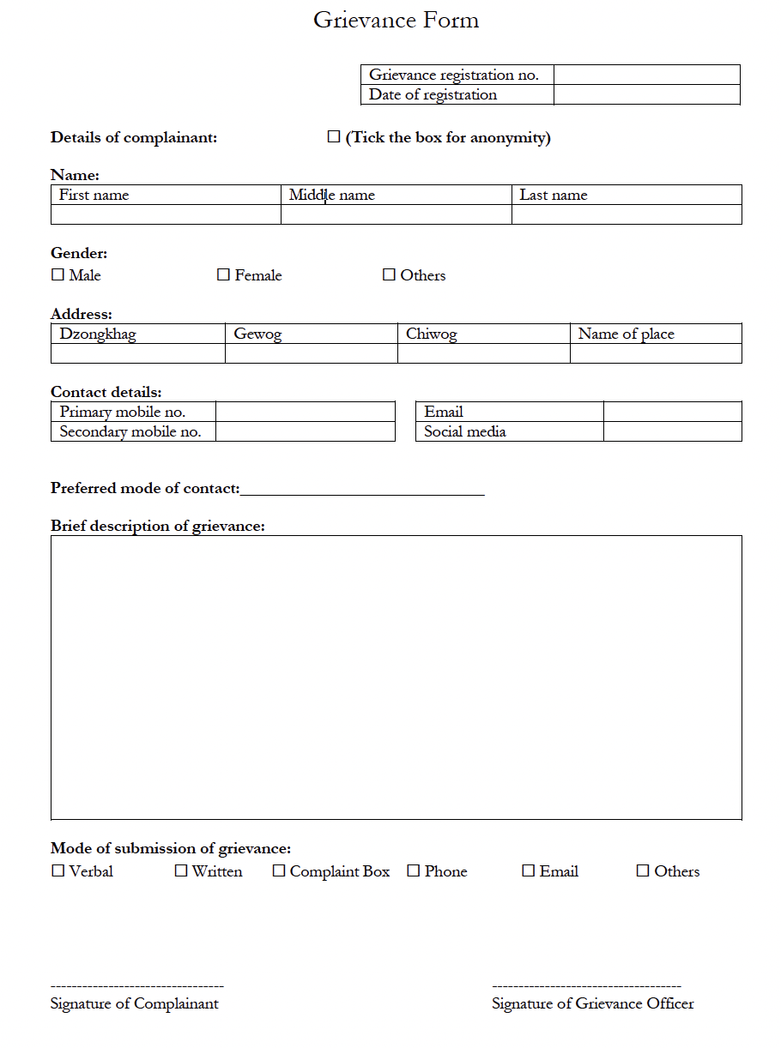

Annex 2. Grievance Closure Form
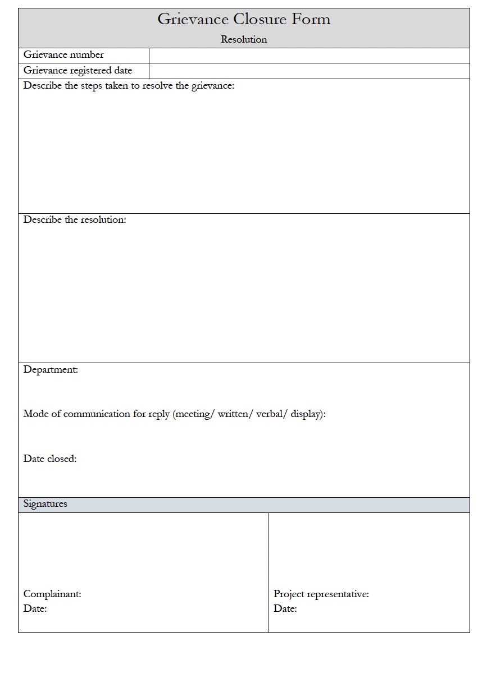

Annex 3. Resolution Notification Form
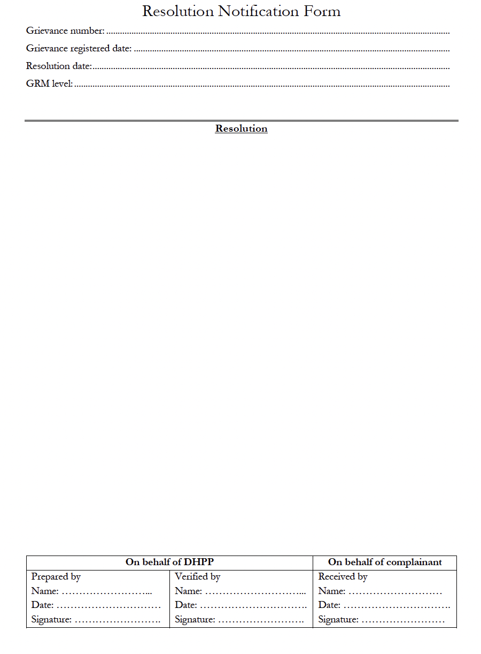

Annex 4. Public Notices regarding Environment and Social Assessment and RAP Survey
